Wildlife Resource 5-Report (Article 410)
Settlement Agreement Concerning Wildlife
Skagit River Hydroelectric Project No. 553
August 2007 –March 2011
April 25, 2011

This Wildlife Resources Report (WRR) summarizes wildlife resources activities completed under the Settlement Agreement (SA) Concerning Wildlife Resources for the Skagit River Hydroelectric Project (P-553) between August 2007 and March 2011. The following sections describe progress on wildlife habitat acquisition and management, wildlife research center operation, long-term monitoring, and wildlife research grant program.

1.0 Wildlife Habitat Acquisition and Management
Wildlife Management Review Committee (WMRC)/Land Acquisition Group (LAG) meetings have been held a minimum of once a year between 2007 and 2011. At each meeting, committee members were given a presentation on activities completed the previous year, a spending report for that year, and a plan for the coming year including anticipated expenditures.

1.1 Land Acquisitions
The LAG chose not to expend Wildlife Habitat Settlement Agreement funds on land acquisitions in 2007. In 2008, the LAG decided that additional acquisitions could be pursued over the next few years, as long as $700,000 (2011 dollars) of the original budget was set aside for land management purposes.

In 2008 and 2009, City Light pursued several properties along the Sauk River adjacent to existing Wildlife Mitigation Lands (WML) properties. Unfortunately, the property owners did not agree to sell at the appraised fair market value. City Light continues to pursue these parcels.

In 2010, City Light acquired 1,015 acres of wildlife habitat on five properties in the Skagit and South Fork Nooksack River drainages (Table 1). Three of the properties were acquired from the Washington State Department of Natural Resources (DNR) under the state's Trust Land Transfer (TLT) Program. The additional acreage brings the total amount in the Wildlife Mitigation Lands Program (based on property titles) to 9,311 acres. However, the acreage of land actually owned by City Light is less than this because the Skagit and Sauk river channels have shifted over time, creating new channels and eroding substantial area on several of the WML properties. There have also been several adjustments to property lines based on land survey results. The current estimated total WML is approximately 9,186 acres.
City Light expects to receive one more property from DNR TLT Program in 2011 and is continuing to express interest to DNR in acquiring additional parcels of land in the Skagit watershed under this program. City Light continues to explore other acquisition opportunities.

In December 2010, City Light submitted a new set of Exhibit J drawings and Geographic Information System (GIS) files to FERC along with a table that accounts for land owned by City Light under the Skagit WML Program. This set of drawings is currently being revised to more accurately reflect the property ownership changes discussed above. The new drawings and GIS data will be filed with FERC in 2011 as part of the license amendment application for the Gorge Second Tunnel Project.

Table 1. Skagit Wildlife Mitigation Lands Program Properties Acquired, 2007-2010
Year | Property | Watershed | Acres
2010 | Olivine Ends (TLTP) | S.F. Nooksack | 210
2010 | Finney Creek (TLTP) | Skagit | 640
2010 | South Marble 40 (TLTP) | Skagit | 40
2010 | Goodwin | Skagit | 80
2010 | Savage Slough | Skagit | 45¹
 | TOTAL |  | 1,015
¹ This acreage is approximate. The 211-acre Savage Slough property was purchased with a combination of FERC Project 553 WML and fisheries funds as well as non-project funding sources from the City of Seattle Early Action Program for endangered species and a Salmon Recovery Funding Board grant. The 45 acres apportioned to the WML is based on the funding amount provided by the WNL program

1.2 Land Management Actions
1.2.1 Weed Management
City Light has been collaborating with The Nature Conservancy, U.S. Forest Service, and National Park Service to control knotweed infestations along the Skagit and Sauk rivers in the Skagit Cooperative Weed Management Area. Several knotweed infestations located on or near WML properties have been treated with approved herbicides and are revisited each year. City Light continues to monitor the WML properties for infestations of other weed species designated for control in Washington, but to date has only had to conduct very limited control actions.
1.2.2 Road Maintenance and Abandonment
Between 2007 and 2009, City Light abandoned several unneeded forest roads on the WML properties following the Road Maintenance and Abandonment Plan (RMAP) approved by DNR in 2002. City Light provides road status reports annually to DNR staff. As of 2009, a total of 23 miles of forest roads had been abandoned to the satisfaction of the DNR; approximately 1.5 miles of WML roads still need to be addressed before 2016 to meet RMAP requirements.

To maintain and control vehicular access to the Illabot South and Lucas Slough properties, City Light paid for upgrading two gates on roads that border the WML properties.
1.2.3 Riparian Habitat Enhancement
In March 2010, the Nooksack Indian Tribe began a riparian habitat enhancement project on a 2-ace site on WML property in the Nooksack drainage. They planted conifers, mainly western redcedar, grand fir, and Sitka spruce under the existing alders at a 200 trees/acre density. Monitoring and replacement of dead seedlings is continuing through 2011. City Light also planted trees and shrubs along O’Brien Slough in fall 2007 following forest road removal in this area.
1.2.4 Deer and Elk Habitat Management
In 2009, the WMRC approved expending $12,000 on a 3-year elk forage pilot project located on a City Light-owned parcel (Johnson property) that is part of the Fisheries Non-Flow Mitigation Program. Management activities have included seeding clover, testing soil, fertilizing, and periodic mowing of 2 acres of former pasture. Vegetation metrics (species composition, cover, and height) and ungulate use on the treatment area and untreated control area have been monitored and compared. Monitoring results indicate regular use of the property by a small group of elk, as well as deer, coyote, and black bear.

1.2.5 Protection of Cultural Resources
In 2010, two previously unidentified archaeological sites were discovered on WML properties. City Light consulted with affected tribes, National Park Service, and the Washington Department of Archaeology and Historic Preservation on proper management of the sites.

1.3 Parcel-Specific Management Activities
The following sections summarize parcel-specific management activities completed between 2007 and 2010.

1.3.1 South Fork Nooksack River
- River and Riparian Enhancement – Using a combination of City Light and grant funding, the Lummi Indian Nation removed the “Road 330 bridge” over the South Fork Nooksack River in 2007. The Lummi Indian Nation removed the bridge, installed four engineered log jams to direct the river channel away from the eroded northern riverbank (Figure 1), and abandoned 0.4 mile of forest road. Monitoring of site conditions will continue through 2011.

In 2010, the Lummi Nation removed the “Road 300 bridge” that is located on private timber company land immediately upstream of City Light WML property. They also removed culverts from small tributary streams that flow onto the WML. Now that the bridge is removed, the active river channel will likely meander, creating side channels on WML property.

To improve riparian conditions and river shading for salmon, conifer seedlings have been planted at various locations along the river. In 2010, the Nooksack Tribe planted conifers in a deciduous stand downstream of the “Road 200 bridge”. The tribe will be monitoring survival of the plantings and replacing any dead seedlings in 2011.

- Road Maintenance – There are approximately 1.5 miles of road on the Nooksack property that must remain open for timber company access. These 1.5 miles need treatments to improve stream crossings and drainage culverts to comply with RMAP. In 2009, City Light hired a forest engineer to assess the road system and identify corrective actions. A Forest Practices Application was approved by DNR for City Light to complete work at 33 locations along the road; one stream crossing that requires very deep fill was not included in the package and would require a separate FPA. A Lummi Tribal contractor estimated the cost of the work at $375,000. However, this estimate excluded the $25k to $50k for the deep fill site, so the total cost estimate is over $400k.

In light of the high road maintenance cost, the City Light proposed, and the LAG agreed, to explore a land exchange with the timber company owning the adjacent lands. The exchange would involve transferring the road and approximately 128 acres of WML to the timber company in return for 350 acres of land farther upstream in the watershed. This would eliminate the need for City Light to maintain a forest road that is only open to serve private timber companies. As of this date, a joint appraisal of the two properties has been completed and is being reviewed by an independent review appraiser. The LAG will decide whether to approve the exchange after reviewing appraisal results and determining the amount of cash that would be needed to be paid to the timber company to equalize the trade. City Light and the adjacent timber company also continue to negotiate on maintenance agreement for a separate 9-mile-long section of private forest road bordering City Light land in the watershed.

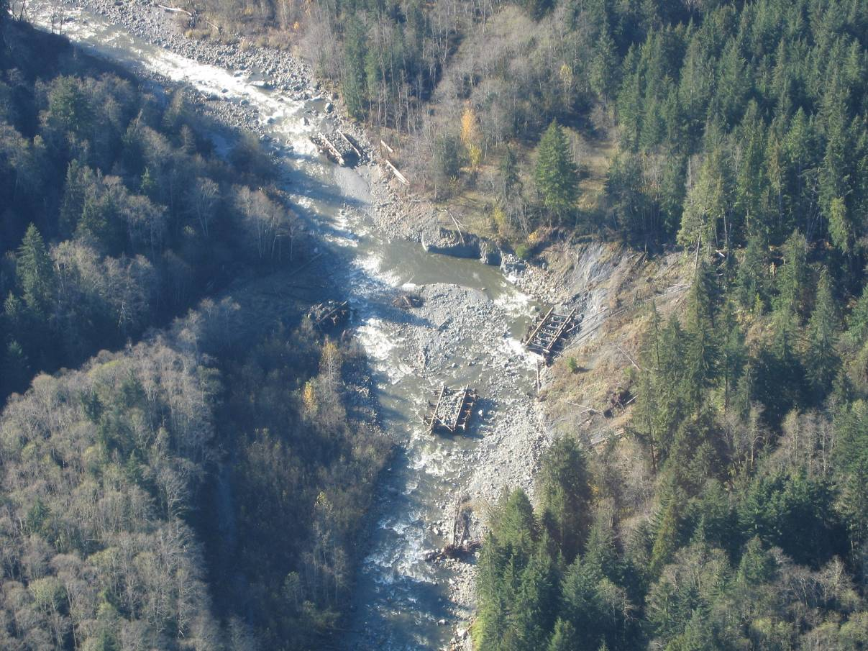
Figure 1. South Fork Nooksack River 330 bridge removal site, showing engineered log jams.

- Legacy Issues – In 2009, City Light successfully entered into a Release of Claims and Settlement Agreement with an individual that may have had a potential “adverse possession” claim for a long-used, isolated cabin site (5,000 sq. ft.) on the nearly 4,000 acre Nooksack property. The release removes the possibility of an adverse possession claim in return for limited continued use of the cabin site. City Light monitors the site several times a year to ensure environmental impacts are minimized and will restore the disturbed area once the occupant leaves the area and the term of the Settlement Agreement is complete.

1.3.2 Bacon Creek
- Bacon Creek Road – In 2009, City Light and the U.S. Forest Service agreed on an easement for the portion of the Bacon Creek Road that is located on City Light WML property. Under the easement, the U.S. Forest Service assumes maintenance responsibilities for 0.8 miles of road.

- Bacon Creek Quarry – With WMRC approval, City Light is moving forward with planning for the use the 6-acre former gravel quarry on the property (Figure 2) as a rock disposal area for the Gorge Second Tunnel Project in 2015. Following rock disposal, which will fill up a large portion of the quarry, City Light will re-contour the area and restore native vegetation according to a detailed restoration plan that will first be approved by the WMRC.

1.3.3 Illabot North & O’Brien Slough
- Weeds – In September 2007, an infestation of policemen’s helmet, a Class B noxious weed designated for control in Skagit County, was found along a side channel of the Skagit River on the Illabot North parcel. Since then, City Light personnel have controlled this invasive weed by hand pulling all visible plants annually. This has resulted in a substantial decrease in the extent of the infestation. City Light will continue to implement weed control at the site as necessary until this species is eradicated.

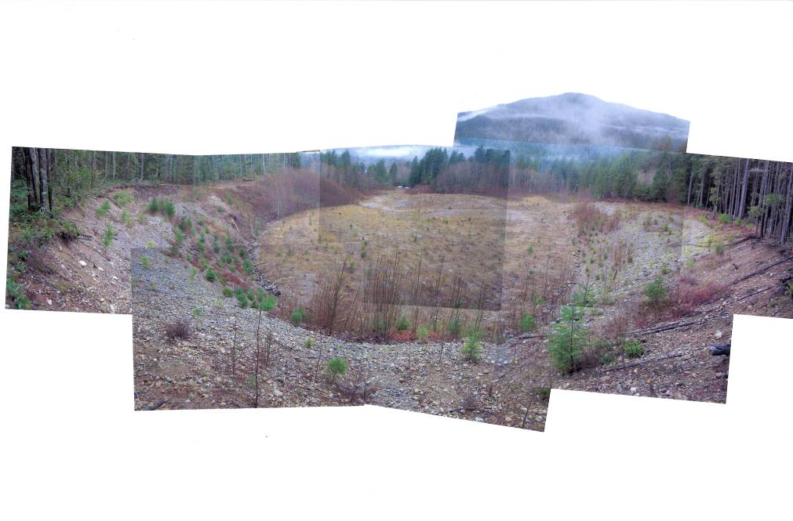
Figure 2. Bacon Creek Quarry.

- O’Brien Slough Restoration – In 2007, City Light removed an abandoned forest road that bisected the slough and planted trees and shrubs on the former roadbed and banks along the slough (Figure 3).

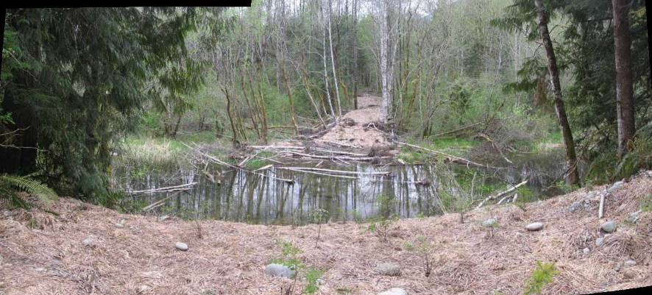
Figure 3. Reconnected slough and site of removed road at O'Brien Slough, 2008.

1.3.4 Illabot South
In 2007-2008, City Light abandoned approximately 18 miles of unnecessary forest roads on the Illabot South property. Approximately 2 miles remain open but have been treated to meet RMAP requirements.

1.3.5 McLeod Slough
In 2010, City Light resolved a long-running property line dispute with the adjacent landowner. A land survey was completed and filed with Skagit County to reflect the corrected common boundary that is based on the location of a historical access road. This resulted in a small decrease in City Light ownership.

1.3.6 Sauk Properties
The unregulated Sauk River has been very active, moving across a wide channel migration zone (Figure 4). This has resulted in some substantial changes in the acreage of WML ownership because river channels are considered state-owned land. As discussed in Section 1.1, new FERC drawings showing City Light WML properties were filed with the FERC in early 2011.

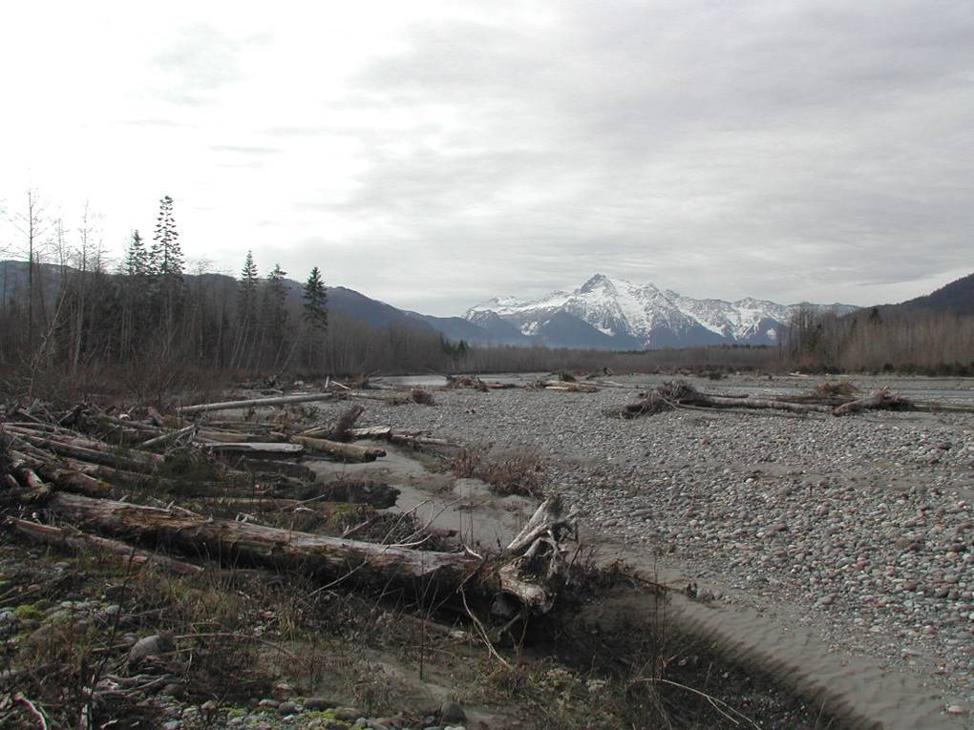
Figure 4. Sauk River channel migration near WML property.

1.4 Lands Budget Status
The status of the Wildlife Habitat Mitigation budget as of February 2011 is presented below:

- Settlement Agreement Amount $17 million(1990$)
- Expended through 2010 $16,272,600(1990$)
- Remaining $727,400 (approximately $1.3 million in 2011$)

2.0 Wildlife Research Center
The Wildlife Research Center in Newhalem continues to operate under the management of the National Park Service.

3.0 Long-Term Wildlife Monitoring

3.1 Wildlife Monitoring in the Ross Lake National Recreation Area
Between 2007 and 2010, City Light continued to fund wildlife-related studies conducted by the National Park Service, including the following projects:

- Marbled murrelet surveys
- Northern spotted owl surveys
- Landbird monitoring
- Rare and sensitive plant surveys
- Forest carnivore inventory
- Mountain goat monitoring
- American pika – climate change study

3.2 Bald Eagle Inventory and Planning
During the 2010-2011 winter, the U.S. Forest Service conducted bald eagle monitoring on the Skagit and Sauk rivers as part of the bald eagle inventory and planning element of the Wildlife Settlement Agreement. City Light paid $7,342.51 to the U.S. Forest Service for these surveys and is currently reviewing a draft report.

4.0 Wildlife Research Grant Program
The Seattle City Light Wildlife Research Grants Program is advertised on the website http://www.seattle.gov/light/environment/wildlifegrant/. Since 2007, the Wildlife Research Advisory Committee (WRAC) solicited proposals during the following time periods:

- Spring 2008
- Fall 2008
- Spring 2009
- Spring 2011 (in progress)

In 2008, the Western Washington University faculty member on the WRAC finished their 3-year term and was replaced with a faculty representative from the University of Washington. No grant solicitation was held in 2010 because the WRAC decided to add funding to two ongoing grants. During each solicitation, the WRAC reviews all pre-proposals and asks finalists to prepare full-length, detailed proposals. The proposals are peer-reviewed prior to final review a selection by the WRAC. The selected proposals are awarded grant funding through City Light.

Between 1999 and 2010, City Light funded 24 research projects, totaling $766,870 (1990 dollars). Table 3 shows the research projects that have been funded since the start of the program. Of these, seven are ongoing as of March 2011.

Table 3. Skagit Wildlife Research Grants Program Funded Research, 1999-2010.
Year | Project Name | Amount Awarded | Principal, Institution
1999 | Do Introduced Trout Reduce the Genetic Integrity of long-toed Salamanders in High Elevation Lakes? | $51,667 | Liss, OSU
1999 | Grizzly Bear Presence and Population Estimate for the North Cascades | $61,331 | Wielgus, WSU
2000 | Grizzly Bear Presence and Population Estimate for the North Cascades | $25,000 | Wielgus, WSU
2000 | Species Identification and Genetic Differentiation Among Ranid Frog Populations in the Skagit River Watershed | $29,642 | LaCava, OSU
2000 | Pilot Study to Develop a Long-term Landbird Monitoring Program at North Cascades National Park Service Complex | $20,000 | Kuntz, NPS
2000 | Macroinvertebrate drift in Non-fish Bearing Streams within the North Cascades Ecoregion | $15,000 | Svendsen, SVC
2000 | Habitat Selection by Lynx in the North Cascades | $74,555 | Kohler WDFW
2001 | Avian Distributions and Habitat Relationships Across North Cascades National Park Service Complex | $44,200 | Kuntz, NPS
2001 | Macroinvertebrate Drift in Headwater Streams of the North Cascades | $39,052 | Svendsen, SVC
2003 | Grizzly Bear Outreach Project Evaluation | $49,952 | Davis, Conservation Partner. Ctr,
2003 | Mountain Goat Habitat Relations in the North Cascades | $59,137 | Rice, WDFW
2003 | Potential Impact of Regulated Flows on the Life History and Ecology of Black Cottonwood Along the Skagit River | $58,771 | Jeff Braatne, Univ. of Idaho
2005 | Mountain Goat Sightability Surveys in the North Cascades | $32,625 | Cliff Rice, WDFW
2006 | Wolverine Distribution and Ecology in the North Cascades | $32,270 | Keith Aubrey, USFS
2006 | Clark's Nutcracker Habitat Use and Relative Abundance in the Cascade Range | $78,900 | Teresa Lorenz, Utah State Univ.
2006 | Space Use and Habitat Selection by Dunlin in the Skagit River Delta | $50,782 | Slater, Ecostudies Instit.
2007 | Lynx Cycles and Barriers: Evaluating Dispersal versus Climate Change in Flat-lining Populations | $20,000 | Boyce, Univ. of Alberta
2007 | Identifying Key Habitats and Spatial Requirements of Mountain Goats in the North Cascades | $40,000 | Garton, Univ. of Idaho
2007 | Mountain Goat Conservation in the Washington Cascades: A Genetic Approach | $36,640 | Wallin, Western Wash. Univ.
2006 | Wolverine Distribution and Ecology in the North Cascades | $47,950 | Aubrey, USFS
2008 | Factors Affecting Spotted Owl Persistence in Northwest Washington: A 20 year Retrospective: | $64,000 | Hamer Environmental, Inc.
2009-  2010 | Factors Affecting Pika Population Dynamics in the North Cascades Ecosystem | $89,920 | Bruggeman, Beartooth Inc.,
2009 | Canada Lynx Conservation in the North Cascades: Habitat Use of GPS Marked Animals | $75,699 | Wielgus, Wash. State Univ.
2009-  2010 | The Cascades Carnivore Connectivity Project: Evaluating Habitat Connectivity for Carnivores in Washington’s Cascade Mountains | $102,000 | Long, Montana State Univ.

