National Park Service
U.S. Department of the Interior

North Cascades National Park Service Complex
Acoustic Monitoring
Newhalem, 2009

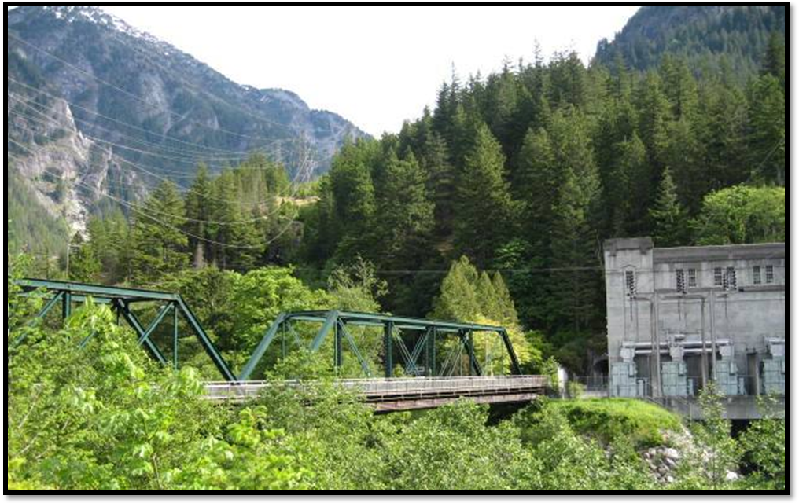

Contents
Executive Summary 1
Introduction 1
Background 1
National Park Service Natural Sounds Program 1
Soundscape Planning Authorities 1
Study Area 1
Methods 1
Automatic Monitoring 1
Off-Site Listening 1
On-Site Listening 1
Calculation of Metrics 1
Results 1
Conclusion 1
BIBLIOGRAPHY 1

FIGURES
Figure 1. Newhalem Acoustic Monitoring Site 1
Figure 2. Locations of Acoustic Monitoring Sites 1
Figure 3. Approximate Location of the Newhalem Acoustic Monitoring Site 1
Figure 4. Plot of Hour, Frequency, and Sound Pressure Level in Newhalem 1
Figure 5. Plot of Hour, Frequency, and Sound Pressure Level at Easy Pass 1
Figure 6. Median Hourly Exceedence Metrics at Newhalem in dBA 1
Figure 7. Hourly Percent Time Audible of Total Extrinsic, Aircraft, and Vehicle Sounds 1
Figure 8. Day and Night dB Levels for 33 One-third Octave Bands at Newhalem 1

TABLES
Table 1. Percent time above metrics for 2009 Newhalem site 1
Table 2. Mean Percent Time Audible for Extrinsic Sounds, Vehicle Sounds, and Aircraft Sounds 1

Executive Summary
In July of 2009, NPS resource managers deployed an acoustic monitoring system for 30 days near the Seattle City Light company town of Newhalem. The Newhalem site is one of several that were selected to develop a baseline inventory of the “soundscape” of North Cascades National Park Service Complex. The baseline data collected during this period will help park managers determine if desired conditions for natural soundscapes are being met at this location. The site was also chosen in order to measure current ambient sound levels that could be affected by the proposed Gorge Tunnel II project. This report is being provided to Seattle City Light to help inform the environmental assessment for the proposed project.

Introduction
A 1998 survey of the American public revealed that 72 percent of respondents thought that providing opportunities to experience natural quiet and the sounds of nature was a very important reason for having national parks, while another 23 percent thought that it was somewhat important (Haas & Wakefield 1998). In another survey specific to park visitors, 91 percent of respondents considered enjoyment of natural quiet and the sounds of nature as compelling reasons for visiting national parks (McDonald et al. 1994). Acoustic monitoring provides a scientific basis for assessing the current status of acoustic resources, identifying trends in resource conditions, quantifying impacts from other actions, assessing consistency with park management objectives and standards, and informing management decisions regarding desired future conditions.

Background

National Park Service Natural Sounds Program
The NPS Natural Sounds Program (NSP) Office was established in 2000 to help parks manage sounds in a way that balances access to the park with the expectations of park visitors and the protection of park resources. The NSP addresses acoustical issues raised by Congress, NPS Management Policies, and NPS Directors Orders. An important element of this mission is working with the Federal Aviation Administration (FAA) to implement the National Parks Air Tour Management Act. Congress mandated that FAA and NPS jointly develop Air Tour Management Plans (ATMPs) for more than 106 parks where commercial air tours operate. The program also provides technical assistance to parks in the form of acoustic monitoring, data processing, park planning support, and comparative analyses of acoustic environments throughout the national park system.
In 2006, North Cascades National Park Service Complex requested technical assistance from the NSP Office to begin acoustic monitoring within the park complex. In 2009 the park complex received funding to purchase two acoustic monitoring stations and to hire seasonal help to continue the program more independently. Park personnel are now working to develop a full soundscape inventory of the park complex and a soundscape management plan.

Soundscape Planning Authorities
The National Park Service Organic Act of 1916 states that the purpose of national parks is "… to conserve the scenery and the natural and historic objects and the wild life therein and to provide for the enjoyment of the same in such manner and by such means as will leave them unimpaired for the enjoyment of future generations." In addition to the NPS Organic Act, the Redwoods Act of 1978 affirmed that, "the protection, management, and administration of these areas shall be conducted in light of the high value and integrity of the National Park System and shall not be exercised in derogation of the values and purposes for which these various areas have been established, except as may have been or shall be directly and specifically provided by Congress."
NPS Management Policies 2006 provide direction for the management of natural soundscapes in Section 4.9:
The Service will restore to the natural condition wherever possible those park soundscapes that have become degraded by unnatural sounds (noise), and will protect natural soundscapes from unacceptable impacts. Using appropriate management planning, superintendents will identify what levels and types of unnatural sound constitute acceptable impacts on park natural soundscapes. The frequencies, magnitudes, and durations of acceptable levels of unnatural sound will vary throughout a park, being generally greater in developed areas. Adjacent to and in parks, the Service will monitor human activities that generate noise that adversely affects park soundscapes [acoustic resources], including noise caused by mechanical or electronic devices. The Service will take action to prevent or minimize all noise that through frequency, magnitude, or duration adversely affects the natural soundscape [acoustic resource] or other park resources or values, or that exceeds levels that have been identified through monitoring as being acceptable to or appropriate for visitor uses at the sites being monitored (NPS 2006).
It should be noted that “the natural ambient sound level—that is, the environment of sound that exists in the absence of human-caused noise—is the baseline condition, and the standard against which current conditions in a soundscape [acoustic resource] will be measured and evaluated” (NPS 2006). However, the desired acoustic condition may also depend upon the resources and the values of the park.

Study Area
During 2009 four study areas were selected based on their geographical location, elevation and distance into the backcountry. Acoustic monitoring stations were deployed during the summer months, with Newhalem and Colonial Creek Campground serving as front country sites, and Easy Pass and the Rainbow Loop Trail serving as backcountry sites. This document only reports the results from the Newhalem site.
The Newhalem site (Figure 1) is positioned on the eastern side of Newhalem and south of the Skagit River. Situated on a bedrock bench behind the Gorge Powerhouse, the site is about 620 feet above sea level, less than 200 feet away from the transmission lines, and 100 feet above the Skagit River. Figure 2 is a map of the site location, including an inset that shows the site relative to the town of Newhalem. Due to the topography of the valley, sounds from the valley floor are amplified as they resonate off the steep valley walls. In combination with the proximity of power lines, rushing water, and power generation equipment, the topography of the valley causes the site to have an overall higher ambient sound level than other survey locations.
Figure 1. Newhalem Acoustic Monitoring Site
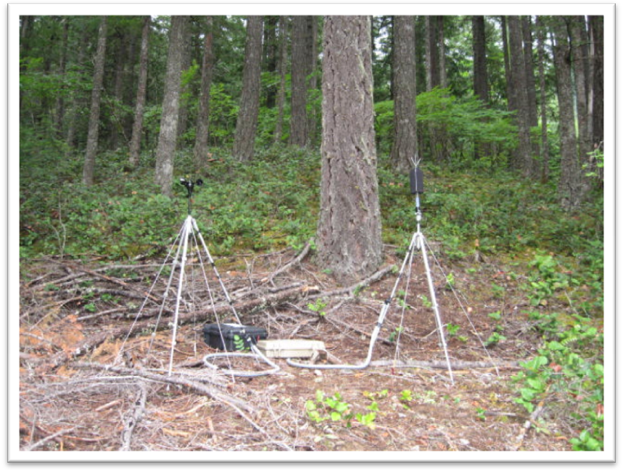
Figure 2. Locations of Acoustic Monitoring Sites
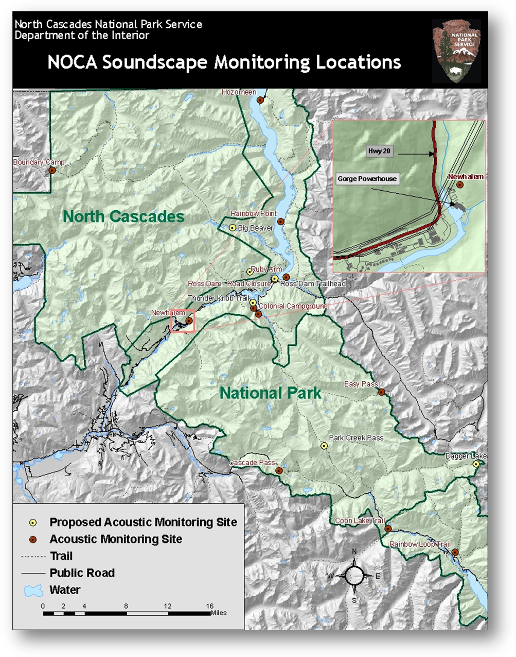
Figure 3. Approximate Location of the Newhalem Acoustic Monitoring Site
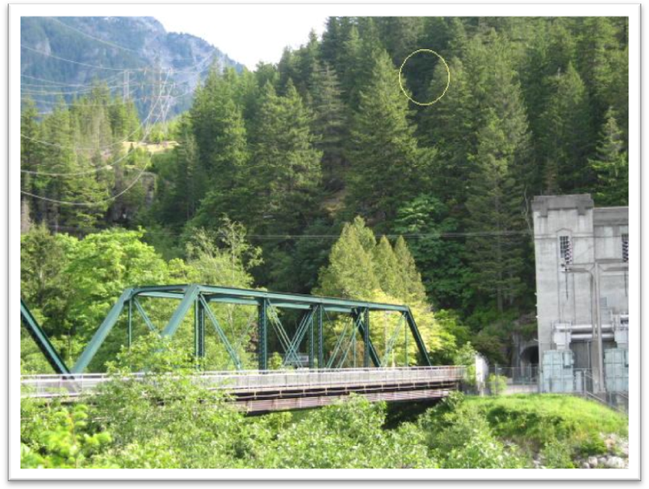
Newhalem Acoustic Monitoring Site

Methods

Automatic Monitoring
Larson Davis 831 sound level meters (SLM) were employed over the thirty day monitoring period. The Larson Davis SLM is a hardware-based, real-time analyzer which constantly records one second sound pressure level (SPL) and 1/3 octave band data, and exports these data to a portable storage device (thumb drive). Data collected using the Larson Davis SLM meets American National Standards Institute (ANSI) Type 1 standards.
The acoustic sampling station included the following equipment:
- Microphone with environmental shroud
- Preamplifier
- 8 LiFePO4 batteries
- Anemometer
- MP3 recorder
- Meteorological data logger
The acoustic sampling station collected:
- SPL data in the form of A-weighted decibel readings (dBA) every second
- Continuous digital audio recordings
- One third octave band data every second ranging from 12.5 Hz – 20,000 Hz

Off-Site Listening
Sites are analyzed differently according to their location in relation to human caused sound. Since backcountry sites have fewer audible sound sources on average, they are visually analyzed. Frontcountry sites are much more complex, and must be analyzed by listening to the sound data.
When analyzing frontcountry sites, for each day of monitoring, resource managers analyzed acoustic data by breaking the eight day subset into 10 second sound clips every two minutes. This method was developed to capture the overflights of commercial jets, which are audible for approximately 110 seconds. The sound clips were then analyzed using Adobe Audition to isolate sound sources when necessary, and cross referenced with visual analysis. Events which were not captured in the ten second sound clips (ie. Military jets) were noted. The total percent time extrinsic sounds were audible was used to calculate the natural ambient sound level.

On-Site Listening
On-site listening is the practice of placing an observer near the acoustic monitoring station with a handheld PDA (Personal Digital Assistant). The observer listens for a designated period of time (in this case, one hour), and identifies all sound sources and their durations. On-site listening takes full advantage of human binaural hearing capabilities, and closely matches the experience of park visitors. Logistic constraints prevent comprehensive sampling by this technique, but selective samples of on-site listening provide a basis for relating the results of off-site listening to the probable auditory perception of events by park visitors and wildlife. On-site listening at this site was performed during three sessions, primarily in the afternoon hours on weekdays.

Calculation of Metrics
The current status of the acoustic environment can be characterized by spectral measurements, durations, and overall sound levels (intensities). The Natural Sounds Program uses descriptive figures and metrics to interpret these characteristics. Two fundamental descriptors are existing and natural ambient sound levels. Existing ambient (L50) is characterized by spectra (in dB) drawn from uncensored data, and encompasses all sound sources. Natural ambient (Lnat) is an estimate that attempts to remove the sound energy contributed by all extrinsic or anthropogenic noises from the existing ambient. For a given hour (or other specified time period), Lnat is calculated to be the decibel level exceeded x percent of the time, where x is defined by the equation:
and P_{H} is the percentage of samples containing extrinsic or anthropogenic sounds for the hour. For example, if human caused sounds are present 30% of the hour, x = 65, and the Lnat is equal to the L65, or the level exceeded 65% of the time. Note: all samples with local wind speed greater than 5 m/s are excluded from analysis.
Following these calculations, the open source statistical program R2.11.0 was used in the creation of diagrams and figures. R is free software and a collaborative project with several contributors created by the R Foundation for Statistical Computing.
Additionally, metrics are usually calculated for on-site listening sessions. Due to technical difficulties, however, these metrics were not calculated for this site’s sessions.

Results
In determining the current conditions of an acoustic environment, is important to examine how often sound pressure levels exceed certain thresholds. Table 1 reports the percent of time that measured levels were above four key thresholds. The first, 35 dBA is designed to address the health effects of sleep interruption. Recent studies suggest that sound events as low as 35 dB can have adverse effects on blood pressure while sleeping (Haralabidis 2008). Sound levels at the Newhalem site exceeded this threshold 100 percent of the time during both day and night. The second threshold addresses the World Health Organization’s recommendations that noise levels inside bedrooms remain below 45 dBA (Berglund et al. 1999). Sound levels exceeded this threshold 63 percent of the time during the day and 11 percent of the time during the night. The third threshold, 52 dBA, is based on the EPA’s speech interference threshold for speaking in a raised voice to an audience at 10 meters. This threshold addresses the effects of sound on interpretive presentations in parks, and was exceeded 6 percent of the time during the day, and less than 1 percent of the time during the night. The final threshold, 60 dBA, provides a basis for estimating impacts on normal voice communications at one meter. Hikers and visitors viewing scenic vistas in the park would likely be conducting such conversations. This threshold was exceeded less than 1 percent of the time during both day and night.
Topography plays a large role in the overall high ambient sound level of this site, along with its close proximity to SR 20 and SCL operations. Sounds from the valley floor are amplified as they reverberate against steep cliffs. The exceedence of the 52 dBA and 60 dBA levels were generated by highway noise, in particular by heavy trucks and motorcycles.

Table 1. Percent time above metrics for 2009 Newhalem site
 | % Daytime Exceedence (7am-6:59pm) |  |  |  | % Nighttime Exceedence (7pm-6:59am)
Site Name | 35 dBA | 45 dBA | 52 dBA | 60 dBA | 35 dBA | 45 dBA | 52 dBA | 60 dBA
Newhalem | 100 | 63 | 6 | <1 | 100 | 11 | <1 | <1
The generally high ambient sound level at this site is further emphasized in the spectral view of the site (Figure 4). This spectral view combines the data from the site to create a picture of average decibel and frequency levels. Brighter levels of orange indicate higher decibel levels. Blue signifies quiet, or very low sound pressure levels. Figure 4 demonstrates that this was a site with a high ambient sound level. This is especially evident when comparing the site to a backcountry site such as Easy Pass. Figure 5 shows the overall spectral view of Easy Pass for comparison.
Figure 4. Plot of Hour, Frequency, and Sound Pressure Level in Newhalem
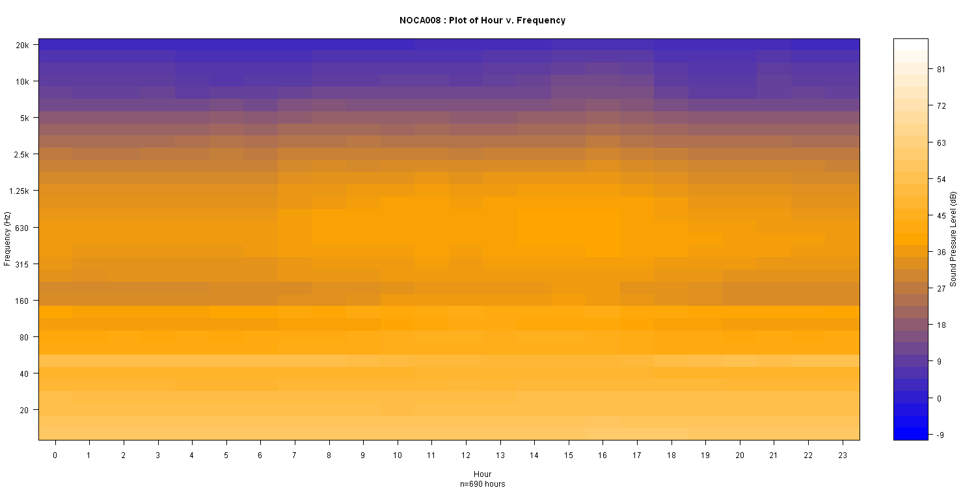

Figure 5. Plot of Hour, Frequency, and Sound Pressure Level at Easy Pass
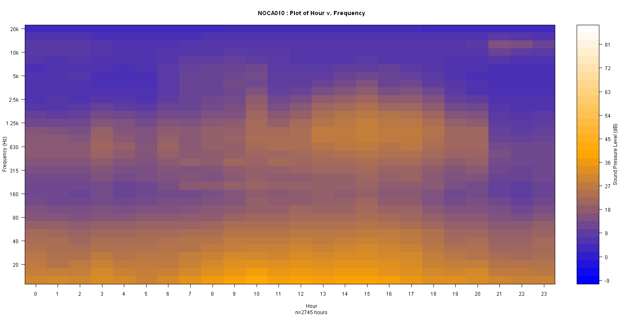

In order to determine the effect that extrinsic noise audibility has on the acoustic environment, it is useful to examine the median hourly exceedence metrics. Figure 6 shows existing and natural ambient levels. The existing ambient (or median) level for each hour is marked by the upper limit of the gray boxes while natural ambient levels (L_{nat}) are marked by the lower limit of the gray boxes. The height of the box is a measure of the contribution of human caused noise to the existing ambient sound levels per hour. Thus, the size of these boxes is directly related to the percent time that human caused sounds are audible. When boxes do not appear, the natural and existing ambient levels were either very close to each other, or equal for that hour. As is evident in the figure, human caused sounds raised the natural ambient levels during the daytime hours more than at night.
This figure also shows exceedence metrics L₁₀ and L₉₀, which essentially mark the average maximum and minimum levels, respectively, over the 30 day monitoring period. The peaks in L₁₀ values correspond to high amounts of vehicle traffic mid-day. The absence of an L₉₀ value indicates that L₉₀ is equal to the natural ambient level. This is to be expected in a site where human-caused sounds were audible nearly 100 percent of the time.

Figure 6. Median Hourly Exceedence Metrics at Newhalem in dBA
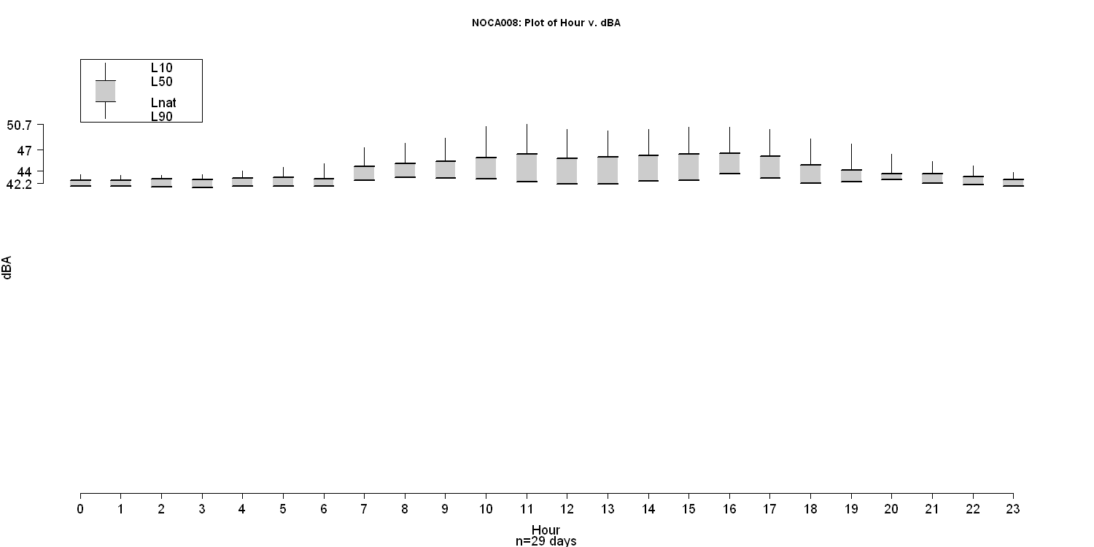

Table 2 shows results from in-depth off-site analysis. The first two columns report the percent of time that certain sound sources were audible during eight continuous days of sound source analysis. During analysis, technicians identify each audible sound source and compile overall statistics by hour. The remaining columns report existing sound levels as well as estimated natural ambient sound levels. This study indicated that human-caused sounds are audible nearly 100 percent of the time at Newhalem. Inherently, this makes it impossible to determine the natural ambient level, since the program used for analysis does not allow for the omission of a specific frequency. This explains the proximity in values of existing (46 dBA day/43 dBA night) and natural (43 dBA day/42 dBA night) ambient levels in the table, even though the percent audible value of vehicle sounds is high (36 percent). The human caused sound that was audible in nearly all of the samples was a distant hum, most likely produced by the adjacent power lines or power generation equipment. In addition, natural ambient levels were intrinsically high due to rushing water from the Skagit River and Ladder Creek. The rushing water may have added to the overall high ambient sound level at the site.

Table 2. Mean Percent Time Audible for Extrinsic Sounds, Vehicle Sounds, and Aircraft Sounds
Site Location | Mean % time audible |  |  | Median Existing Ambient (in dBA) |  | Median Natural Ambient (in dBA)
 | All Extrinsic sounds | All Aircraft sounds | All Vehicle Sounds | Day | Night | Day | Night
Newhalem | 100 | 3 | 36 | 46 | 43 | 43 | 42

An overall view of human caused sounds over the average day is shown in Figure 7. This graph clearly illustrates the fluctuations in summer traffic, with a peak of 68 percent audibility between the hours of 11 a.m. and 2 p.m. The previously mentioned hum throughout the site data causes the total extrinsic values to hover around 100 percent.
Figure 7. Hourly Percent Time Audible of Total Extrinsic, Aircraft, and Vehicle Sounds
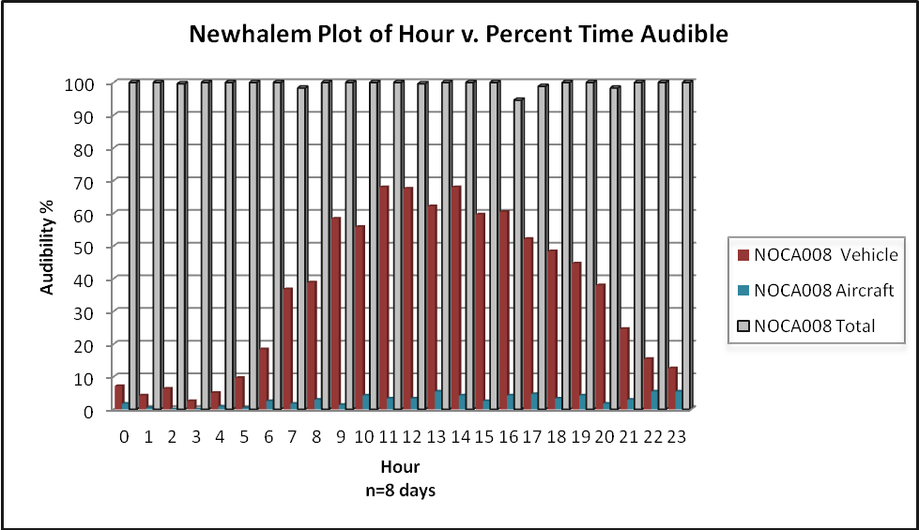

High frequency sounds (e.g. a bird call) and low frequency sounds (e.g. transportation noise) often occur simultaneously, and do not always occur constantly throughout the day. Figure 8 illustrates these concepts by dividing the full frequency spectrum into 33 smaller frequency bands (each encompassing a one-third octave range), and by plotting the daytime and nighttime sound pressure level range for each band. The gray area in the background of the graph represents sound pressure levels outside of the typical range of human hearing. The typical frequency ranges for transportation, conversation and songbirds are presented on the figure as examples for interpretation of the data. These ranges are estimates and are not vehicle, species, or habitat specific. However, the high levels at the lowest octave ranges are most likely due to the presence of human caused sounds. While these sounds are inaudible to the human ear, they would be audible to some wildlife. The peak at the lowest end of the audible spectrum is most likely due to the constant hum throughout the site, or to vehicle traffic.
Figure 8. Day and Night dB Levels for 33 One-third Octave Bands at Newhalem
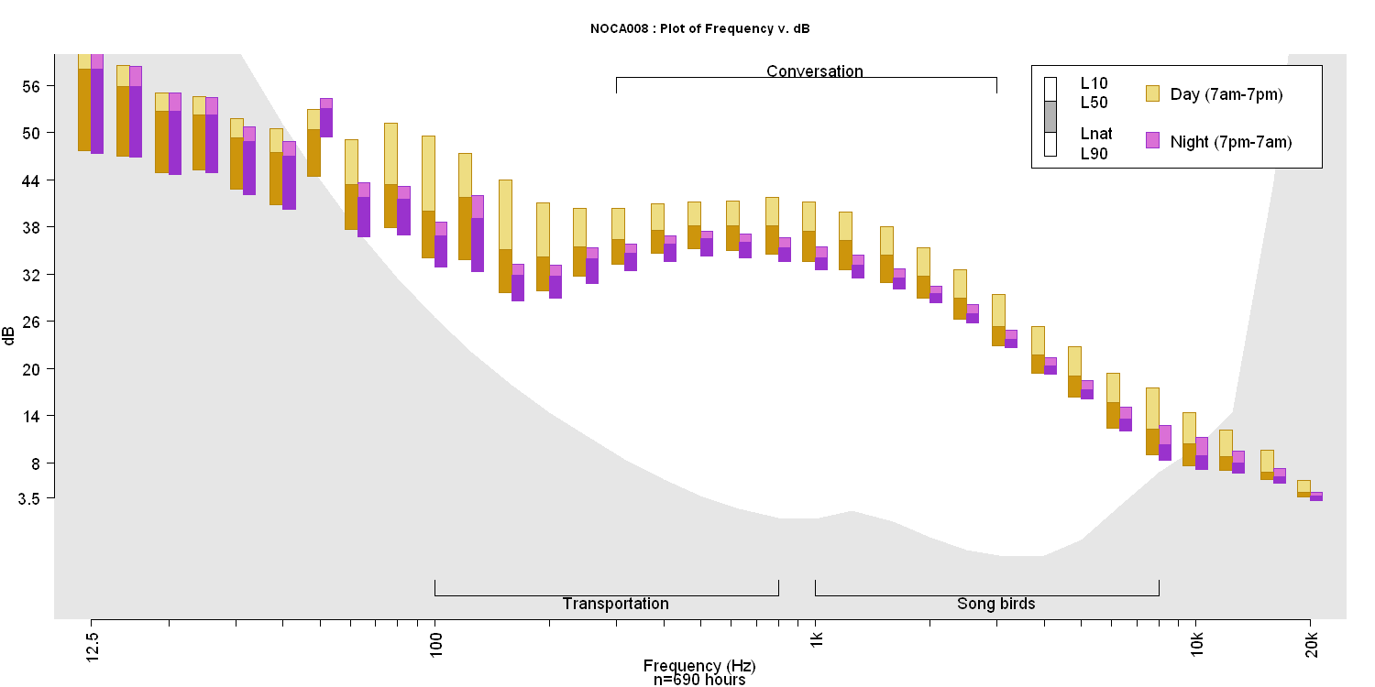

Conclusion
Acoustic monitoring in national parks not only permits us to gain insight into biologic activity, but also allows us to determine the prevalence of extrinsic noise, and perhaps estimate its effects. This study was successful in determining current acoustic conditions at this Newhalem site. This data is specific to the site, and does not necessarily reflect ambient sound levels in the town of Newhalem. The location of the site elevated above steep valley walls, near transmission lines, the Gorge Powerhouse, and the highway, contributes to an elevated extrinsic sound level. Results included measures of existing ambient levels, calculations of sound source durations, and estimates of natural ambient levels. We determined that human-caused sounds were audible an average of 100 percent of the time, due to the proximity of the Gorge Powerhouse and transmission lines. Additionally, highway noise was audible 36 percent of the time and aircraft was audible an average of 3 percent of the time. Nevertheless, nighttime and weekday sound levels were more tranquil due to the lowered amount of vehicle traffic. Much of the noise at this site was at lower frequencies than are audible by the human ear, and have unknown effects on wildlife. The information gathered within this report will serve as a baseline of what the Newhalem site sounded like in July, 2009.

BIBLIOGRAPHY
Berglund, B., Lindvall, T. and Schwela, D.H (Eds.). 1999. HWO. Guidelines for community noise. World Health Organization, Geneva.
Haas, G.E. and Wakefield, T. 1998. National Parks and the American Public. National Parks and Conservation Association, Washington, D.C.
Haralabidis Alexandros S., et. al. 2008. Acute effects of night-time noise exposure on blood pressure in populations living near airports. European Heart Journal Advance Access. Published online February 12, 2008.
McDonald, C.D., Baumgartner, R.M. and R. Iachan. 1994. "National Park Service Visitors Survey," HMMH Report No 290940.12, NPOA Report No. 94-2.
National Park Service. 2005. Acoustic and Soundscape Studies in National Parks: Draft. Fort Collins, CO: NPS Natural Sounds Program.
US Department of the Interior, National Park Service. 2006. Management Policies 2006.

