SKAGIT - FERC PROJECT #553

EROSION CONTROL PROGRAM

2003- COMPLETION REPORT

North Cascades National Park and Seattle City Light

May 2004

INTRODUCTION

As stipulated in the 1991 Erosion Control Settlement Agreement (SA) between the National Park Service (NPS) and Seattle City Light (SCL), erosion control activities in Ross Lake National Recreation Area (NRA) continued for an eighth year (including pre-license work).

NPS crews, funded by SCL, conducted work at several sites in 2003 (Figure 1). Sites completed, including revegetation:
-Rock wall for erosion control were built at sites E-87 (Ponderosa Camp);
Cribbing at sites E-70A-6 and E-70A-4 along the East Bank Trail; and
-Trail relocation at site E-64 on the East Bank Trail.

Detailed accounting of expenditures is provided in other reports and is not duplicated here. The purpose of this report is to update the Federal Energy Regulatory Commission (FERC) on progress under the terms of the new operating license for the Skagit Project.

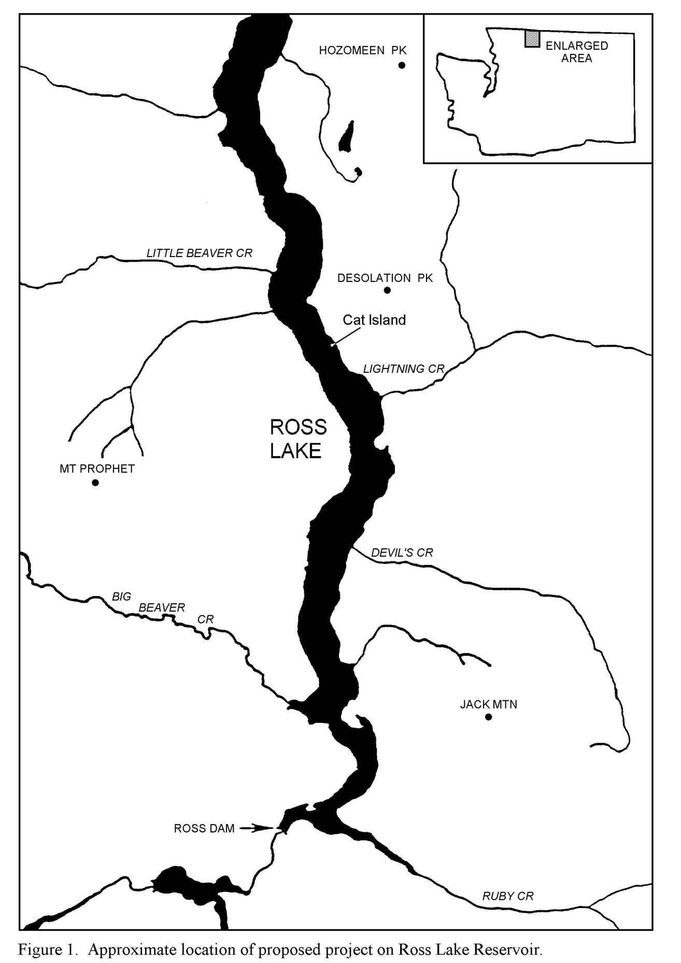

E-87

E70A4
E70A6

E64

Photo 2. Site E-70A-5A on the East Bank trail, Ross Lake. Cribbing construction completed in fall 1997.
Figure 1. Approximate locations of 2003 completed erosion mitigation sites.
N

PROGRESS REPORTS BY PROJECT

E-70A-6: 100’ of cedar cribbing, 5’ in height, installed to replace old cribbing.

E-70A-4: 3 tiers of cedar cribbing installed extending up from lake shore to East Bank Trail.
85 linear ft at lake shore.

E-87: 150’ of rock wall, 5’ tall, installed at Ponderosa Campground. Wall includes canoe pullout.

E-64: 100’ of trail relocation on East Bank Trail. Trail bumped uphill due to erosion extending up
from shoreline. Erosion at shoreline receded to bedrock and naturally stable, no corrective
structure necessary.

Ross Lake Erosion Control Planting Summary:

The NOCA nursery crew grew and installed 758 plants to complete two new sites and augment plantings at a previously planted site on Ross Lake. The new sites were the Ponderosa Campground (E87) and one behind newly constructed cribbing at the East Bank Cribbing Site (E-70A6b). Supplemental planting was done at the East Bank Cribbing Site E-70-A5.

The nursery crew also collected seeds and cuttings at Thunder Point Campground and Buster Brown Campground on Diablo Lake for use at these erosion control sites. The Diablo Lake sites will be worked on during 2005-2006.

COMPLIANCE: Permits from the U.S. Army Corps of Engineers (404 permit) and the State Department of Fish and Wildlife (WDFW hydraulic permit) were obtained before work began at all erosion control work sites. Copies of these permits are kept at the NPS Geology office in Marblemount and are available on request. We are basically working under a three-year permit obtained from the WDFW, which will take us through year 10 of the license and completion of most projects.

