SKAGIT - FERC PROJECT #553

EROSION CONTROL PROGRAM

2002- COMPLETION REPORT

North Cascades National Park and Seattle City Light

May 2003

INTRODUCTION

As stipulated in the 1991 Erosion Control Settlement Agreement (SA) between the National Park Service (NPS) and Seattle City Light (SCL), erosion control activities in Ross Lake National Recreation Area (NRA) continued for an eighth year (including pre-license work).

North Cascades National Park (NOCA), funded by SCL, conducted work at several sites in 2002. Sites completed, including revegetation, were site E-47 and site W-36. Rock walls for erosion control were built at sites E-47 (May Cr. Camp) and W-36 (Big Beaver Camp).

Detailed accounting of expenditures is provided in other reports and is not duplicated here. The purpose of this report is to update the Federal Energy Regulatory Commission (FERC) on progress under the terms of the new operating license for the Skagit Project.

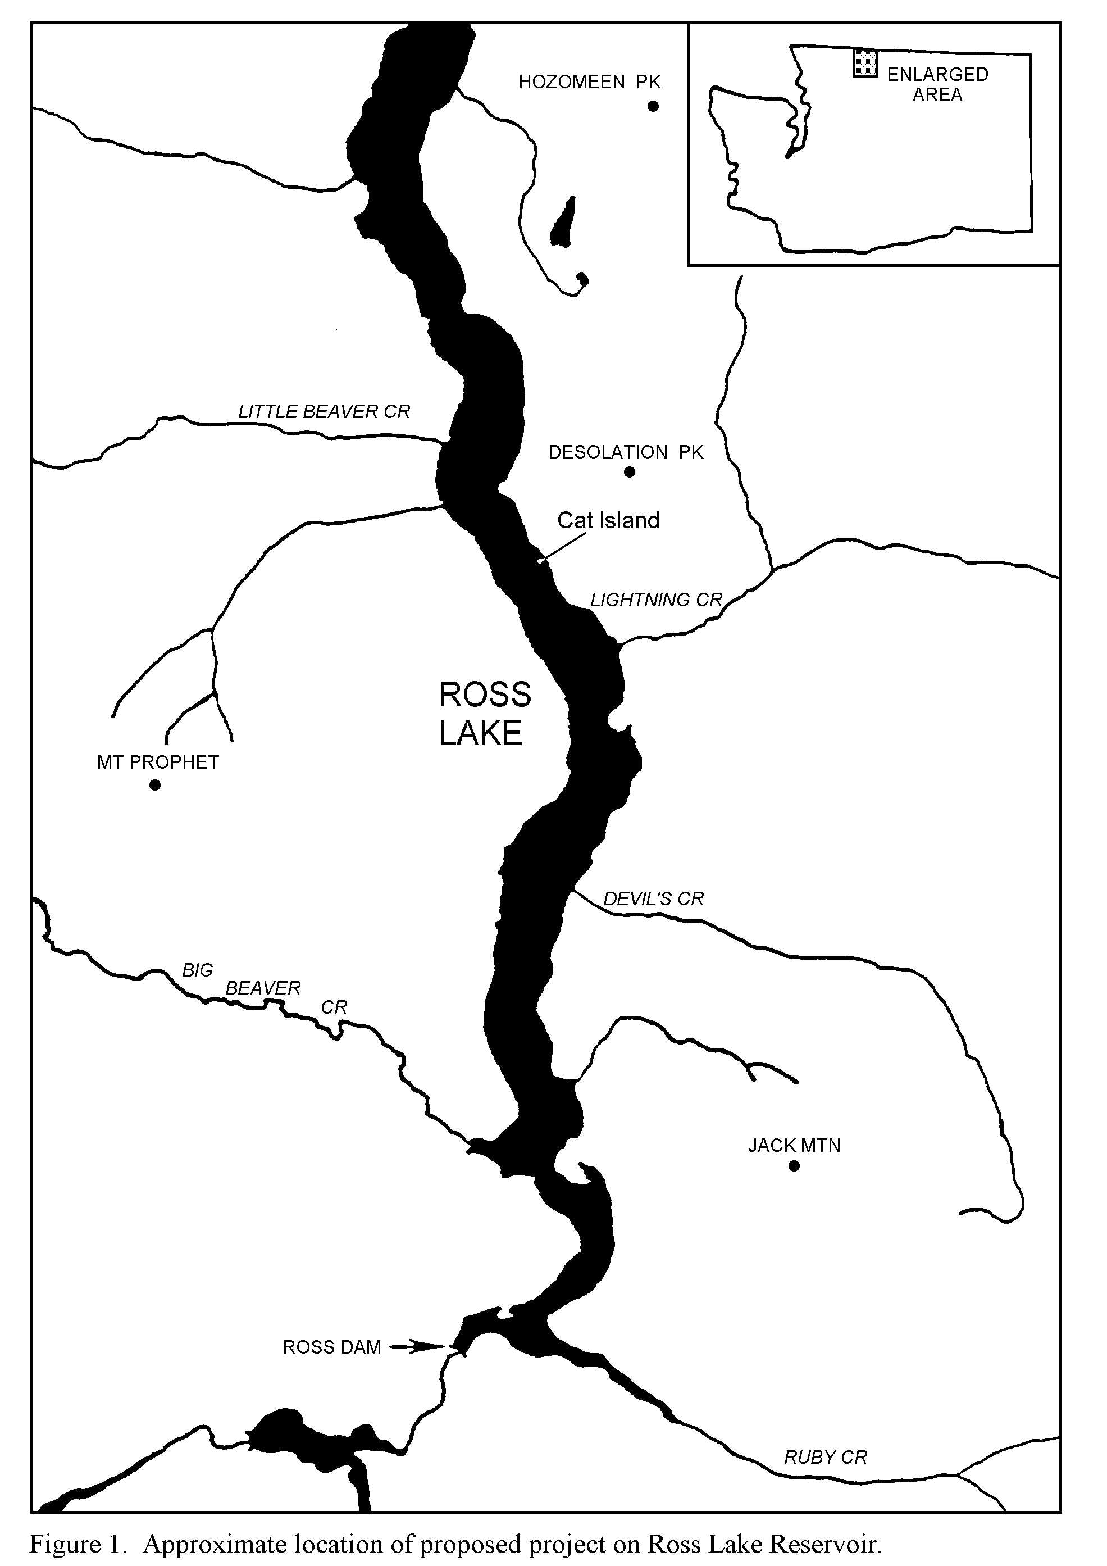

E-47

W-36

Photo 2. Site E-70A-5A on the East Bank trail, Ross Lake. Cribbing construction completed in fall 1997.
Figure 1. Approximate locations of completed erosion mitigation sites for 2002
N
PROGRESS REPORTS BY PROJECT

W- 36 Big Beaver Campground Rock Wall: A 40 foot long, 2-3 ft tall rock wall was built to protect one of the lakeside campsites at Big Beaver Camp (Figure 1)

E- 47 May Creek Campground Rock Wall: A 50 ft long rock wall that reaches a height of 5 ft was constructed to protect the dock bulkhead and campground from a severe erosion problem (Figure 2).

Ross Lake Erosion Control Planting Summary, 2002
The NOCA revegetation program propagated and installed 1,200 plants to complete five new sites and augment plantings at three previously planted sites on Ross Lake. The new sites were: Big Beaver Campground (W-36), May Creek (E-47) (Figures 3-6), East Bank Trail (E-64), East Bank Cribbing Site (E-70A6) and Cat Island (E-134, site B). Sites worked on previously that received additional plants include: Little Beaver (W-124, 125), East Bank cribbing Site (E-70A4) and the Rock Quarry Site (E-147).

Compliance: Permits from the U.S. Army Corps of Engineers (404 permit) and the State Department of Fish and Wildlife (WDFW hydraulic permit) were obtained before work began at all erosion control work sites. Copies of these permits are kept at the NPS Geology office in Marblemount and are available on request. We are basically working under a three-year permit obtained from the WDFW, which will take us through year 10 of the license and completion of most projects.

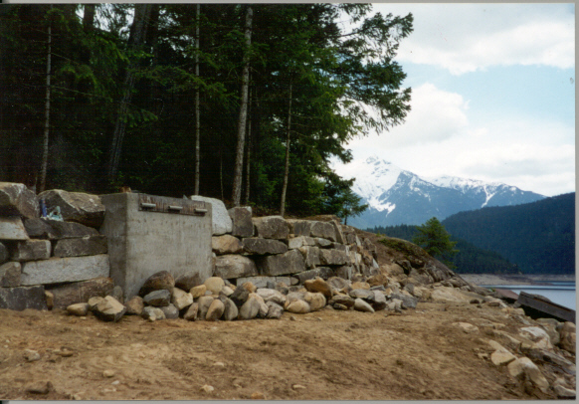
Figure 1. E-47 Rock wall at May Creek Camp.
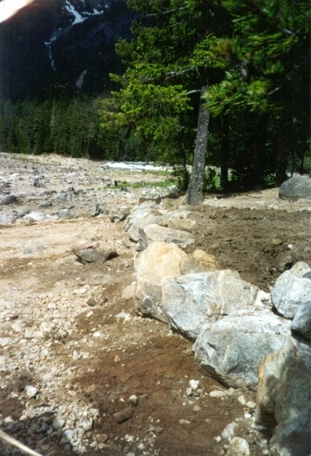
Figure 2. W-36- Rock wall at Big Beaver Camp.

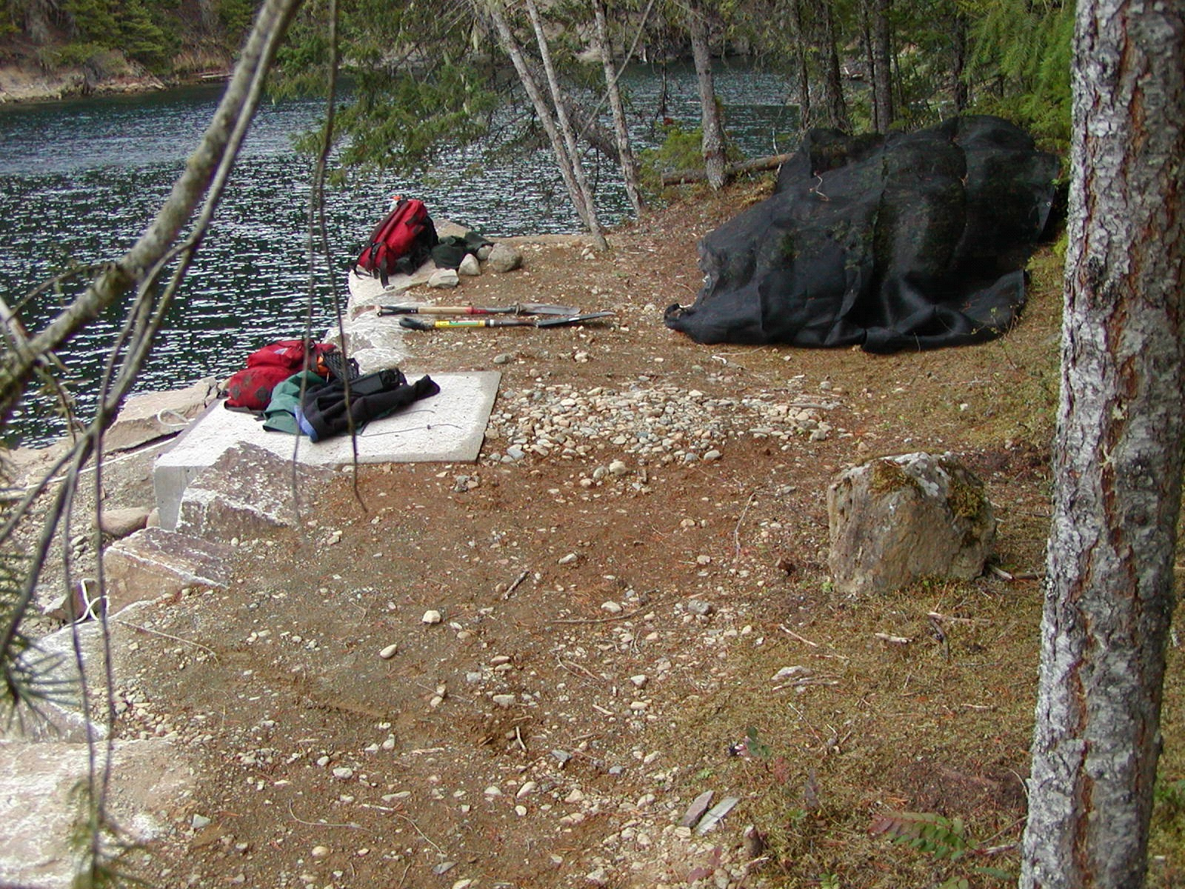
Figure 3. May Creek Bulkhead, prior to revegetation
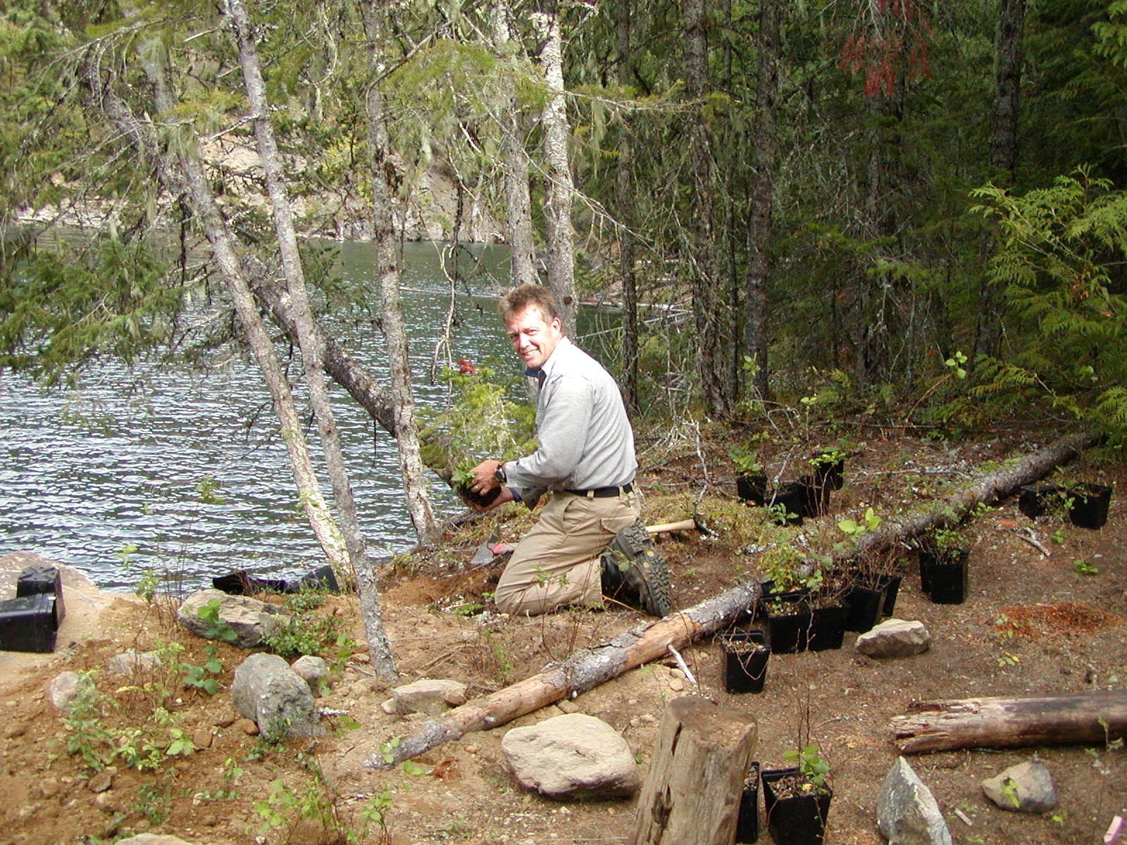
Figure 4. May Creek Bulkhead, during planting

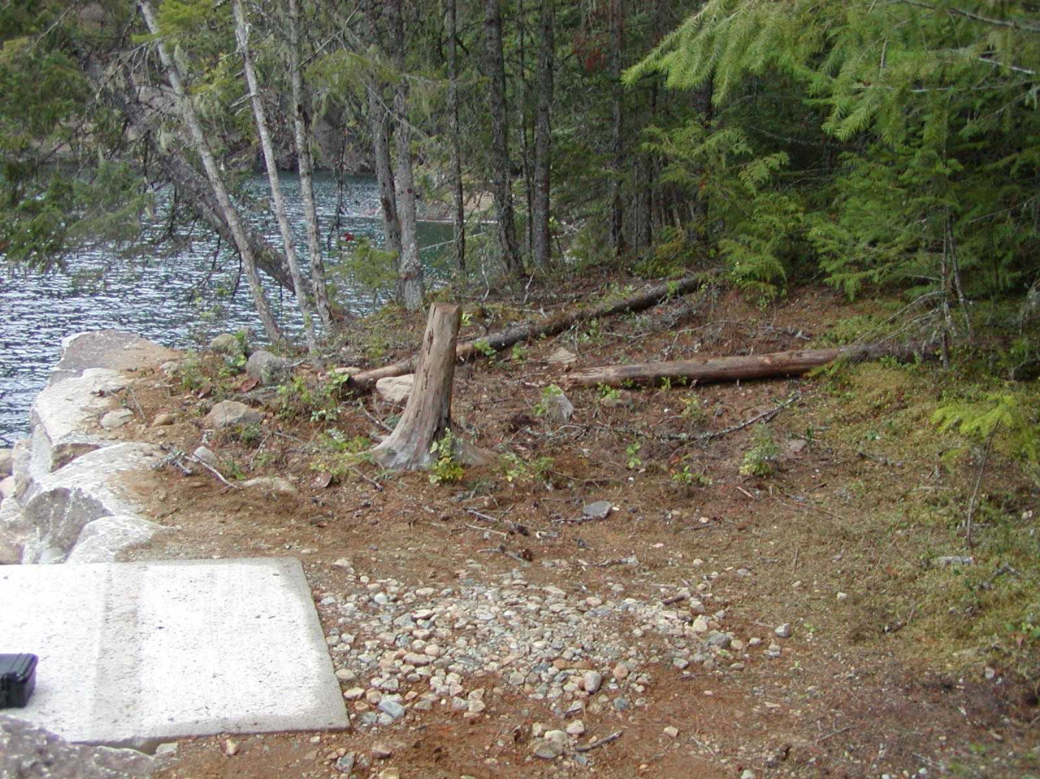
Figure 5. May Creek Bulkhead, after planting and debris placement

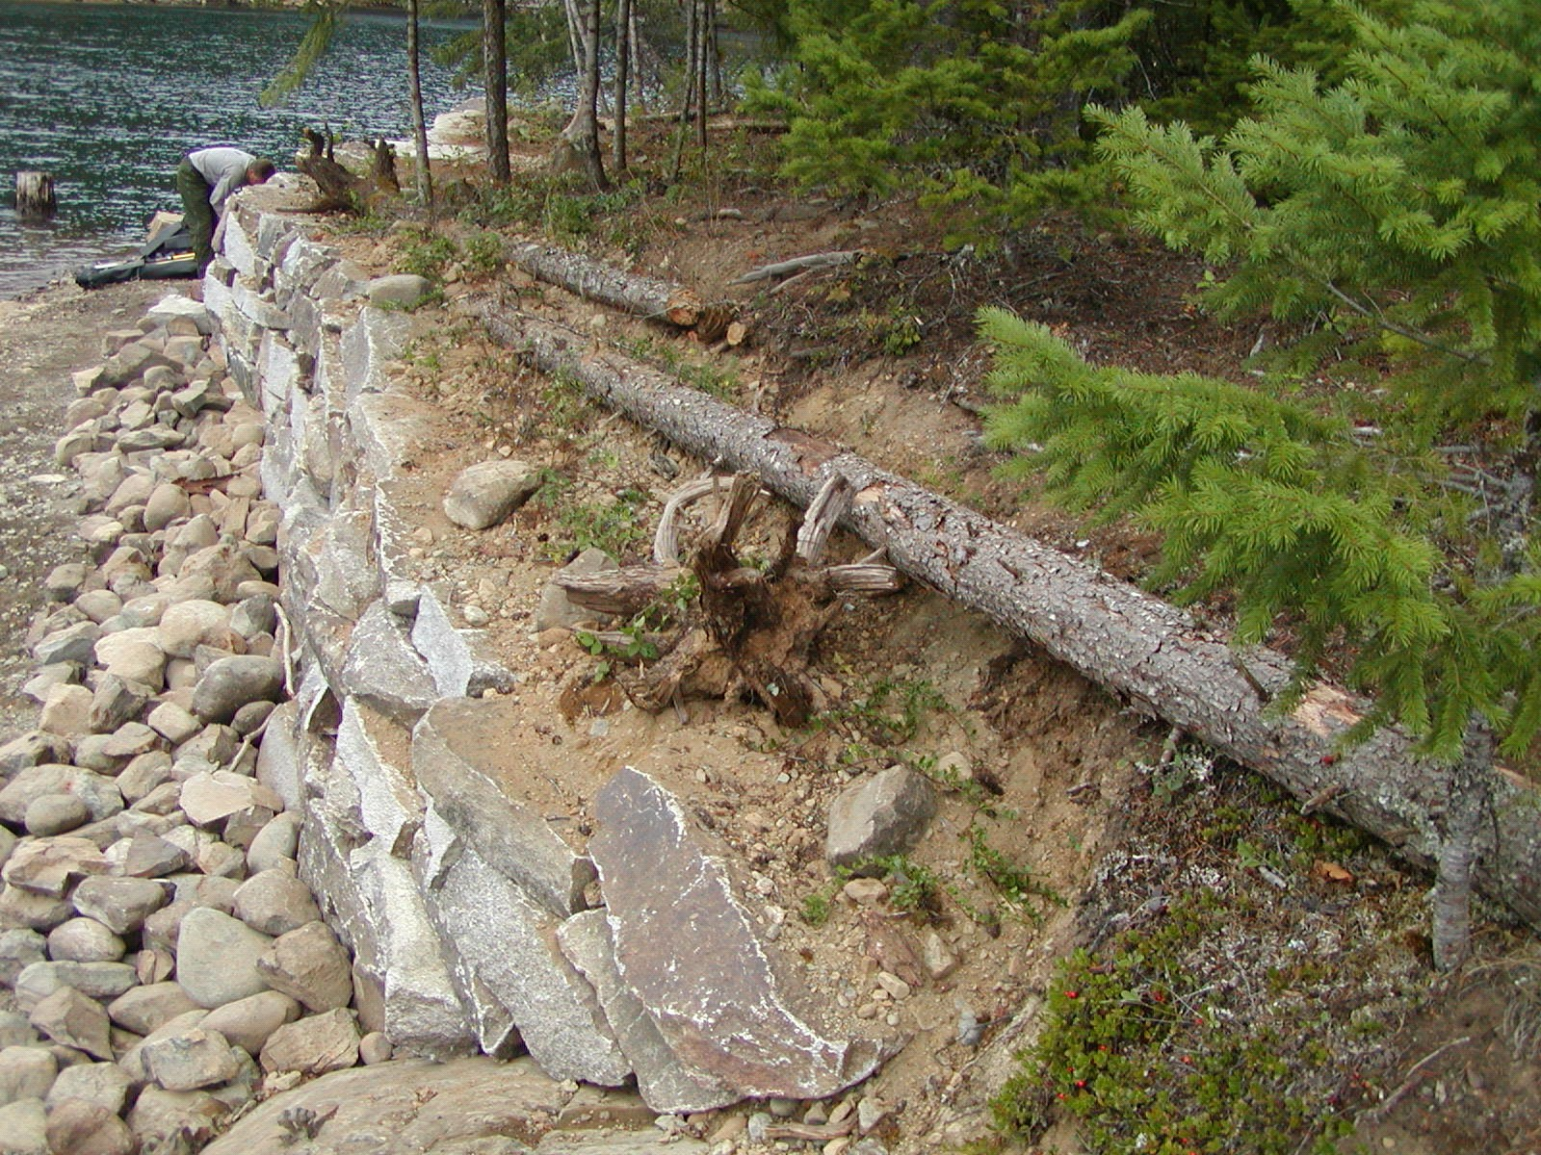
Figure 6. May Creek Rock Wall, after planting and debris placement.

