SKAGIT - FERC PROJECT #553

EROSION CONTROL PROGRAM

2001 COMPLETION REPORT

North Cascades National Park and Seattle City Light

Sept, 2002

INTRODUCTION

As stipulated in the 1991 Erosion Control Settlement Agreement (SA) between the National Park Service (NPS) and Seattle City Light (SCL), erosion control activities in Ross Lake National Recreation Area (NRA) continued for an eighth year (including pre-license work).

NPS crews, funded by SCL, conducted work at several sites in 2001. Sites completed, including revegetation, were site E-100, Ten Mile Island campground, W-126, Little Beaver Campground Trail, and W-36B, Big Beaver Campground Bulkhead.

Detailed accounting of expenditures is provided in other reports and is not duplicated here. The purpose of this report is to update the Federal Energy Regulatory Commission (FERC) on progress under the terms of the new operating license for the Skagit Project.

PROGRESS REPORTS BY PROJECT

E-100 Ten Mile Island Campground: Construction of 100' of rock wall as per erosion control design, including the use of filter fabric and soil filter. Site replanted with native vegetation propagated from on site sources. (see photo # 1, 2)

W-126 Little Beaver Campground Trail: Former trail along lakeshore abandoned. Reroute of trail from new dock site in cove of Little Beaver Creek. 1402' of new trail built to tie in with main trail. Abandoned trail replanted with native vegetation propagated from on site sources. (no photos available at present time)

W-36B Big Beaver Campground Bulkhead: Old dock bulkhead eliminated. New bulkhead installed. Twenty feet of rock wall on either side of new bulkhead installed as per erosion control design, including use of filter fabric and soil filter. Site replanted with native vegetation propagated from on site sources. (see photo # 1, 2)

COLLECT AND STOCKPILE MATERIALS AT HOZOMEEN: Demolition of the old Ross Guard Ranger Station presented an opportunity to salvage the cedar float logs beneath the structure. These logs were in excellent shape due to their submergence in cold water. The erosion control crew worked for two weeks in the spring of 2001 cutting the old logs into cribbing members. This material was stockpiled along with rock taken from the drawdown at the Hozomeen barge-loading facility. These materials will be used at erosion control sites throughout the project area.

COMPLIANCE: Permits from the U.S. Army Corps of Engineers (404 permit) and the State Department of Wildlife (hydraulic permit) were obtained before work began at all erosion control work sites. Copies of these permits are kept at the NPS Geology office in Marblemount and are available on request.

Site Photos:

E-100 Ten Mile Island

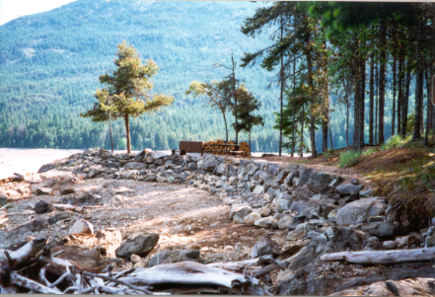

E-100 Ten Mile Island:

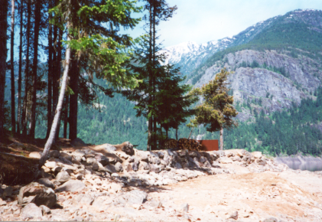

W-36 Big Beaver Campground
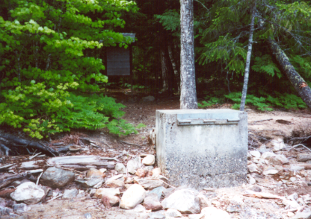

W-36 Big Beaver Campground:
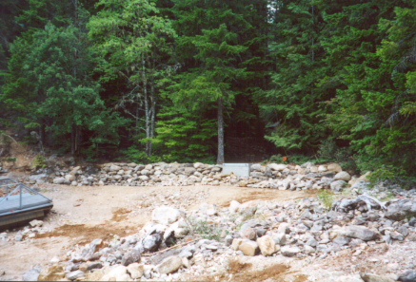

W-36 Big Beaver Campground:
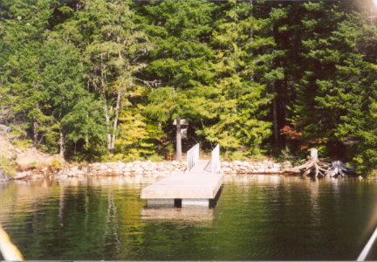

W-36 Big Beaver Campground – Revegetation:

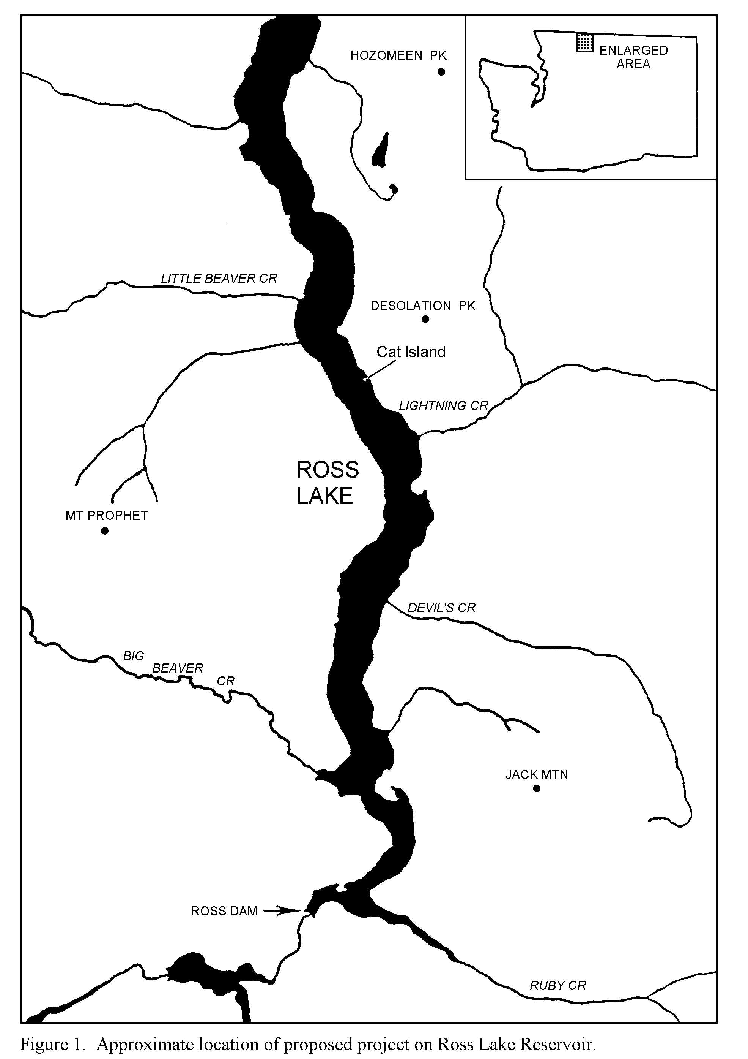

W-126

E-100

W-36B

Photo 2. Site E-70A-5A on the East Bank trail, Ross Lake. Cribbing construction completed in fall 1997.
Figure 1. Approximate locations of completed erosion mitigation sites for 2002
N

Photo 3. Temporary stabilization of dock bulkhead at site D-11, Thunder Point Campground, Diablo Lake.

Photo 4. Office and storage building for native plant propagation program, Marblemount. Constructed in summer 1997.

