SKAGIT - FERC PROJECT #553

EROSION CONTROL PROGRAM

1999 COMPLETION REPORT

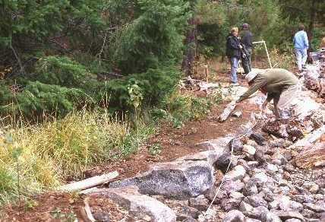

North Cascades National Park and Seattle City Light

April 2000

INTRODUCTION

As stipulated in the 1991 Erosion Control Settlement Agreement (SA) between the National Park Service (NPS) and Seattle City Light (SCL), erosion control activities in Ross Lake National Recreation Area (NRA) continued for a seventh year (including pre-license work).

NPS crews, funded by SCL, conducted work at several sites in 1999. Activity this year focused on site E-95, Lightning Creek Stock Camp, where 160’ of rock wall was constructed, completing a project begun in 1998. At site E-112, Dry Creek Camp 50’ o0f rock wall was constructed. At site E70A-6, south of Devil’s Creek, 80’ of new cribbing installed. This project will be completed in fall 2000.

Detailed accounting of expenditures is provided in other reports and is not duplicated here. The purpose of this report is to update the Federal Energy Regulatory Commission (FERC) on progress under the terms of the new operating license for the Skagit Project.

PROGRESS REPORTS BY PROJECT

SITE E-70A-6: The East Bank Trail along Ross Lake was threatened by erosion at this site. NPS staff identified this as a new, high-priority site due to serious deterioration, and SCL approved including it in this year’s activities.

Erosion control measures at this site called for reconstruction of failing cribbing, along with revegetation of the work area. Plans called for construction of a two-tiered crib. The lower crib is 100 ft long and 5 ft tall. Work at this site was initiated in the fall of 1999 with 40%completion. The remaining 60% will be addressed in fall of 2000.

SITE E-95: The Lightning Creek Horse Camp was being threatened by erosion at this site. The bank edge had receded to the face of two of the three fire grates. Plans called for the construction of a rock wall 3’ high along 300’ of shoreline. NPS crews initiated construction in March 1998 and completed 125’ of the wall. The remainder of this site, 160’, was completed in spring 1999. Building rock was barged to the site in the fall of 1998 (see photo 1).

SITE E-112: Dry Creek campground was being threatened by erosion along a 50’ stretch of shoreline placing the camp outhouse at risk. A 4’ tall, 50’ long rock wall was constructed to correct this situation. Native rocks were used for this construction. Two smaller sites fronting campsites, approximately 10’ long, each, were fixed with rockwork as per design. (See photo 2).

NATIVE PLANT PROPAGATION: On March 18, 1997, FERC approved an agreement to transfer implementation of the Skagit native plant propagation program from SCL to the NPS. In 1999, the NPS staff planted 1,555 plants at five erosion control sites on Ross Lake and revisited erosion control sties outplanted in 1998 to assess plant condition. All sites were considered to be in excellent condition except one, Little Beaver (W-122), which may need additional planting. Site plans were prepared for future planting at Lightning Creek Horse Camp (E-95) and Dry Creek Campground (E-112). 2,000 plants were propagated for revegetation of Ross Lake erosion control sites.

COLLECT AND STOCKPILE MATERIALS AT HOZOMEEN: Demolition of the old Ross Guard Ranger Station presented an opportunity to salvage the cedar float logs beneath the structure. These logs were in excellent shape due to their submergence in cold water. The erosion control crew worked for two weeks in the spring of 1999 cutting the old logs into cribbing members. This material was stockpiled along with rock taken from the drawdown at the Hozomeen barge-loading facility. These materials will be used at erosion control sites throughout the project area.

MONITORING: Wooden stakes were placed at five class-one sites to measure the rate of bank recession in 1994. The sites will be revisited in 1999.

COMPLIANCE: Permits from the U.S. Army Corps of Engineers (404 permit) and the State Department of Wildlife (hydraulic permit) were obtained before work began at all erosion control work sites. Copies of these permits are kept at the NPS Geology office in Marblemount and are available on request.

