**Highland Park Way SW Connection Project**

*Updated April XX, 2025*

**What's Happening Now?**

Haga clic aquí para la versión en español.

**What we heard from the community**

Last May and June, we heard from nearly 2,000 people through our survey and conversations at community events. Thank you for sharing your thoughts about our initial concepts! All the feedback is summarized in our Outreach Report [link to summary report]. Shape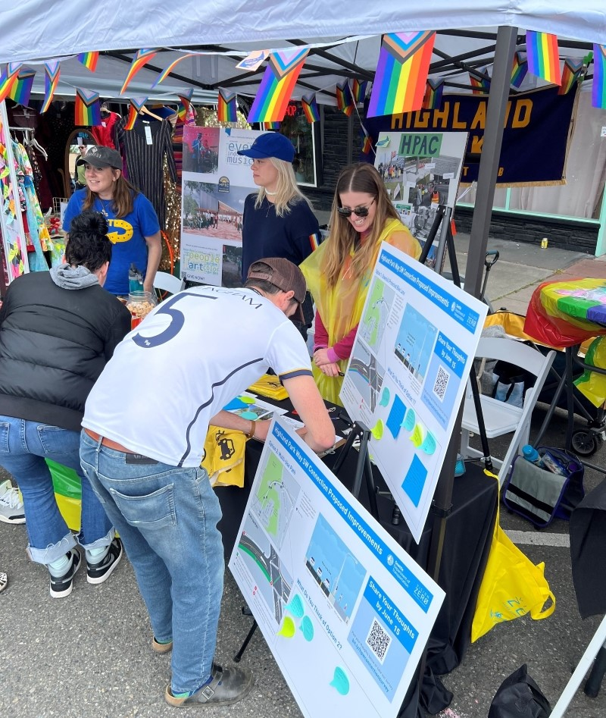

*Team member Colleen Woods talking to community members at the White Center Pride Street Festival. Thank you to the Highland Park Action Coalition and the Highland Park Improvement Club members who shared their booth with us! Photo: SDOT*

**What we heard from community feedback**

Here are the key themes from our conversations with you:

* **Concerns About Traffic:**
  + Many worry that removing a driving lane may increase congestion and make driving through the area more difficult.
* **Path Usage**
* About 40% of survey respondents use the existing path – 368 bike, 318 walk, 65 use it to get to the bus, 19 use a mobility device, and 14 use a scooter.
* Some feel the existing path needs repairs, while others shared that its current condition— not well kept, dark at night, too close to the road, and people drive too fast—makes it unsafe and unpleasant to use.
* **Interest in Improved Options**
* Of the three proposed concepts, the multi-use path for walking, biking, and transit received the most support with 36% of survey respondents, though some have concerns about pedestrian safety due to fast-moving cyclists.
* **Local Safety Suggestions**
* Some people suggested other ideas including speed cameras, a center barrier in the road, and more consistent path maintenance.

**What’s next**

Thanks to the recent approval of the 2024 Seattle Transportation Levy, this corridor has been identified for funding and will continue moving forward working with community throughout the design process. The project team will further develop a concept of an improved facility for people walking, rolling and biking, and continue to engage with the community once the updated concept is ready to share.

**To stay informed about the project, please**[**sign up for email updates.**](https://public.govdelivery.com/accounts/WASEATTLE/subscriber/new?qsp=WASEATTLE_8.xml) You can also reach us at [HighlandHolden@Seattle.gov](mailto:HighlandHolden@Seattle.gov) or [(206) 900-8741](tel:%20+1%20(206)%20900-8741).

**Project Overview**

The Highland Park Way SW Connection project is intended to provide an improved path for people to walk, roll, and bike between Highland Park and the Duwamish River Trail, while improving safety and calming traffic along Highland Park Way SW.

Our 2024 [Seattle Transportation Plan](https://www.seattle.gov/documents/Departments/SDOT/STP/Bicycle.pdf) (pages B-43 and B-45) recognizes the need for better walking, biking and rolling facilities along this corridor connecting a high equity priority neighborhood to the regional Duwamish River Trail network. This project is also important from a safety perspective as it is part of our High Injury Network identified in our latest [Vision Zero Action Plan](https://www.seattle.gov/documents/Departments/SDOT/VisionZero/VZ_Action_Plan.pdf) (page 55) and we have a history of motorists driving 40+ MPH relative to a posted speed limit of 25 MPH.

**Project Goals**

* Improve safety for all road users.
* Calm traffic along Highland Park Way SW to help prevent collisions.
* Create better connections for people who walk, roll, bike, and take transit between Highland Park and the Duwamish River Trail, thereby making progress towards our [Climate Action goals](https://www.seattle.gov/transportation/about-us/climate-response).

**Current Conditions**

There is an existing path on the east side of Highland Park Way SW. It runs from SW Holden St to West Marginal Way SW with a section of grass serving as a landscape buffer between the path and the street. The path varies in width from 3.5 to 7 feet and the landscape buffer varies in width from 2.5 to 9.5 feet.

The path needs repairs and is very close to the street in some places, making it less comfortable for people walking, rolling, and biking – particularly when people drive over the speed limit, which happens quite often in this area. Seattle Police collision reports and recent traffic data also indicate that people have driven off the street, crossed the centerline into oncoming traffic near and at the curve, sideswiped other vehicles, and even crashed into a person biking.

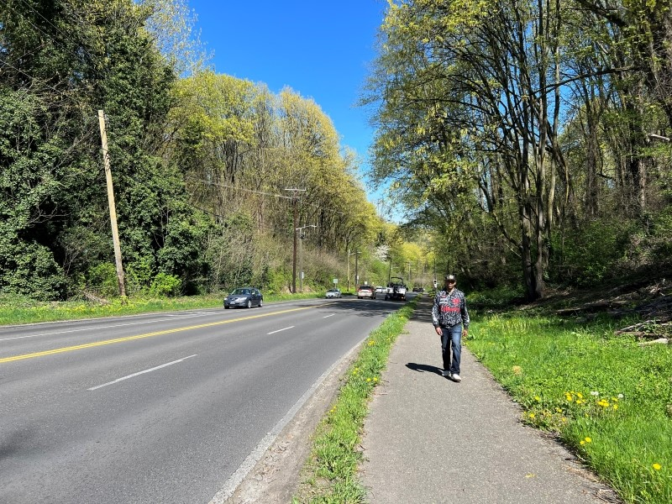

*Highland Park community member walking on the existing path along Highland Park Way SW. This section of the path just north of SW Holden St, where the path is about 6 feet wide, and the landscape buffer is about 2.5 feet wide.*

**Illustration and Map of Current Conditions**

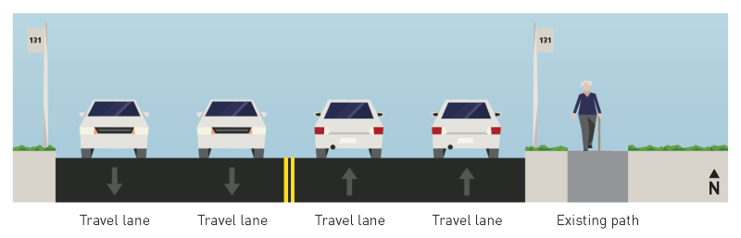

Updated graphic [HPW_Existing](https://seattlegov.sharepoint.com/:b:/r/sites/DOT_CP_HPWPathWiden_GRP/Documents/5.Outreach/B_Materials/Maps%20%26%20Diagrams/2025_Updated%20graphics/HPW_Existing.pdf?csf=1&web=1&e=che0Ic)

**Community Engagement**

In 2023, we met with community groups in the area, including the [Highland Park Action Coalition](https://hpacinfo.wordpress.com/) and [West Seattle Bike Connections](https://westseattlebikeconnections.org/). We also received input through the [Seattle Transportation Plan](https://www.seattle.gov/documents/Departments/SDOT/STP/Bicycle.pdf) (pages B-43 and B-45), which recognizes the need for better walking, biking and rolling facilities along this corridor.

In the spring of 2024, we gathered input on some early project concepts through different outreach activities including a survey and attending community events.

We heard from more than 2,000 people during the outreach period. The concepts that were shared and the feedback we received is summarized in our Outreach Report. [Link to PDF] We will continue to engage community members and collect feedback throughout the design process. Please [sign up for our email updates](https://public.govdelivery.com/accounts/WASEATTLE/subscriber/new?qsp=WASEATTLE_8.xml) to stay informed!

**Timeline**

Once we secure funding, we will move into the early design phase for this project.

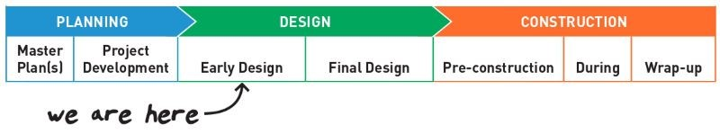

**Document Library**

* Outreach Report (January 2025) [Link to PDF]
* [Fact Sheet](https://www.seattle.gov/documents/Departments/SDOT/VisionZero/Highland-Holden/HighlandParkWaySWConnectionFactSheet.pdf) (May 2024)
* [Mailer](https://www.seattle.gov/documents/Departments/SDOT/VisionZero/Highland-Holden/HPW_Folded_Mailer_Final.pdf) (May 2024)
* [Flyer](https://www.seattle.gov/documents/Departments/SDOT/VisionZero/Highland-Holden/2024_0508_SDOT_HighlandParkWaySWConnectionProject_Flyer.pdf) (May 2024)
* [Yard Sign](https://www.seattle.gov/documents/Departments/SDOT/VisionZero/Highland-Holden/2024_0508_HighlandParkWaySWConnectionProject_YardSign_24x17.pdf) (May 2024)
* [Narrated Slide Deck](https://youtu.be/yw-6Yfoq354) (May 2024)