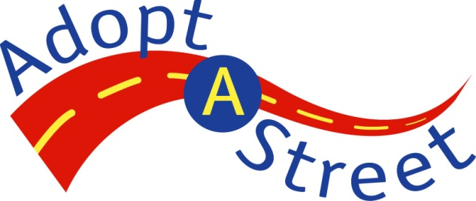
Adopt-A-Street Sign Request Form (Optional)

Volunteers like you ensure the Adopt-A-Street program fulfills its mission of promoting civic responsibility and community pride, and enhancing Seattle’s quality of life through clean streets and beautiful neighborhoods. Traditional Adopters remove litter along one or more miles of city street(s) a minimum of four times per year for at least two years. In recognition of our volunteers, the Adopt-A-Street program offers one Adopt-A-Street sign. Volunteers are eligible for one sign after one year of service with a minimum of four cleanups. If you are a Traditional Adopter and would like an Adopt-A-Street sign recognizing you and/or your volunteer group, complete the following three steps.

Please print clearly and legibly.

Step 1. Contact Information for Adopt-A-Street Volunteer Group
First and last name: | Today’s date:
Phone number: | Email address:
Location of adopted streets:

Step 2. Name of Organization to Appear on Sign (Maximum of 19 Characters in Each Line)
(Character limit includes lower and/or upper case letters, numbers, abbreviations, and spaces.
The Adopt-A-Street Program will center your group’s name for you.)

Step 3. Desired Sign Locations
Indicate the exact location to post your sign. Be as specific as possible, stating what section of intersection. Note that sign should face oncoming traffic. (For example, NE corner of E Union St and 23rd Ave facing south.) If possible, attach a map indicating your desired location. The sign must be posted on your adopted street.

Location of sign:

Return completed form to AdoptaStreet@Seattle.gov or fax to 206-684-8529.
Questions? Call the Adopt-A-Street Hotline at 206-684-7647.
http://www.seattle.gov/util/Services/Garbage/KeepSeattleClean/Adopt-A-Street/index.asp

