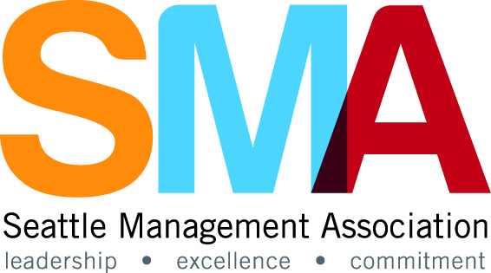
Excellence in Leadership Awards
2016 Nomination Form

Igniting Innovation
“Exemplary leaders know if they want to gain commitment and achieve the highest standards, they must be models of the behavior they expect of others.”
― James M. Kouzes, The Leadership Challenge: How to Make Extraordinary Things Happen in Organizations

Completed Nominations Forms are due by close of business on Friday, September 16, 2016.

This year the Seattle Management Association (SMA) “Excellence in Leadership Awards Program” will recognize significant accomplishments and contributions of public employees demonstrating innovative leadership in four categories: Public Service, Community Service, Planning and Project Management and Race and Social Justice. Nominations will be accepted for individuals and teams in each category. This year SMA has focused on the “Challenge the Process” chapter of The Leadership Challenge by Kouzes & Posner. These leadership qualities include seizing initiative, exercising outsight, generating small wins and learning from experience.
Please describe how your nominee has exemplified our 2016 theme:
“Challenge the Process – Search for Opportunities, Experiment and Take Risks”

Return this form via mail: SMA Awards Committee – Mail Stop: SMT-55-00
or email: sma@seattle.gov
Award winners will be recognized at the annual awards program on Thursday, November 3rd, 4:00 p.m. at the Washington Athletic Club on 1325 6th Avenue, Seattle, WA.
If you have any questions, please email sma@seattle.gov. Thank you for participating.

- Identify the Nominator: Provide the contact information for the individual(s) submitting an SMA Awards Nomination.

Nominator name |  | Phone:
Division |  | e-Mail
Department |  | SMA Member

2.The Award Categories: Chose the category that best fits your nominee(s).
Leadership in Innovative Public Service:
This award recognizes an individual or team who consistently promotes and delivers innovation and excellence in public leadership and exemplifies the values and vision of their department. The nominee should be a person or team whose innovation or new ideas enhance the quality of service delivery in some way or whose work significantly impacted the efficiency and excellence by which a public service is provided. The nominee should demonstrate long range, effective strategic planning; develop and motivate staff or other participants involved in completing the work; and serve with the public good in mind.

Leadership in Community Service Award:
This award recognizes an individual or team who has shown extraordinary dedication to positively impact and contribute to the community in which we work and live. The commitment can be demonstrated through service and volunteer activities, fundraising efforts, or by providing leadership to a charitable organization or community cause. The nominee should inspire and strengthen the community by promoting awareness and encouraging investment that results in a positive change in the community. This category is distinguished from the Public Service Award in that it is focused external to the City rather than internal.

Leadership in Planning and Project Management Award:
This award recognizes an individual or team who has demonstrated outstanding leadership in planning, developing and/or establishing a broadly impactful project or planned course of action(s) for self and others. The nominee should successfully include and collaborate with stakeholders, encourage and recognize alternative voices, and provide inspiring leadership throughout the planning and implementation of the project.

Leadership in Race and Social Justice Award:
This award recognizes an individual or team who has shown exceptional leadership in eliminating institutional systems, practices, and policies that serve as barriers to race and social justice; transforming civic engagement processes for greater equity and inclusion; promoting opportunity and access for all individuals, and/or providing education on racial and social justice issues. The nominee should communicate a vision of an equitable City and challenge institutions and organizations that unwittingly continue barriers to social justice.

Please note: The award selection committee reserves the right to reassign nominee award categories to more closely align with stated nomination criteria.
3.Identify the Nominee(s)

Nominee(s) |  | Phone:
Division |  | Nominee e-Mail
Department |  | SMA Member
Manager/Supervisor |  | Mgr/Supv  e-Mail

Provide information about the nominee(s) in the category selected. If a team is being nominated, please provide the name of the person who will serve as the team contact and attach a complete list of team members to the application form. Please use additional pages if more space for explanation is required.
Please check one (individual/team):

Please check one leadership category:
Innovative Public Service
Community Service
Planning and Project Management
Race and Social Justice

4. Nomination Details
For the Award Category you identified, please provide additional information below applicable to the category you believe best aligns with the work or accomplishment. Provide details describing why you believe the team or individual should be considered for recognition. Please provide a brief and concise summary (250 words or less) in how your nominee has “Challenged The Process” to improve procedures, services, involvement or experiences either internally or for the community.
Category (PICK FROM DROP DOWN MENU): Public Service
Please describe in detail how the nominee exemplifies the leadership qualities in challenging the process either through proposing new concepts, searching for new opportunities, experimenting or taking risks. These leadership qualities include seizing initiative, exercising outsight, generating small wins and learning from experience. Also describe how the nominee exemplifies the best of leadership in the one specific category for which they are being nominated.
Summary:

