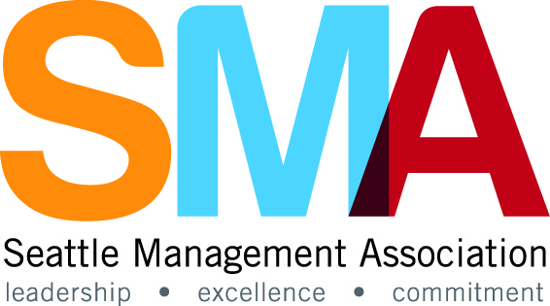

**Join the Seattle Management Association Board of Directors**

Nominations **for the Seattle Management Association Board** are being accepted now! SMA is looking for **at least three individuals who will serve a** **three year term, 2016-2019**.

We encourage you to apply if you are interested in meeting other City employees and taking part in shaping activities and events of interest to current and aspiring City leaders. We are a dynamic working board with opportunities to use or develop event planning, project management, budgeting and marketing skills.

The time commitment involves attending monthly 1.5 hour board meetings. Additional time is spent outside of the board meetings in subcommittees that are usually 1-2 hours monthly.

Board membership provides the opportunity for:

* **Leadership Skills Development**   
  Add to or refresh your professional skills by attending special training events targeted to help develop leadership skills that are relevant to the work of our members.
* **Outstanding Networking and Professional Growth Opportunities**   
  Take advantage of a variety of opportunities to expand your professional network by planning and promoting events or chairing a committee.
* **Excellence in Leadership Awards Programs**   
  Be involved in this unique City program that recognizes individual employees and teams for their outstanding leadership throughout the City. 2015 Awards categories included Public Service, Community Service, Planning and Project Management, Race and Social Justice, and Environmental Stewardship.

If you are a current or aspiring City leader, complete the attached application and submit to [sma@seattle.gov](mailto:sma@seattle.gov) by Friday, March 18th.

For more information review our website and sign up for our listserv at <http://www.seattle.gov/seattle-management-association>.

If you have any questions please contact Jennifer Greenlee, SMA President, at [Jennifer.greenlee@seattle.gov](mailto:Jennifer.greenlee@seattle.gov) or 206-233-7118.

SMA Board Member Application

Information provided on this nomination form may be used

to describe the candidate on the Ballot.

|  |  |  |  |
| --- | --- | --- | --- |
| Nominee Name |  | | |
| Organization/Department |  | | |
| Job Title |  | Years w/City |  |
| Phone |  | Mail Stop |  |
| Email |  | SMA Member |  |

|  |
| --- |
| **Nominee’s Bio**  Please provide relevant background information about yourself i.e.: jobs, skills and or special committees you served: |
|  |

|  |
| --- |
| **Nominee’s Interest in Joining the Board**  In 100 words or less, please explain why you should be selected to the SMA Board: |
|  |