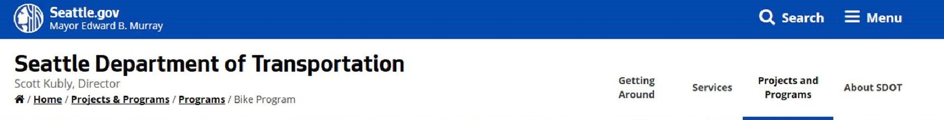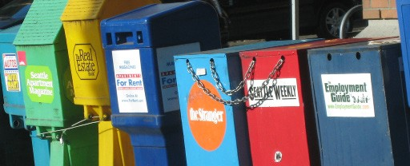 Newsstands in the Right of Way Newsstands
Street Use Division
Kevin O’Neill, Director
Home / Services / Newsstand Maintenance

Overview

Seattle is fortunate to have a diverse range of news publications accessible through self- serve newsstands along city sidewalks. While these newsstands provide a useful service, it can sometimes be challenging to monitor their condition and placement.

To address this challenge, the Seattle Department of Transportation Public Space Management Program has worked with newspaper publishers and distributors to create a one-stop online portal called SeattleNewsstands.org.

How Do I Use the Portal?

Phone: 206-684-5267
Email: newsstands@seattle.gov

Related Links
Director ’s Rule 02-2014
Street Furniture & Decorations

Newsstand Maintenance
You may submit two kinds of requests:

Maintenance Requests; and
- Temporary Construction Relocation Requests.

If you choose to submit a maintenance request, you will be asked to provide the following information:

  - The news publication(s) that will be affected;
  - A short description of the problem or concern;
  - Your email contact information; and
  - A photo of the newspaper box site to the request.

If you choose to submit a temporary construction relocation request, you will be asked to provide the following information:

  - The nature of the construction project;
  - The expected timeframe for the newsstand relocation;
  - A short description of which newspaper boxes and publications would be affected by the project; and
  - Your contact information.

Once you submit your report, it goes directly to the
identified newsstand owner to resolve.


The homepage of the portal.

