October 18, 2017

Dear Neighbor,

We are writing to share an update on the Rainier Valley Neighborhood Greenway project planned along your street. We’re pleased to announce we have a construction contractor on board and **work should begin in late October.**

**What's happening?**

The Rainier Valley Neighborhood Greenway is a route over 6 miles long stretching all the way from Mount Baker to Rainier Beach. The route includes small improvements like crosswalks, curb ramps, speed humps, stop signs, and pavement repairs that go a long way to make walking and biking around the neighborhood easier. We’ll also make pathway improvements where the route connects between streets, and later in 2018, we’ll build a new connection to the Mountains to Sound Trail. See enclosed fact sheet and section map for more details.

**What to expect?**

Because of the length of the route, you may not see activity outside your home immediately, and there will be periods of inactivity on your street. We will continue to update you with information on what to expect with targeted outreach efforts, such as email updates, posters, flyers, signage, and mailings. Please sign up for email updates on our website: www.seattle.gov/transportation/rainiervalleygreenways2.htm.

Starting in late October, crews plan to begin installing crossing improvements at major crossings and speed humps along the whole route. They’ll start on the north end of the route and work south. Signage and flaggers may detour traffic for short-term road closures during this work and some of the work requires temporary parking restrictions. Crews will place “No Parking” signs 72 hours in advance.

**We want to keep you informed!**

If you’d like updates on construction activities, please sign up for email updates on our website:

www.seattle.gov/transportation/rainiervalleygreenways2.htm

Feel free to contact us with questions.

Thank you!

Rainier Valley Neighborhood Greenway Outreach Team

[RainierNSGW@seattle.gov](mailto:RainierNSGW@seattle.gov)

(206) 684-8766

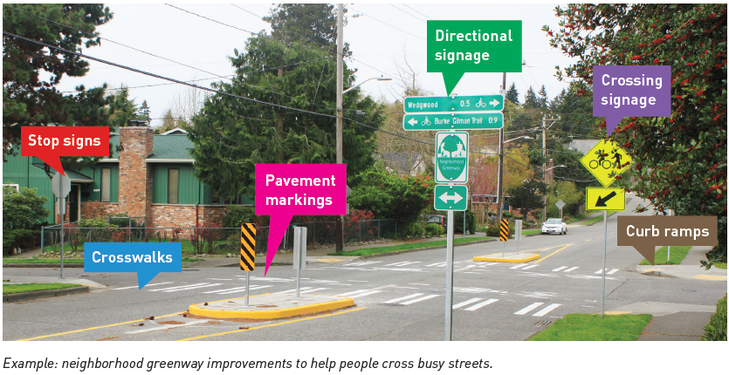

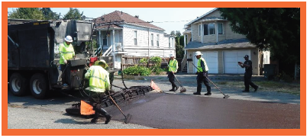

The City of Seattle is creating a network of safer, calmer residential streets in Rainier Valley. Check out the color-coded photos to see some of the planned improvements including pavement maintenance, crossing signage, crosswalks, curb ramps, directional signage, pavement markings, and stop signs. For translation services, please call (206) 684-8766.

*Microsurfacing pavement maintenance work is complete*

