
Cost and Expenditures Update
Fall 2005

This fact sheet provides an update on the amount spent on project work as of
September 1, 2005, as well as anticipated costs and expenditures moving forward.

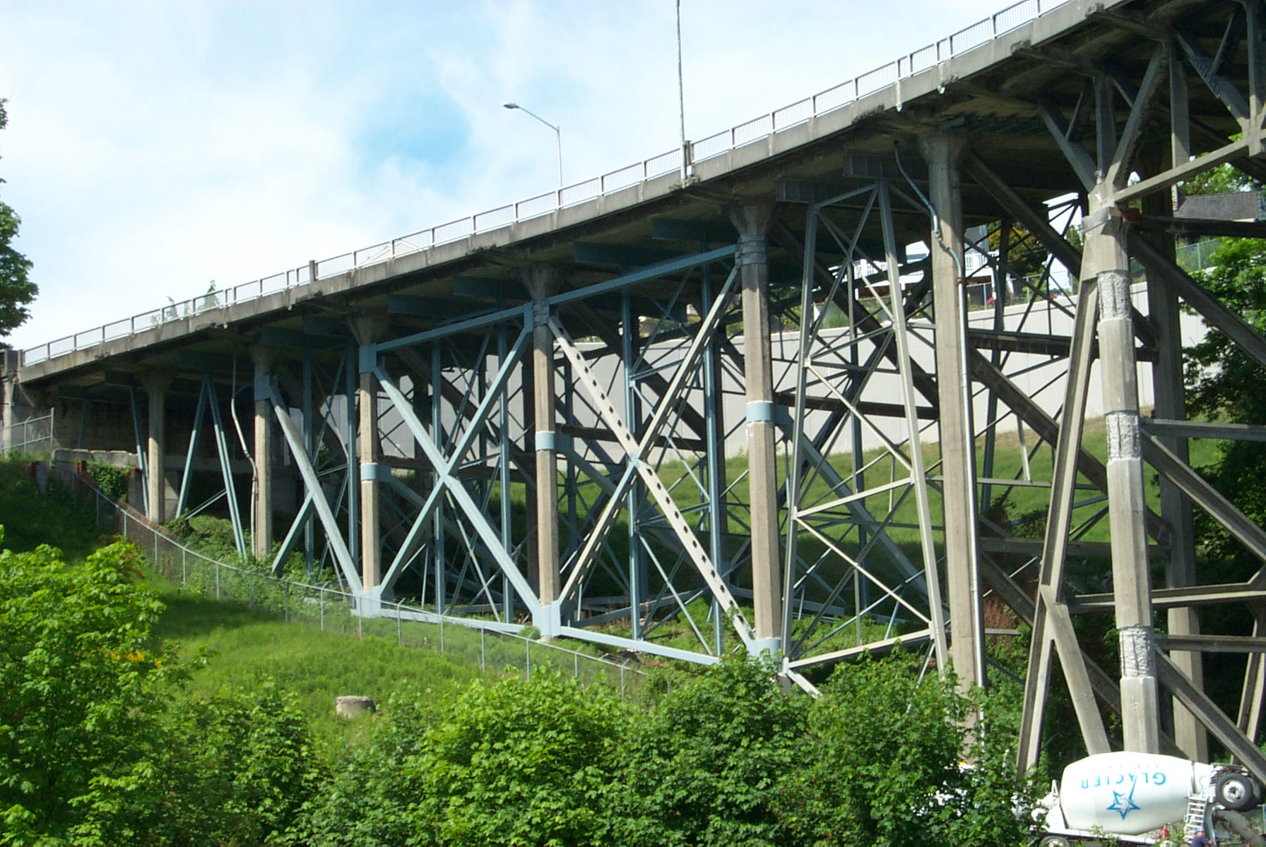
The aging Magnolia Bridge, twice damaged by landslides and an earthquake, needs to be replaced. The Seattle Department of Transportation (SDOT) has been studying three alternatives, known as Alternatives A, C and D, for replacing the bridge. The City is also studying an option that would rehabilitate the existing bridge to bring it up to current design standards. If nothing is done to rehabilitate or replace the bridge, the project team estimates vehicle weight limits will likely be imposed in approximately 15 to 20 years.

Estimated Project Costs

Table 1. Estimated Alternative Costs*

Alternative | Right of Way (ROW) Acquisition Costs  ($Millions) | Design / Construction  ($Millions) | Total Initial Cost  Estimate (w/ ROW)  ($Millions)
A | $32 | $164 | $196
C | $63 | $151 | $214
D | $56 | $157 | $213
Rehabilitation | $1 | $177 | $178
As part of the evaluation process, SDOT conducted a Schedule, Cost and Risk Evaluation (SCoRE) to determine how the alternatives compare. Through this process, SDOT identified factors that could impact or improve the project’s schedule and cost, and developed related estimates for each alternative. These findings, summarized in the table below, will help the City select a preferred alternative for replacing the bridge.

Please note that the total initial cost estimate does not include future maintenance and replacement costs. This total would be higher for the Rehabilitation Alternative because it would not be a new facility and would require more frequent upkeep.

July 2005 Capital Improvement Program Update

The City of Seattle’s Capital Improvement Program (CIP) allocates existing funds and anticipated revenues to projects to rehabilitate, restore, improve, and add to the City’s capital facilities. The current CIP shows the Magnolia Bridge Replacement Project total cost as $213 million with roughly $9 million in federal funds and $1 million in local funds currently available, and $203 million to be determined.

Expenditures to Date

Project expenditures as of September 1, 2005, total $3,760,921, comprised of expenses for planning, design, environmental review, and public involvement efforts as described in Table 2.
Table 2. Expenditures to Date by Activity

Activity | Percentage of Total Expenditure | Total Spent  to Date
Planning | 12% | $451,311
Design | 24% | $902,621
Environmental Review | 43% | $1,617,196
Public Involvement | 21% | $789,793
Total Spent to Date | 100% | $3,760,921

Of the total expenditures described above, City staff have spent $517,847, and the project’s consultant team has spent $3,242,073. Table 3 lists the contract totals held by SDOT consultants for the Magnolia Bridge Replacement Project through the end of 2006.

Table 3: Magnolia Bridge Project Consultants Contracts through 2006

Firm | Expertise | Contract Total
HNTB | - Project management  - Engineering  - Environmental  - Public involvement | $4,782,782
KTJ | - Project management | $244,270
KBA | - Project management | $120,000
Total |  | $5,147,052

The current consultant contracts will fund completion of the environmental review process and the Type, Size, and Location Study by the end of 2006, which will determine the type of construction material used, deck span lengths, and many other architectural features. At the beginning of 2007, SDOT estimates they will have approximately $4 million remaining of the current funds to begin developing the contract plans. It is estimated that those funds are enough to develop 50% plans for the project. An additional $4 million will be needed to complete the contract plans.

The City is committed to finding a safe and cost-effective alternative for replacing the Magnolia Bridge. Transportation is one of Mayor Nickels’ four top priorities and he is actively lobbying in Olympia and working with cities throughout the state to identify new revenue. In the meantime, SDOT will continue to look for opportunities to reduce project costs.

More Information
Contact: Kirk T. Jones, (206) 615-0862, kirkt.jones@seattle.gov, or Cela Fortier, (206) 233-7157, cela.fortier@seattle.gov, Seattle Department of Transportation Project Managers.


Visit the project website at www.seattle.gov/transportation/magbridgereplace.htm

* Costs are defined as “Year of Expenditure,” meaning they account for inflation based on when SDOT estimates that dollars will be spent. The earliest construction could begin is 2009, and the estimates assume there would be no delay in obtaining funding.

