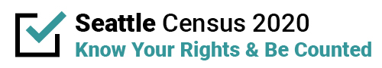

Contact Name:
Media outlet:

Proposed campaign ads
Please share how you plan to engage the identified population/community to overcome barriers to participation, so they ultimately are counted in the 2020 Census.

In the template below, please document anticipated activities, timeline, and location related to phases of 2020 Census work.
Months | Activities | Indicate if you will be strategizing, producing, and/or distributing content | Geographic Coverage

