SCHOOL DEVELOPMENT
STANDARD DEPARTURE
ADVISORY COMMITTEE

QUEEN ANNE ELEMENTARY SCHOOL DESIGN DEPARTURE RECOMMENDATIONS
Project #3026198
AUGUST 21, 2017
This report is produced pursuant to the City of Seattle Municipal Code (SMC 23.44.17 and 23.79) (the “Code”). The intent and purpose of this report is to document public testimony and make recommendations to the City for modifications to development standards in order to facilitate renovation of the Queen Anne Elementary School located at 411 Boston St., Seattle.

Table of Contents
1. Background 1
1.1 Project Description 1
1.2 Neighborhood Characteristics 2
1.3 Requests for Departure and Committee Formation 3
2. Departures 4
2.1 Specific District Requests 4
Departure #1 – Greater than Allowed Lot Coverage 4
Departure #2 – Less than Required Off-street Parking 5
Departure #3.a – Off-site Bus Loading & Unloading on Bigelow Ave N. (PREFERRED) 6
Departure #3.b – Off-site Bus Loading & Unloading on 4th Ave N. (ALTERNATIVE) 6
2.2 Committee Review and Recommendations 7
2.2.1 Process & Public Meeting 7
2.2.2 Review Criteria 7
2.2.3 Application of Review Criteria to Requested Departures and Committee Recommendations 8
Need for Departures 8
Departure #1 – Greater than Allowed Lot Coverage 8
Departure #2 – Less than Required Off-street Parking 9
Departure #3.a – Off-site Bus Loading & Unloading on Bigelow Ave N. 11
Departure #3.b – Off-site Bus Loading & Unloading on 4th Ave N. 12
Exhibit 1 Existing Site Plan 2
Exhibit 2 Proposed Site Plan 2
Exhibit 3 Proposed Lot Coverage 5
Exhibit 4 Impact of Code Required On-Site Parking Stalls 5
Exhibit 5 Location of Off-site Bus Loading & Unloading on Bigelow Ave N. 6
Exhibit 6 Location of Off-site Bus Loading & Unloading on 4th Ave N. 7
Attachment 1: Meeting #1 Minutes, June 6, 2017
Attachment 2: Meeting #2 Minutes, July 20, 2017

Queen Anne Elementary School
Design Departure Advisory Committee
Report and Recommendations

Background

Project Description
On March 30, 2017, the Seattle Public Schools submitted a request for departures from three (3) Seattle Municipal Code (SMC) Development Standards to accommodate a addition project at Queen Anne Elementary School located at 411 Boston St., Seattle.
Queen Anne Elementary School has an existing enrollment of approximately 420 students to provide a total capacity of 500 students to address current and projected elementary growth in Queen Anne and downtown Seattle, and reduce overcrowding at elementary schools in the area. The proposed project includes building an addition with 8 classrooms of permanent capacity four of which are sized and configured to serve Kindergarten, and shared learning/small group spaces; a gymnasium with associated support; an expanded dining commons that doubles as both a “We Wonder” project based learning lab and a performance stage; and a new main office, relocated to the center of campus for improved function, equitable faculty support, closer student connection, a physical presence, and heightened security. The work will also provide improvements to the site including a staff parking lot and a service loading dock.
In order to reclaim the ‘heart’ of the campus, staff parking and dumpster storage are being moved out from the middle of the site and relocated to the perimeter of the site, away from student play, and visually shielded from drop-off and arrival areas. Currently, both bus and parent drop-off occur on Bigelow Ave N. This has created space and safety concerns. The new configuration explores bus loading and unloading along Bigelow, and parent drop-off along 4th Ave N. To accommodate this, new site entry stairs and accessible ramps are proposed mid-block on both sides.

Exhibit 1 Existing Site Plan

Exhibit 2 Proposed Site Plan

Neighborhood Characteristics
The existing 2.99-acre (130,293.45 square feet) site for the school is located in East Queen Anne, bounded by Boston Street to the north, Bigelow Ave N. to the east, Newton Street to the south and 4th Ave N. to the west. The property is located within SF 5000 zoning and is mostly surrounded by SF 5000 zoning, with the exception of commercial zone, Neighborhood Commercial 1 (NC1-30), on the north side of Boston Street between 4th Ave N. and Bigelow Ave N. and Lowrise multifamily zone, Lowrise 2 (LR2), along the west side of 4th Ave N. between Crockett St and Boston Street.
Located on the north side of Boston Street, in the NC1-30 zone, is a single-story commercial building with a parking lot and a two-story apartment building. Located on the west side of 4th Ave N., in the LR2 zone, is a three-story apartment building on the corner of Boston Street and 4th Ave N. Additionally, there is a four-story apartment building on the corner of Crockett Street and 4th Ave N., in the SF 5000 residential zone.
Access to the site is limited, as it is surrounded entirely by either retaining wall or sharply graded landscaping. The existing brick building can be accessed directly from 4th Ave N., Boston Street and Bigelow Ave N. via stair only; no ADA accessible ramps are available. The front door, as designed, was intended to be on Boston Street. The 1905 wood building must be accessed from the site. Site access is limited to stairs at the intersection of Crockett Street and both 4th Ave N. and Bigelow Ave N, and on Newton Street near the SE corner. Additionally, there is a non-accessible ramp at the SW corner of the site and a driveway at the SW corner of the 1922 brick building that provides access to the parking lot and has become one the main entrances for students, staff and visitors.
Furthermore, SDCI identifies an area in the NE corner of the site, between the north retaining wall and the north façade of the existing brick building as a steep slope area, “slopes with an incline of forty percent or more within a vertical elevation change of at least ten feet”. The project submitted an ECA exemption request and based on review of the submitted information, SDCI concluded that the proposed development does not encroach within this area and therefore the standards have been waived for this project.

Requests for Departure and Committee Formation
The City initiated the Development Standard Departure Process, pursuant to SMC 23.44.17 and 23.79. The Code requires that the Department of Neighborhoods (DON) convene a Development Standard Advisory Committee (hereinafter as the Committee) when the School District proposes a departure from the development standards identified under the Code. These standards are popularly referred to as the “zoning code”.
The purpose of the Committee is 1) to gather public comment and evaluate the proposed departures for consistency with the objectives and intent of the City’s land use policies to ensure that the proposed facility is compatible with the character and use of its surroundings; and 2) to develop a report and recommendation to the Seattle Department of Construction and Inspections (SDCI) from DON. (SMC 23.79.008)
Following completion of the Committee Report and its transmittal to SDCI, the Director of SDCI will issue a formal report and decision. The Director of SDCI will consider the recommendations of the Committee and will determine the extent of departure from established development standards which may be allowed, as well as identify all mitigating measures which may be required. The Director’s decision is appealable.
On April 4, 2017, DON sent notices to residents within 600 feet of the Queen Anne Elementary School requesting self-nominations for membership on the Committee. Fifteen community members applied, and on May 9, 2017 the Committee was formed. The Committee is composed of eight voting members and two alternates, a representative from SDCI and a City non-voting Chair.
The Committee was appointed as follows:
Tammi DeVore | Person residing within 600’
Sandra Harui | Person owning property or a business within 600’
Laura Cole Jackson | Representative of the general neighborhood
Mindy Black | Representative of the general neighborhood
Angie Kim | At large to represent citywide education issues
Mark Meuter | Representative of the Queen Anne Elementary PTSA
Kari Edmondson | Representative of the Queen Anne Elementary PTSA
Vincent Gonzales | Representative of the Seattle School District
Karen Lonergan | Alternate - Resigned
Jason Robert | Alternate
Holly Godard  (Ex-officio) | Seattle Department of Construction and Inspections (SDCI)
Maureen Sheehan  (Ex-officio) | Department of Neighborhoods (DON)

Departures

Specific District Requests
The Queen Anne Elementary School Addition will expand the area of the existing 1922 brick building and will not impact the Seattle City Landmark 1905 wood building. It will house the existing program with the capacity to accommodate 500 students. The existing 1922 brick building is 20,707 square feet and the existing 1905 wood building is 7,959 square feet. The existing portables are a combined 5,002 square feet and will be demolished on site, leaving a remaining 33,668 square feet of building area across the site. The new addition will be a one-story structure of approximately 22,850 square feet, of which 3,000 square feet is for covered play. The site will not be occupied during construction.
In order to accommodate the educational program for this project, the District requested the following departures from provisions of the SMC 23.79.008 C1a.

Departure #1 – Greater than Allowed Lot Coverage
Existing Standard: SMC 23.51B.002 C - LOT COVERAGE IN SINGLE FAMILY ZONES
For new public-school construction and additions to existing public school structures on existing public school sites, the maximum lot coverage permitted is the greater of the following: 45 percent of the lot area for one story structures or 35 percent of the lot area if any structure or portion of a structure has more than one story.
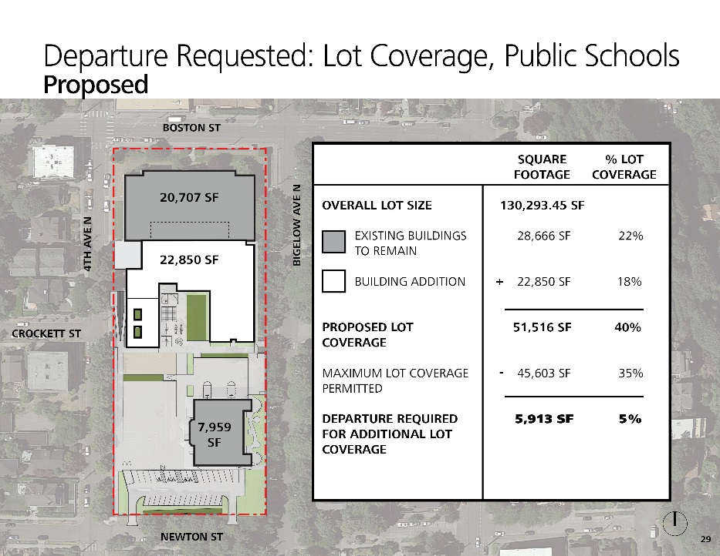

Exhibit 3 Proposed Lot Coverage
Departure Requested: 5% additional lot coverage.

Departure #2 – Less than Required Off-street Parking
Existing Standard: SMC 23.54.015 (Table C – Row N)
1 space for each 80 square feet of all auditoria or public assembly rooms, OR 1 space for every 8 fixed seats in auditoria or public assembly rooms containing fixed seats, for new public schools on a new or existing public school site.
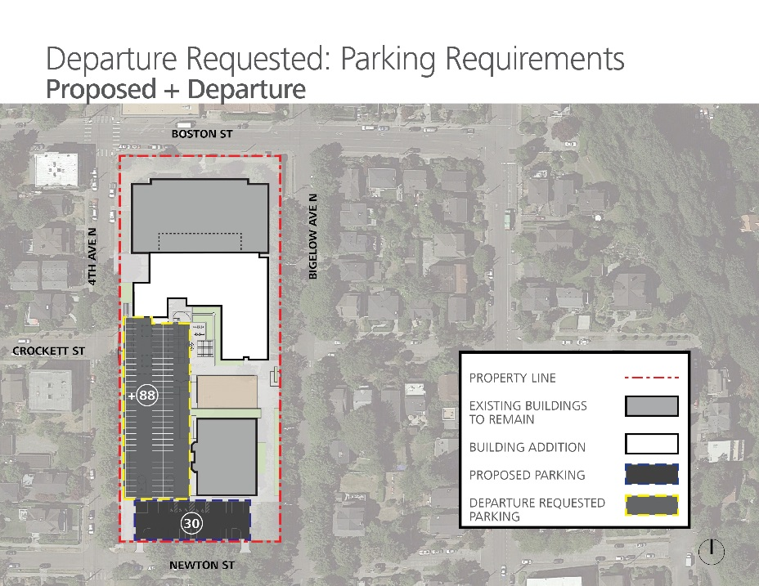

Exhibit 4 Impact of Code Required On-Site Parking Stalls

Departure Requested: to allow for 88 parking spaces less than the code required parking to be provided on-site. [118 required stalls – minimum of 30 proposed stalls = 88 departure stalls requested]

Departure #3.a – Off-site Bus Loading & Unloading on Bigelow Ave N. (PREFERRED)
Note: Bigelow Ave N. is part of the Historic Queen Anne Boulevard, a city park managed by Seattle Parks and Recreation (SPR). SPS buses currently load and unload on Bigelow Ave N., however that loading zone was not permitted by SPR, therefore SPS must formally request the use of the Boulevard for this purpose. At the time of this report, SPR has not made a determination whether they will allow this use, therefore the design team is proposing an alternative solution, 4th Ave N., as a potential location in the event SPR will not allow bus load and unload to take place.
Existing Standard: SMC 23.51B.002.I.4
When a public school is remodeled or rebuilt at the same site, an existing on-street bus loading area is allowed if the following conditions are met:
- The school site is not proposed to be expanded;
- The student capacity of the school is not being expanded by more than 25 percent; and
- The location of the current on-street bus loading remains the same.
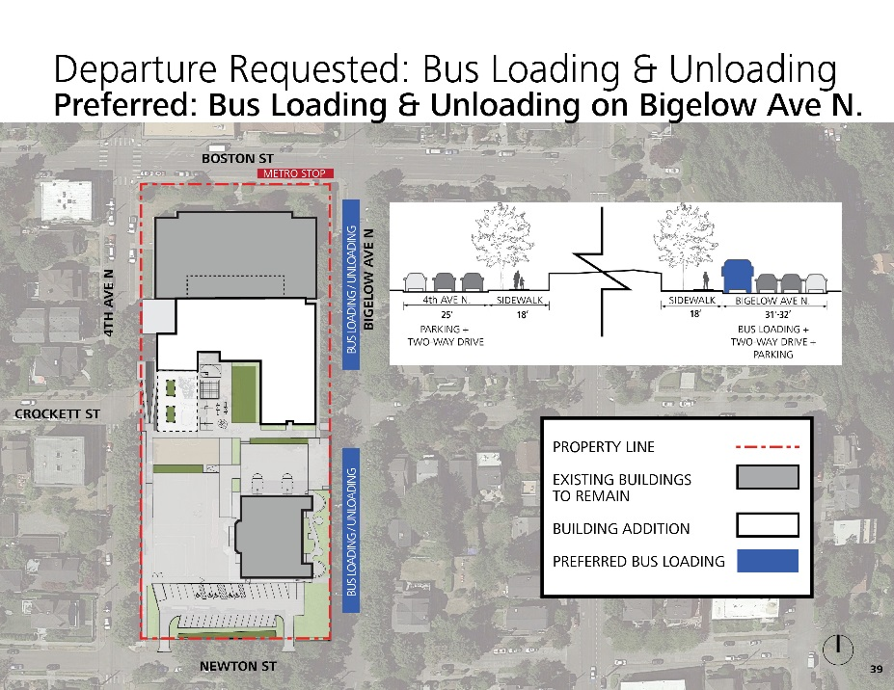

Exhibit 5 Location of Off-site Bus Loading & Unloading on Bigelow Ave N.
Departure Requested: Additional bus loading & unloading on Bigelow Ave N.

Departure #3.b – Off-site Bus Loading & Unloading on 4th Ave N. (ALTERNATIVE)
Existing Standard: SMC 23.51B.002.I.4
When a public school is remodeled or rebuilt at the same site, an existing on-street bus loading area is allowed if the following conditions are met:
- The school site is not proposed to be expanded;
- The student capacity of the school is not being expanded by more than 25 percent; and
- The location of the current on-street bus loading remains the same.
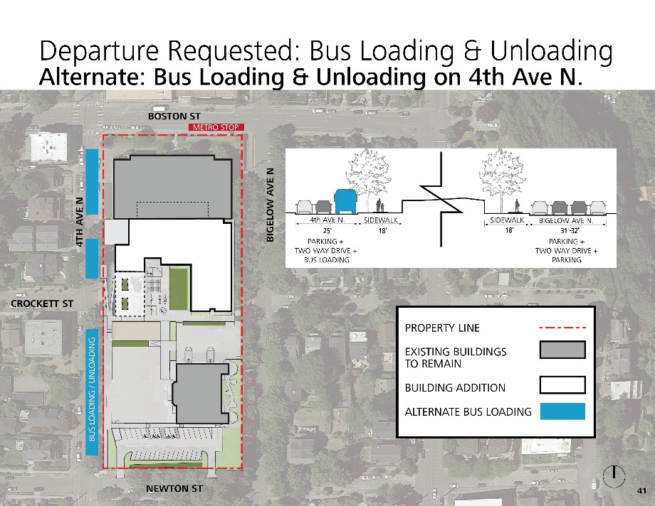

Exhibit 6 Location of Off-site Bus Loading & Unloading on 4th Ave N.
Departure Requested: Additional bus loading & unloading on 4th Ave N.

Committee Review and Recommendations

Process & Public Meeting
The Committee was convened in two public meetings on June 6, approximately 20 people attended, 15 of whom provided public comment, and July 20, approximately 33 people attended, 11 of whom provided public comment at Queen Anne Elementary School. The common theme raised in public comment were the parking and traffic impacts on the neighborhood due to the lack of on-site parking will disproportionately affect neighbors living adjacent to the school;

2.2.2 Review Criteria
Section 23.79 of the Code directs the Committee to evaluate the requested departures for consistency with the general objectives and intent of the Code, and to balance the interrelationships among the following factors:

a. Relationship to Surrounding Areas:
(1) Appropriateness in relation to the character and scale of the surrounding area
(2) Presence of edges (significant setbacks, major arterials, topographic breaks, and similar features) which provide a transition in scale.
(3) Location and design of structures to reduce the appearance of bulk;
(4) Impacts on traffic, noise, circulation and parking in the area; and
(5) Impacts on housing and open space.

b. Need for Departure: The physical requirements of the specific proposal and the project's relationship to educational needs shall be balanced with the level of impacts on the surrounding area. Greater departure may be allowed for special facilities, such as a gymnasium, which are unique and/or an integral and necessary part of the educational process; whereas, a lesser or no departure may be granted for a facility which can be accommodated within the established development standards.
Section 23.51.002 contains further restriction related to single family and other low-rise residential zones.

2.2.3 Application of Review Criteria to Requested Departures and Committee Recommendations
The Seattle Municipal Code intent is to grant departures from the requirements of the Municipal Code to accommodate the educational needs of the programs to be located in single family zoned neighborhoods. The Seattle School District has demonstrated that it cannot accommodate the program necessary for this area without granting departures for: 1) lot coverage, 2) parking, and 3) off-site bus loading.

Need for Departures
The committee recognized the need for the requested departures to accommodate essential school functions on the site, meanwhile requiring less than required parking on site and relocating bus loading and unloading off site. There was significant discussion on how to utilize the site to relieve the additional burden on the neighbors with as much on-site parking as possible, while maintaining necessary open space.

Departure #1 – Greater than Allowed Lot Coverage
- Appropriateness in relation to the character and scale of the surrounding area were considered by the committee, and they did not have concerns about the school’s increased lot coverage having an impact on its relationship to the neighborhood.
- Presence of edges (significant setbacks, major arterials, topographic breaks, and similar features) which provide a transition in scale were considered by the committee, and they did not have concerns about the school’s increased lot coverage having an impact on the transition in scale.
- Location and design of structures to reduce the appearance of bulk were considered by the committee, and they did not have concerns about the school’s increased lot coverage having an impact on the appearance of bulk.
- Impacts on traffic, noise, circulation and parking in the area were considered by the committee, and they did have concerns about the school’s increased lot coverage having an impact on traffic, circulation and parking the neighborhood, which were addressed in departures #2 & 3.
- Impacts on housing and open space were considered by the committee, and they did not have concerns about the school’s increased lot coverage having an impact on housing and open space.
The design team explored locating the gym immediately south of the existing lunchroom rather than expanding the lunch room, reducing a need for additional lot coverage, but due an existing boiler room below the current covered play space if the lunchroom were located above the boiler room, it would need to be modified or upgraded. Locating the gymnasium at the proposed location is the most efficient and cost effective. The committee considered ways to reduce the lot coverage to allow additional parking, but the need for usable play space and adjacency of school functions were a priority. Of the 5% requested departure, 2.5% is covered play space, and the committee agreed this was a reasonable request.
After consideration of the above, the Committee recommends:
Recommendation 1 – That the departure to allow greater than allowed lot coverage be GRANTED as requested by Seattle Public Schools without modifications and without conditions.

Departure #2 – Less than Required Off-street Parking
- Appropriateness in relation to the character and scale of the surrounding area were considered by the committee, and they did not have concerns about the school’s less than required off-street parking having an impact on its relationship to the neighborhood.
- Presence of edges (significant setbacks, major arterials, topographic breaks, and similar features) which provide a transition in scale were considered by the committee, and they did not have concerns about the school’s less than required off-street parking having an impact on the transition in scale.
- Location and design of structures to reduce the appearance of bulk were considered by the committee, and they did not have concerns about the school’s less than required off-street parking having an impact on the appearance of bulk.
- Impacts on traffic, noise, circulation and parking in the area were considered by the committee, and they did have concerns about the school’s less than required off-street parking having an impact on traffic, circulation and parking the neighborhood, which were addressed in the recommended conditions.
- Impacts on housing and open space were considered by the committee, and they did not have concerns about the school’s less than required off-street parking having an impact on housing and open space.
The committee grappled with the public comment they received on the impacts of parent drop-off/pick-up and parking and staff parking, sometimes illegally, on the street in front of homes, as well as a need for play space for students. At the second meeting, the design team presented a chart showing the student enrollment, staff, site area, and number of on-site parking spaces for schools in the area. Queen Anne has a comparatively high number of parking stalls for its site size. The committee noted it did not consider the context of those neighborhoods, i.e. accessibility to additional parking opportunities in the neighborhood. The value of each parking spot was very important to the committee, therefore they requested a scheme where open play space could be used for parking during large after school events that would alleviate parking in the neighborhood when it is at its highest demand.
The school Principal, Janine Roy, was present at both meetings. She made clear to the committee and public that this was the beginning of a larger, on-going conversation between the school community and the neighborhood. Plans were already in place for the following school year to begin implementing some of the recommendations proposed by the committee and public, such as the parent drop off/pick up valet system. She also announced the formation of a Traffic Advisory Committee to continue to address these issues. This relieved some concerns that if these conditions are incorporated into the Transportation Management Plan, it is still up to the discretion of the principal to initiate, and more importantly enforce.
After consideration of the above, the Committee recommends:
Recommendation 2 – That the departure to reduce the parking requirement be GRANTED as requested by the Seattle Public Schools without modifications and with the following conditions:
- Use of play space as overflow parking for large after-hours school sponsored events where the play space is not utilized.
- The school must create an enhanced Transportation Management Plan (TMP) and incorporate the following:
- A designated parent drop-off and pick up along the southeast side 4th Ave N or Bigelow Ave N (depending on where bus loading/unloading takes place) and/or in the south parking lot, with the desire for the drop-off/pick-up be a valet-type of system that would be administered by SPS and volunteers, with SPS analysis and SDOT approval. If the south parking lot were to be recommended as a parent valet drop-off/pick-up, SDOT would like SPS to ensure that two volunteers be located at the entrance and exit of the parking lot, ensuring safety for people walking and biking along Newton St.
- A rigorous staff parking management component to minimize school-day parking impacts to neighbors nearest the school where teachers and staff who cannot park in the south parking lot park at least one block away from the school, (beyond Lynn St, Nob Hill Ave N, Howe St, and 5th Ave N) and provide resources to educate the school community and enforce the plan.
- That the findings and Recommendations contained in the Transportation Technical Report for the Queen Anne Elementary School Addition, prepared by Heffron Transportation Inc. dated May 24, 2017 and contained on page 25 of that report, be a required condition of the implementation of this reconstruction plan and become a condition attached to the Master Use Permit.
- Allowance for a departure from the required ratio of large to compact stall sizes to increase the number of parking stalls available to staff.
- Optimize the number of parking stalls in the south parking lot, with a minimum of 30 parking stalls.
- A minimum of 3 ADA parking stalls, with 2 flexible ADA parking stalls, to be converted to and from ADA as necessary, to increase the number of parking stalls available to staff.
- Plan for future expansion of bike racks to not limit the number of students that can bike to school in the future.

Departure #3.a – Off-site Bus Loading & Unloading on Bigelow Ave N.
- Appropriateness in relation to the character and scale of the surrounding area were considered by the committee, and they did not have concerns about the school’s off-site bus loading & unloading on Bigelow Ave N. having an impact on its relationship to the neighborhood.
- Presence of edges (significant setbacks, major arterials, topographic breaks, and similar features) which provide a transition in scale were considered by the committee, and they did not have concerns about the school’s off-site bus loading & unloading on Bigelow Ave N. having an impact on the transition in scale.
- Location and design of structures to reduce the appearance of bulk were considered by the committee, and they did not have concerns about the school’s off-site bus loading & unloading on Bigelow Ave N. having an impact on the appearance of bulk.
- Impacts on traffic, noise, circulation and parking in the area were considered by the committee, and they did have concerns about the school’s off-site bus loading & unloading on Bigelow Ave N. having an impact on traffic, circulation and parking the neighborhood, which were addressed in the recommended conditions.
- Impacts on housing and open space were considered by the committee, and they did not have concerns about the school’s off-site bus loading & unloading on Bigelow Ave N. having an impact on housing and open space.
Bigelow Ave N. is the best option available for bus loading and unloading. Boston Ave is unsafe for bus loading and unloading due to sightlines and does not provide adequate space in front of the school for the necessary number of buses, and Newton St is functionally incompatible. Bigelow Ave N is the District’s preferred option. Traffic around the school is challenging, and the committee is supportive separating bus traffic from any designated parent drop off and pick up due to safety concerns. Parking in the neighborhood is highly coveted, and any further loss of parking would be a hardship on the neighborhood, as heard during public comment. The Bigelow Ave N. option does not remove any additional parking and it is wide enough for a bus to park as well as two-way traffic and street parking in the east side of the street. Additional suggestions were made to alleviate parking strains on the neighbors, provide safer routes for students to walk/bike to school, and for buses to minimize their presence in the neighborhood.
After consideration of the above, the Committee recommends:
Recommendation 3 – That the departure to allow additional bus loading and unloading on Bigelow Ave N. be GRANTED as requested by the Seattle Public Schools without modifications and with the following conditions:
- The school must create an enhanced Transportation Management Plan (TMP) and incorporate the following:
  - A designated parent drop-off and pick-up along the southeast side 4th Ave N and/or in the south parking lot, with the desire for the drop-off/pick-up be a valet-type of system that would be administered by SPS and volunteers, with SPS analysis and SDOT approval. If the south parking lot were to be recommended as a parent valet drop-off/pick-up, SDOT would like SPS to ensure that two volunteers be located at the entrance and exit of the parking lot, ensuring safety for people walking and biking along Newton St.
  - Strategies to keep buses on arterial streets to minimize bus traffic on Newton St. and prevent bus traffic through adjacent neighborhood streets.
  - Minimize bus traffic on Newton St. and non-arterial streets, in a manner that parent and bus traffic are separated.
  - A Safe Routes to School Committee initiated and hosted by the School. Committee to include at least two representatives from the QAES neighborhood to evaluate safety surrounding the school, identify actions to improve pedestrian safety in the neighborhood and seek funding to implement identified improvements.
  - Encourage parents that want to park their vehicle to drop-off or pick-up to park in neighboring streets (not streets immediately adjacent to the school) and walk their children to school. This will help alleviate traffic circulation and parking issues.
  - That the findings and Recommendations contained in the Transportation Technical Report for the Queen Anne Elementary School Addition, prepared by Heffron Transportation Inc. dated May 24, 2017 and contained on page 25 of that report, be a required condition of the implementation of this reconstruction plan and become a condition attached to the Master Use Permit.
- Prohibit school buses from idling while waiting for students to unload and load, and modify bus loading protocol to minimize time spent idling.
- The school district must evaluate the utilization of buses to find ways to reduce the number of buses going to and from the school.
- Evaluate locating a 4-way stop at 4th Ave N and Boston St. and at Newton and Boston St. with SPS analysis and SDOT approval.
- Evaluate establishing a crosswalk at Boston St. and Bigelow Ave N. to encourage safe travel across Boston St. with SPS analysis and SDOT approval.

Departure #3.b – Off-site Bus Loading & Unloading on 4th Ave N.
- Appropriateness in relation to the character and scale of the surrounding area were considered by the committee, and they did not have concerns about the school’s off-site bus loading & unloading on 4th Ave N. having an impact on its relationship to the neighborhood.
- Presence of edges (significant setbacks, major arterials, topographic breaks, and similar features) which provide a transition in scale were considered by the committee, and they did not have concerns about the school’s off-site bus loading & unloading on 4th Ave N. having an impact on the transition in scale.
- Location and design of structures to reduce the appearance of bulk were considered by the committee, and they did not have concerns about the school’s off-site bus loading & unloading on 4th Ave N. having an impact on the appearance of bulk.
- Impacts on traffic, noise, circulation and parking in the area were considered by the committee, and they did have concerns about the school’s off-site bus loading & unloading on 4th Ave N. having an impact on traffic, circulation and parking the neighborhood, which were addressed in the recommended conditions.
- Impacts on housing and open space were considered by the committee, and they did not have concerns about the school’s off-site bus loading & unloading on 4th Ave N. having an impact on housing and open space.
The committee wanted to outright reject this departure. With that said, they understood that SPR has final say if Bigelow Ave N can be used for bus loading and unloading, and if it must happen on 4th Ave N the committee wanted to make sure there were conditions put on the use. The biggest concerns were: loss of parking on the west side of 4th Ave N due to the narrow width of the street and blocking the emergency route on 4th Ave N. Regardless, vehicle activity will need to happen on Bigelow Ave N since parent drop off and pick up should be physically separated from bus load and unload. If bus functions can stay on Bigelow, 4th is much better suited for cars dropping off and picking up than buses. There are opportunities for improved circulation around the school and suggestions were made to alleviate parking strains on the neighbors, provide safer routes for students to walk/bike to school, and for buses to minimize their presence in the neighborhood.
After consideration of the above, the Committee recommends:
Recommendation 3.b – That the departure to allow additional bus loading and unloading on 4th Ave N. be REJECTED as requested by the Seattle Public Schools:
- The school must create an enhanced Transportation Management Plan (TMP) and incorporate the following:
- A designated parent drop-off and pick-up along the southeast side Bigelow Ave N and/or in the south parking lot, with the desire for the drop-off/pick-up be a valet-type of system that would be administered by SPS and volunteers, with SPS analysis and SDOT approval. If the south parking lot were to be recommended as a parent valet drop-off/pick-up, SDOT would like SPS to ensure that two volunteers be located at the entrance and exit of the parking lot, ensuring safety for people walking and biking along Newton St.
- Strategies to keep buses on arterial streets to minimize bus traffic on Newton St. and prevent bus traffic through adjacent neighborhood streets.
- Minimize bus traffic on Newton St. and non-arterial streets, in a manner that parent and bus traffic are separated.
- A Safe Routes to School Committee initiated and hosted by the School. Committee to include at least two representatives from the QAES neighborhood to evaluate safety surrounding the school, identify actions to improve pedestrian safety in the neighborhood and seek funding to implement identified improvements.
- Encourage parents that want to park their vehicle to drop-off or pick-up to park in neighboring streets (not streets immediately adjacent to the school) and walk their children to school. This will help alleviate traffic circulation and parking issues.
- That the findings and Recommendations contained in the Transportation Technical Report for the Queen Anne Elementary School Addition, prepared by Heffron Transportation Inc. dated May 24, 2017 and contained on page 25 of that report, be a required condition of the implementation of this reconstruction plan and become a condition attached to the Master Use Permit.
- Prohibit school buses from idling while waiting for students to unload and load, and modify bus loading protocol to minimize time spent idling.
- The school district must evaluate the utilization of buses to find ways to reduce the number of buses going to and from the school.
- Evaluate locating a 4-way stop at 4th Ave N and Boston St. and Newton and Boston St. with SPS analysis and SDOT approval.
- Evaluate establishing a crosswalk at Boston St. and Bigelow Ave N. to encourage safe travel across Boston St. with SPS analysis and SDOT approval.
- Any solution to use 4th Ave N for bus loading and unloading should maintain parking along the west side of 4th Ave N.
For the Committee

Maureen Sheehan
Non-Voting Chair

