EXCESS PROPERTY DESCRIPTION

December 2, 2015

The Department of Finance and Administrative Services, as the Jurisdictional Department of this City owned property has identified the following information about this excess property.

**Property Name:**  Parcel at

|  |  |  |  |  |  |  |
| --- | --- | --- | --- | --- | --- | --- |
| PMA | PMA Size | Parcel # | Address | Zoning | 2016 Est. Value | Lat/. Long. |
| 69 | 2,100sf | 772110-0006 | 4502 Midvale Ave N, 98103 | LR 2 | $75,000- $100,000 | 47.661404  -122.343790 |

**Map:**

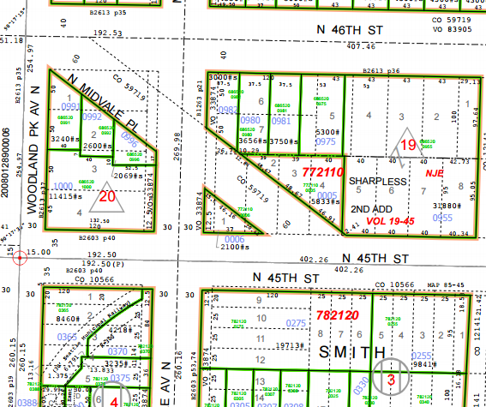

PMA 69

**Ordinances:**

7/10/1930, [Ordinance 59719](http://clerk.seattle.gov/~archives/Ordinances/Ord_59719.pdf)  An ordinance providing for the laying off, opening, widening, extending and establishing of a public street and highway to be known as Aurora Avenue, from Broad Street to Hillside Place, and Aurora Avenue from North 36th Street to West Green Lake Way at North 65th Street; West Green Lake Way, between North 65th Street and Woodland Park Avenue; Lynn Place, from the intersection of Aurora Avenue as established herein and Lynn Street, southeasterly to an intersection with Dexter Avenue near Crockett Street; 6th Avenue North, between Halladay Street and McGraw Street; Hillside Place, between Aurora Avenue as established herein and Halladay Street; Ray Street, from 4th Avenue North to Aurora Avenue as established herein; of a public street and highway to be known as Linden Place, from Aurora Avenue north of North 36th Street northwesterly to Fremont Avenue south of North 39th Street; of a public street and highway to be known as Whitman Place, from Aurora Avenue; north of North 36th Street, northeasterly to Stone Way north of North 39th Street; of a public street and highway to be known as Greenwood Place, from Aurora Avenue and Allen Place northwesterly to Linden Avenue and North 46th Street; of a public street and highway to be known as Woodland Place, from Aurora Avenue and Allen Place northeasterly to Stone Way and North 50th Street; of a public street and highway to be known as Midvale Place, from North 46th Street and Woodland Park Avenue southeasterly to North 45th Street and of North 46th Street at Stone Avenue; providing for the changing and establishing of the curb grades of the above named streets, avenues and places, and of Aloha Street from 6th Avenue North to Dexter Avenue; Ward Street, Prospect Street and Highland Drive, each from 6th Avenue North to Aurora Avenue as established herein; North 38th Street, from Linden Avenue to Whitman Avenue; Whitman Avenue between North 36th Street and North 39th Street; Albion Place, from North 38th Street to North 39th Street; Winslow Place between Allen Place and North 45th Street; of North 46th Street, between Fremont Avenue and Woodland Park Avenue; Linden Avenue and Whitman Avenue, each between North 45th Street and North 47th Street; and North 50th Street, from Fremont Avenue to Whitman Avenue; providing for the condemnation appropriation, taking and damaging of land and other property necessary therefor; and for the making of the necessary slopes for cuts and fills upon the property abutting upon said streets, avenues and places; providing for the condemnation, appropriation and taking of land and other property in fee simple for general municipal purposes; providing for the changing of the use of certain portions of West Green Lake Way, used for park and parkway purposes, from such use to a commercial use; providing that the entire cost of such improvement shall be paid by special assessment upon the property specially benefited, or from such fund as the City Council of the City of Seattle may direct, except as herein otherwise provided, or by both special assessment and from such fund; and providing for the changing of the names of certain streets and avenues.

Portion laid off for public street Midvale Place 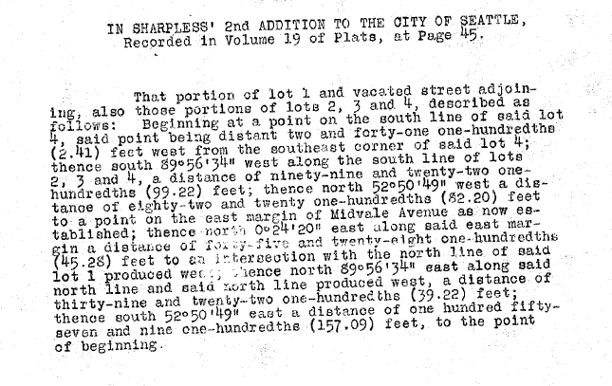

10/30/1914 [Ordinance 33874](http://clerk.seattle.gov/~archives/Ordinances/Ord_33874.pdf) An Ordinance vacating a portion of Midvale Avenue on the petition of F. M. Muldoon, and others.

**Acquisition Deeds:**

**Acquisition Fund Source:**  Street fund

**Jurisdictional Department’s estimated market value:**

FAS determines value based upon the following factors:

* 1. Previous one year vacant property sales within 2 miles of the subject property.
  2. Adjacent King County assessed land value on per square foot basis.
  3. Either positive or negative factors for unique topography, property dimensions and shape.
  4. Evaluation of potential added development capacity if combined with adjacent property.
  5. Perpetual easements or reservations for slope easements or native vegetation.

A review has been conducted as summarized below:

* 1. The value of separate vacant building lots ranges from between $50 and $70 per square foot.
  2. The property is a triangle shape.
  3. The property has a small developable portion to support one housing unit.
  4. The property has existing trees and landscaping that are currently maintained by Seattle Department of Transportation.

The 2016 value of PMA is based upon an evaluation of the property. The LR2 zoning designation of the property and development regulations may allow for the construction of one single family residence. The property is bounded by public streets on three sides. The only possible vehicular access is from Midvale Ave North.

**Destination of funds upon sale:**  Street fund.

**Current easements, covenants and restrictions:**  None

**Recommended easements, covenants and restrictions upon Transfer:**  The Seattle Department of Transportation has identified in a public road project to use approximately the northern two feet of the property for roadside landscaping. SDOT maintains the entire parcel for street landscaping. Transferring the property to SDOT and laying off the parcel as right of way is consistent with past use of the property.

**Potential problems with property and possible measures to mitigate their recurrence:** None.

**Neighborhood:**  Wallingford

**Legal Description:**

Lot 1 and 2 Sharpless 2nd Addition to the City of Seattle, volume 19 page 45, less portion for street condemned under ordinance 59719, together with portion of street under vacation ordinance 33874