EXCESS PROPERTY DESCRIPTION

June 5, 2015

The Department of Finance and Administrative Services, as the Jurisdictional Department of this City owned property has identified the following information about this excess property.

**Property Name:** Parcel at 280 NW Market St.

|  |  |  |  |  |  |  |
| --- | --- | --- | --- | --- | --- | --- |
| PMA | Size | Parcel # | Address | Zoning | 2015 Value | Legal Description |
| 66 | 4,387 | 953010-0940 | 280 NW Market St,  Seattle 98107 | Residential Single Family 5000 | $50,933 | S ½ lot 4 & all 5-9 block 9, all lying Ely of Market Street, Woodlawn Terrace Add to the City of Seattle, Recorded in volume 12 page 55 King County, Washington |

**Maps:** 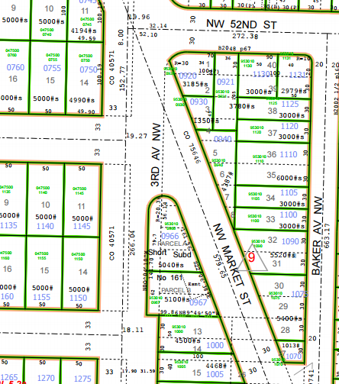

**History:** This property was obtained subject to council action in 1946 as result of the establishment and construction of NW Market Street

**Ordinances:**

12/23/1946, Ordinance 75646, AN ORDINANCE providing for the laying off, opening, widening, extending and

establishing of a public street, commonly known as the Ballard University Highway, from the intersection of 5th Avenue Northwest and West 55th Street, to the intersection of Greenwood avenue and North 46th Street; providing for the changing and establishing of the curb grades of said street and approaches thereto; providing for the condemnation, appropriation, taking and damaging of land and other property necessary therefor; and for the making of the necessary slopes for cuts and fills upon the property abutting upon said street and the approaches thereto; providing for the taking of land for General Municipal Purposes; and providing for the payment therefor.

1/17/1949, Ordinance 77696, AN ORDINANCE naming a portion of a new street North Market Street and another

portion, including a portion of West 55th Street, Market Street.

3/1/1951, Ordinance 79741, An ordinance setting aside certain City property in Block 9, Woodlawn Terrace

Addition for street purposes and designating said property as Market Street.

**Acquisition Deeds:**

1/26/1947, SC 381657, COUNTY SUPERIOR COURT VERDICT 381657

**Acquisition Fund Source:**  General fund

**Jurisdictional Department’s estimated market value:**

FAS determines value based upon the following factors:

* 1. Previous one year vacant property sales within 2 miles of the subject property
  2. Adjacent King County assessed land value on per square foot basis
  3. Either positive or negative factors for unique topography, property dimensions and shape
  4. Evaluation of potential added development capacity if combined with adjacent property.
  5. Perpetual easements or reservations for slope easements or native vegetation.

A review has been conducted as summarized below:

* 1. The value of separate vacant building lots ranges from between $27.50 and $80 per square foot.
  2. The average of the adjacent lots is valued by the King County Assessor at $46.45 per square foot
  3. The property contains slopes, is triangle shape, and is adjacent to a busy road with limited direct access.
  4. It is unknown if the property is buildable due the existing environmental restrictions.
  5. The property contains steep slopes and vegetation which may affect the ability to build on the property.

The 2015 value of this property is based upon a review of the above factors:

A value of $11.61 per square feet reflects a fair market value of the property due to the existence of steep slopes on the property.

**Destination of funds upon sale:** A portion to the Facility Services Sub-fund for expenses relating to sale of property, the remainder to general fund.

**Current easements, covenants and restrictions:**  none

**Recommended easements, covenants and restrictions upon Transfer:** Property is to be transferred including existing easements on title. The property is subject to existing zoning and critical area restrictions.

**Potential problems with property and possible measures to mitigate their recurrence:**

**Neighborhood:** Ballard

**Legal Descriptions:** South half lot 4 & all lots 5-9 block 9, all lying northeasterly of Market Street, Woodlawn Terrace add to the City of Seattle, Recorded in volume 12 page55, King County, Washington.

**Adjacent Property Owner:**  953010-0930

CANTRELL DANIEL L+LYNN PAS

Land value $5,000, $3.70 per sf

953010-0921

HINTON KEVIN L+MELISSA A

Land value: $243,000, $.64.00 per sf

953010-1120

JONES REBECCA ANN #1586

Land value: $252,000, $.84.00 per sf

953010-1110

BOILEAU JACK

Land value: $227,000, $37 per sf

953010-1105

LANE WENDY+D'MELLOW DEAN

Land value: $182,000, $60.00per sf

953010-1100

WINCHESTER SIMON

Land value: $252,000, $30 per sf