EXCESS PROPERTY DESCRIPTION

June 5, 2015

The Department of Finance and Administrative Services, as the Jurisdictional Department of this City owned property has identified the following information about this excess property.

**Property Name:** Parcel at 180 NW Market Street

|  |  |  |  |  |  |  |
| --- | --- | --- | --- | --- | --- | --- |
| PMA | Size | Parcel # | Address | Zoning | 2015 Value | Legal Description |
| 63 | 2,355 | 798640-0755 | 180 NW Market Street | Res/Single 5,000 | $21,595 | STEEL WORKS ADD TO SEATTLE POR E 1/2 LOT 8 & POR LOT 9, ALL LY NELY OF MARKET STREET |

**Map:** 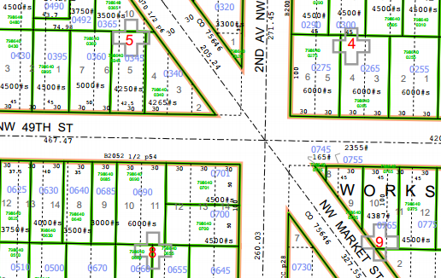

**History:** This property was obtained subject to council action in 1946 as result of the establishment and construction of NW Market Street.

**Ordinances:**

12/23/1946, Ordinance 75646, AN ORDINANCE providing for the laying off, opening, widening, extending and

establishing of a public street, commonly known as the Ballard University Highway, from the intersection of 5th Avenue Northwest and West 55th Street, to the intersection of Greenwood avenue and North 46th Street; providing for the changing and establishing of the curb grades of said street and approaches thereto; providing for the condemnation, appropriation, taking and damaging of land and other property necessary therefor; and for the making of the necessary slopes for cuts and fills upon the property abutting upon said street and the approaches thereto; providing for the taking of land for General Municipal Purposes; and providing for the payment therefor.

1/17/1949, Ordinance 77696, AN ORDINANCE naming a portion of a new street North Market Street and another

portion, including a portion of West 55th Street, Market Street.

**Acquisition Deeds:**

1/26/1947, SC 381657, COUNTY SUPERIOR COURT VERDICT 381657

**Acquisition Fund Source:** General Fund

**Jurisdictional Department’s estimated market value:**

FAS determines value based upon the following factors:

* 1. Previous one year vacant property sales within 2 miles of the subject property
  2. Adjacent King County assessed land value on per square foot basis
  3. Either positive or negative factors for unique topography, property dimensions and shape
  4. Evaluation of potential added development capacity if combined with adjacent property.
  5. Perpetual easements or reservations for slope easements or native vegetation.

A review has been conducted as summarized below:

* 1. The value of separate vacant building lots ranges from between $27.50 and $80 per square foot.
  2. The adjacent lot is valued by the King County Assessor at $36.69 per square foot.
  3. This property may not be large enough to build a separate house. The property contains slopes and is adjacent to a busy road.
  4. If combined with the either adjoining property, the lot may be developable.
  5. The property contains slopes and vegetation which affect the ability to development the property. .

The 2015 value of this property is based upon a review of the above factors:

A value of $9.17 per square feet reflects a fair market value of the property due to the existence of steep slopes.

**Destination of funds upon sale:** A portion to the Facility Services Sub-fund for expenses relating to sale of property, the remainder to general fund.

**Current easements, covenants and restrictions:**  Property is to be transferred including existing easements on title.

**Recommended easements, covenants and restrictions upon Transfer:**  Property is to be transferred including existing easements on title. The property is subject to existing zoning and critical area restrictions.

**Potential problems with property and possible measures to mitigate their recurrence:** Property is to be transferred including existing easements on title. The property is subject to existing zoning and critical area restrictions.

**Neighborhood:** Ballard

**`**

**Legal Description:**

Portion of lots 11-12, block 5, Steel Works Add to Seattle, as recorded in Volume 4, Page 2, lying NE of Market Street.

**Adjacent Property Owner:** 798640-0765

\ Robert Krause

125 NW 49th St

Seattle WA 98107

Land value $161,00 $36.69 per sq ft

798640 0745

King County Property Services

Lot size 165

No listed value