EXCESS PROPERTY DESCRIPTION

November 12, 2015

The Department of Finance and Administrative Services, as the Jurisdictional Department of this City owned property has identified the following information about this excess property.

**Property Name:** Parcels at 9701 Myers Way S

|  |  |  |  |  |  |  |
| --- | --- | --- | --- | --- | --- | --- |
| PMA | Building Size | Lot Size | Parcels | Address | Zoning | 2015 Est. Value |
| 4541 | Undeveloped lot | 458,384 square feet | 062304-9053  052304-9259 | 9701 Myers Way S | C2- 65 | $1- 2 million |

**Map:**

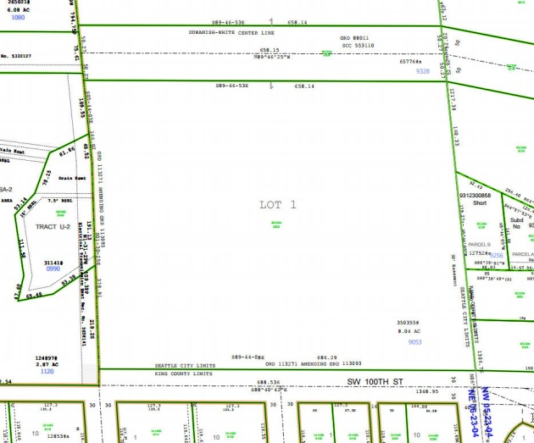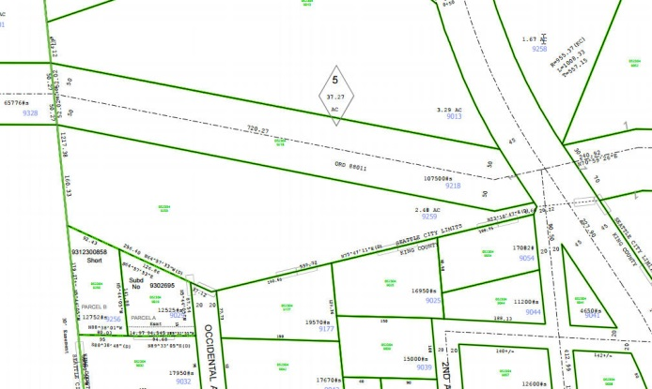

PMA 1656

**History:** The land known as the Myers Way Properties was purchased as part of a larger parcel in mid-2003 for development of the Joint Training Facility (JTF) at 9401 Myers Way South. In 2006, the Seattle City Council, by ordinance 122308, declared 31 acres of the properties surplus and authorized a sale. The sale transaction was not completed due to environmental and permitting issues. Additionally, the downturn in the local economy negatively affected prospects for a sale. Since this time, the Department of Finance and Administrative Services (FAS) staff have evaluated potential other municipal uses of the property, including a municipal jail, urban farming, support of seawall project, Seattle Public Utilities Drainage operations facility and a Seattle City Light training facility.

The portion of this property is identified as PMA 4541 has been identified by FAS for potential sale for use by economic development or to be held by the City for future uses and environmental buffers.

**Documents:**Detailed environmental studies and reports have been conducted, including a wetland delineation report by Raedeke and Associates and a site constraint map prepared by Goldsmith Engineering. Visit <https://opendata.socrata.com/Government/Myers-Way-Properties-Public-Information/v6bs-a4e8> for copies of these and other documents.

**Jurisdictional Department’s estimated market value:**

FAS has evaluated the value based upon a recent appraisal of the property.

**Destination of funds upon sale:**  A portion to the Facility Services Sub-fund for expenses relating to sale of property, a portion to repay an interfund loan on the property, and as designated by Council.

**Current easements, covenants and restrictions:**  3.

**Recommended easements, covenants and restrictions upon Transfer:**  Record upon sale of property storm drainage easements for existing drainage system located over parcel 062304-9053.

**Potential problems with property and possible measures to mitigate their recurrence:**

The southern border of parcel 062304-9053 abuts the King County public right of way of SW 100th street serving a single family zoned neighborhood. There is a steep slope separating the developable portion of the property and this right of way. On the northern border of the property lies Seattle City Light’s fee owned transmission right of way. Permission to use the right of way for access to the property will require City Light and Council approval. Both parcels contain steep slopes and some hillside

**Neighborhood:** West Seattle, Highland Park

**Legal Descriptions:**

|  |  |
| --- | --- |
| 0623049053 | POR OF NE 1/4 DAF - BEG AT NE COR OF SEC 6 TH N 88-23-50 W ALG N LN OF SD SEC 654.11 FT TH S 05-28-00 W 30.07 FT TH S 05-44-05 E ALG E LN THOF 648.73 FT TO TPOB TH CONT ALG E LN S 05-44-05 E 146.02 FT TH S 01-30-25 E ALG SD E LN 378.91 FT TO N MGN OF SW 100TH ST TH S 89-44-08 E ALG SD N MGN 686.29 FT TO E LN OF SD SEC 6 TH N 05-44-05 W ALG SD E LN OF SD SEC 527.36 FT TO TRNS LN R/W TH N 89-46-53 W ALG SLY LN 658.14 FT TO POB BEING LOT 1 OF SEATTLE LOT SEG #4326 DATED 02-19-03 |
| 0523049259 | POR LYING SLY OF TRAN LN R/W OF PAR DAF - BEG 495 FT S 06-50-52 E OF NW COR OF GL 5 TH N 70-29-08 E 498 FT TH N 46-29-08 E 125.86 FT TH N 88-15-15 E 244.56 FT TH S 62-56-00 E 195.81 FT TH S 22-04-00 W 496.69 FT TH S 74-40-24 W 537.72 FT TH N 66-04-40 W 256.4 FT TO W LN OF GL 5 TH N 06-50-52 W ALG W LN 329.5 FT TO BEG LESS CO RD LESS TRANS LN R/W LESS ST HWY |