EXCESS PROPERTY DESCRIPTION

September 11, 2015

The Department of Finance and Administrative Services, as the Jurisdictional Department of this City owned property has identified the following information about this excess property.

**Property Name:** Parcel at 10612 55th Ave South and Snippet at 1060855th Ave South

|  |  |  |  |  |  |  |
| --- | --- | --- | --- | --- | --- | --- |
| PMA | Building Size | Lot Size | Parcel # | Address | Zoning | 2015 Est. Value |
| 4522 | Undeveloped lot | 12,942 sf | 9368700111 | 10612 55th Ave South | SF 7200 | $65,000- $75,000 |

PMA 4522

**Map:** 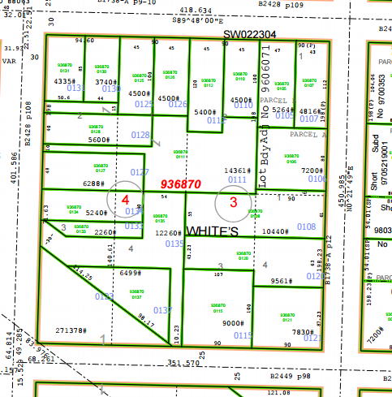

**History:** This property was acquired by the City through a local improvement assessment foreclosure as a result of a judgment in King County Court on December 22 1976. The property was acquired by the City of Seattle Treasury through a local improvement assessment deed dated May 15, 1979. For purposes of property management, the City of Seattle Department of Finance and Administrative Services created two property management area (PMA) to reflect that the deed and tax parcel consists two properties separate by other tax parcels

**Documents:**

7/14/1967, 95943, AN ORDINANCE providing for the improvement of South Spencer Street from Beacon Avenue South to 28th Avenue South; and certain other streets and avenues.

5/9/1972, SC 710272, King County Superior Court cause action SC 710272

**Acquisition Deeds:** 5/15/1979, 197912310591, Fee simple deed transfer, From Seattle City Treasure to Seattle Executive Services Department, Recording Number AF 197912310591.

**Acquisition Fund Source:**  General Fund.

**Jurisdictional Department’s estimated market value:**

FAS determines value based upon the following factors:

* 1. Previous one year vacant property sales within 2 miles of the subject property
  2. Adjacent King County assessed land value on per square foot basis
  3. Either positive or negative factors for unique topography, property dimensions and shape
  4. Evaluation of potential added development capacity if combined with adjacent property.
  5. Perpetual easements or reservations for slope easements or native vegetation.

A review has been conducted as summarized below:

* 1. The value of separate vacant building lots ranges from between $6.00 and $15 per square foot.
  2. The average of the adjacent lots is valued by the King County Assessor at $11.80 per square foot
  3. The property contains some slopes, trees, has limited access width that limits subdivision/
  4. It is unknown if the property is buildable due the existing environmental restrictions.
  5. The property contains steep slopes and vegetation which may affect the ability to build on the property.

The 2015 value PMA 4522 is based upon a review of the above factors:

A value of $11.80 per square feet indicates a value of a property that includes improvements. Limited access may only allow for the construction of one house on the property. The value range of the property is $65,000- $70,000

**Destination of funds upon sale:**  A portion to the Facility Services Sub-fund for expenses relating to sale of property, the remainder to general fund.

**Current easements, covenants and restrictions:**  None of record

**Recommended easements, covenants and restrictions upon Transfer:**  None

**Potential problems with property and possible measures to mitigate their recurrence:** Existing trees on the site may reduce location of foot print. The location of utilities serving the property is unknown. The access has been used by the adjacent property owner for multiple years, and an easement may be negotiated for continued shared access.

**Neighborhood:** Rainier Beach and Skyway

Parcel PMA 4522

Lot 2 of block 3, less east 45 of North 100 feet, less west 45 of North 120 feet;

together with, Lot 1 of block 4, less East 45 feet of north 100 feet, less west 45 feet of north 140 feet, less south 48 of west 36th feet together with Lot 2 of block 4, less North 140 feet, less south 48 feet, all located in

White’s Rainer Beach Gardens Addition, volume 13 page 38 of plats recorded in King County Washington

**Adjacent Property Owners:**

9368700126 9368700106

Edmon, Elisha E. Tran Truong Nhat

5515 S. Bangor St. 10617 56th Ave S.

Seattle, WA 98178 Seattle, WA 98178

Land value: $71,000, $12.60 per sf Land value: $78,000, $10.83 per sf

9368700112 9368700108

Cormier, Donald J. Nguyen, Hoa

5519 S. Bangor St. 10621 56th Ave S.

Seattle, WA 98178 Seattle, WA 98178

Land value: $66,000, $12.22 per sf Land Value: $88,000, $8.49 per sf

9368700110 9368700127

Winstead, Raymond H. Jr. + Makeb Bushnell, Roger G.

5521 S. Bangor St. 10616 55th Ave S.

Seattle, WA 98178 Seattle, WA 98178

Land Value: 64,000, $14.50 per sf Land Value: $74,000, $11.76 per sf

9368700135 9368700128

Pratt, Mitchell-Roberta Murray, Jacqueline

5516 S. Hazel St. 10610 55th Ave S.

Seattle, WA 98178 Seattle, WA 98178

Land value: $89,000, $7.26 per sf. Land value $71,000, $12.6 per sf

936870 0131 9368700130

Morningstar, Sarah Emerald Real Estate Solution

5503 S Bangor St 5507 S Bangor St

Seattle, WA 98178 Seattle, WA 98178

Land value: $56,000, $12.93 per sf Land value: $ 67,000, $14.50 per sf