EXCESS PROPERTY DESCRIPTION

December 4, 2015

The Department of Finance and Administrative Services, as the Jurisdictional Department of this City owned property has identified the following information about this excess property.

**Property Name:**  Snippet at 1704 Alki Ave SW

|  |  |  |  |  |  |
| --- | --- | --- | --- | --- | --- |
| PMA | PMA Size | Parcel # | Address | Zoning | 2016 Est. Value |
| 4502 | 122 sf | Portion of 927920-1410 | SE of 1704 Alki Ave SW, 98116  [47.588004, -122.395308](http://www.latlong.net/c/?lat=47.588004&long=-122.395308) | SF 7200 | $610 $1,220 |

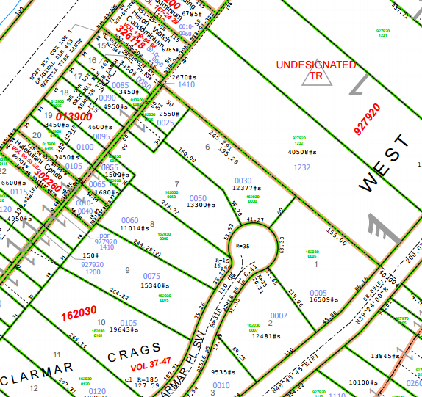

PMA 4502

**Map:**

**History:** The City of Seattle acquired the property in 1960 from King County for unpaid taxes. The City has envisioned in the City comprehensive plan the establishment of green belts of which is adjacent to this parcel. The City has passed regulations regarding the maintenance and development of property located on steep hillsides. In 2008 the property as a part of a larger tax lot was formally evaluated for potential disposition in accordance with City of Seattle Resolution 29799 and as amended by 30862.

**Ordinances:**

7/14/1959, 88399, An Ordinance authorizing the City Treasurer to acquire certain tax title property under RCW Chap. 35.49, and to discharge the trust thereon; and also addition such property by negotiation with King County or at public auction for general municipal purpose to establish certain “greenbelt” areas contemplated by the Comprehensive Plan of the City; and making a reimbursable appropriation from the Emergency fund in connection therewith.

2/2/1960, [46473](http://clerk.seattle.gov/~scripts/nph-brs.exe?s3=&s4=46473&s5=&s1=&s2=&S6=&Sect4=AND&l=0&Sect2=THESON&Sect3=PLURON&Sect5=CBORY&Sect6=HITOFF&d=ORDF&p=1&u=%2F%7Epublic%2Fcbor1.htm&r=1&f=G), An ordinance relating to property bid in by the City for delinquent local assessments, establishing a special fund to facilitate the handling thereof to be known as "Tax Property Sales Fund", appropriating thereto the sum of Fifty Thousand ($50,000) Dollars from the General Fund as a temporary loan, and providing for the repayment thereof.

10/7/1981, [110170](http://clerk.seattle.gov/~archives/Ordinances/Ord_110170.pdf) AN ORDINANCE relating to the Tax Property Sales Fund, as created by Ordinance 46473, eliminating the Fund, and transferring all remaining balances to the General Fund and Guaranty Fund.

(Related City of Seattle Property Sale) 12/22/1995, [117973](http://clerk.seattle.gov/~scripts/nph-brs.exe?s1=117973&Sect4=AND&l=MAX&Sect1=IMAGE&Sect2=THESON&Sect3=PLURON&Sect5=LEGI2&Sect6=HITOFF&d=LEGA&p=1&u=http%3A%2F%2Fclerk.seattle.gov%2F~public%2Flegisearch.htm&r=2&f=G), AN ORDINANCE declaring that certain City (Department of Administrative Services) real property, commonly known as a portion of 1798 Alki Avenue Southwest, is surplus to the City's needs, and authorizing the sale of that portion of said real property to the abutting property owner.

**Acquisition Deeds:** 2/3/1960, 5127857, AF 5127857, RECORDING TREASURER'S DEED 37665.

**Acquisition Fund Source:**  General Fund.

**Jurisdictional Department’s estimated market value:**

FAS determines value based upon the following factors:

* 1. Previous one year vacant property sales within 2 miles of the subject property
  2. Adjacent King County assessed land value on per square foot basis
  3. Either positive or negative factors for unique topography, property dimensions and shape
  4. Evaluation of potential added development capacity if combined with adjacent property.
  5. Perpetual easements or reservations for slope easements or native vegetation.

A review has been conducted as summarized below:

* 1. The value of separate vacant building lots ranges from between $2 and $70 per square foot.
  2. The average of the adjacent lots is valued by the King County Assessor at $90.00 per square foot
  3. The property is land locked with no recorded acess.
  4. The property is not developable due to property small size.
  5. The property is adjacent to steep slopes and is located in a steep slope buffer area.

The 2016 value of PMA is based upon an evaluation of the property. As the zoning of one of the adjacent parcels of land is LR3, has access to a city Street, and views and the zoning of the other adjacent parcel is SF 7200, has no access to a city street, and is subject to a steep slope buffer. The value of PMA is not derived by an average of the adjacent parcels, but reflects the value associated with the adjoining parcel. The value range for PMA 4502 is $5 to $10 a square feet.

**Destination of funds upon sale:**  Upon the sale of the property, a portion to the Facility Services Sub-fund for expenses relating to sale of property, and the remainder will be deposited into the general fund.

**Current easements, covenants and restrictions:**  There is no recorded access to the property.

**Recommended easements, covenants and restrictions upon Transfer:**  A sale of PMA 4502 will require a King County tax parcel segregation, and may require a lot line adjustment to allow for the reconfiguration of the property lines.

**Potential problems with property and possible measures to mitigate their recurrence:** There is no access from the City street to this property. Sale of the property to an adjacent property owner with access will resolve this issue.

**Neighborhood:** West Seattle

**Draft Legal Description:** **(to be verified by surveyor prior to authorization for property sale)**

A strip of land, approximately 5 feet in width, which lies between

the northwesterly line of Clarmar Crags, as recorded in Vol. 37 of Plats, page 47, records of King County, Washington, and the southeasterly line of Alki Beach, an unrecorded plat; (being a portion of the undivided tract of West Seattle Park Addition, as recorded in Vol. 3 of Plats, page 177, records of King County, Washington, described as follows:

Beginning on the Southeasterly corner of tract 15 of West Park Addition and proceeding approximately five feet S 51° 55’00” E to the northerly line of lot 6 of Clarmar Crags, thence along said northerly line N 38°05’00” E approximately 21 feet to the NE corner of lot 6 of Clarmar Crags, thence northwesterly along the extension of the northeasterly line of Lot 6 Clarmar Crags approximately 5feet to the north east corner of tract 15, thence along the southeasterly line of tract 15 approximately 21 feet to the point of beginning.

**Adjacent Property Owners:**

013900-0080

Steven Quant

1704 Alki Ave SW

Seattle, WA

Land value $619,000, $179.60 per sf

162030 0025

Gregory Brackett

17473 SE Cougar Mountain Dr.

Bellevue, WA 98006

[greg@bellevuenissan.com](mailto:greg@bellevuenissan.com)

425-269-3559

Land value: $5,000, $1.96 per sf