**Excess Property Notice**

**June 5, 2015**

TO: City of Seattle Departments and Other Public Agencies

FROM: Daniel Bretzke, Department of Finance and Administrative Services (FAS)

SUBJECT: Excess Property

The Department of Finance and Administrative Services (FAS) has declared the property which is known as PMA 4331 located at 102 Martin Luther King Jr. Way South, excess to the needs of the Department. FAS’s initial recommendation is that the property is sold through a competitive sale.

In accordance with City of Seattle property disposition policies, this notice informs other City Departments and public agencies of its availability.

FAS manages the evaluation process for the reuse or disposal of City property. This is in accordance with City Council policies adopted under Resolution 29799 and amended by Resolution 30862.

*All departments and agencies are requested to return the* ***Excess Property Response Form****. In particular, please identify if your department has existing facilities, utilities, or property rights that affect the property. Please complete the* ***Excess Property Proposed Use Form*** *if your Department or agency is interested in acquiring the property for:*

|  |  |
| --- | --- |
| * Short term use (less than six months) | * Potential City uses |
| * Permanent easements or covenants that will run with the land | * Other public agency use |

For questions regarding the City's excess property disposition process please contact Daniel Bretzke at 206-733-9882 or at [daniel.bretzke@seattle.gov](mailto:daniel.bretzke@seattle.gov) **Please provide your comments and completed forms by July 6, 2015** to the following:

Inter office mail

Daniel Bretzke

Mail Stop SMT -52-01

US Mail

Daniel Bretzke

City of Seattle - FAS

P.O. Box 94689

Seattle, Washington, 98124-4689

Daniel Bretzke

Daniel.bretzke@seattle.gov

EXCESS PROPERTY DESCRIPTION

June 5, 2015

The Department of Finance and Administrative Services, as the Jurisdictional Department of this City owned property has identified the following information about this excess property.

**Property Name:** Parcel at 102 Martin Luther King Jr. Way South

|  |  |  |  |  |  |  |
| --- | --- | --- | --- | --- | --- | --- |
| PMA | Size | Parcel # | Address | Zoning | 2015 value | Legal Description |
| 4331 | 2,947 | 0007600207 | 102 MLK Jr. Way S | LR2 | $67,781 | Yesler H L-D C # 42 & 47 Portion of tract 11 lying Easterly of MLK JR Way S, less east 60 feet thereof |

**Map:** 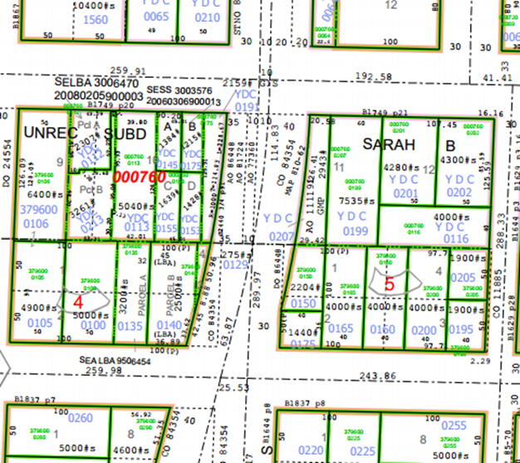

**History:** This property was acquired by the City to be used for the establishment and extension of Temple Place, which was renamed as Empire Way, and then renamed to Martin Luther King Jr. Way South. The property was acquired under condemnation. A portion of the property was accepted for street purposes. This parcel is the second portion of the original parcel, and was identified in 1955 to be used for general municipal purposes. This property is adjacent to a lot with improved with a multifamily residence.

7/7/1949, ORD [78109,](http://clerk.seattle.gov/~archives/Ordinances/Ord_78109.pdf)  An ordinance providing for the laying off, opening, widening, extending and establishing of 27th Avenue South between Bayview Street and Jackson Street; of Temple Place South between Jackson Street and Yesler Way; of Temple Place between East Jefferson Street and East Cherry Street; of 28th Avenue North from East Harrison Street to East Roy Street; providing for the establishing of the curb grades of Empire Way from McClellan Street to College Street; and of the aforesaid Avenues, Place and approaches thereto; providing for the condemnation, appropriation, taking and damaging of land and other property necessary therefor and for the making of the necessary slopes for cuts and fills upon the property abutting on said streets and approaches thereto; providing for the condemnation, appropriation and taking of land and other property in fee simple for general municipal purposes; and providing that the entire cost of such improvement shall be paid from the City Street Fund, except as herein otherwise provided.

7/7/1949, ORD 78110, An ordinance relating to the acquisition of right of way for 26th Avenue South and other streets and avenues, as contemplated by Ordinance No. 60444; repealing said Ordinance; providing for the dismissal of Eminent Domain proceedings, and for payment of costs appertaining thereto; abandoning any unexpended balances of rights of way appropriations made by Ordinances numbered 69512, 69608, 70292, 71026, 71294 and 74886, and ratifying and confirming all actions taken, pursuant to said ordinances.

3/4/1957, ORD 85958, An ordinance relating to the acquisition of property by condemnation for the widening of Empire Way and Empire Way South as contemplated by Ordinance No. 84354; and amending Section 1 of Ordinance No. 84463, by increasing the appropriation therein provided.

7/5/1983, ORD 111191, An ordinance accepting a deed over a portion of Sarah B. Yesler's Donation Claim in Township 24 North, Range 5 East W.M. for general municipal purposes (Sarah B. Yesler Tract II).

**Acquisition Deeds:** Madeline J. Gates on May 22, 1957, conveying to the City of Seattle , KC Recording no 4896340; R/W 8312

**Acquisition Fund Source:**  Street Fund

**Jurisdictional Department’s estimated market value:** FAS determines value based upon the following factors:

* 1. Previous one year vacant property sales within 2 miles of the subject property
  2. Adjacent King County land value on per square foot basis
  3. Either positive or negative factors for unique topography, property dimensions and shape
  4. Evaluation of potential added development capacity if combined with adjacent property.
  5. Perpetual reservations for slope easements or native growth

A review has been conducted as summarized below:

* 1. The value of separate vacant building lots ranges from between $10 and $60 per square foot.
  2. The adjacent lot is valued by the King County Assessor at $47 per square foot.
  3. This property is not large enough to build a separate structure.
  4. The property is adjacent to a busy road with limited direct access.

The 2015 value of this property is based upon a review of the above factors:

A value of $23 per square feet would reflect a fair market value of the property.

**Destination of funds upon sale:** A portion to the Facility Services Sub-fund for expenses relating to sale of property, the remainder to general fund

**Current easements, covenants and restrictions:** None

**Recommended easements, covenants and restrictions upon Transfer:**

**Potential problems with property and possible measures to mitigate their recurrence:**

The property may not be large enough to be developable without combining with the adjacent property.

**Neighborhood:** Central

**Legal Description:**

Beginning on the south line of Sarah B. Yesler’s Donation Claim, in Township 24 North, Range 5 East W.M. at a point which is 25 feet east of the center line of Temple Place, formerly Temple Street, as shown on the plat of Kaufman’s Addition to the City of Seattle, according to the plat thereof recorded in Volume 1 of Plats, Page 221 records of King County, Washington:

Thence east along said south line 45 Feet;

Thence at right angles north to an intersection with the south line of Yesler Way;

Thence west along said south line 45 feet;

Thence south to the point of beginning;

(being known as the east 45 feet of the west 70 feet of tract 2, Sarah B. Yesler Tracts, according to the unrecorded plat thereof as shown on map in the Estate of Sarah B Yesler, deceased, King County Probate Case No. 628;

Except that portion lying within Yesler Way.)

(K.C. Recording No. 4896340; R/W 8312)

Adjacent Property Owner: 0007600199

Michael Marqucio

2755 E. Yesler Way

Seattle, WA 98122

Land Value 2013: $353,000, $47.00 per sf

**CITY OF SEATTLE**

**EXCESS PROPERTY RESPONSE FORM**

**PMA 63**

|  |
| --- |
| * **Seattle Public Utilities** * **Seattle Department of Transportation** * **Seattle Office of Housing** * **Seattle City Light** * **Seattle Parks and Recreation** * **Seattle Department of Neighborhoods** * **Seattle Department of Planning and Development** * **Seattle Office of Economic Development** * _____________________________________   _________ We have no interest in this property.  _________ We are interested in acquiring the property or jurisdiction over it. A completed ***Excess Property Proposed Use Form*** is attached to this response.  _________ We have facilities on the property or access rights through or across the property as described below (add additional sheets as necessary):  _________ We need facilities on the property or access rights through or across the property as described below (add additional sheets as necessary):  _________ We have identified the following plans, policies, objectives, limitations or other factors as found in adopted or proposed City plans and policies that may affect the Reuse or Disposition of the property (add additional sheets as necessary): |
| **___________________________ _______________________ ______________**  **Reviewer Department Date** |
|  |
| **EXCESS PROPERTY PROPOSED USE FORM** | |
| _______________________________________ (department/agency ) wants to acquire property rights over all or a portion of:  PMA 1583 | |
| **PROPOSED USE:** Describe the proposed use for the property, including information on potential improvements, users, tenure, impact on neighborhood such as parking, traffic volumes. (Attach additional pages as necessary). | |
| **EST. IMPLEMENTATION DATE:** _________ **EST. COST** : _________________  **EXPECTED TERM OF USE**: ______________ **FUND SOURCE(S)**: _____________________  Are funds appropriated? € YES € NO If no, when will funds be appropriated? ________ | |
| **BENEFITS TO THE CITY OF SEATTLE FROM THIS PROPOSAL:** | |
| **SUPPORTING POLICIES**. List the adopted plans and policies (itemize specific sections in major documents) which support, or are implemented by, this proposed use. | |
| **CONTACT PERSON:_____________________________** **PHONE:___________________**  ________________________________________________ **Date** : ___________________  **Director or designee** | |