EXCESS PROPERTY DESCRIPTION

July 1, 2015

The Department of Finance and Administrative Services, as the Jurisdictional Department of this City owned property has identified the following information about this excess property.

**Property Name:** Parcel at 2265 Harbor Ave SW

|  |  |  |  |  |  |  |  |
| --- | --- | --- | --- | --- | --- | --- | --- |
| PMA | Lot Size | Year Purchased/Built | Parcel # | Address | Zoning | Value | Legal Description |
| 4217 | 19,900 (KC) |  | 6911200225 | 2765 Harbor Ave SW 98126 | GBIBU/8 (Industrial),  Industrial Buffer U/85 SF 7200 | $99,500 | Portion of Lot C of Prospect tracts westerly of Harbor Ave SW, less the south 150 feet. |

**Map: b**

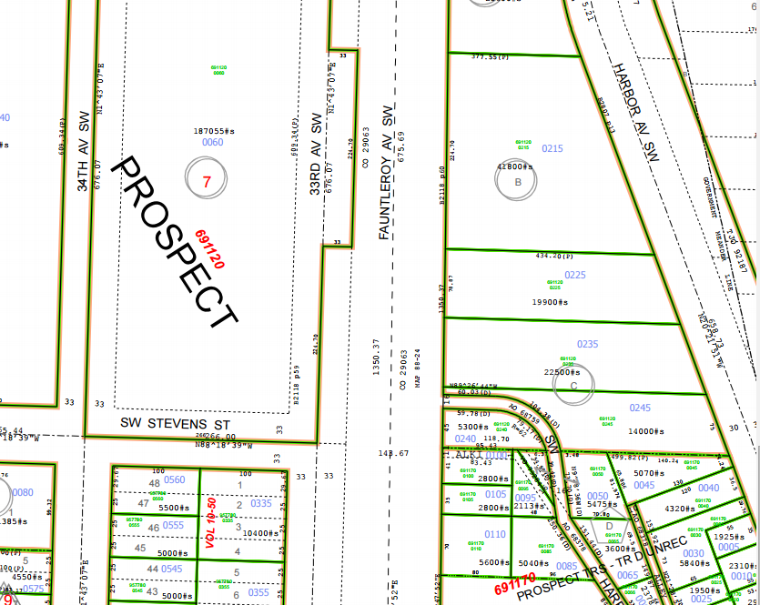

**History:** Acquired for general municipal purposes to be used for greenbelt areas as part of the comprehensive Plan of the city beginning with the property upon which are delinquent general taxes and also unpaid local improvement district assessments. Property is located between Fauntleroy Ave SW and Harbor Ave SW, immediately North of 2783 Harbor Ave SW. Acquired by King County Treasurer’s Deed, recording number 5069648, recorded on August 18, 1959, as authorized by Ordinance number 88399.

**Documents:**

3/12/1912, 29062, AN ORDINANCE providing for the laying off, extending and establishing of a public street and highway from Arizona Avenue and West Spokane Street to Thirty-seventh Avenue Southwest and West Waite Street, and other streets: providing for the condemnation, appropriating, taking and damaging of land and other property necessary therefor; providing for the changing and establishing of curb grades, providing for the condemnation, etc. of land and other property for grading, etc. and for payment to be made by special assessment against property.

4/16/1915, 34630, AN ORDINANCE vacating a portion of Spokane Street on the petition of G.M Taggart.

11/7/1938, 68759, AN ORDINANCE accepting deeds from Barney Brush, Inc., and other for street purposes, and laying off streets over the dedicated lands.

5/21/1957, 86184, AN ORDINANCE accepting a deed from H.A. Winquist and wife, to a portion of Government Lot 5, Section 13, Township 24 North, Range 3 East, W.M., and other properties for street purposes.

7/14/1959, 88399, AN ORDINANCE authorizing the City Treasurer to acquired certain tax title property under RCW Chap. 35.49, and to discharge the trust thereon; and also addition such property by negotiation with King County or at public auction for general municipal purposes to establish certain “greenbelt” areas contemplated by the Comprehensive Plan of the City; and making a reimbursable appropriation from the Emergency Fund in connection therewith.

**Acquisition Deeds:** Deed 5069648 - Acquired by King County Treasurer’s Deed, recording number 5069648, recorded August 18, 1959, as authorized by Ordinance number 88399.

**Acquisition Fund Source:** Emergency Fund

**Jurisdictional Department’s estimated market value:**  $99,500.00

**Destination of funds upon sale:** A portion to the Facility Services Sub-fund for expenses relating to the sale of property, and the remainder will go into the Emergency Fund.

**Current easements, covenants and restrictions:**  Steep slopes

**Recommended easements, covenants and restrictions upon Transfer:**  None

**Potential problems with property and possible measures to mitigate their recurrence:** None

**Neighborhood: Southwest**

**Legal Description:**

Tract C of Prospect Tracts, according to the plat thereof, recorded in Volume 10 of Plats, page 13, in King County, Washington, lying west of the westerly margin of Harbor Avenue Southwest and east of the easterly margin of Fauntleroy Avenue as condemned in King County Superior Court Cause Number 93059, under Ordinance No. 29063 of The City of Seattle; EXCEPT the south 150 feet as measured at right angles to the south line thereof.

**Adjacent Property Owners:**

**Parcel# 691120-0235**

**East Peak LLC**

**2775 Harbor Ave SW**

**Seattle, WA 98126**