***Final Recommendation Report***

***On Reuse and Disposal of the***

**Seattle Department of Transportation Mercer Corridor Excess Property**

**PMA 4193, 900 Broad Street**

**and the**

**Report on the Public Involvement Plan**

**June 1, 2016**

**Final Report**

The Final Recommendation report updates information that was included in the “Preliminary Recommendation Report on the Reuse and Disposal of Excess Property” that was published on September 8, 2014.

**Purpose of Preliminary Report**

In response to a City of Seattle Jurisdictional Department identifying a property as “Excess” to their needs, the Real Estate Services (RES) section of the Department of Finance and Administrative Services (FAS) initiates a process to review and evaluate various options for the property. RES prepares a report titled “Preliminary Recommendation Report on the Reuse and Disposal of Excess Property”, which documents the Departments’ analysis and recommendations. This report is prepared in accordance with City of Seattle Council Resolution [29799](http://clerk.seattle.gov/~scripts/nph-brs.exe?s1=&s3=29799&s2=&s4=&Sect4=AND&l=20&Sect2=THESON&Sect3=PLURON&Sect5=RESNY&Sect6=HITOFF&d=RESF&p=1&u=%2F%7Epublic%2Fresny.htm&r=1&f=G), as modified by Resolution [30862](http://clerk.seattle.gov/~scripts/nph-brs.exe?s1=&s3=30862&s2=&s4=&Sect4=AND&l=20&Sect2=THESON&Sect3=PLURON&Sect5=RESNY&Sect6=HITOFF&d=RESF&p=1&u=%2F%7Epublic%2Fresny.htm&r=1&f=G).

**Executive Recommendation**

FAS recommends that the property be sold at fair market value through an open and competitive sales process.

**Background Information**

The property is under the jurisdiction of the Seattle Department of Transportation (SDOT). This property is located at 900 Broad Street, which is at the southern portion of a block bounded by 9th Avenue, Broad Street, and Westlake Avenue North. (See Appendix A for a detailed property description) The property was acquired in 1971 to be used as a part of the proposed Bay Freeway Project, which was never built. The Mercer Corridor Project identified a small corner of this property for street improvements. The adjoining street improvements have been completed. The property is currently leased to the adjacent property owner.

**Reuse or Disposal Options Evaluation Guidelines**

City of Seattle Resolution 29799, Section 1, requires the Executive to make its recommendation for the reuse or disposal of any property that is not needed by a Department using the following guidelines.

# Guideline A: Consistency

*The analysis should consider the purpose for which the property was originally acquired, funding sources used to acquire the property, terms and conditions of original acquisition, the title or deed conveying the property, or any other contract or instrument by which the City is bound or to which the property is subject, and City, state or federal ordinances, statues and regulations.*

***Funding Sources:*** The property was purchased with monies from the Arterial Street Fund.

***Purpose for which property was acquired:*** The property was purchased in order to establish the Bay Freeway, and subsequently for Mercer Corridor improvements.

***Deed or contractual restrictions:*** The property is not bound by any other contracts or instruments and is not subject to any extraordinary laws or regulations.

***City, State or Federal Ordinance status and regulations including, Bond, grant or loan programs, State Accountancy Act, Payment of True and full value, Zoning and land use, Comprehensive Plan, and Other plans:***

State Law requires government organizations to receive fair market value for the disposal of surplus real property. The fair market value can be determined by an appraisal, or through an open competitive sales process. The City of Seattle incurs costs associated with the disposition process including staff time, public notice expenses and real estate transactions costs. FAS will be reimbursed for expenses incurred in the sale of the property.

The property is located in the South Lake Union neighborhood and is subject to zoning incentives and restrictions.

The property is currently zoned SM-85.

# Guideline B: Compatibility and Suitability

*The recommendation should reflect an assessment of the potential for use of the property in support of adopted Neighborhood Plans; as or in support of low-income housing and/or affordable housing; in support of economic development; for park or open space; in support of Sound Transit Link Light Rail station area development; as or in support of child care facilities; and in support of other priorities reflected in adopted City policies.*

***Neighborhood Plan:*** The property is located in the [South Lake Union Urban Center.](http://www.seattle.gov/DPD/cs/groups/pan/@pan/documents/web_informational/dpdp025941.pdf)  The Seattle City council adopted legislation in 2013 that increased the development capacity of the neighborhood.

***Housing and Economic Development:*** The sale of the property to a private owner will return the property to the active tax rolls. Subsequent development of the property will increase economic activity in the City. Due to the size and shape of the property, it is not economically feasible to redevelop the property to fullest extent allowed by zoning.

***Nearby City owned property:*** The property is near the South Lake Union Park. The City also purchased other nearby parcels for the Mercer Corridor Transportation Project. It is near an excess Seattle City Light property at 8th and Roy Street. None of the City-owned properties are contiguous with this parcel. These other City-owned excess properties are subject to the City’s disposition policies and will be addressed separately in other preliminary reports. A map showing nearby City properties is included in the attached Excess Property Description.

***Other City Uses***: In March 2014, an Excess Property Notice for this property was circulated to City of Seattle Departments. City Departments were asked to evaluate the property for current or potential future city uses. FAS/RES received Excess Property Response Forms indicating no interest from the following departments or public agencies: Seattle Public Library, Seattle City Light, Seattle Department of Planning and Development, and the Seattle Dept. of Parks and Recreation. The Human Services Department (HSD) expressed interest in the property for potential use as a day care. HSD evaluated the possibility with potential day care providers and determined that its location and size of the property was not suitable for a day care.

The Office of Housing conducted a review of the property and has determined that it is not suitable for housing.

***Other Agencies Uses*:** An Excess Property Notice for this property was circulated in March 2014 to assess other agencies interest. No other non-city agency expressed interest in the property.

***Range of Options***

The “Guiding principles for the Reuse and Disposal of Real Property” state, “it is the intent of the City to strategically utilize real property in order to further the City’s goals and to avoid holding properties without an adopted municipal purpose.” The options for disposition of this property include retention by the City for a public purpose, negotiated sale with a motivated purchaser, market sale, or through a request for proposal process.

***Transfer of Jurisdiction to other City Department:*** No other City Department expressed a current or future need for the property.

***Negotiated Sale*:** A negotiated sale is typically recommended when the selection of a particular purchaser has specific benefits to the City.

The adjacent property owner has expressed interest in purchasing the property. A negotiated sale to the adjacent property owner may allow this property to be redeveloped to the maximum height with structured underground parking, offices, and ground floor retail. The adjacent property owner currently leases the property for use by the existing tenants in the adjacent building.

***Sale through an open competitive process:*** A sale through a public competitive process would allow the market to determine the optimum price for the property in its current size and configuration.

***Request for Proposal Process:*** This process is used when specific development goals are desired. The City does not have a development plan for this property.

***Guideline C: Other Factors***

*The recommendation should consider the highest and best use of the property, compatibility of the proposed use with the physical characteristics of the property and with surrounding uses, timing and term of the proposed use, appropriateness of the consideration to be received, unique attributes that make the property hard to replace, potential for consolidation with adjacent public property to accomplish future goals and objectives, conditions in the real estate market, and known environmental factors that may affect the value of the property.*

***Highest and Best Use*:** The Highest and Best Use is generally defined as the reasonably probable and legal use that produces the highest property value. The highest and best use is determined by evaluating potential uses as follows:

* ***Legally permissible****:* The subject property is zoned SM-85 which allows a wider range of mixed commercial spaces with incentives for residential uses.
  + ***Physically possible****:* The property includes an existing structure that is used for parking. An analysis of the zoning and development regulations as applied to the parcel as a separate lot shows that the site could not be developed to the maximum allowed by zoning.
* ***Financially feasible and maximally productive:***The property as it exists could continue to provide parking for the adjacent businesses. The property could also be developed for a standalone business. The property could also be a part of a larger development that could achieve the maximum height and density that is allowed under the current zoning.

The highest and best of the property is redevelopment with the adjoining property for commercial uses and possible mixed uses as allowed under the current zoning.

***Compatibility with the physical characteristics and surrounding uses*:** The continued use of the property for parking would be consistent with the adjacent uses. Construction of a mixed-use development project on this parcel would also be compatible with the surrounding uses in South Lake Union.

***Appropriateness of the consideration:*** Sale of the property at fair market value through a negotiated sale or competitive sale process will result in the City receiving the fair market value of the property.

***Unique Attributes*:**  The property contains an existing building.

***Potential for Consolidation with adjacent public property*:** There are no public properties that lie adjacent to this property. A map showing neighborhood City properties is attached to the Excess Property Description.

***Conditions in the real estate market*:** The real estate market in the City of Seattle remains fairly stable, and the South Lake Union area has a great demand for new development.

***Known environmental factors:*** Excerpts from the *Hazardous Materials Discipline Report* completed for the City’s Mercer Corridor Improvements Project in 2006 and a *Transaction Screening Report* completed for the property in 2008 are included in Appendix E. However, SDOT does not have any record of soil or groundwater samples taken from the property. SDOT would allow prospective buyers time to conduct due diligence reviews.

***Guideline D: Sale***

*The recommendation should evaluate the potential for selling the property to non-City public entities and to members of the general public.*

***Potential for Use by Non-City Public Entities:*** No non-City public entities’ use has been identified.

***Public Involvement:*** In accordance with Resolution Nos. 29799 and 30862, in November 2013, a notice concerning disposition or other use of this property was sent to all businesses, residents and property owners within a 1,000 foot radius of the subject property. A total of 708 notices were mailed. Three responses regarding this property were received.

One response was from the adjacent property owner who is interested in purchasing the property.

One response was received from the adjacent property owner’s broker.

One response was from an investor who is interested in purchasing the property.

***Threshold Determination***

*The Disposition Procedures require FAS assess the complexity of the issues on each excess property following the initial round of public involvement. The purpose of this analysis is to structure the extent of additional public input that should be obtained prior to forwarding a recommendation to the City Council.*

The Disposition Procedures require that FAS assess the complexity of the issues on each excess property following the initial round of public involvement. The purpose of this analysis is to structure the extent of additional public input that should be obtained prior to forwarding a recommendation to the City Council. Appendix B is the Property Review Process Determination Form prepared for PMA 4193, Parcel at 900 Broad Street. Due to the estimated value of the property at over $1,000,000 and the recommendation to sell, the disposition of this property is determined to be a “Complex” transaction.

***Public Involvement Plan:***

For projects that have been determined to be a Complex transaction, RES develops a Public Involvement Plan (PIP) that is included with the Preliminary Report. The PIP is to be tailored to the characteristics of each specific excess property and those issues which have been raised during the circulation and notification phase. FAS prepares the Preliminary Report and PIP, with input from SDOT, the department with jurisdictional control over the excess property. This PIP is completed before legislation for real estate disposition is approved by the City Council.

A PIP for this property has been attached as Appendix C.

***Next Steps***

The Preliminary Report and the Public Involvement Plan are published on the RES website and sent to the parties of record as listed in Appendix D.

The City of Seattle Real Estate Oversight Committee, (REOC) reviews the recommendation in the Preliminary Report.

FAS will finalize the Preliminary Report and the Report on the Public Involvement Process. Both the Final Report and the Report on the Public Involvement Process are included with the legislation necessary to implement the final recommendation for the excess property.

**Appendix A**

**EXCESS PROPERTY DESCRIPTION**

**Mercer Corridor Excess Property**

**PMA 4193**

EXCESS PROPERTY DESCRIPTION

Parcel at 900 Broad Street

The Seattle Department of Transportation (SDOT), as the Jurisdictional Department of this City owned property has identified the following information about this excess property.

**Property Name:** 900 Broad Street

|  |  |  |  |  |  |  |
| --- | --- | --- | --- | --- | --- | --- |
| PMA | Parcel Size | Parcel # | Address | Zoning | 2014 Est Value* | Legal Description |
| 4193 | 7,711* | 408880-3495 | 900 Broad Street  Seattle, WA 98109 | SM 85 | $1,100,000 - $1,800,000 | Lot 1, Block 81, Lake Union Shore Lands, less portion designated for street per Ordinance 123336 |

*KC records

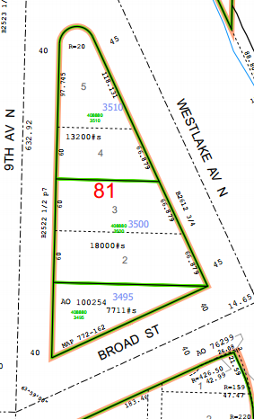

ROW portion

`

**Map:**

**History:** In 1971 the property was purchased as a part of the future Bay Freeway Project. The property has been held by the City pending the final design of the Mercer Corridor Project, which is scheduled to be completed in the near future. The property has now been determined to be excess to the City’s needs.

**Ordinances:**

Ord. [99377](http://clerk.seattle.gov/~scripts/nph-brs.exe?s3=&s4=99377&s5=&s1=&s2=&S6=&Sect4=AND&l=0&Sect2=THESON&Sect3=PLURON&Sect5=CBORY&Sect6=HITOFF&d=ORDF&p=1&u=%2F%7Epublic%2Fcbor1.htm&r=1&f=G), Recording 197104230427, Right of Way and Limited Access Plans for the Bay Freeway, Findings of the City Council.

Ord. [99545](http://clerk.seattle.gov/~scripts/nph-brs.exe?s3=&s4=99545&s5=&s1=&s2=&S6=&Sect4=AND&l=0&Sect2=THESON&Sect3=PLURON&Sect5=CBORY&Sect6=HITOFF&d=ORDF&p=1&u=%2F%7Epublic%2Fcbor1.htm&r=1&f=G), 10/19/1970, an ordinance relating to the Engineering Department, authorizing the acquisition of property and property rights necessary for the Bay Freeway; making a reimbursable appropriation from the Arterial City Street Fund for such purpose.

Ord. [100059](http://clerk.seattle.gov/~scripts/nph-brs.exe?s3=&s4=100059&s5=&s1=&s2=&S6=&Sect4=AND&l=0&Sect2=THESON&Sect3=PLURON&Sect5=CBORY&Sect6=HITOFF&d=ORDF&p=1&u=%2F%7Epublic%2Fcbor1.htm&r=1&f=G), 6/28/1971, An ordinance relating to the Engineering Department; authorizing completion of right of way acquisition for, execution of demolition contracts in connection with and construction of the Bay Freeway Project and making a partially reimbursable appropriation. Related: CF 268017, 269856, Ord. 99377, 99545, 95227, 99662.

Ord. [100254](http://clerk.seattle.gov/~scripts/nph-brs.exe?s3=&s4=100254&s5=&s1=&s2=&S6=&Sect4=AND&l=0&Sect2=THESON&Sect3=PLURON&Sect5=CBORY&Sect6=HITOFF&d=ORDF&p=1&u=%2F~public%2Fcbor1.htm&r=1&f=G), 9/7/1971, An ordinance accepting deeds from Allen J. Kleinsasser and others to a portion of Lots 1, 2, 7 and 8, block 12, Eden Addition No. 2 to the City of Seattle, and other

Properties for limited access highway purposes. (Bay Freeway) (Lot1 Block 81 of Lake Union Shore Lands, May 27, 1971 from J.S. Brace Inc. a Washington Corporation).

Ord. [123336](http://clerk.seattle.gov/~archives/Ordinances/Ord_123336.pdf) 6/7/2010, An ordinance relating to the Mercer Corridor Project; redesignating a portion of two parcels of property owned by the City and needed to construct the Mercer Corridor Project from limited-access highway purposes to general-street purposes; one parcel being a portion of Parcel 40, Block 2, Eden Addition, and the other parcel being a portion of Parcel 57, Block 81, Lake Union Shoreland Addition.

**Acquisition Deeds:**

Statutory warranty deed dated 5/13/1971 from J.S. Brace, Inc. to Seattle Department of Transportation, Recording Number AF 197105210127.

**Other:**

Limited Access Plans, 4/23/1971 KC Records 197104230427 Right of Way and Limited Access Plans for the Bay Freeway, Findings of the City Council, and Ordinance 99377.

7/11/1991, Interdepartmental Agreement: Management of Property between Seattle Engineering Department and Department of Administrative Services dated July 11, 1991.

**Acquisition Fund Source:** Arterial City Street Fund

**Jurisdictional Department’s estimated market value:** $1,100,000 to $1,800,000. The value of the property is based upon a comparative market analysis performed by Real Estate Services using comparable sales of similar properties sold between spring 2013 and spring 2014. The range of value is due to unknown development and environmental costs.

**Destination of funds upon sale:** The proceeds from the sale of the property are restricted to certain transportation uses because the property was purchased with funds from the Arterial City Street Fund, which no longer exists. Proceeds from the sale of the Property will be deposited in the City Street Fund, a subfund of the Transportation Operating Fund.

**Current easements, covenants and restrictions:**  None

**Recommended easements, covenants and restrictions upon Transfer:** none

**Potential problems with property and possible measures to mitigate their recurrence:** Potential subsurface environmental contamination from adjacent properties and from previous uses.

**Neighborhood:** South Lake Union

**Legal Description:**

Lot 1, Block 81, Lake Union Shore Lands, in King County, Washington, as shown on the official maps on file in the Office of the Commissioner of Public Lands at Olympia, Washington;

Except that portion thereof designated for general street purposes pursuant to Ordinance No. 123336 of the City of Seattle.

Situate in the city of Seattle, county of King, state of Wahsington.

**Building Information:**

Masonry Construction

Built in 1941

5,595 Square feet

Current use is parking

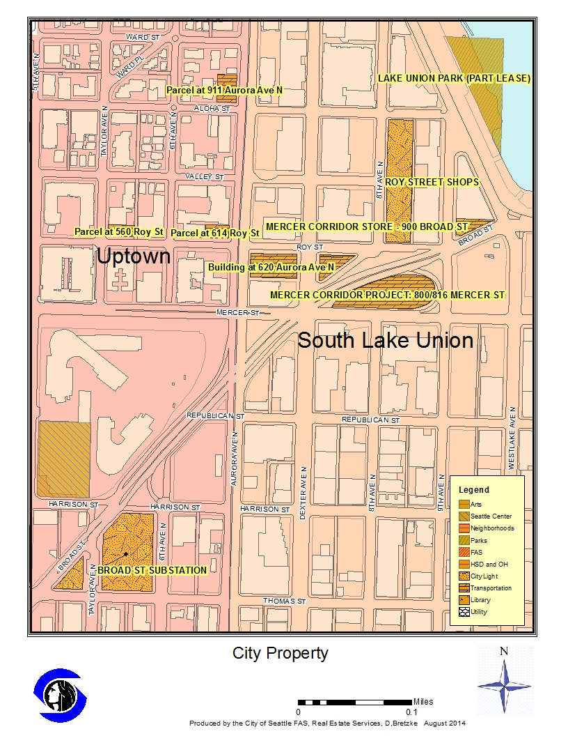

**Appendix B**

|  |  |  |  |  |  |  |  |
| --- | --- | --- | --- | --- | --- | --- | --- |
| **PROPERTY REVIEW PROCESS DETERMINATION FORM** | | | | | | | |
| Property Name: | | Parcel at 900 Broad Street | | | | | |
| Address: | 900 Broad Street | | | | | | |
| PMA ID: | PMA. 4193 | | Parcels No. 408880-3495. | |  | | |
| Dept./Dept ID: | SDOT | | | Current Use: | PARKING | | |
| Area (Sq. Ft.): | 7,771 sq. est. | | | Zoning: | SM85/ | | |
| Est. Value: | $ 1.2-1.8 Million | | | Assessed Value: | $ NA | | |
| **PROPOSED USES AND RECOMMENDED USE** | | | | | | | |
| *Department/Governmental Agencies: None* | | | | *Proposed Use: N/A* | | | |
|  | | | |  | | | |
| *Other Parties wishing to acquire:*  Adjacent property owner and other developers. | | | | *Proposed Use:* Mixed Use Development | | | |
|  | | | |  | | | |
| RES’S RECOMMENDED USE: Sell through an open and competitive process. | | | | | | | |
| **PROPERTY REVIEW PROCESS DETERMINATION** (circle appropriate response) | | | | | | | |
| 1.) Is more than one City Dept. /Public Agency wishing to acquire? | | | | | | No / Yes | 15 |
| 2.) Are there any pending community proposals for Reuse/ Disposal? | | | | | | No / Yes | 15 |
| 3.) Have citizens, community groups and/or other interested parties contacted the City regarding any of the proposed options? | | | | | | No / Yes | 15 |
| 4.) Will consideration be other than cash? | | | | | | No / Yes | 10 |
| 5.) Is Sale or Trade to a private party being recommended? | | | | | | No / Yes | 25 |
| 6.) Will the proposed use require changes in zoning/other regulations? | | | | | | No /Yes | 20 |
| 7.) Is the estimated Fair Market Value between $250,000-$1,000,000? | | | | | | No / Yes | 10 |
| 8.) Is the estimated Fair Market Value over $1,000,000? | | | | | | No/ Yes | 45 |
| Total Number of Points Awarded for "Yes" Responses: | | | | | |  | **70** |
| Property Classification for purposes of Disposal review: Simple Complex (circle one) (a score of 45+ points result results in a “Complex” classification)  Signature: Daniel Bretzke, AICP Department: FAS Date: May 10 2016 | | | | | | | |

**Appendix C   
Proposed Public Involvement Plan**

**Proposed Public Involvement Plan (PIP) for Parcel at 900 Broad Street**

City procedures require a proposed Public Involvement Plan for property dispositions which have been determined to be complex. The PIP’s purpose is to assure there is an adequate amount of public involvement on significant real estate transactions. To date, there has been low public interest in this property and no substantive issues have been identified. For this reason, and because the City Council has, through the 2013 budget process provided strategic direction for the sale of excess SDOT property in South Lake Union to fund the Mercer Corridor West project, FAS is recommending a PIP that focuses on the public comments received to date, and collection and presentation of any additional comments received through posting and publication of this plan. Previous public involvement to date included:

* Public hearings, council review, planning commission review and design commission review of the Mercer Corridor Improvement plans and zoning and development changes in the South Lake Union planning area.
* Notice of Excess Property sent to nearby property owners and residents.
* The Preliminary Report was sent to parties of record and is available on the City website.
* A public notice sign was placed onsite indicating the recommendation to sell the property, and advising how to contact FAS for information and/or make comments.
* In September 2014 The Real Estate Oversight Committee (REOC) was given the opportunity to review the Preliminary Report and the Public Involvement Plan.

**The following are the next steps and offer opportunity for community input:**

* FAS / SDOT will forward legislation authorizing sale of the property, including the Final Report and Public Involvement Report, to the City Council.
* An update on the disposition process will be sent to property owners and residents located within 1,000 feet of the property if the Council has not acted with legislation within 18 months of the initial public notice.
* FAS will continue to collect all comments and or proposals to the Council Committee meeting to take action on the legislation. FAS will provide an updated summary of all comments received to date.
* If the Council determines to hold a public hearing, FAS will provide 14 days notice of the public hearing to parties of record on the mailing list (Appendix D) so that interested parties can attend the public hearing and present their ideas and interests to the City Council.

**Appendix D**

Parties of Record

|  |  |  |  |
| --- | --- | --- | --- |
| Name | Email | Address/Company | Phone |
| Robert Hines | rlhinesjr@msn.com |  | 206 499 6464 |
| Jerry Kenny | circlejwk@aol.com |  | 206 550 2225 |
| Bob Meyer | meyer@ewingandclark.com | Ewing & Clark Inc. | 206 695 4823 |

**Appendix E**

Environmental

The following is an excerpt from Hazardous Materials Discipline Report Prepared by CH2m Hill for SDOT, Dated November 2006

*Mercer Corridor Improvements Project Hazardous Materials Discipline Report 4-39*

*November 2006*

**Parcel 13, Tap Plastics at 900 Broad Street**. This property is a 7,700-square-foot triangular parcel located at the corner of Broad Street and Ninth Avenue North. The property contains a 5,595-square-foot; one-story building that is currently occupied by Tap Plastics and Outback Steakhouse. This property is owned by the City of Seattle and was evaluated by the City of Seattle Office of Economic Development in 2000 for development opportunities. The parcel was designated as Parcel 13 by the City of Seattle. The following paragraphs are excerpts from the 2000 Heartland report (environmental report):

A Phase I ESA completed for the City of Seattle by Garry Struthers Associates, Inc., dated December 1999 revealed that there are several indications of potentially adverse soil and groundwater impacts on and around Parcel 13, particularly petroleum hydrocarbons and chlorinated solvents. Properties surrounding Parcel 13 that have the most potential to impact the property include the City of Seattle’s 630 Westlake Avenue North site, also known as Parcel 14. Parcel 14 has been identified to have the potential for soil and groundwater contamination from petroleum hydrocarbons. The extent of any potential contamination to Parcel 13 from the 630 Westlake Site was not identified.

Past use of Parcel 13 as an auto dealer and repair facility dating back to 1941 poses a potential for environmental impacts, specifically petroleum hydrocarbons.

Clayton Environmental Consultants conducted a hazardous material survey of this property and reported its findings in a report titled *Hazardous Materials Investigative Report*, *900 Roy Street, dated, November 30, 1999*. The report revealed the presence of asbestos and lead paint at levels that exceeded those regulated by the Federal Occupational Safety and Health Administration. Asbestos was found in the built-up roofing and in the tar on the parapet. These materials will require removal prior to renovation or demolition of the building. Sample lead paint chips were taken from the building and these samples showed detectable levels of lead in the paint. As part of the investigation, a Toxicity Characteristics Leaching Procedure test was conducted to determine if the building debris should be disposed of as dangerous waste. Results from the samples proved to be below the criteria for dangerous waste.

The following is an excerpt from a Transaction Screening Report prepared by CH2m Hill for SDOT, Dated February 2008.

*Phase III Mercer Corridor Improvements Project Transaction Screening Report: Tax ID no. 4088803495 (Parcel 57) Tin Cup / Parking 900 Broad Street Seattle, WA 98109; February 2008; p.3-1.*

CH2M HILL has performed a transaction screen of the subject property located at 900 Broad Street, Seattle, Washington. The transaction screen process was performed in general agreement with the scope of the ASTM 1528-06, as described in Section 1 of this report.

This assessment has revealed no potential environmental concern associated with the

exception of the following:

• **Potential onsite migration from adjacent property.** The subject property is located one block east of Maryatt Industries/American Linen Supply Co. (Parcel 48). Releases from this site are known to have impacted the soil and groundwater at the property. Since this site is up-gradient from the subject property, it is possible that offsite contaminant migration impacting the subject property has occurred.