**EXCESS PROPERTY DESCRIPTION**

**Building at 614 Aurora Ave N**

**July 23, 2015**

The Seattle Department of Transportation as the Jurisdictional Department of this City owned property has identified the following information about this excess property.

|  |  |  |  |  |  |  |
| --- | --- | --- | --- | --- | --- | --- |
| PMA | Parcel Size | Parcel # | Address | Zoning | 2015 Estimated value | Legal Description |
| 4186 | 24,192 | 224900-0120 | 614 Aurora Ave N  615 Dexter Ave N 98109 | SM 160/ 180-240 | $9.5-$10.5 million | Portions of Lots 3-6, Block 3, Volume 1 of Plats, Page 61A. |

**Map:**

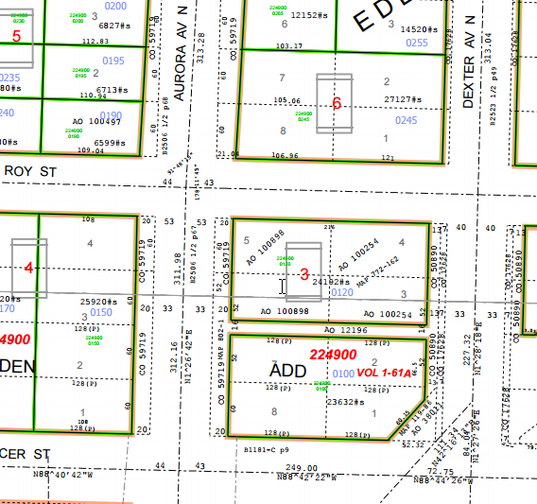

**History:**

In 1971 the property was purchased for the planned Bay Freeway project, which was later abandoned. The property has been held under city ownership until a final decision was made regarding Mercer Corridor transportation improvements. The Mercer Corridor transportation project is scheduled to be complete in the near future, and this property is excess to the Department of Transportation needs. The property was previously circulated as excess property in 2013.

**Acquisition Deeds:**

Fee simple deed, 6/3/1971, from Searle & Dudman & Dudman to City of Seattle, Recording Number AF 197107080139.

Statutory Warranty Deed, 9/30/1971, from Grace Francis Helgren & Ruth Prost Pomel & Carl A. Niese & Rosemary Niese to City of Seattle , Recording Number AF 7110290147.

Easement, 6/8/1929.

Easement granted to Postal Telegraph-Cable Company

**Ordinances:**    
Ord. [17628](http://clerk.seattle.gov/~archives/Ordinances/Ord_17628.pdf), 12/23/1907, An ordinance providing for the laying off, widening, extending and establishing of Dexter Avenue, from Mercer Street to Fourth Avenue North, etc…

Ord. [50890](http://clerk.seattle.gov/~scripts/nph-brs.exe?s3=&s4=50890&s5=&s1=&s2=&S6=&Sect4=AND&l=0&Sect2=THESON&Sect3=PLURON&Sect5=CBORY&Sect6=HITOFF&d=ORDF&p=1&u=%2F%7Epublic%2Fcbor1.htm&r=1&f=G), 5/83/1926, An ordinance providing for the laying off, opening, widening, extending and establishing of Taylor Avenue, from 5th Avenue to Broad Street; 6th Avenue North and 7th Avenue North each from Denny Way to Broad Street; etc.

Ord. [59719](http://clerk.seattle.gov/~archives/Ordinances/Ord_59719.pdf), 5/29/1930, An ordinance providing for the laying off, opening, widening, extending and establishing of a public street and highway to be known as Aurora Avenue, from Broad Street to Hillside place, and Aurora Avenue, etc..

Ord. [99377](http://clerk.seattle.gov/~scripts/nph-brs.exe?s3=&s4=99377&s5=&s1=&s2=&S6=&Sect4=AND&l=0&Sect2=THESON&Sect3=PLURON&Sect5=CBORY&Sect6=HITOFF&d=ORDF&p=1&u=%2F%7Epublic%2Fcbor1.htm&r=1&f=G), Recording 197104230427, Right of Way and Limited Access Plans for the Bay Freeway, Findings of the City Council.

Ord. [99545](http://clerk.seattle.gov/~scripts/nph-brs.exe?s3=&s4=99545&s5=&s1=&s2=&S6=&Sect4=AND&l=0&Sect2=THESON&Sect3=PLURON&Sect5=CBORY&Sect6=HITOFF&d=ORDF&p=1&u=%2F%7Epublic%2Fcbor1.htm&r=1&f=G), An ordinance relating to the Engineering Department, authorizing the acquisition of property and property rights necessary for the Bay Freeway; making a reimbursable appropriation from the Arterial City Street Fund for such purpose.

Ord. [100059](http://clerk.seattle.gov/~scripts/nph-brs.exe?s3=&s4=100059&s5=&s1=&s2=&S6=&Sect4=AND&l=0&Sect2=THESON&Sect3=PLURON&Sect5=CBORY&Sect6=HITOFF&d=ORDF&p=1&u=%2F%7Epublic%2Fcbor1.htm&r=1&f=G), An ordinance relating to the Engineering Department; authorizing completion of right of way acquisition for, execution of demolition contracts in connection with and construction of the Bay Freeway project and making a partially reimbursable appropriation.

Interdepartmental Agreement - Management of Property between Seattle Engineering Department and Department of Administrative Services, dated July 11, 1991.

**Acquisition Fund Source:** Arterial Street fund (Originally 38.5% of funds came from State UATA; those funds were repaid in 1976)

**Destination of funds upon sale:** Transportation Master Fund

**Current easements, covenants and restrictions:** State Law requires government organizations to receive fair market value for the disposal of surplus real property. There is an existing lease to Copiers Northwest for use of the property that expires in December, 2015.

**Recommended easements, covenants and restrictions upon Transfer:** Easements of record as shown on title report.

**Potential problems with property and possible measures to mitigate their recurrence:**

Phase one environmental assessment to be completed. Additional subsurface testing may be needed. The property is designated for limited access highway purposes for the Bay Freeway. This limitation will be lifted through City legislation before transfer.

**Building Information:**

Use: Warehouse

Size: 6,000 Square feet

Built: 1926

A previous building on the existing parking lot was destroyed by fire.

**Legal Description**

**Parcel A:**

The North 52 feet of Lot 3 and all of Lot 4, Block 3, Eden Addition to the City of Seattle, according to the plat thereof recorded in Volume 1 of Plats, Page 61A, in King County, Washington;

Except the East 20 feet thereof condemned in King County Superior Court Cause No. 193437, as

provided by Ordinance No. 50890 of the City of Seattle; and

Except that portion thereof condemned in King County Superior Court Cause No. 486551 for street.

**Parcel B:**

Lot 5 and the North 52 feet of Lot 6, Block 3, Eden Addition to the City of Seattle, according to the plat thereof recorded in Volume 1 of Plats, Page 61A, in King County, Washington;

Except that portion thereof condemned for Aurora Avenue, in King County Superior Court Cause No. 236360 under Ordinance No. 59719 of the City of Seattle.