***Final Recommendation Report***

***on Reuse and Disposal of the***

**Seattle Department of Transportation Mercer Corridor Excess Property**

**PMA 4185, 911 Aurora Avenue North**

**and the**

**Report on the Public Involvement Plan**

**June 1, 2016**

**Final Report**

The Final Recommendation report updates information that was included in the “Preliminary Recommendation Report on the Reuse and Disposal of Excess Property” that was published on September 8, 2014.

**Purpose of Preliminary Report**

In response to a City of Seattle Jurisdictional Department identifying a property as “Excess” to their needs, the Real Estate Services (RES) section of the Department of Finance and Administrative Services (FAS) initiates a process to review and evaluate various options for the property. RES prepares a report titled “Preliminary Recommendation Report on the Reuse and Disposal of Excess Property”, which documents the Departments’ analysis and recommendations. This report is prepared in accordance with City of Seattle Council Resolution [29799](http://clerk.seattle.gov/~scripts/nph-brs.exe?s1=&s3=29799&s2=&s4=&Sect4=AND&l=20&Sect2=THESON&Sect3=PLURON&Sect5=RESNY&Sect6=HITOFF&d=RESF&p=1&u=%2F%7Epublic%2Fresny.htm&r=1&f=G), as modified by Resolution [30862](http://clerk.seattle.gov/~scripts/nph-brs.exe?s1=&s3=30862&s2=&s4=&Sect4=AND&l=20&Sect2=THESON&Sect3=PLURON&Sect5=RESNY&Sect6=HITOFF&d=RESF&p=1&u=%2F%7Epublic%2Fresny.htm&r=1&f=G).

**Executive Recommendation**

(FAS) recommends that the property be sold at fair market value through an open and competitive process.

**Background Information**

The property is under the jurisdiction of the Seattle Department of Transportation (SDOT). This property is located at 911 Aurora Avenue North, and is located on the northwest corner of Aloha Street and Aurora Avenue North. (See Appendix A for a detailed property description) The property was acquired in 1971 to be used as a part of the proposed Bay Freeway project, which was never built. The property was previously circulated as excess property in 2003. The disposition process was previously put on hold pending review of potential city uses.

**Reuse or Disposal Options Evaluation Guidelines**

City of Seattle Resolution 29799, Section 1, requires the Executive to make its recommendation for the reuse or disposal of any property that is not needed by a Department using the following guidelines.

# Guideline A: Consistency

*The analysis should consider the purpose for which the property was originally acquired, funding sources used to acquire the property, terms and conditions of original acquisition, the title or deed conveying the property, or any other contract or instrument by which the City is bound or to which the property is subject, and City, state or federal ordinances, statues and regulations.*

***Funding Sources:*** The property was purchased with monies in part from the Arterial City Street Fund and from funding for the Bay Freeway.

***Purpose for which property was acquired:*** The property was purchased in order to establish the Bay Freeway, which was never built.

***Deed or contractual restrictions:*** The property is not bound by any other contracts or instruments and is not subject to any extraordinary laws or regulations. It does have a deed restriction relating to its designation as a limited access freeway purposes.

***City, State or Federal Ordinance status and regulations including, Bond, grant or loan programs, State Accountancy Act, Payment of True and full value, Zoning and land use, Comprehensive Plan, and Other plans:***

State Law requires government organizations to receive fair market value for the disposal of surplus real property. The fair market value can be determined by an appraisal, or through an open competitive sales process. The City of Seattle incurs costs associated with the disposition process including staff time, public notice expenses and real estate transactions costs. FAS will be reimbursed for expenses incurred in the sale of the property.

The property is located in the Uptown Urban Center and is subject to zoning incentives and restrictions. The property is currently zoned C1-65.

# Guideline B: Compatibility and Suitability

*The recommendation should reflect an assessment of the potential for use of the property in support of adopted Neighborhood Plans; as or in support of low-income housing and/or affordable housing; in support of economic development; for park or open space; in support of Sound Transit Link Light Rail station area development; as or in support of child care facilities; and in support of other priorities reflected in adopted City policies.*

***Neighborhood Plan:*** The property is located in the Uptown Urban Center. This area is close to the Seattle Center. The neighborhood includes buildings that vary in age and size.

***Housing and Economic Development:*** The sale of the property to a private owner will return the property to the active tax rolls. Subsequent development of the property will increase economic activity in the City. The owner of Chef’n, a small business to the immediate north has requested to purchase the property in order to consolidate existing office space at this location. Chef’n is founded in Seattle and would like to remain in this neighborhood. Chef’n is a Seattle based company with millions in yearly sales.

***Nearby City owned property:*** There are no City-owned properties which are contiguous with this parcel. There are several City-owned excess properties located in the Uptown and South Lake Union Planning area. Excess city properties are subject to the City’s disposition policies and will be addressed separately in other preliminary reports. A map showing nearby City properties is included with the attached Excess Property Description.

***Other City Uses***: In March 2014, an Excess Property Notice for this property was circulated to City of Seattle Departments. City Departments were asked to evaluate the property for current of future city uses of the property. FAS/RES received Excess Property Response Forms indicating no interest from the following departments or public agencies: Seattle Public Library, Seattle City Light, Seattle Department of Planning and Development, and the Seattle Department of Parks and Recreation. The Human Services Department (HSD) expressed interest in the property for potential use as a day care, although HSD is currently investigating other excess properties.

The Seattle Office of Housing has reviewed the property for use for affordable housing development and determined that is not suitable.

***Other Agencies Uses*:** An Excess Property Notice for this property was circulated in March 2014 to assess other agencies interest. No other non-city agency expressed interest in use of the property.

***Range of Options***

The “Guiding Principles for the Reuse and Disposal of Real Property” state, “it is the intent of the City to strategically utilize real property in order to further the City’s goals and to avoid holding properties without an adopted municipal purpose.” The options for disposition of this property include retention by the City for a public purpose, negotiated sale with a motivated purchaser, market sale, or through a request for proposal process.

***Transfer of Jurisdiction to other City Department:*** No other City Department expressed a need for the property.

***Negotiated Sale*:** A negotiated sale is typically recommended when the selection of a particular purchaser has specific benefits to the City. The adjacent property owner, Chef’n, has expressed interest in purchasing the property at fair market value. The adjacent condominium association may also wish to acquire the property to protect views.

Neither of the adjacent property owners provided a plan that would provide specific benefits to the City. Once the property has been authorized to sell through an open and competitive process, each of the adjacent property owners can make an offer on the property.

***Sale through an open competitive process:*** A sale through a public competitive process would allow the market to determine the optimum price and use of the property.

***Request for Proposal Process:*** This process is used when specific development goals are desired. FAS does not have a development plan for this property. HSD investigated whether a developer could be identified to develop the property to include a child care facility and it was decided that the topography and the adjacent Aurora Ave North made this site unsuitable for a day care development.

***Guideline C: Other Factors***

*The recommendation should consider the highest and best use of the property, compatibility of the proposed use with the physical characteristics of the property and with surrounding uses, timing and term of the proposed use, appropriateness of the consideration to be received, unique attributes that make the property hard to replace, potential for consolidation with adjacent public property to accomplish future goals and objectives, conditions in the real estate market, and known environmental factors that may affect the value of the property.*

***Highest and Best Use*:** The Highest and Best Use is generally defined as the reasonably probable and legal use that produces the highest property value. The highest and best use is determined by evaluating potential uses as follows:

* ***Legally permissible****:* The subject property is zoned C1-65 which allows a wide range of mixed commercial spaces.
  + ***Physically possible****:* The adjacent properties and the adjacent streets have been graded to a lower elevation than the site. In order for this site to be developed, some excavation of the site will be needed.
* ***Financially feasible and maximally productive:***The property is currently undeveloped. The site zoning would allow a wide variety of uses including commercial and office uses.

The highest and best use of the property is commercial and office uses as allowed under its current zoning.

***Compatibility with the physical characteristics and surrounding uses*:** To the west of the property lies a residential condominium structure. The condominium has an open deck that is adjacent to the flat area of the property. The property to the north consists of offices for Chef’n. Potential development on this property may restrict some of the current views from some of the condominium units. Expansion of Chef’n on the property would be compatible with Chef ‘n’s use. Any development of the property would need to obtain permits through the Department of Planning and Development.

***Appropriateness of the consideration:*** Sale of the property at fair market value through a negotiated sale or competitive sale process will result in the City receiving fair market value for the property.

***Unique Attributes*:**  The property is undeveloped, although the slopes on the sides of the property gives it a unique topography.

***Potential for Consolidation with adjacent public property*:** There are no public properties that lie adjacent to this property.

***Conditions in the real estate market*:** The real estate market in the City of Seattle remains fairly stable, and the South Lake Union area has a great demand for new development.

***Known environmental factors:*** SDOT has no knowledge of any environmental issues. SDOT has declined to obtain a phase I or phase II environmental report, but would allow prospective buyers time to conduct due diligence reviews.

***Guideline D: Sale***

*The recommendation should evaluate the potential for selling the property to non-City public entities and to members of the general public.*

***Potential for Use by Non-City Public Entities:*** Due to the extent of excavation and the value of the property, it appears to be financially infeasible for a day care provider to purchase and construct a day care facility on this property.

***Public Involvement:*** In accordance with Resolution Nos. 29799 and 30862, in March 2014, a notice concerning disposition or other use of this property was sent to all business, residents and property owners within a 1,000 foot radius of the subject property. A total of 708 notices were mailed. Five responses regarding this property were received.

* One response was from the adjacent property owner who is interested in purchasing the property.
* One response was from the attorney of the adjacent property owner.
* Two responses were received from brokers.
* One response was from an investor who is interested in purchasing the property.

A notice of excess property was also sent in 2003. Parties of record are included in this report.

***Threshold Determination***

*The Disposition Procedures require FAS assess the complexity of the issues on each excess property following the initial round of public involvement. The purpose of this analysis is to structure the extent of additional public input that should be obtained prior to forwarding a recommendation to the City Council.*

The Disposition Procedures require that FAS assess the complexity of the issues on each excess property following the initial round of public involvement. The purpose of this analysis is to structure the extent of additional public input that should be obtained prior to forwarding a recommendation to the City Council. Appendix B is the Property Review Process Determination Form prepared for PMA 4185, 911 Aurora Street. Due to the estimated value of the property at over $1,000,000 and the recommendation to sell, the disposition of this property is determined to be a “Complex” transaction.

***Public Involvement Plan:***

For projects that have been determined to be a Complex transaction, RES develops a Public Involvement Plan (PIP) that is included with the Preliminary Report. The PIP is to be tailored to the characteristics of each specific excess property and those issues which have been raised during the circulation and notification phase. FAS prepared the Preliminary Report and PIP with input from SDOT, the department with jurisdictional control over the excess property. This PIP is completed before legislation for real estate disposition is approved by the City Council.

A PIP for this property has been attached as Appendix C.

***Next Steps***

* The Preliminary Report and the Public Involvement Plan are published on the RES website and sent to the parties of record as listed in Appendix D.
* The City of Seattle Real Estate Oversight Committee, (REOC) reviews the recommendation in the Preliminary Report.
* FAS will finalize the Preliminary Report and the Report on the Public Involvement Process. Both the Final Report and the Report on the Public Involvement Process are included with the legislation necessary to implement the final recommendation for the excess property.
* No Council briefings or hearings will be held for at least 30 days following a notice of legislation sent to the mailing list. FAS will continue to collect all comments. All interested parties are provided with at least two weeks’ notice of the public hearing date so that interested parties can attend the public hearing before the City Council makes a decision concerning disposition of PMA 4185.

**Appendix A**

EXCESS PROPERTY DESCRIPTION

Parcel at 911 Aurora Avenue N

August 15, 2014

The Seattle Department of Transportation (SDOT), as the Jurisdictional Department of this City owned property has identified the following information about this excess property.

**Property Name:** 911 Aurora Ave N

|  |  |  |  |  |  |  |
| --- | --- | --- | --- | --- | --- | --- |
| PMA | Parcel Size | Parcel # | Address | Zoning | 2014 Est Value* | Legal Description |
| 4185 | 11,440 | 224950-0015 | 911 Aurora Avenue N. | C1- 65 | $1,200,000-  $1,800,000 | Lot 1 and 2, Block 12, Eden Add. No. 2, TGQW portion of Vacated Aloha St adj |

**Map:**

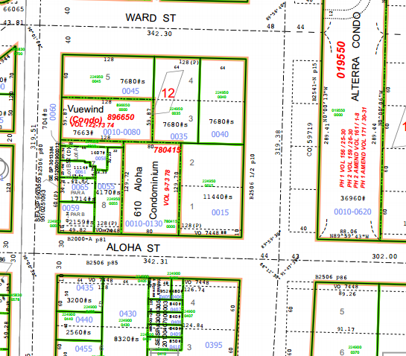

**History:** In 1901 a portion of Aloha Street was vacated to the adjacent property owners. The property was acquired in 1971 as part of the proposed Bay Freeway. The property has been held pending the final design of the Mercer Corridor project. The property is excess to needs of SDOT.

**Ordinances:**

Ord. [7448](http://clerk.seattle.gov/~archives/Ordinances/Ord_7448.pdf) 7/1/1909, Vacation ordinance: An ordinance to narrow Aloha Street in the City of Seattle and to vacate and release to the abutting property owners the parking strips on said street between Queen Anne Avenue and Lake Union.

Ord. [59719](http://clerk.seattle.gov/~archives/Ordinances/Ord_59719.pdf), 5/29/1930, An ordinance providing for the laying off, opening, widening, extending and establishing of a public street and highway to be known as Aurora Avenue, from Broad Street to Hillside place, and Aurora Avenue, etc.

Ord. [99377](http://clerk.seattle.gov/~scripts/nph-brs.exe?s3=&s4=99377&s5=&s1=&s2=&S6=&Sect4=AND&l=0&Sect2=THESON&Sect3=PLURON&Sect5=CBORY&Sect6=HITOFF&d=ORDF&p=1&u=%2F%7Epublic%2Fcbor1.htm&r=1&f=G), 10/23/70, Recording No. 197104230427, Right of Way and Limited Access Plans for the Bay Freeway, Findings of the City Council.

Ord. [99545](http://clerk.seattle.gov/~scripts/nph-brs.exe?s3=&s4=99545&s5=&s1=&s2=&S6=&Sect4=AND&l=0&Sect2=THESON&Sect3=PLURON&Sect5=CBORY&Sect6=HITOFF&d=ORDF&p=1&u=%2F%7Epublic%2Fcbor1.htm&r=1&f=G), 12/23/1970, An ordinance relating to the Engineering Department, authorizing the acquisition of property and property rights necessary for the Bay Freeway; making a reimbursable appropriation from the Arterial City Street Fund for such purpose.

Ord. [100059](http://clerk.seattle.gov/~scripts/nph-brs.exe?s3=&s4=100059&s5=&s1=&s2=&S6=&Sect4=AND&l=0&Sect2=THESON&Sect3=PLURON&Sect5=CBORY&Sect6=HITOFF&d=ORDF&p=1&u=%2F%7Epublic%2Fcbor1.htm&r=1&f=G), 6/28/1971, An ordinance relating to the Engineering Department; authorizing completion of right of way acquisition for, execution of demolition contracts in connection with and construction of the Bay Freeway project and making a partially reimbursable appropriation. Related: CF 268017, 269856, Ord. 99377, 99545, 95227, 99662

Ord. 100254, 9/10/1971, An ordinance accepting deeds from Allen J. Kleinsasser and others to a portion of lots 1, 2, 7, and 8, Block 12 Eden Addition No. 2 to the City of Seattle, and other properties for limited access highway purposes.

**Acquisition Deeds:**

3/15/1971 Fee simple/Fee title Transfer Dated 3/15/1971 From Allen J Kleinsasser and others, to Seattle Transpiration Department, Recording Number AF 197104200126.

**Acquisition Fund Source:**  Arterial City Street Fund and funding related to the Bay Freeway project.

**Jurisdictional Department’s estimated market value:**  $1,200,000 to $1,800,000. The value of the property is based upon a comparative market analysis performed by Real Estate Services using comparable sales of similar properties sold between spring 2013 and spring 2014. The range of value is due to unknown development costs.

**Destination of funds upon sale:** City Street Fund, a sub fund of the Transportation Operating Fund, because this property was purchased using gas tax revenue, the proceeds from the sale are restricted to certain transportation uses. The City Arterial Street Fund contains only gas tax revenue eligible activities. The City Arterial Street Fund no longer exists.

**Current easements, covenants and restrictions:** The right for the City of Seattle to enter the portion vacated under ordinance 7448 for the purpose of sloping in order to protect the sidewalk from sliding earth.

**Recommended easements, covenants and restrictions upon Transfer:**  Reserve a slope easement over vacated portion of the property.

**Potential problems with property and possible measures to mitigate their recurrence:**  The site contains some steep slopes, which appear to be previously graded for the construction of Aurora Avenue and Aloha Street.

**Neighborhood:** Uptown Urban Center

**Legal Descriptions**: (Parcel No. 224950-0015):

Lots 1 and 2, Block 12, Eden Addition No. 2 to the City of Seattle, according to the plat thereof recorded in Volume 1, Page 67A, in King County, Washington;

Except the West 40 feet thereof; and

Together with the North 10 feet of vacated Aloha St adjoining said Lot 1, as vacated by Ordinance 7448 of the City of Seattle;

Except the West 40 feet thereof.

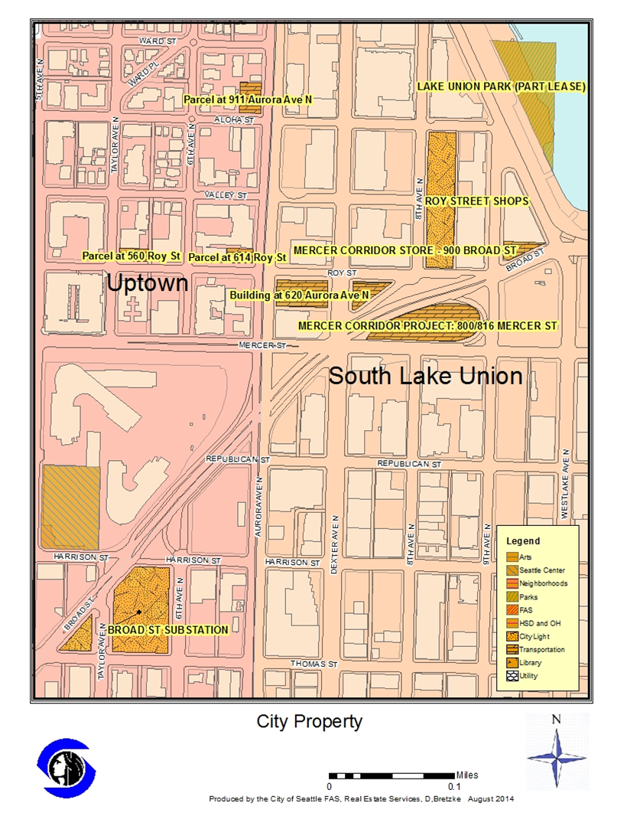

**Appendix B**

|  |  |  |  |  |  |  |  |
| --- | --- | --- | --- | --- | --- | --- | --- |
| **PROPERTY REVIEW PROCESS DETERMINATION FORM** | | | | | | | |
| Property Name: | | 911 Aurora Avenue North | | | | | |
| Address: | 911 Aurora Ave North | | | | | | |
| PMA ID: | PMA. 4185 | | Parcels No . 224950-0015 | |  | | |
| Dept./Dept ID: | SDOT | | | Current Use: | Vacant land | | |
| Area (Sq. Ft.): | 7,771 sq.ft. est. | | | Zoning: | C1 65/ | | |
| Est. Value: | $ 1.2-1.8 Million | | | Assessed Value: | $ NA | | |
| **PROPOSED USES AND RECOMMENDED USE** | | | | | | | |
| *Department/Governmental Agencies: None* | | | | *Proposed Use: N/A* | | | |
| *Other Parties wishing to acquire:*  Adjacent property owner Chef’n  Condo Association | | | | *Proposed Use:*  Office space *Preserve views* | | | |
| RES’S RECOMMENDED USE:  Sell through an open and competitive process to receive the highest dollar value. | | | | | | | |
| **PROPERTY REVIEW PROCESS DETERMINATION** (circle appropriate response) | | | | | | | |
| 1.) Is more than one City Dept. /Public Agency wishing to acquire? | | | | | | No / Yes | 15 |
| 2.) Are there any pending community proposals for Reuse/ Disposal? | | | | | | No / Yes | 15 |
| 3.) Have citizens, community groups and/or other interested parties contacted the City regarding any of the proposed options? | | | | | | No / Yes | 15 |
| 4.) Will consideration be other than cash? | | | | | | No / Yes | 10 |
| 5.) Is Sale or Trade to a private party being recommended? | | | | | | No / Yes | 25 |
| 6.) Will the proposed use require changes in zoning/other regulations? | | | | | | No /Yes | 20 |
| 7.) Is the estimated Fair Market Value between $250,000-$1,000,000? | | | | | | No / Yes | 10 |
| 8.) Is the estimated Fair Market Value over $1,000,000? | | | | | | No/ Yes | 45 |
| Total Number of Points Awarded for "Yes" Responses: | | | | | |  | **70** |
| Property Classification for purposes of Disposal review: Simple Complex (circle one) (a score of 45+ points result results in a “Complex” classification)  Signature: Daniel Bretzke, AICP Department: FAS Date: April 7, 2016 | | | | | | | |

**Appendix C   
 Proposed Public Involvement Plan and Report**

**Public Involvement Plan (PIP) for Parcel at 911 Aurora Ave North**

City procedures require a proposed Public Involvement Plan for property disposition which have been determined to be complex. The PIP’s purpose is to assure there is an adequate amount of public involvement on significant real estate transactions.. To date, there has been low public interest in this property and no substantive issues have been identified. FAS is recommending a PIP that focuses on the public comments received to date, and collection and presentation of any additional comments received through posting and publication of this plan. The following have provided opportunities for input:

* Previous public comment from circulation in 2003 included comments from neighboring property owners and other interested parties.
* Previous public involvement to date include public hearings, council review, planning commission review and design commission review of the Mercer Corridor Improvement plans.
* The Preliminary Report has been sent to parties of record and is available on the City website.
* A public notice sign was placed onsite indicating the recommendation to sell the property, and advising how to contact FAS for information and/or make comments.
* The Real Estate Oversight Committee (REOC) has reviewed the Preliminary Report and the Public Involvement Plan.

**The following are the next steps and offer opportunity for community input.**

* As the initial public notice has been over 18 months until the legislation is to be acted on by City Council. FAS will send an update on the property disposition status to property owners and residents within 1,000 feet of the property.
* FAS / SDOT will forward legislation authorizing sale of the property including the Final Report and Public Involvement Report, to the City Council. No Council briefings or hearings will be held for at least 30 days following a notice of legislation sent to the party of record mailing list.
* FAS will continue to collect all comments and or proposals at the Council committee meeting to take action on the legislation, FAS will provide an updated summary of all comments received to date.

**Appendix D**

Parties of Record

|  |  |  |  |
| --- | --- | --- | --- |
| Name | Email | Address/Company | Phone |
| Robert Hines | rlhinesjr@msn.com |  | 206 499 6464 |
| David and Rosalie Holcomb | Rosalie.holcomb@comcast.net | Chef’n Company |  |
| Bob Myer | meyer@ewingandclark.com | Ewing Clark | 206 695 4823 |
| Tom Peterson | tpeterson@sociuslaw.com | Socius Law Group | 206 838 9153 |
| lmckenzie@sociuslaw.com | lmckenzie@sociuslaw.com | Socius Law Group |  |
|  | [Stef197z@comcast.net](mailto:Stef197z@comcast.net) |  |  |
|  | [mikeeastman@hotmail.com](mailto:mikeeastman@hotmail.com) |  |  |
|  | [phaggerty@usa.net](mailto:phaggerty@usa.net) |  |  |
|  | [loriyosh@gmail.com](mailto:loriyosh@gmail.com) |  |  |
|  | [mdburkard@gmail.com](mailto:mdburkard@gmail.com) |  |  |
|  | [reznickb@hotmail.com](mailto:reznickb@hotmail.com) |  |  |
|  | [joannadooley@johnlscott.com](mailto:joannadooley@johnlscott.com) |  |  |
|  | [caweber@myexcel.com](mailto:caweber@myexcel.com) |  |  |
|  | [thediamondlady.57@gmail.com](mailto:thediamondlady.57@gmail.com) |  |  |
| Parties of Record from 2003 Circulation | | | |
| Randy Nelson, Paula Russell |  | 610 Aloha St Unit 201  Seattle WA 98109 | 206 284 4477 |
| Paula Weber, President Condo Association |  | 610 Aloha St, Unit 204  Seattle WA 98109 |  |
| Andy White |  | 610 Aloha St, Unit 403  Seattle WA 98109 |  |
| Elizabeth Pheasant |  | 610 Aloha St  Seattle 98109 | 206 691 1198 |
| Arelene Rapinian |  | 1000 Aurora Ave N 209 Seattle WA 98190 | 206 286 9897 |
| Edwin and Areline Roupinian |  | 2 Yellow Brick Rd  Rancho Palos Verdes Ca 90275 | 310 375 5595 |
| Sarah Steves | sarahsteves@comcast.net | 810 Taylor Avenue N.  Unit 325  Seattle W 98109 |  |
| Kathy McDowell | skullcreek@msn.com |  |  |
| Larry Cobb |  | 1243 NE 152nd Street Shoreline WA 98155 | 206 369 7646 |
| Sylvia Luton | bluton@attbi.com | 1008 6th Ave. N #301  Seattle WA 98109 | 206 691 3725 |
| Douglas Smith  Horizon Church | horizonch@isomedia.com | 602 Valley St  Seattle WA 98109 | 206 282 9400 |