**EXCESS PROPERTY DESCRIPTION**

**Roy Street Shops**

Seattle City Light as the Jurisdictional Department of this City owned property has identified the following information about this excess property.

|  |  |  |  |  |  |  |
| --- | --- | --- | --- | --- | --- | --- |
| PMA | Parcel Size | Parcel # | Address | Zoning | 2017  Estimated value | Short Legal Description |
| 4171 | 67,025 sf | 408880-3530 | 800 Aloha St  802 Roy St | SM 85 | $20- $30 million | Lake Union Shore Lands Add, & Blk 8 Eden Add, Ly wly of Lake Union Shore Lands Add, tgw portion lots 1-4 blk 80 & lots 1-5 blk 82 in Lake Union Shore Lands Add, ly wly of alley, tgw portion of vacated Broad St. |

**Map:**

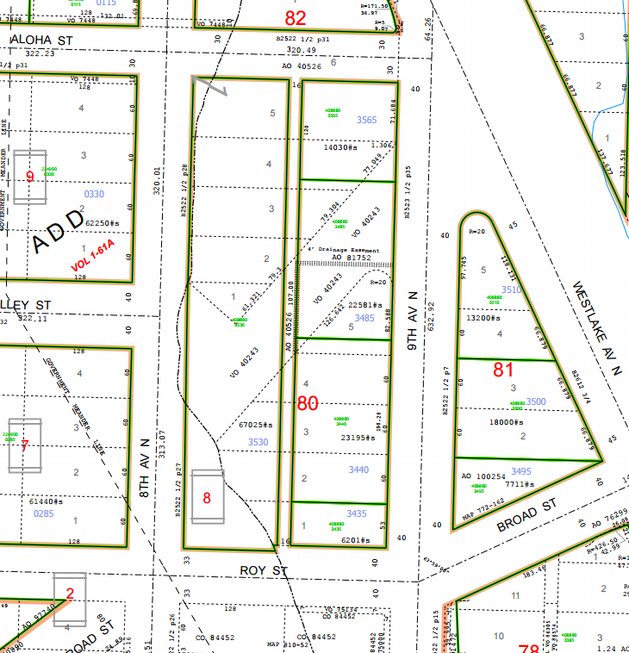

**History:**

The building on this property was designed by John Graham Sr. and was built by Puget Sound Power and Light in 1926 for use as a warehouse, shop, and garage. In 1951, the property was sold to Seattle City Light. From 1975 until 1994, the building was used by the Seattle Parks and Recreation, and was transferred to Parks in 1984. In 2003 the property was transferred back to Seattle City Light to be used as storage warehouse. In 2008 the property was declared excess to the needs of Seattle City Light.

**Acquisition Deeds:**

2/3/1949, Deed 4114711, Grantor: Puget Sound Power & Light, Grantee: Seattle City Light

**Ordinances:**

12/8/1919 [Ordinance 40243](http://clerk.seattle.gov/~archives/Ordinances/Ord_40243.pdf). Street Vacation, An ordinance vacating a portion of Broad Street on petition of the Struve Estate Inc.

1/10/1920 [Ordinance 40526](http://clerk.seattle.gov/~archives/Ordinances/Ord_40526.pdf), An Ordinance accepting a deed from Struve estate, Inc., to the City of Seattle, dated the 17th day of November, 1919, and laying off Aloha Street.

7/31/1951, [Ordinance,79165](http://clerk.seattle.gov/~scripts/nph-brs.exe?s3=&s4=79165&s5=&s1=&s2=&S6=&Sect4=AND&l=0&Sect2=THESON&Sect3=PLURON&Sect5=CBORY&Sect6=HITOFF&d=ORDF&p=1&u=%2F~public%2Fcbor1.htm&r=1&f=G) An ordinance relating to, and specifying and adoption a plan or system of additions and betterments to, and extensions of, the existing municipal light and power plant and system; providing for the purchase of all the real and personal property of the Puget Sound Power & Light Company used or useful in the conduct of said company's electric utility business within the boundary lines herein set forth, with certain specified exceptions; declaring the estimated cost thereof as near as may be; providing for the issuance and sale of bonds to provide funds therefor; creating and establishing an acquisition fund; and creating and establishing a special fund to pay the principal and interest of such bonds; all subject to ratification by the voters at a special municipal election to be held on November 7, 1950, and specifying a ballot title.

11/2/1981 Ordinance 110233, An Ordinance authorizing an Interdepartmental Agreement for the contract sale to the Parks and Recreation Department of surplus City Light Department property located in and adjacent to Block 8, Eden Addition and making an appropriation from the Park Acquisition and Development Fund to provide the down payment thereof. (P. M. 250430-1-302).

8/19/2003, [Ordinance 121248](http://clerk.seattle.gov/~scripts/nph-brs.exe?s3=&s4=121248&s5=&s1=&s2=&S6=&Sect4=AND&l=0&Sect2=THESON&Sect3=PLURON&Sect5=CBORY&Sect6=HITOFF&d=ORDF&p=1&u=%2F~public%2Fcbor1.htm&r=1&f=G), An Ordinance authorizing the transfer of jurisdiction over real property located at 8th Avenue and Roy Street, in Seattle, from the Department of Parks and Recreation to the City Light Department.

**Acquisition Fund Source:** The fund source for City Light's acquisition inn 2003 was the City Light Fund. Purchase prices was fair market value of $5,565,000.

**Destination of funds upon sale:** Seattle City Light Fund, Fund No. 41000

**Current easements, covenants and restrictions:** State Law requires government organizations to receive fair market value for the disposal of surplus real property. .

**Recommended easements, covenants and restrictions upon Transfer:** Easements of record are shown on title report and Alta survey by Bush Roed & Hitchings, Inc. December, 2011.

**Potential problems with property and possible measures to mitigate their recurrence:**

An Environmental Condition report, dated June 8, 2011was prepared by Shannon and Wilson. This report summarizes previous reports and provided additional research on conditions. Sound Earth Strategies, as a part of the 700 Dexter Building environmental remediation discloses the existence of a large plume of various contaminates emanating from the American Linen Supply property and extending under the building on this property. Future development of the property will need to address the environmental concerns.

The site and building has been designated by the City of Seattle Landmarks Preservation Board a Seattle Landmark.

**Building and Property Description**

Use: The building is currently vacant. The parking lot is leased for use as a paid parking Building size: 50,292 gross square feet, 22,536 net square feet

Built: 1926

**Legal Description**

All of Block 8 of Eden Addition to the City of Seattle according to the plat thereof recorded in Volume 1 of Plats, Page 61½, Records of King County, Washington; and

That portion of Lots 1, 2, 3, and 4 in Block 80 lying west of the alley deeded to the City of Seattle, and that portion of Lots 1, 2, 3, 4 and 5 in Block 82 lying west of the alley deeded to the City of Seattle in Lake Union Shore Lands as per recorded plat thereof.

Also that portion of the vacated street adjoining said Land, described as follows:

Beginning at the most westerly corner of Lot 1 in Block 82 of said Lake Union Shore Lands;

thence southeasterly along the southwesterly line of said lot to the most southerly corner thereof;

thence northeasterly along the southeasterly line of said Block 82 to the west line of said alley;

thence south along said west line to the northwesterly line of said Block 80;

thence southwesterly along said northwesterly line to the easterly line of said Block 8 of Eden Addition;

thence northerly along said line to the east line of Eighth Avenue North;

thence northerly along said east line to the place of beginning.

Being all the land lying south of the south line of Aloha Street, north of the north line of Roy Street, east of the east line of Eighth Avenue North, and west of the west line of the alley as deeded to the City of Seattle under Auditor's File No. 1394444, records of King County, Washington.