***DRAFT***

***Preliminary Recommendation Report***

***On Reuse and Disposal of the***

**Seattle Department of Transportation Excess Property**

**PMA 4077, the Building at 805 NE Northlake Pl**

**December 3, 2015**

**Purpose of Preliminary Report**

In response to a City of Seattle Jurisdictional Department identifying a property as “Excess” to their needs, the Real Estate Services (RES) section of the Department of Finance and Administrative Services (FAS) initiates a process to review and evaluate various options for the property. RES prepares a report titled “Preliminary Recommendation Report on the Reuse and Disposal of Excess Property”, which documents the Departments’ analysis and recommendations. This report is prepared in accordance with City of Seattle Council Resolution [29799](http://clerk.seattle.gov/~scripts/nph-brs.exe?s1=&s3=29799&s2=&s4=&Sect4=AND&l=20&Sect2=THESON&Sect3=PLURON&Sect5=RESNY&Sect6=HITOFF&d=RESF&p=1&u=%2F%7Epublic%2Fresny.htm&r=1&f=G), as modified by Resolution [30862](http://clerk.seattle.gov/~scripts/nph-brs.exe?s1=&s3=30862&s2=&s4=&Sect4=AND&l=20&Sect2=THESON&Sect3=PLURON&Sect5=RESNY&Sect6=HITOFF&d=RESF&p=1&u=%2F%7Epublic%2Fresny.htm&r=1&f=G).

**Executive Recommendation**

(FAS) recommends that the property to be offered for sale to the University of Washington through a negotiated sale at fair market value. If a negotiated sale with University of Washington is not completed, then property should be sold at fair market value through an open and competitive process.

**Background Information**

The property is under the jurisdiction of the Seattle Department of Transportation. This property is located at 805 NE Northlake Place and is located between NE Northlake Way and NE Northlake Pl. (See Appendix A for a detailed property description) The property was purchased in 1971, as part of the NE Pacific St. relocation. The property is currently leased to the heir of Theodore Jonsson. The property is expected to be vacated by the end of 2015.

**Reuse or Disposal Options Evaluation Guidelines**

City of Seattle Resolution 29799, Section 1, requires the Executive to make its recommendation for the reuse or disposal of any property that is no longer needed by a Department using the following guidelines.

# Guideline A: Consistency

*The analysis should consider the purpose for which the property was originally acquired, funding sources used to acquire the property, terms and conditions of original acquisition, the title or deed conveying the property, or any other contract or instrument by which the City is bound or to which the property is subject, and City, state or federal ordinances, statues and regulations.*

***Funding Sources:*** The property was purchased with monies from the Arterial Street Fund.

***Purpose for which property was acquired:*** For a road construction project, but the property was not needed.

***Deed or contractual restrictions:*** The property is not bounded by any other contracts or instruments.

***City, State or Federal Ordinance status and regulations including, Bond, grant or loan programs, State Accountancy Act, Payment of True and full value, Zoning and land use, Comprehensive Plan, and Other plans:***

State Law requires government organizations to receive fair market value for the disposal of surplus real property. The fair market value can be determined by an appraisal, or through an open competitive sales process. The City of Seattle incurs costs associated with the disposition process including staff time, public notice expenses and real estate transactions costs. FAS will be reimbursed for expenses incurred in the sale of the property as provided in a memorandum of agreement between SDOT and FAS.

The property is located in the [University Campus Urban Village](http://www.seattle.gov/Documents/Departments/Neighborhoods/Planning/Map/University-map.pdf) and is subject to zoning incentives and restrictions.

The property is currently zoned MIO-65-IC-45 which allows for a wide range of institutional and industrial uses. The development regulations of the industrial overlay apply to the future development of the property.

# Guideline B: Compatibility and Suitability

*The recommendation should reflect an assessment of the potential for use of the property in support of adopted Neighborhood Plans; as or in support of low-income housing and/or affordable housing; in support of economic development; for park or open space; in support of Sound Transit Link Light Rail station area development; as or in support of child care facilities; and in support of other priorities reflected in adopted City policies.*

***Neighborhood Plan:*** The property is located in the University Campus Urban Village. The property is close to Lake Union and near the Wallingford neighborhood. The neighborhood includes buildings that vary in age and size, although predominantly the area includes industrial and warehouse spaces. [The University Of Washington Master Plan, Seattle Campus](http://www.washington.edu/community/?p=89%E2%80%8B) was approved in 2003 by the Seattle City Council and the University Board of Regents. This property is located in the Major Institutional Overlay zoning.

***Housing and Economic Development:*** Sale of the property to the University of Washington will allow the University to consolidate this parcel with other parcels they own in the area for future development. Subsequent development of the property either by the University of Washington or by a private property will increase economic activity in the City. The sale of the property to a private owner would return the property to the active tax rolls. As the property is located in an industrial zone, it is unlikely that the property could be developed for housing.

***Nearby City owned property:*** There are no City-owned properties which are contiguous with this parcel. There is one City-owned excess property located on Northlake Place, and is currently being reviewed for reuse or disposition. Excess city properties are subject to the City’s disposition policies. A map showing nearby City properties is included with the attached Excess Property Description.

***Other City Uses***: In April 2015, an Excess Property Notice for this property was circulated to City of Seattle Departments. City Departments were asked to evaluate the property for current or future city uses of the property. FAS/RES received Excess Property Response Forms indicating no interest from the following departments or public agencies: the Human Services Department, Parks, Seattle Public Utilities, and Seattle Department of Transportation.

***Other Agencies Uses*:** An Excess Property Notice for this property was circulated in April 2015 to assess other agencies’ interest. The University of Washington has expressed an interest in purchasing the property at fair market value*.*

***Range of Options***

The “Guiding principles for the Reuse and Disposal of Real Property” state, “it is the intent of the City to strategically utilize real property in order to further the City’s goals and to avoid holding properties without an adopted municipal purpose.” The options for disposition of this property include retention by the City for a public purpose, negotiated sale with a motivated purchaser, market sale, or through a request for proposal process.

***Transfer of Jurisdiction to other City Department:*** No other City Department expressed a current or future need for the property.

***Negotiated Sale*:** A negotiated sale is typically recommended when the selection of a particular purchaser has specific benefits to the City. In this case a negotiated sale with the University of Washington would provide a fair market value price for the property and would assist the University of Washington in acquiring property located in the Major Institutional Overlay zone.

***Sale through an open competitive process:*** A sale through a public competitive process would allow the market to determine the optimum price for the property. It is likely that a sale on the open market would result in the sale of the property.

***Request for Proposal Process:*** This process is used when specific development goals are desired. At this time it does not appear that a specific City goal has been identified for the future use of this property.

***Guideline C: Other Factors***

*The recommendation should consider the highest and best use of the property, compatibility of the proposed use with the physical characteristics of the property and with surrounding uses, timing and term of the proposed use, appropriateness of the consideration to be received, unique attributes that make the property hard to replace, potential for consolidation with adjacent public property to accomplish future goals and objectives, conditions in the real estate market, and known environmental factors that may affect the value of the property.*

***Highest and Best Use*:** The Highest and Best Use is generally defined as the reasonably probable and legal use that produces the highest property value. The highest and best use is determined by evaluating potential uses as follows:

* ***Legally permissible****:* The subject property is zoned MIO-65 IC-45 which is an industrial and commercial zone with specific development regulations based upon the Major Institutional Overlay zone.
  + ***Physically possible****:* The property is flat and contains a building. Future development is physically possible.
* ***Financially feasible and maximally productive:***The property is currently leased for artist studios. Future uses could include a range of institutional uses.

The highest and best of the property could be r commercial, industrial, or institutional uses as allowed under the current zoning overlay.

***Compatibility with the physical characteristics and surrounding uses*:** The property is surrounded by other developments that vary in size. The range of options in the zoning code allow for a variety of development options, although the property is small in size which limits development options.

***Appropriateness of the consideration:*** Sale of the property at fair market value through a negotiated sale or competitive sale process will result in the City receiving the fair market value of the property.

***Unique Attributes*:** The property has brick warehouse building and associated storage yard.

***Potential for Consolidation with adjacent public property*:** The property could be consolidated through the street vacation process with nearby University of Washington property which lies across NE Northlake Place,

***Conditions in the real estate market*:** The real estate market in the City of Seattle remains fairly stable, and there has been a great demand for new development.

***Known environmental factors:*** No environmental assessments have been conducted on this property.

***Guideline D: Sale***

*The recommendation should evaluate the potential for selling the property to non-City public entities and to members of the general public.*

***Potential for Use by Non-City Public Entities:*** The University of Washington has requested to purchase the property for consolidation with other properties they own.

***Public Involvement:*** In accordance with Resolution Nos. 29799 and 30862, in March 2014, a notice concerning disposition or other use of this property was sent to all business, residents and property owners within a 1,000 foot radius of the subject property. A total of 477 notices were mailed. Three responses from the public regarding this property were received. The responses where from parties interested purchasing the property.

***Threshold Determination***

*The Disposition Procedures require FAS assess the complexity of the issues on each excess property following the initial round of public involvement. The purpose of this analysis is to structure the extent of additional public input that should be obtained prior to forwarding a recommendation to the City Council.*

The Disposition Procedures provide that FAS assesses the complexity of the issues on each excess property following the initial round of public involvement. The purpose of this analysis is to structure the extent of additional public input that should be obtained prior to forwarding a recommendation to the City Council. Appendix B is the Property Review Process Determination Form prepared for PMA 4077, the building at 805 NE Northlake Pl. The disposition of this property is determined to be a “simple” transaction. No additional public involvement is required other than the notice process describe below.

***Next Steps***

FAS will publish the Preliminary Report on the RES website and sent to the parties of record as listed in Appendix D.

FAS will post a notice board on the property to that includes information about the published preliminary recommendations report and collect responses.

The City Real Estate Oversight Committee (REOC) reviews in the recommendation in the Preliminary Report.

After 30 days comment period, FAS will review comments and publish a Final Report.

FAS will include the Final Report with the legislation necessary to implement the final recommendation for the excess property.

No Council decision will be made for at least 30 days following a notice of legislation and notice of Public Hearing is announce and sent to the parties of record list. FAS will continue to collect all comments regarding the property.

**Appendix A**

PMA 4077 EXCESS PROPERTY DESCRIPTION

April 2, 2015

**Property Name:** Building at 805 NE Northlake Place

|  |  |  |  |  |  |  |  |
| --- | --- | --- | --- | --- | --- | --- | --- |
| **PMA** | **Size** | **Parcel #** | **Address** | **Zoning** | **2015 Est value** | **Building Size** | **Status** |
| 4077 | 2,875* | 4092302290 | 805 NE Northlake Pl | MIO-65-IC-45 | $170,000  $288,000 | 1,248 sf | Leased |

*KC records show 3,200 square feet

**Map:**

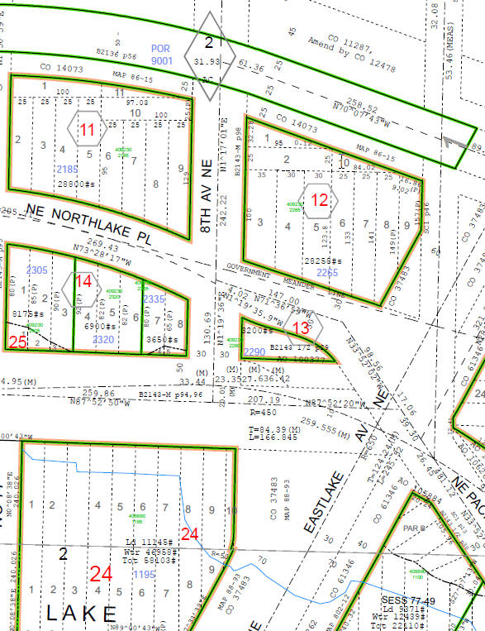

**Street view from NE Northlake Way** **[Street view from 8](\\\\cosfs01\\fas\\data\\RES\\PMA by Number\\PMAs 4000-4999\\PMA 4077  805 NE Northlake PL\\Photos\\St-View-1.jpg)[th](\\\\cosfs01\\fas\\data\\RES\\PMA by Number\\PMAs 4000-4999\\PMA 4077  805 NE Northlake PL\\Photos\\St-View-1.jpg) [Ave. NE and NE Northlake Place](\\\\cosfs01\\fas\\data\\RES\\PMA by Number\\PMAs 4000-4999\\PMA 4077  805 NE Northlake PL\\Photos\\St-View-1.jpg)**

**History:** The City acquired the property in 1971 as part of the Northeast Pacific Street Relocation. The street relocation was related to the University Addition-Northlake Urban Renewal Project (Wash. R-8). The Urban Renewal plan was first approved in 1963 and later amended. In 1974, the City Council made a final determination on the route of Northeast Pacific Street which did not directly affect this parcel. The property was never laid off and established as a street, and does not require a street vacation. In 1989 City Council authorized the sale of the property through a competitive bid or negotiated sale. The City adopted disposition policy resolutions, which requires this property to be reviewed under those guidelines.

**Legal Description:** Lots 1, 2, and 3, Block 13, Lake View Addition, according to the plat recorded in Volume 5 of plats, page 34, in King County, Washington, less portion for street.

|  |  |  |
| --- | --- | --- |
| **Selected Ordinances** | | |
| **Ord #** | **Date** | **Description** |
| [37483](http://clerk.seattle.gov/~archives/Ordinances/Ord_37483.pdf) | 1917 | Lays off Eastlake Avenue from south line Block 24, Lake Union Shore Lands to Tenth Ave NE. (Includes portions of lots 1,2, and 3, Block 13 Lake View Add lying south of a line 100 feet north of and parallel with the north line of Block 24, Lake Union Shore Lands. |
| [95877](http://clerk.seattle.gov/~scripts/nph-brs.exe?s1=95877&Sect4=AND&l=MAX&Sect1=IMAGE&Sect2=THESON&Sect3=PLURON&Sect5=LEGI2&Sect6=HITOFF&d=LEGA&p=1&u=http%3A%2F%2Fclerk.seattle.gov%2F~public%2Flegisearch.htm&r=3&f=G) | 1966 | Authorizes acquisition of property for relocation of NE Pacific Street between Latona Ave Northeast and 15th Avenue NE and appropriates funds from the Arterial City Street Fund. |
| [100377](http://clerk.seattle.gov/~archives/Ordinances/Ord_100377.pdf) | 1971 | Ordinance accepted the property – Lots 1,2 and 3, Block 13, Lake View Add except portion lying south of a line 100 feet north of and parallel with the north line of Block 24, Lake Union Shore Lands and any portion of Lot 3 lying within Northlake Ave (now known as Northlake Place) --from E.F. and Amelia Pugsley for street purposes. Does not lay off and established as a street. |
| [114502](http://clerk.seattle.gov/~scripts/nph-brs.exe?s1=114502&Sect4=AND&l=MAX&Sect1=IMAGE&Sect2=THESON&Sect3=PLURON&Sect5=LEGI2&Sect6=HITOFF&d=LEGA&p=1&u=http%3A%2F%2Fclerk.seattle.gov%2F~public%2Flegisearch.htm&r=2&f=G) | 1989 | This parcel and several others are authorized for sale as they were acquired for the purpose of relocating NE Pacific Street and are no longer needed. |

**Acquisition Deeds:** a deed from E.F. Pugsley and Amelia Pugsley for $11,500 dated 1/18/1971. Recording Number 197101260229

**Acquisition Fund Source:** Arterial City Street Fund

**Destination of funds upon sale:** Arterial City Street Fund

**Jurisdictional Department’s estimated market value:** Similar zoned properties have King County taxed assess value that ranges between $60 and $90 a square foot for land value. The existing building has no value, and attributes a negative value to the property. The Department of Finance and Administrative Services has estimated the value for an environmentally clean and vacant site would sell between $170,000 and $288,000. The jurisdictional value will be determined by appraisal.

**Current easements, covenants and restrictions:**

The City has a current 5-year lease with tenant Theodore Jonsson, expiring on 10/31/2019. Mr. Jonsson has occupied the property since before the City’s acquisition. There are no options or renewals in the lease. Mr. Jonsson is not eligible for relocation assistance under City policies. Improvements on the property encroach into the street right-of-way at several points.

**Recommended easements, covenants and restrictions upon Transfer:**  None

**Potential problems with property and possible measures to mitigate their recurrence:**

* The Seattle Department of Transportation has identified the need for sidewalk improvements along NE Northlake Way adjacent to PMA 4077. The project is currently unscheduled.
* Due to changes in the street right of way and real property lines that occurred through legislative actions surveyed property lines are not located on the ground. There may be other encroachments into the right of way existing building. Additional title research and survey will be necessary prior to drafting sales legislation.
* The property was acquired by the City without the benefit of a phase I environmental report. In addition the property has been used in the fabrication of metal sculptures for 40 plus years. No records are available for use of solvents or other common metal fabrication material is available. To limit the City’s liability, phase II evaluation of the subsurface conditions will need to be completed prior to sale.

**Neighborhood:** University District

**Building Information:** 1,248 square foot masonry building with metal roof.

**Nearby Property Owners:**

|  |  |
| --- | --- |
| 4092302265  814 NE Northlake PL  University of Washington | 4092302265  730 NE Northlake Way  University of Washington |
| 4092302185  714 NE Northlake PL  University of Washington | 4088801195  705 NE Northlake Pl  Washington Boat Center |

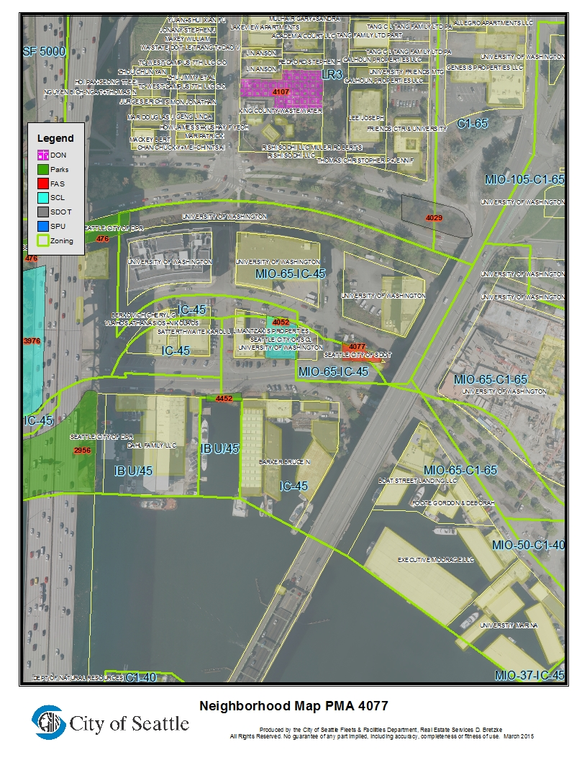

**Appendix B**

|  |  |  |  |  |  |  |  |
| --- | --- | --- | --- | --- | --- | --- | --- |
| **PROPERTY REVIEW PROCESS DETERMINATION FORM** | | | | | | | |
| Property Name: | | Building at 805 NE Northlake Pl | | | | | |
| Address: | 805 NE North Lake Pl | | | | | | |
| PMA ID: | PMA. 4077 | | Parcels No. 409230 2290 | |  | | |
| Dept./Dept ID: | SDOT | | | Current Use: | Warehouse space | | |
| Area (Sq. Ft.): | 2,875sq. | | | Zoning: | MIO 65-IC 45 | | |
| Est. Value: | $ 170,000- $288,000 | | | Assessed Value: | $ NA | | |
| **PROPOSED USES AND RECOMMENDED USE** | | | | | | | |
| *Department/Governmental Agencies:*  *University of Washington* | | | | *Proposed Use: None* | | | |
|  | | | |  | | | |
| *Other Parties wishing to acquire:* | | | | *Proposed Use:* none | | | |
|  | | | |  | | | |
| RES’S RECOMMENDED USE:  Sell through negotiate sale to the University of Washington. | | | | | | | |
| **PROPERTY REVIEW PROCESS DETERMINATION** (circle appropriate response) | | | | | | | |
| 1.) Is more than one City Dept. /Public Agency wishing to acquire? | | | | | | No / Yes | 15 |
| 2.) Are there any pending community proposals for Reuse/ Disposal? | | | | | | No / Yes | 15 |
| 3.) Have citizens, community groups and/or other interested parties contacted the City regarding any of the proposed options? | | | | | | No / Yes | 15 |
| 4.) Will consideration be other than cash? | | | | | | No / Yes | 10 |
| 5.) Is Sale or Trade to a private party being recommended? | | | | | | No / Yes | 25 |
| 6.) Will the proposed use require changes in zoning/other regulations? | | | | | | No /Yes | 20 |
| 7.) Is the estimated Fair Market Value between $250,000-$1,000,000? | | | | | | No / Yes | 10 |
| 8.) Is the estimated Fair Market Value over $1,000,000? | | | | | | No/ Yes | 45 |
| Total Number of Points Awarded for "Yes" Responses: | | | | | |  | **35** |
| Property Classification for purposes of Disposal review: Simple Complex (circle one) (a score of 45+ points result results in a “simple” classification)  Signature: Daniel Bretzke, AICP Department: FAS Date: December 3, 2015 | | | | | | | |

Appendix D

Parties of Record

|  |  |  |  |
| --- | --- | --- | --- |
| Name | Email | Address/Company | Phone |
| Gary Eng | Gary Eng <geng@uw.edu> | University of Washington | 206 616 3415 |
| Sherry Capes | <Sherry@lproperties.com> | Limantzakis Properties | 206-632-1222 |
| Cheng-Nan Lin | LINCCA@aol.com |  | 206-914-8549 |
| Anson Lin | Anson Lin <al367@cornell.edu> |  | 206 313 8848 |
| Pree Carpenter | Pree.Carpenter@seattle.gov | SPU |  |
| Ken Astrein | Ken.Astrein@seattle.gov | HSD |  |
| Larry Huggins | [Larry.huggis@seattl.gov](mailto:Larry.huggis@seattl.gov) | SDOT |  |