***DRAFT***

***Preliminary Recommendation Report***

***On Reuse and Disposal of the***

**Seattle City Light Excess Property**

**PMA 4052 Former University Substation**

**December 3, 2015**

**Purpose of Preliminary Report**

In response to a City of Seattle Jurisdictional Department identifying a property as “Excess” to their needs, the Real Estate Services (RES) section of the Department of Finance and Administrative Services (FAS) initiates a process to review and evaluate various options for the property. RES prepares a report titled “Preliminary Recommendation Report on the Reuse and Disposal of Excess Property”, which documents the Department’s analysis and recommendations. This report is prepared in accordance with City of Seattle Council Resolution [29799](http://clerk.seattle.gov/~scripts/nph-brs.exe?s1=&s3=29799&s2=&s4=&Sect4=AND&l=20&Sect2=THESON&Sect3=PLURON&Sect5=RESNY&Sect6=HITOFF&d=RESF&p=1&u=%2F%7Epublic%2Fresny.htm&r=1&f=G), as modified by Resolution [30862](http://clerk.seattle.gov/~scripts/nph-brs.exe?s1=&s3=30862&s2=&s4=&Sect4=AND&l=20&Sect2=THESON&Sect3=PLURON&Sect5=RESNY&Sect6=HITOFF&d=RESF&p=1&u=%2F%7Epublic%2Fresny.htm&r=1&f=G).

**Executive Recommendation**

(FAS) recommends that the property to be offered for sale to the University of Washington through a negotiated sale at fair market value. If a negotiated sale with University of Washington is not completed, then property should be sold at fair market value through an open and competitive process.

**Background Information**

The property is under the jurisdiction of Seattle City Light (SCL). This property is located at 711 NE Northlake Place and is located between NE Northlake Way and NE Northlake Pl. (See Appendix A for a detailed property description) The property was purchased in 1940 and a building was constructed in 1941 to provide electric power to Seattle electric trolley cars. Additional property was purchased in 1946 and the building was further expanded in 1953. In the 1960’s the building was decommission for electrical power uses. The property is currrently used as a Seattle City Light landscape maintenance yard.

**Reuse or Disposal Options Evaluation Guidelines**

City of Seattle Resolution 29799, Section 1, requires the Executive to make its recommendation for the reuse or disposal of any property that is no longer needed by a department using the following guidelines.

# Guideline A: Consistency

*The analysis should consider the purpose for which the property was originally acquired, funding sources used to acquire the property, terms and conditions of original acquisition, the title or deed conveying the property, or any other contract or instrument by which the City is bound or to which the property is subject, and City, state or federal ordinances, statues and regulations.*

***Funding Sources:*** The property was purchased with monies from the City Light Fund.

***Purpose for which property was acquired:*** For an electrical substation to provide electricity for electric trolleys.

***Deed or contractual restrictions:*** The property is not bound by any other contracts or instruments.

***City, State or Federal Ordinance status and regulations including, Bond, grant or loan programs, State Accountancy Act, Payment of True and full value, Zoning and land use, Comprehensive Plan, and Other plans:***

State Law requires government organizations to receive fair market value for the disposal of surplus real property. The fair market value can be determined by an appraisal, or through an open competitive sales process. The City of Seattle incurs costs associated with the disposition process including staff time, public notice expenses and real estate transactions costs. FAS will be reimbursed for expenses incurred in the sale of the property as provided in a memorandum of agreement.

The property is located in the [University Campus Urban Village](http://www.seattle.gov/Documents/Departments/Neighborhoods/Planning/Map/University-map.pdf) and is subject to zoning incentives and restrictions.

The property is currently zoned IC-40 which allows for a wide range of industrial uses.

# Guideline B: Compatibility and Suitability

*The recommendation should reflect an assessment of the potential for use of the property in support of adopted Neighborhood Plans; as or in support of low-income housing and/or affordable housing; in support of economic development; for park or open space; in support of Sound Transit Link Light Rail station area development; as or in support of child care facilities; and in support of other priorities reflected in adopted City policies.*

***Neighborhood Plan:*** The property is located in the University Campus Urban Village. The property is close to Lake Union and near the Wallingford neighborhood. The neighborhood includes buildings that vary in age and size, although predominantly the area includes industrial and warehouse spaces. [The University Of Washington Master Plan, Seattle Campus](http://www.washington.edu/community/?p=89%E2%80%8B)  was approved in 2003 by the Seattle City Council and the University Board of Regents. This property lies across the street from property that is included in the Major Institutional Overlay zoning. Development of this property is regulated by City Seatttle zoning and development codes.

***Housing and Economic Development:*** Sale of the property to the University of Washington will allow the University to consolidate this parcel with an adjacent parcel that they own. Subsequent development of the property either by the University of Washington or by a private property will increase economic activity in the City. The sale of the property to a private owner would return the property to the active tax rolls. As the property is located in an industrial zone, it is unlikely that the property could not be developed for housing.

***Nearby City owned property:*** There are no City-owned properties which are contiguous with this parcel. There is one City-owned excess property located on Northlake Place, and it is currently being reviewed for reuse or disposition. A map showing nearby City properties is included with the attached Excess Property Description.

***Other City Uses***: In October 2015, an Excess Property Notice for this property was circulated to City of Seattle Departments. City Departments were asked to evaluate the property for current or future city uses of the property. FAS/RES received Excess Property Response Forms indicating no interest from the following departments or public agencies: the Human Services Department, Parks, Seattle Public Utilities, and Seattle Department of Transportation.

***Other Agencies Uses*:** An Excess Property Notice for this property was circulated in October 2015 to assess other agencies’ interest. The University of Washington has expressed an interest in purchasing the property at fair market value*.*

***Range of Options***

The “Guiding principles for the Reuse and Disposal of Real Property” state, “it is the intent of the City to strategically utilize real property in order to further the City’s goals and to avoid holding properties without an adopted municipal purpose.” The options for disposition of this property include retention by the City for a public purpose, negotiated sale with a motivated purchaser, market sale, or through a request for proposal process.

***Transfer of Jurisdiction to other City Department:*** No other City Department expressed a current or future need for the property.

***Negotiated Sale*:** A negotiated sale is typically recommended when the selection of a particular purchaser has specific benefits to the City. In this case a negotiated sale with the University of Washington would allow would provide a fair market value price for the property and would assist the University of Washington in acquiring property that is adjacent to property that they own.

***Sale through an open competitive process:*** A sale through a public competitive process would allow the market to determine the optimum price for the property. It is likely that a sale on the open market would result in the sale of the property.

***Request for Proposal Process:*** This process is used when specific development goals are desired. At this time it does not appear that a specific City goal has been identified for the future use of this property.

***Guideline C: Other Factors***

*The recommendation should consider the highest and best use of the property, compatibility of the proposed use with the physical characteristics of the property and with surrounding uses, timing and term of the proposed use, appropriateness of the consideration to be received, unique attributes that make the property hard to replace, potential for consolidation with adjacent public property to accomplish future goals and objectives, conditions in the real estate market, and known environmental factors that may affect the value of the property.*

***Highest and Best Use*:** The Highest and Best Use is generally defined as the reasonably probable and legal use that produces the highest property value. The highest and best use is determined by evaluating potential uses as follows:

* ***Legally permissible****:* The subject property is zoned IC-40 which is an industrial and commercial zone.
  + ***Physically possible****:* The property is flat and contains a building. Future development is physically possible.
* ***Financially feasible and maximally productive:***The property is currently used for Seattle City Light landscaping operations. With future development, the property could be more productive.

The highest and best of the property could be r commercial, industrial, or institutional uses as allowed under the current zoning.

***Compatibility with the physical characteristics and surrounding uses*:** The property is surrounded by other developments that vary in size. The range of options in the zoning code allow for a variety of development options.

***Appropriateness of the consideration:*** Sale of the property at fair market value through a negotiated sale or competitive sale process will result in the City receiving the fair market value of the property.

***Unique Attributes*:** The property has a former Seattle Light substation, which is unique in that it was built for a specific use that is no longer needed.

***Potential for Consolidation with adjacent public property*:** The property could be consolidated with adjacent University of Washington property.

***Conditions in the real estate market*:** The real estate market in the City of Seattle remains fairly stable, and there has been a great demand for new development.

***Known environmental factors:*** Seattle City Light has performed a variety of environmental review for the property. The following reports are available for review on the RES web site.

* Phase I and Limited Phase II Environmental Site Assessment for University Substation, Dated 10/5/2011.
* Memorandum regarding University Rectifier Property Environmental Status, Dated 1/27/2015.
* On Site Environmental Inc. analytical results and associated quality control, Dated 1/13/2011.

***Guideline D: Sale***

*The recommendation should evaluate the potential for selling the property to non-City public entities and to members of the general public.*

***Potential for Use by Non-City Public Entities:*** The University of Washington has requested to purchase the property.

***Public Involvement:*** In accordance with Resolution Nos. 29799 and 30862, in March 2014, a notice concerning disposition or other use of this property was sent to all business, residents and property owners within a 1,000 foot radius of the subject property. A total of 477 notices were mailed. Three responses from the public regarding this property were received. The responses where from parties interested in purchasing the property.

***Threshold Determination***

*The Disposition Procedures require FAS assess the complexity of the issues on each excess property following the initial round of public involvement. The purpose of this analysis is to structure the extent of additional public input that should be obtained prior to forwarding a recommendation to the City Council.*

The Disposition Procedures provide that FAS assesses the complexity of the issues on each excess property following the initial round of public involvement. The purpose of this analysis is to structure the extent of additional public input that should be obtained prior to forwarding a recommendation to the City Council. Appendix B is the Property Review Process Determination Form prepared for PMA 4052, the Former University Substation. The disposition of this property is determined to be a “simple” transaction. No additional public involvement is required other than the notice process describe below.

***Next Steps***

FAS will publish the Preliminary Report on the RES website and sent to the parties of record as listed in Appendix D.

FAS will post a notice board on the property to that includes information about the published preliminary recommendations report and collect responses.

The City Real Estate Oversight Committee (REOC) reviews in the recommendation in the Preliminary Report.

After 30 days comment period, FAS will review comments and publish a Final Report.

Seattle City Light will include the Final Report with the legislation necessary to implement the final recommendation for the excess property.

A public hearing is required for the sale of this property as it is a utility owned property.

No Council decision will be made for at least 30 days following a notice of legislation and notice of public hearing is announced and sent to the parties of record list. FAS will continue to collect all comments regarding the property.

**Appendix A**

**EXCESS PROPERTY DESCRIPTION**

**Former University Substation**

**October 16, 2015**

Seattle City Light as the Jurisdictional Department of this City owned property has identified the following information about this excess property.

|  |  |  |  |  |  |  |
| --- | --- | --- | --- | --- | --- | --- |
| PMA | Parcel Size | Parcel # | Address | Zoning | 2015 Estimated value | Short Legal Description |
| 4052 | 6,900 | 409230-2320 | 711 NE Northlake Pl. 98105 | IC 40 | $500,000 | Lots 4, 5, 6 block 14 Lake View Addition, according to the plat recorded in Volume 5 of plats , page 34, in King County, Washington, |

**Map:**

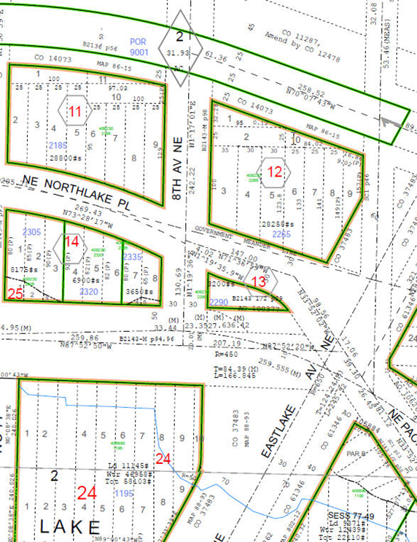

**History:** The property was purchased in 1940 and a building was constructed in 1941 to provide electric power to Seattle electric trolley cars. Additional property was purchased in 1946 and the building was further expanded in 1953. In the 1960’s the building was decommission for electrical power uses. The property has been used a landscape maintenance yard.

**Acquisition Deeds:**

August 26 1940, City of Seattle from James and Alice Chambers, Lot 5 and 6, Block 14 Lake View addition to City of Seattle, volume 5, and page 34 with portion of block 24 Lake Union Shore Lands as condemned in KC Superior Court Cause No 125369

Lots

September 23 1946 City of Seattle, Department of Lighting, from the Ice Delivery Co. Lot 4, Block 14 Lake View addition to City of Seattle, volume 5, page 34 with portion of block 24 Lake Union Shore Lands as condemned in KC Superior Court Cause No 125369

**Ordinance:** 70175 Relating to the Department of Lighting; providing for the acquisition of a site for a substation, and making an appropriation therefor from surplus in the Light Fund.

**Acquisition Fund Source:** Light Fund

**Destination of funds upon sale:** Seattle City Light Fund, Fund No. 41000

**Current easements, covenants and restrictions:** State Law requires government organizations to receive fair market value for the disposal of surplus real property.

**Recommended easements, covenants and restrictions upon Transfer:**

**Potential problems with property and possible measures to mitigate their recurrence:**

A phase I and a limited phase II report was prepared by Shannon and Wilson in 2011

**Building and Property Description**

Use: The building is currently used for landscaping maintenance

Building size: 1,644 gross square feet

Built: 1941 and 1946

**Legal Description**

LOTS 4, 5 AND 6 IN BLOCK 14 OF LAKE VIEW ADDITION TO THE CITY OF SEATTLE, ACCORDING TO THE PLAT RECORDED IN VOLUME 5 OF PLATS AT PAGE 14, IN KING COUNTY, WASHINGTON;

EXCEPT THOSE PORTIONS OF SAID LOTS LYING SOUTH OF A LINE WHICH IS DISTANT 100 FEET NORTH FROM AND PARALLEL TO THE NORTH LINE OF BLOCK 24, LAKE UNION SHORE LANDS, HERETO CONDEMNED IN KING COUNTY SUPERIOR COURT CAUSE NO. 125369 AND FURTHER DESCRIBED IN CITY OF SEATTLE ORDINANCE NO. 3748

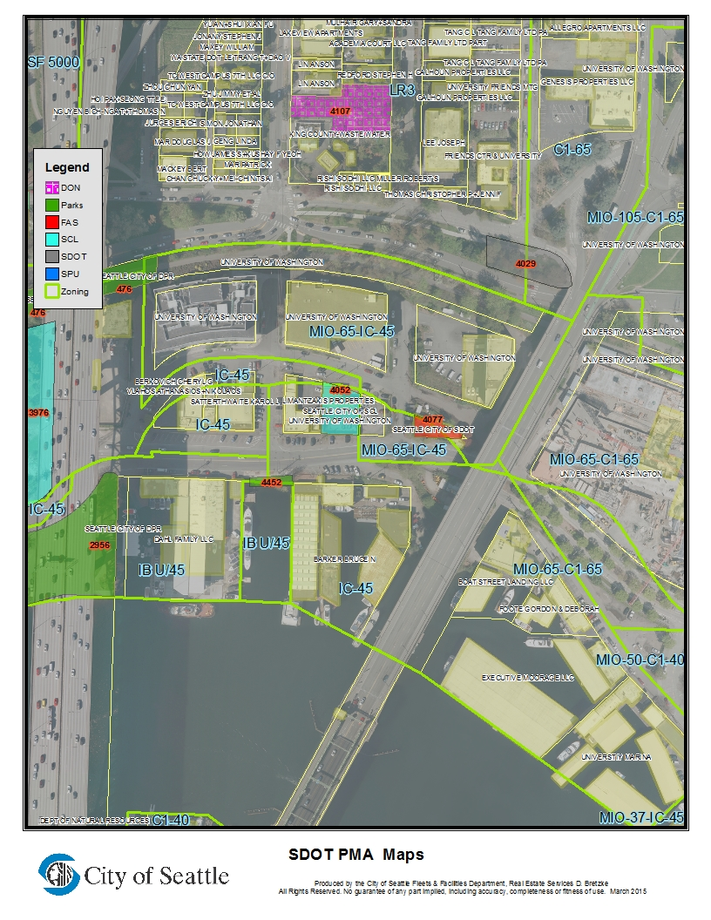

**Appendix B**

|  |  |  |  |  |  |  |  |
| --- | --- | --- | --- | --- | --- | --- | --- |
| **PROPERTY REVIEW PROCESS DETERMINATION FORM** | | | | | | | |
| Property Name: | | Former University Substation | | | | | |
| Address: | 711 NE Northlake Place 98105 | | | | | | |
| PMA ID: | PMA. 4052 | | Parcels No. 409230-2320 | |  | | |
| Dept./Dept ID: | SCL | | | Current Use: | Landscape Maintenance | | |
| Area (Sq. Ft.): | 6,900 sq. ft. | | | Zoning: | IC 40 | | |
| Est. Value: | $ 450,000- $550,000 | | | Assessed Value: | $ NA | | |
| **PROPOSED USES AND RECOMMENDED USE** | | | | | | | |
| *Department/Governmental Agencies: University of Washinton* | | | | *Proposed Use: Support of UW operations.* | | | |
|  | | | |  | | | |
| *Other Parties wishing to acquire:*  Adjacent property owner | | | | *Proposed Use:* | | | |
|  | | | |  | | | |
| RES’S RECOMMENDED USE:  Sell through negotiate sale to the Universtity of Washington or if a sale is not completed, then sell at fair market value through a competitive process. | | | | | | | |
| **PROPERTY REVIEW PROCESS DETERMINATION** (circle appropriate response) | | | | | | | |
| 1.) Is more than one City Dept. /Public Agency wishing to acquire? | | | | | | No / Yes | 15 |
| 2.) Are there any pending community proposals for Reuse/ Disposal? | | | | | | No / Yes | 15 |
| 3.) Have citizens, community groups and/or other interested parties contacted the City regarding any of the proposed options? | | | | | | No / Yes | 15 |
| 4.) Will consideration be other than cash? | | | | | | No / Yes | 10 |
| 5.) Is Sale or Trade to a private party being recommended? | | | | | | No / Yes | 25 |
| 6.) Will the proposed use require changes in zoning/other regulations? | | | | | | No /Yes | 20 |
| 7.) Is the estimated Fair Market Value between $250,000-$1,000,000? | | | | | | No / Yes | 10 |
| 8.) Is the estimated Fair Market Value over $1,000,000? | | | | | | No/ Yes | 45 |
| Total Number of Points Awarded for "Yes" Responses: | | | | | |  | **35** |
| Property Classification for purposes of Disposal review: Simple Complex (circle one) (a score of 45+ points result results in a “simple” classification)  Signature: Daniel Bretzke, AICP Department: FAS Date: December 3, 2015 | | | | | | | |

Appendix D

Parties of Record

|  |  |  |  |
| --- | --- | --- | --- |
| Name | Email | Address/Company | Phone |
| Gary Eng | Gary Eng <geng@uw.edu> | University of Washington | 206 616 3415 |
| Sherry Capes | <Sherry@lproperties.com> | Limantzakis Properties | 206-632-1222 |
| Cheng-Nan Lin | LINCCA@aol.com |  | 206-914-8549 |
| Anson Lin | Anson Lin <al367@cornell.edu> |  | 206 313 8848 |
| Pree Carpenter | Pree.Carpenter@seattle.gov | SPU |  |
| Ken Astrein | Ken.Astrein@seattle.gov | HSD |  |
| Larry Huggins | [Larry.huggins@seattl.gov](mailto:Larry.huggins@seattl.gov) | SDOT |  |