EXCESS PROPERTY DESCRIPTION

July 30, 2015

The Department of Finance and Administrative Services, as the Jurisdictional Department of this City owned property has identified the following information about this excess property.

**Property Name:**  Snippet at 1060855th Ave South

|  |  |  |  |  |  |  |
| --- | --- | --- | --- | --- | --- | --- |
| PMA | Building Size | Lot Size | Parcel # | Address | Zoning | 2015 Est. Value |
| 1656 | Snippet | 1,419 sf | Portion of 9368700111 | 1060855th Ave South | SF 7200 | $5,000-$7,000 |

PMA 1656

**Map:** 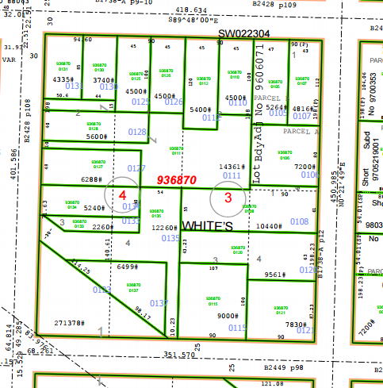

PMA 4522

**History:** This property was acquired by the City through a local improvement assessment foreclosure as a result of a judgment in King County Court on December 22, 1976, and was transferred to the City of Seattle Treasury through a local improvement assessment deed dated May 15, 1979. For purposes of property management, the City of Seattle Department of Finance and Administrative Services created two property management area numbers (PMA) to reflect that the deed and tax parcel are two properties separated by other tax parcels. PMA 4522 is a larger undeveloped parcel to be disposed through a separate process. PMA 1656 is a smaller parcel that is currently used for driveway access for the house at 10610 55th Ave South.

**Documents:**

7/14/1967, 95943, AN ORDINANCE providing for the improvement of South Spencer Street from Beacon Avenue South to 28th Avenue South; and certain other streets and avenues.

5/9/1972, SC 710272, King County Superior Court cause action SC 710272

**Acquisition Deeds:** 5/15/1979, 197912310591, Fee simple deed transfer, From Seattle City Treasure to Seattle Executive Services Department, Recording Number AF 197912310591.

**Acquisition Fund Source:**  General Fund. The transfer from

**Jurisdictional Department’s estimated market value:**

FAS determines value based upon the following factors:

* 1. Previous one year vacant property sales within 2 miles of the subject property
  2. Adjacent King County assessed land value on per square foot basis
  3. Either positive or negative factors for unique topography, property dimensions and shape
  4. Evaluation of potential added development capacity if combined with adjacent property.
  5. Perpetual easements or reservations for slope easements or native vegetation.

A review has been conducted as summarized below:

* 1. The value of separate vacant building lots ranges from between $6 and $15 per square foot.
  2. The average of the adjacent lots is valued by the King County Assessor at $13.63 per square foot
  3. The property contains a driveway, trees, and deck from adjoining neighbor.
  4. The property is not developable due to property small size.
  5. The property contains some steep slopes.

The 2015 value of PMA 1656 is based upon a 50% of the average price per square foot of an adjacent developable parcel. As the parcel is encumbered with a drive way easement, the value is further adjusted. The value range for PMA 1656 is $5,000- $7,000

**Destination of funds upon sale:**  A portion to the Facility Services Sub-fund for expenses relating to sale of property, the remainder to general fund.

**Current easements, covenants and restrictions:**  Unrecorded access easement.

**Recommended easements, covenants and restrictions upon Transfer:**  A sale of PMA 1656 will require a King County tax parcel segregation from PMA 4522, and may require a lot line adjustment to allow for the reconfiguration of the property lines,

**Potential problems with property and possible measures to mitigate their recurrence:** The access has been used by the adjacent property owner for multiple years, and an easement may be negotiated for continued shared access.

**Neighborhood:** Rainier Beach and Skyway

**Legal Descriptions:**

Snippet PMA 1656

Lot 2 of Block 4,

less the north 85 feet, and less the south 98 feet, located in

Whites Rainer Beach Gardens Addition, Volume 13 Page 38 of plats recorded in King County Washington,

**Adjacent Property Owners:**

9368700128 936870-0125

Murray, Jacqueline Kwong, So Ying

10610 55th Ave S. 5611 S Bangor St

Seattle, WA 98178 Seattle, WA 98178

Land value $71,00, $12.6 per sf Land Value $64,000, $14.50 per sf

936870 0131 9368700130

Morningstar, Sarah Emerald Real Estate Solution

5503 S Bangor St 5507 S Bangor St

Seattle, WA 98178 Seattle, WA 98178

Land value: $56,00, $12.93 per sf Land value: $ 67,00 $14.50 per sf