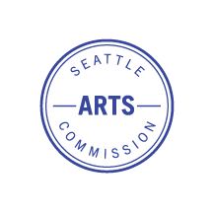

SEATTLE ARTS COMMISSION
Minutes
Monthly Meeting
Tuesday, July 8, 2025
Virtual Meeting
(Only Zoom due to tech issues in conference room)

Commissioners present: Kayla DeMonte, Holly Jacobson, Yoon Kang-O’Higgins, Avery Barnes, Ed King, Kate Nagle-Caraluzzo, Ricky Graboski, Yolanda Spencer, Dhyana Garcia, Linda Lowry, Leslie Anderson, Vanessa Villalobos, Ed King, Jo Mikesell, Carmen Pan
Staff in attendance: Allie Lee, Gülgün Kayim, Kelly Davidson, Alex Rose, Pinky Estell, Kathy Hsieh
Guests: Manny Cawaling, Jessi Wasson

Call to Order, Introduction, Land Acknowledgement (4:07)
- Holly called the meeting at 4:04pm
- Spotlight on local Indigenous artists (Yolanda) – Jamie John

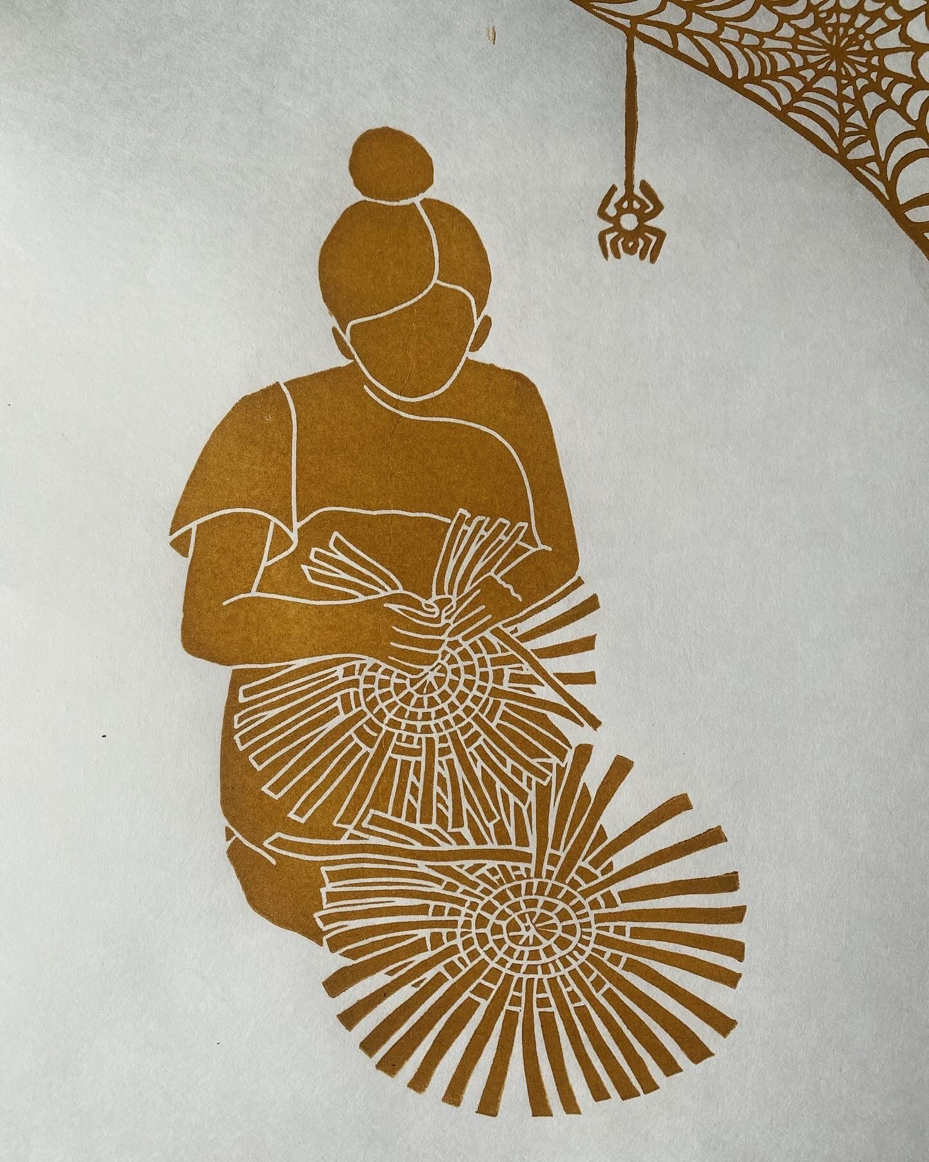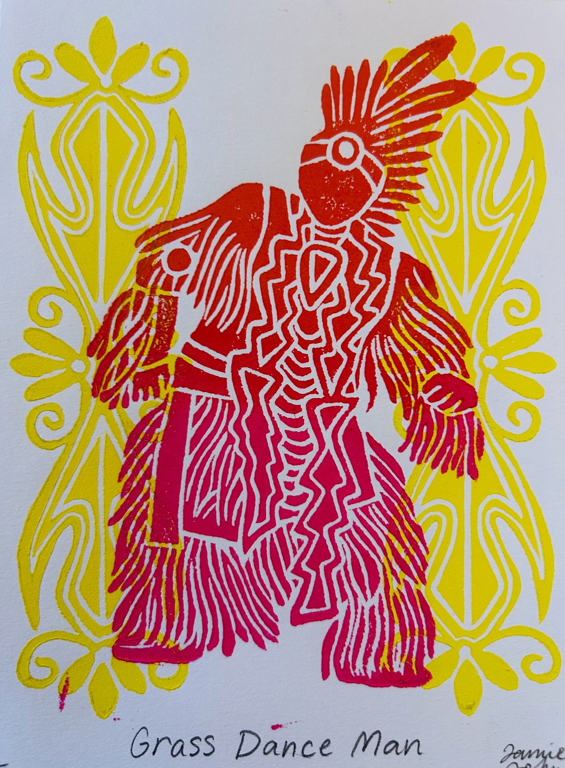

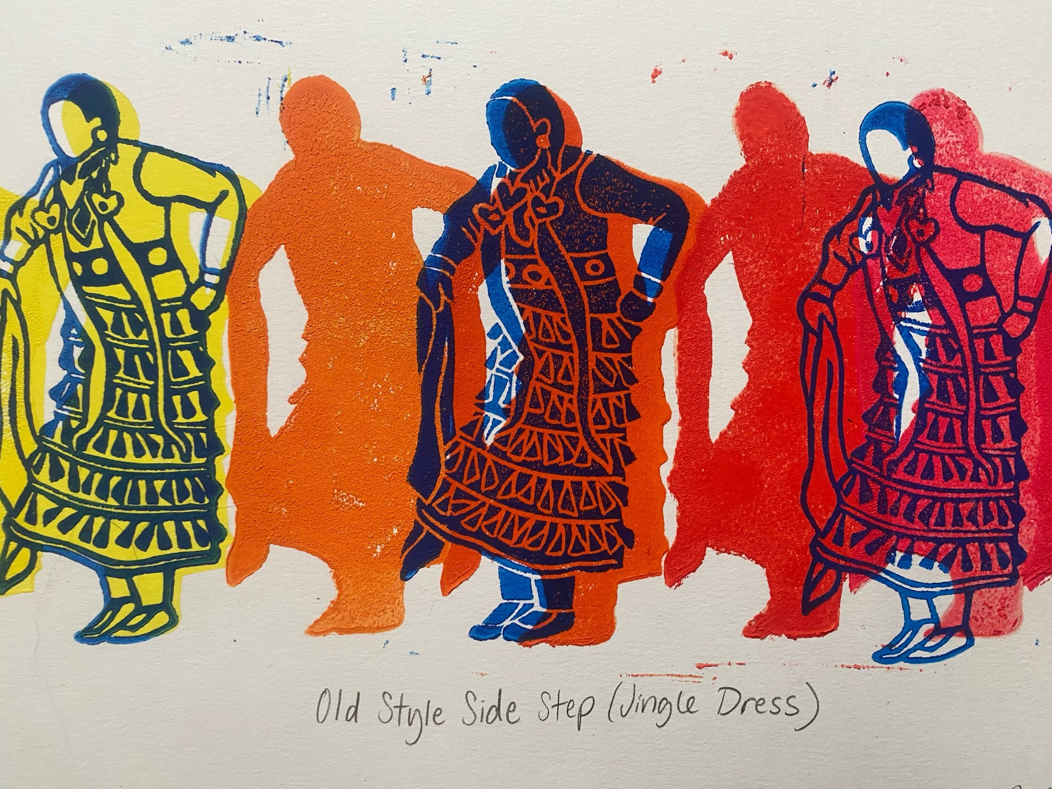
  - https://unitedindians.org/seafairpowwow/
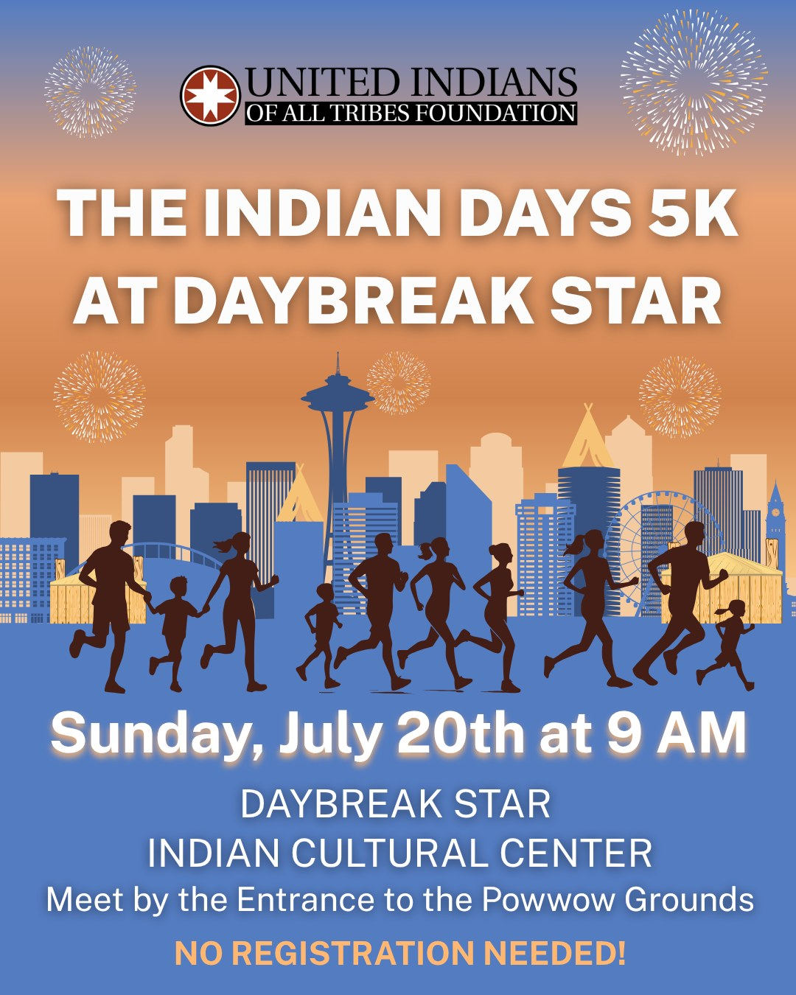
- Approval of minutes
  - Linda moved to approve the June minutes. Leslie seconded the motion. Approved.
- Public Comment:
  - No public comment.

Directors Report
Briefing: Gülgün Kayim, Kelly Davidson
- 2025 grant opportunities https://artbeat.seattle.gov/2025/02/04/2025-grants-and-funding-opportunities/
- ARTS staff retreat on 7/24 (Th) at Seattle Art Museum
- Gülgün will present Jo Mikesell at Council Committee on 7/11 (F) to be confirmed as a new SAC member
- World Cup Community Celebrations panel information (see email language that has been sent out to SAC):
Hi SAC members,

We are in the process of building the selection panel for a grant program that will fund 2026 World Cup Community Celebrations throughout the city, and would like to see if you are interested in serving as a panelist to help select between 7-14 awardees. Your perspective as a leader in the arts community would be valued in this process. If there is someone with experience producing events, that would be a well aligned bonus.
ARTS does not usually seek SAC members as panelists, however this is a unique project for the World Cup event in 2026. It is being closely monitored by the Mayor’s Office, so we are seeking someone from the SAC to participate.
We are planning to hold the panel orientation online (~3 hours) on Weds. July 23, then have our all-day panel deliberation day (roughly 9am-4pm) on either Tues. August 19 or Weds. August 20 (TBD on whether it will be in person, hybrid, or online). Between the orientation and deliberation dates you would be responsible for reviewing and scoring applications online, on your own time.
As compensation for your time and effort, we would offer you a panelist review fee of at least $600 (actual amount will be determined prior to orientation once we know how many applications we will ask you to review). This fee includes:
  - $110 for ½ day (approximately 3 hours) for orientation on 7/23
  - $220 for full day (approximately 8 hours) for panel deliberation on 8/19 or 8/20
  - Compensation for application reviews (TBD)
Are you interested in serving on the selection panel? If so, what is your availability like on the above dates?

Inspire WA Intro Session
Briefing: Manny Cawaling, Jessi Wason
- Slideshow presentation shared with group
  - “Strengthening, Envisioning, and Activating: An overview of our work together”
- Overview of Inspire WA and its partnership work with SAC
  - Process, impact, scope of work
- Definitions
  - Seattle’s boards and commissions, Seattle Arts Commission
  - Prompt questions

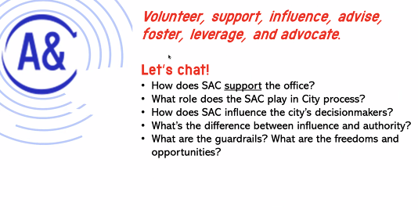
- Next steps
  - Deep dive at SAC retreat in August
  - Homework – review materials on role and purpose of an Arts Commissioners, ARTS’s dedicated revenue, and City of Seattle budget process
  - Inspire WA plans to check in with commissioners before retreat to make sure SAC understands the material – group Zoom, individual Zoom/coffee
SAC Questions and Comments:
- Ed, Avery – Excited about this opportunity; excited about the communication tool
- Vanessa – re: us as a body, we represent underrepresented voices/subcommunities – finds beauty and hope in that, everyone here brings something unique, love the analogy of the basket weaving and doing it together.
- Response to prompt questions by Inspire WA
  - Ed - Interested in learning about the guardrails.
    - Manny - Yes, we will get into that at the retreat. ARTS does the work, and SAC volunteers and influences. Working with a government body/bureaucracy.
  - Kate - How does SAC sit at the center of the ecosystem – like city planning, creative economy, etc. How do we move forward together as a commission – influence other areas, not just Mayor/Council.
  - Manny will send these questions to ponder until the retreat
- Kayla – This is a unique opportunity for the time we are in and excited to collaborate and dig in.

Co-Chairs Report
Briefing: Kayla DeMonte
- August retreat
  - Same day as regular meeting day, but will happen over the latter half of the day
  - Town Hall Seattle – thank you Kate for providing the venue!
  - 8/12 1-5pm
- Rodney King has stepped down as commissioner
- Uptown Art and Culture district reached out; their VP, Cyrus, has been talking about leading the charge on a candidate forum on behalf of ALL Arts & Cultural Districts and wants to collaborate with SAC and Inspire WA.
  - We should put arts and culture districts overview/deep dive on SAC agenda
    - https://www.seattle.gov/arts/programs/cultural-space/arts-and-cultural-districts
  - SAC voted yes to do this. Holly will reach out to Cyrus to see if we can all join forces
    - We are keeping it just SAC, and not Seattle Film Commission and Seattle Music Commission because we have different agendas.
      - Linda - It would still be beneficial to collaborate with the Film commission.
- As elections are coming up, noting that SAC does not endorse a candidate, no one can speak on behalf of SAC without permission - there are practical and legal reasons. Also if you are sponsoring or hosting a fundraiser, promoting an event, that is not sanctioned by ARTS or SAC you cannot use your title as Arts Commissioner.
- As a body we need to start thinking about new co-chairs for SAC. Kayla and Holly are rolling off at the end of year. Also committee co-chairs will be needed for PAAC and FED/CPC.
Committee Overview
Briefing: Committee Co-Chairs
- FED Committee transition update & overview of the opportunity (Ricky) – FED to transition its work, name, and purpose to align with ARTS’s Creative Placemaking Division.
  - After ARTS went through an internal strategic planning process and became engaged in Downtown Activation Plan (DAP) work, the need for a new line of business/realigning was discussed so team spaces made more sense. ARTS has been growing in cultural space, activations, King Street Station (KSS) programming, creative economy, etc., and there is a need for those areas to collaborate more. This called for a supervisory structure that makes sense in relation to new work happening. New division is called Creative Placemaking Division - reports directly to the Director, Alex Rose is the manager, and there is a lot of activation work already underway. The new committee would align its work with this division.
  - FED needs to determine a new focus as the Cultural Space Agency launched in 2020.
  - Arts and cultural districts – want to deepen connection with those who are activating key Seattle neighborhoods
  - Feedback from FED included:
    - Activations beyond World Cup, outside of DAP​
    - Support pilot programs, build the case for ongoing funding​
    - Content creation​
    - Advise on Creative Placemaking projects​ e.g. Denny Substation pilot, DAP Activations funding recommendations review/approval​
    - Interagency check-ins​
      - Cultural Space Agency, Sound Transit, 4Culture/King County Creative​
      - City departments: OPCD, OED (Seattle Restored), SDCI, SDOT, SCL, Seattle Center and SPR (A&C tenants of City-owned property)​
  - Feedback from Districts included:
    - Districts are looking to be more connected on a regular basis to City departments and commissions.​
    - All have a focus on creative placemaking or preservation of current spaces.​
    - They are very successful at convening community ​
meetings/engagement ​
  - Creative Placemaking Committee structure
    - Creative Placemaking Committee could be a standalone committee with revamped purpose statement and membership reflecting A&C District representation + interagency representation ​
    - Or, it could have a representative structure​
      - To keep committee size and scope manageable, encourage representatives from formal or informal groups* to share out progress, successes, and challenges in monthly Creative Placemaking Committee meetings​
      - *e.g. A&C Districts, Tenants of City-owned Properties, King Street Station Advisors, etc.​
  - Timeline
    - Q2 2025 – Socialization + Stakeholder Engagement​
      - FED, Arts & Culture Districts, SAC at large, staff​
    - Q3 2025 – Presentation + Refinement​
      - SAC August Retreat – seek official approval via vote​
    - Q4 2025 – Soft Launch​
      - A&C Districts + existing FED Committee begin to meet​
      - Begin developing shared purpose statement, objectives, and workplan​
    - Q1 2026 – Hard Launch​
      - Committee develops shared identity and works towards objectives, aligned with staff-developed programming
  - Questions and Comments:
    - Vanessa - I think the Cultural Districts might also benefit from membership in the idea of this evolving committee.
    - Ricky – Would love more commissioners to stop by the committee to learn more; leadership recruitment is on hold during this time of transition as it will be a different committee.
      - Vanessa – Linda Lowry has expressed interest in FED leadership.
    - Linda – Is the FED committee no longer a committee?
      - Ricky – It’s still officially a committee at this time, we are just going through a transition. There will be more of a formal structure for the new committee once things are ironed out at the retreat. October is when things may fully form.
      - Linda – At the Denny Substation meeting I suggested an organization that could use the space.
        - Kelly/Pinky – We have to have a process on how to grant space, and there are many areas to define. We also need to hear back from Seattle City Light (SCL) on the funding aspect.
    - Vanessa – Excited about the evolving mission of committee, pivoting with the times. One idea to lift – what if in the interim we survey our arts and cultural district partners to see what the need is, re: Creative Placemaking. It takes time for people to learn, and politics happen so fast. How can we stay proactive to community needs, as changes are happening.
- Add new commissioners to all three committee meetings to observe before selecting the committee they would like to serve on.

Announcements
Briefing: All
- https://seattle.gov/arts/programs/grants/cityartist-grant
- https://seattle.gov/arts/programs/grants/cultural-facilities-fund

Meeting adjourned at 5:24pm.

