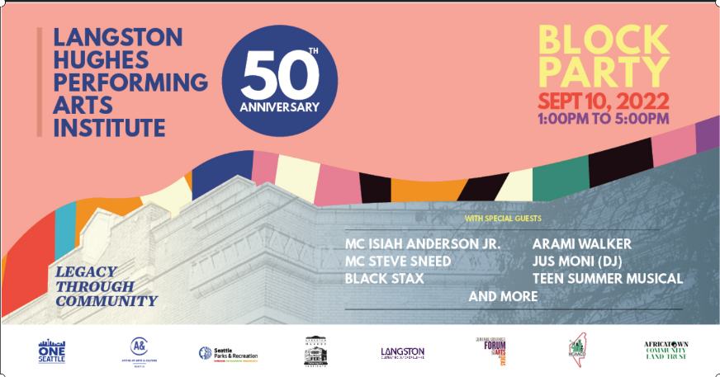

Dear Vendor,

Langston Hughes Performing Arts Institute is excited to present a community block party celebrating our 50th anniversary.The celebration includesmusical entertainment, arts and crafts, special activities, and delicious food vendors. Fun for the entire family!

**There is no fee for a 10x10 space, which includes a 6’ table and 2 chairs. We anticipate our vendor spaces will fill up quickly since there are only 20 openings.** If you are interested in attending, please complete the enclosed entry application form by **Friday, August 12th**. Please note: Electricity will not be available for craft vendors. Small, quiet generators may be used, but must be approved first and noted on your application.

If you have any questions, please contact Amanda Licorish at [langston.institute@seattle.gov](mailto:langston.institute@seattle.gov) or call us at (206) 386-1177.

Sincerely,

**Sandra Boas-Du Pree**

Seattle Office of Arts & Culture

Facility Manager & Community Connections | Langston Hughes Performing Arts Institute

104 17th Avenue South, Seattle, Washington 98144

Langston Hughes Performing Arts Institute

Block Party Vendor Application Form

**Saturday, September 10, 2022 | 1:00-5:00 pm**

104 17th Avenue South | Seattle, WA 98144

|  |  |  |  |  |
| --- | --- | --- | --- | --- |
| **VENDOR** **INFORMATION** | | | | |
| Name: | | | Phone: | |
| Email: | | | Website: | |
| Address: | | | | |
| City: | | | Zip: 98404 | |
| Business Name: | | | | |
| Social Media sites: | | | |
| City of Seattle Business License:  o I need a temporary permit | | | | |
| Products Being Sold: | | | | |
| Why are you interested in becoming a 50th Anniversary Vendor? | | | | |
| Vendors Note:   * If vending food, please provide a menu and pricing along with completed application. * All food vendors must have food-handling safety certifications for all employees that will be handling food. Please provide copies of documentation along with completed application. * Food Vendors must provide a Certificate of Insurance naming the City of Seattle as an additionally insured party. Requirements are below. * We ask that all vendors stay until the end of event. | | | | |
| Vendor Space: 10ft X 10ft (includes 6’ table and 2 chairs) | | | | |
| Date:  Contact: | Saturday, September 10, 2022  Set-up completed by 12:45 PM  Amanda Licorish  langston.institute@seattle.gov  (206) 386-1177 | Please note that vendors are required to come self-sufficient (bring own tents/canopies).  There will be no power provided to vendors, but generators are welcome.  There will be **NO** **FEE** for being a vendor.  There are a limited number of vendor spaces available and will be distributed on a first come first serve basis. | | |
| **\*\*\* ALL** **AREAS** **MUST** **BE COMPLETED \*\*\*** | | | | |
| I certify that the information provided on this form is true and correct to the best of my knowledge and that any false or misleading information supplied may result in my being denied as a vendor for the 2022 Block Party. INITIAL  I understand that signing this document releases the City of Seattle & Langston Hughes Performing Arts Institute from any liability related to my being a vendor. INITIAL | | | | |
| Signature of Applicant: | | | | |
| Print Name: | | | | |
| Date: | | | | |
| INTERNAL USE ONLY: | | | | |
| o Application Received  o Application Approved o General Liability Insurance Submitted  o Vendor Notified o Location Assigned | | | | |

**General Liability Insurance Required for Vendors**

Vendors are required to show proof of General Liability insurance coverage with a minimum of $1,000,000 limit per occurrence.

Proof of insurance must include these two pages (see examples):

1. Certificate of Insurance
2. "Additional Insured" policy endorsement on form CG 20 12 or CG 2026

Provide to your insurance company. [Sample Insurance](https://www.seattle.gov/documents/Departments/ParksAndRecreation/Reserve/COI_Sample.pdf)

**Both must name the City of Seattle as an Additional Insured.**

The Certificate Holder must be:

City of Seattle - Risk Mgt Div

PO Box 94669

Seattle, WA 98124

NOTE: **Do NOT mail your certificate to this address. Please send by email** [**langston.institute@seattle.gov**](mailto:langston.institute@seattle.gov)**.**