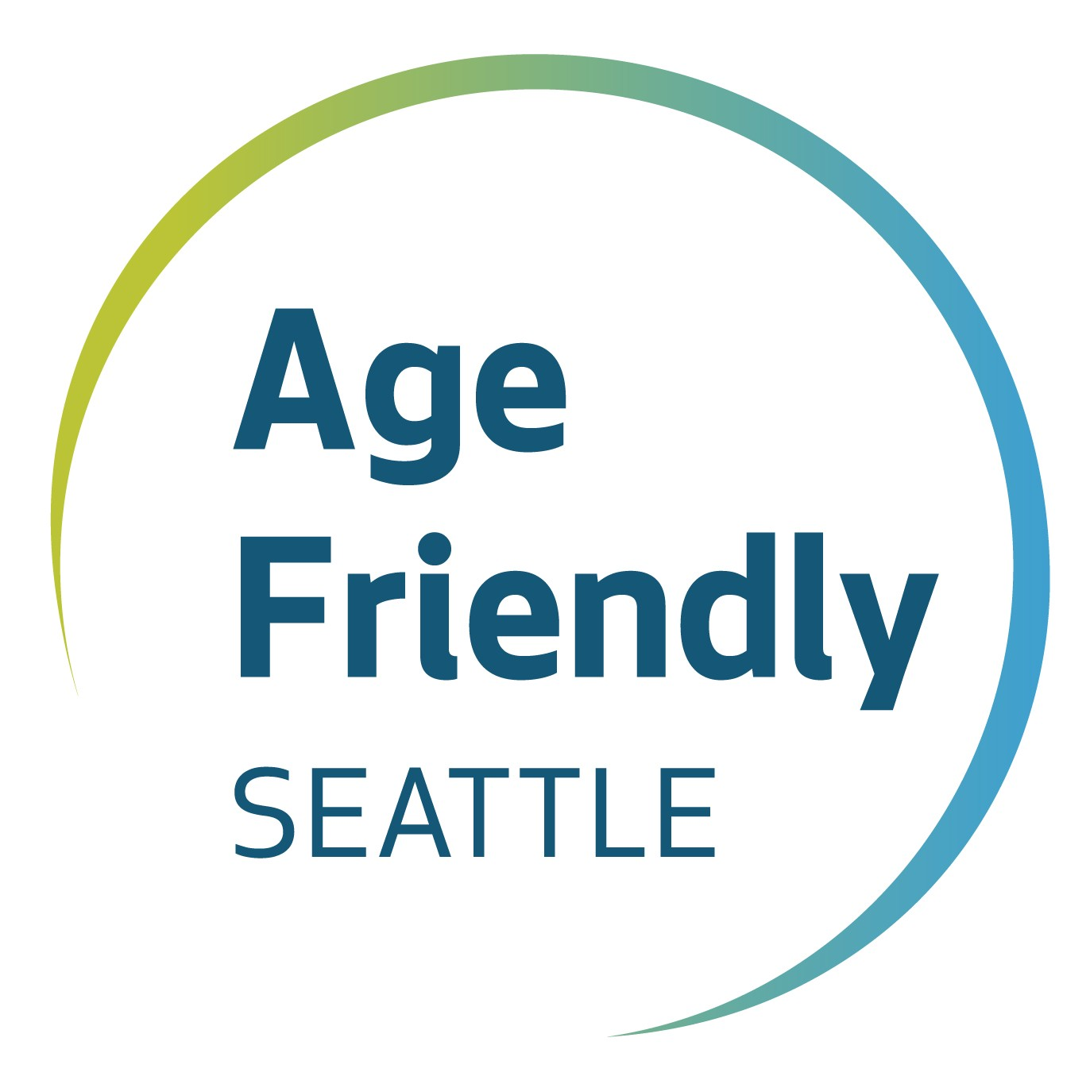
FLASH [Fun Leisure Access Savings and Health] Card

Seattle/King County discount card application for people with disabilities age 18–59
Age Friendly Seattle • 206-233-5121 • PO Box 34215 • Seattle WA 98124-4215

The FLASH Card is for residents/visitors of Seattle and King County, age 18–59, with qualifying disabilities, based on the Eligibility Criteria for the Regional Reduced Fare Permit for public transportation (see https://bit.ly/39WO0JZ).
If age 60+, do NOT complete this form. The Gold Card for Healthy Aging provides similar benefits and is available at community locations throughout Seattle. Visit Seattle.gov/AgeFriendlyDiscounts for more info.
(Online FLASH application can be found at: https://www.seattle.gov/agefriendly/about/discount-program#goldflash)
Step 1. Tell us about yourself. ALL fields are REQUIRED:
Name (first/middle/last): _____________________________________

Street/Unit #: _____________________ City/State/Zip: __________________

Date of Birth (mm/dd/yyyy): __________ Phone (incl. area code): _________________

Step 2. Select ONE (1) proof of eligibility below. Provide a copy (required):
A current Metro ADA Paratransit Card.
Permanent reduced fare permit for disabled persons (only ages 18–59), back & front.
Regional Reduced Fare Permit (RRFP) Certification of Eligibility, signed by approved health care provider.
Award letter or letter of verification of Social Security Disability Income (SSDI), Supplemental Security
Income (SSI); Veterans Administration Income or General Assistance Unemployable (GAU/GAX).
Proof of eligibility for Social Security Disability Benefits or Supplemental Security Income Benefits.
Proof of current eligibility by the Veterans Administration as having a disability of at least 30%.
Valid Medicare card issued by the Social Security Administration.
Valid Regional ADA paratransit card, issued by __________ This card expires ____
Valid ADA paratransit card from outside the region. Agency Date
Proof of enrollment in a vocational career program with the WA Individual Educational Program (IEP).

I have one or more apparent physical impairments – contact one of the in-person locations, below.

If you checked a box above, STOP here and follow instructions in Step 3 to submit. If none of the above applies, continue to p.2.

Step 3. Submit completed form and a copy of proof of eligibility:

Mail: E-mail: Fax:
Aging and Disability Services AgeFriendly@seattle.gov 206-684-0689
Attn: Age Friendly Seattle
P.O. Box 34215
Seattle, WA 98124-4215

In person:
- Disability Empowerment Center • 1401 NE Jefferson St, Ste 506, Seattle, WA 98122 • 206-545-7055
  - Find Redmond & Auburn office locations at www.disabilityempowerment.org/contact
- STAR Resource Center • 2600 S Walker St, Seattle, WA 98144 • 206-325-4284
- Seattle VA Medical Clinic • 1660 S Columbian Way, Seattle, WA 98108 • 206-716-5797

