2025 Surveillance Impact Report

Tracking Devices
Seattle Police Department

Surveillance Impact Report Versions:
- 2022 Surveillance Impact Report: Seattle Police Department Tracking Devices adopted by Ordinance 126776 on 2/28/2023.
- 2025 Surveillance Impact Report: Seattle Police Department Tracking Devices

Retroactive Technology Request By: SPD | Surveillance Impact Report | Tracking Devices |page i

Surveillance Impact Report (“SIR”) overview

About the Surveillance Ordinance
The Seattle City Council passed Ordinance 125376, also referred to as the “Surveillance Ordinance,” on September 1, 2017. SMC 14.18.020.b.1 charges the City’s executive with developing a process to identify surveillance technologies subject to the ordinance. Seattle IT, on behalf of the executive, developed and implemented a process through which a privacy and surveillance review is completed prior to the acquisition of new technologies. This requirement, and the criteria used in the review process, are documented in Seattle IT Policy PR-02, the “Surveillance Policy”.

How this Document is Completed
This document is completed by the requesting department staff, support and coordinated by the Seattle Information Technology Department (“Seattle IT”). As Seattle IT and department staff complete the document, they should keep the following in mind.
- Responses to questions should be in the text or check boxes only; all other information (questions, descriptions, etc.) should not be edited by the department staff completing this document.
- All content in this report will be available externally to the public. With this in mind, avoid using acronyms, slang, or other terms which may not be well-known to external audiences. Additionally, responses should be written using principally non-technical language to ensure they are accessible to audiences unfamiliar with the topic.

Surveillance Ordinance Review Process
The following is a high-level outline of the complete SIR review process.
Upcoming
for Review
Initial Draft
Open
Comment Period
Final Draft
Working
Group
Council
Review

The technology is upcoming for review, but the department has not begun drafting the surveillance impact report (SIR). | Work on the initial draft of the SIR is currently underway. | The initial draft of the SIR and supporting materials have been released for public review and comment. During this time, one or more public meetings will take place to solicit feedback. | During this stage the SIR, including collection of all public comments related to the specific technology, is being compiled and finalized. | The surveillance advisory working group will review each SIR’s final draft and complete a civil liberties and privacy assessment, which will then be included with the SIR and submitted to Council. | City Council will decide on the use of the surveillance technology, by full Council vote.

Privacy Impact Assessment

Purpose
A Privacy Impact Assessment (“PIA”) is a method for collecting and documenting detailed information collected in order to conduct an in-depth privacy review of a program or project. A PIA asks questions about the collection, use, sharing, security and access controls for data that is gathered using a technology or program. It also requests information about policies, training and documentation that govern use of the technology. The PIA responses are used to determine privacy risks associated with a project and mitigations that may reduce some or all of those risks. In the interests of transparency about data collection and management, the City of Seattle has committed to publishing all PIAs on an outward facing website for public access.

When is a Privacy Impact Assessment Required?
A PIA may be required in two circumstances.
- When a project, technology, or other review has been flagged as having a high privacy risk.
- When a technology is required to complete the surveillance impact report process. This is one deliverable that comprises the report.

Abstract
  - Please provide a brief description (one paragraph) of the purpose and proposed use of the project/technology.

Seattle Police Department (SPD) utilizes geolocation trackers to track and locate vehicle information during criminal investigations. Geolocation trackers are devices that SPD utilizes as a tool to locate and track the movements and locations of vehicles. Covert trackers are utilized only after obtaining legal authority via a court order or consent, and once the consent or terms of the order have expired all data collected is maintained only in the investigation file.
A category of GPS trackers (police pursuit management technology) are utilized to tag and track fleeing vehicles as a safer alternative to vehicle pursuits. In accordance with RCW 10.116.060.2.d, which requires agencies to “develop a plan to end the pursuit through the use of available pursuit intervention options,” This specialized GPS tracker allows SPD to track the precise location of a vehicle for which probable cause or reasonable suspicion of involvement in a crime has been established and accomplish the task of recovery or arrest without the need for initiating or continuing a vehicle pursuit.
  - Explain the reason the project/technology is being created or updated and why the PIA is required.

Tracker technology directly tracks and collects location information of vehicles and indirectly tracks and collects the same information about individuals. Despite the requirement that covert trackers be utilized only pursuant to a search warrant or with consent, this could raise potential privacy concerns, such as general surveillance or tracking of the general public.
GPS pursuit mitigation trackers also directly track and collect location information of vehicles and, indirectly, their occupants. While this technology is limited by policy to vehicles for which there is reasonable suspicion or probable cause, they could raise potential privacy concerns, such as general surveillance or tracking of the general public.

2.0 Project / Technology Overview
Provide an overview of the project or technology. The overview gives the context and background necessary to understand the purpose, mission and justification for the project / technology proposed
  - Describe the benefits of the project/technology.
Trackers allow SPD to remotely track vehicles electronically and to locate vehicles and individuals that are sought in connection with an active criminal investigation. They are utilized in these cases with the consent of a witness, a confidential informant, or within the scope of a judicially issued search warrant. They may also be used as a police pursuit management tool, where they can provide a critical alternative to high-speed pursuits that can endanger the safety of both residents and police personnel. Without this technology, SPD would be unable to collect important evidence in some criminal investigations and subject community members to the dangers of high speed pursuit situations.

  - Provide any data or research demonstrating anticipated benefits.

The primary benefit of the covert tracking systems is in the gathering of evidence used in the resolution of criminal investigations. Proper gathering of location evidence of criminal activity by the police supports SPD’s mission to prevent crime, enforce the law, and support quality public safety. “The value of employing electronic surveillance in the investigation of some forms of serious crime, in particular organized crime, is unquestionable. It allows the gathering of information unattainable through other means.”

In the case of the United States vs. Katzin, the U.S. Court of Appeals ruled law enforcement officials are allowed to use location tracking devices to trace a suspect’s vehicle and monitor their activity once a warrant is properly obtained—which prevents law enforcement from trampling on a person’s Fourth Amendment rights that protect them from “unreasonable searches and seizures.”²
GPS pursuit mitigation tracking devices also offer an alternative to the need for vehicular pursuit of suspect vehicles. This only occurs when an officer has the equivalent of probable cause or reasonable suspicion of wrongdoing (including fleeing temporary detention like a traffic stop) and the apprehension of the fleeing suspect is needed but the danger of a pursuit is not reasonable. The device is then removed, and the location tracking ends at the point at which police detain the suspect vehicle. The vehicle-mounted GPS launcher has the ability to tag, track, and locate without compromising officer and community safety. The Police Executive Research Forum (PERF) recently conducted a study that showed that, “when properly deployed, (it) had a positive impact on the pursuit outcome for apprehensions.”³

https://www.unodc.org/documents/organized-crime/Law-Enforcement/Electronic_surveillance.pdf
2 https://info.rastrac.com/blog/police-gps-tracking

3 https://www.ojp.gov/pdffiles1/nij/grants/250549.pdf

  - Describe the technology involved.

Covert tracking technology consists of interconnected hardware and software. The hardware, a real-time tracking and data logger, is a compact unit that adheres to or rides along with a targeted vehicle. These trackers are location tracking devices that report latitude and longitude coordinates on a pre-determined schedule that can be adjusted by users remotely. The hardware also logs high temperature alerts, low battery alerts, device removal, power/shut down alerts and battery level. The software consists of an online portal that collects the information captured by the hardware, and allows for graphic representation of that information, including mapping of locations and movement, alerts for established events (i.e., a vehicle has moved beyond an established boundary, etc.), and scheduling of “check-ins” (the reporting interval records the locations set in seconds, minutes or hours).

The data captured by a device is downloaded out of the online portal after the conclusion of a tracking schedule (due to the expiration of a search warrant or an investigation) and is provided to the Officer/Detective leading the investigation. The data is then purged from the software and the hardware is reset for future deployment, meaning no data captured is stored in any location other than the investigation file. This is in keeping with Washington State Retention Schedule for Records Documented as Part of More Formalized Records (GS2016-009). It requires that such records be retained “until verification of successful conversion/keying/transcription then destroy.”

In the beginning of 2020, cellular providers in the USA announced that the existing 3G cell networks would be decommissioned in 2022 as the newer 5G networks were phased in. Many of the existing SPD tracking devices were tied to the older 3G network and have been or will need to be replaced with similar-functioning updated 5G versions of the same location tracking technology.
In the case of GPS pursuit mitigation trackers, the GPS launcher deploys a GPS tracking tag onto a suspect vehicle. Once the GPS tag is attached to the vehicle, it communicates positional data to a mapping platform in real time. Law enforcement can then plan and coordinate an informed tactical response to make a safe arrest while maintaining community and officer safety. It is important to note that the GPS tag has a limited battery life ( approximately 8 hours), preventing the possibility of long-term surveillance.

  - Describe how the project or use of technology relates to the department’s mission.
Utilizing location tracking devices to locate vehicles in pursuit of an investigation helps SPD to mitigate serious and/or violent criminal activity and reduce crime.
GPS pursuit mitigation trackers allow SPD to effect the arrest of fleeing suspects in vehicles without the need for vehicle pursuits that can place the public, the suspect, and officers, in danger.
  - Who will be involved with the deployment and use of the project / technology?
Maintenance and utilization of covert vehicle trackers is managed by the Technical and Electronic Support Unit (TESU).

For deployment of location covert trackers for investigations by TESU, the requesting Officer/Detective completes requests for deployment (including a Request Form that must be completed, which includes the active search warrant number). A TESU supervisor then approves the request before a tracking device is assigned and deployed to an investigating Officer/Detective. All requests are filed with TESU and maintained within the unit, available for audit.
The hardware and software for GPS pursuit mitigation tracking systems are managed by the RTCC and deployed on police vehicles and via handheld launchers. Individual deployment of the GPS tracking units is determined by the police officer involved in determining probable cause or reasonable suspicion for the stop of a vehicle.

Use Governance
Provide an outline of any rules that will govern the use of the project / technology. Please note: non-City entities contracting with the City are bound by restrictions specified in the surveillance ordinance and privacy principles and must provide written procedures for how the entity will comply with any restrictions identified.
  - Describe the processes that are required prior to each use, or access to the technology, such as a notification, or check-in, check-out of equipment.
Each application of covert tracking technology is screened by the TESU supervisor and held to a legal standard of consent or court issued search warrant. The process is as follows: one member of the Unit is tasked with receiving requests for deployment (including a Request Form that must be completed by the requesting Officer/Detective, which includes the active search warrant number). A TESU supervisor then approves the request before a tracking device is assigned and deployed to an investigating Officer/Detective. All requests are filed with TESU and maintained within the unit, available for audit.
Prior to deployment of GPS pursuit mitigation trackers, officers must establish reasonable suspicion or probable cause for the stop of a vehicle. At that point, officers will have the discretion to deploy the GPS pursuit mitigation trackers if it appears the vehicle may flee. Additionally, if an officer engages in a pursuit with a vehicle, they can deploy a tracker and terminate the pursuit, relying on the tracker to follow the vehicle.
  - List the legal standards or conditions, if any, that must be met before the project / technology is used.
Covert tracking devices are only utilized with express consent or search warrant authority. SPD must comply with all legal requirements for securing consent or a search warrant (see US v. Jones and State v. Jackson).
GPS pursuit mitigation trackers are only deployed when an officer has established reasonable suspicion or probable cause for the stop of a vehicle, the same standard as established by RCW 10.116.060.

  - Describe the policies and training required of all personnel operating the project / technology, and who has access to ensure compliance with use and management policies.
Unit supervisors are responsible for screening all deployments as well as ensuring that staff receive adequate training specific to the involved technologies.

TESU personnel are trained by the vendor in the use of the hardware and software. When an Officer/Detective requests and deploys a tracking device from TESU, TESU personnel train the Officer/Detective in the tracker’s use.

If the geolocation tracking device is being utilized pursuant to a search warrant, the warrant dictates the scope and parameters of the information collected.

SPD Policy 6.060 requires that “information will be gathered and recorded in a manner that does not unreasonably infringe upon: individual rights, liberties, and freedoms guaranteed by the Constitution of the United States and the State of Washington, including freedom of speech, press, association, and assembly; liberty of conscience; the exercise of religion; the right to petition government for redress of grievances; and the right to privacy.”
Officers are required to be trained in the policies and use of GPS pursuit mitigation trackers prior to deploying the equipment. Officers are trained by the Education and Training Section using training developed by SPD in collaboration with the technology vendors. Use of GPS pursuit mitigation trackers is monitored using the vendor software, as well as integrations to the Real Time Crime Center, and documented in police reports stored and maintained in the SPD RMS. Use of GPS pursuit mitigation trackers are reported via radio as soon as feasible and use acknowledged by an SPD supervisor.

Data Collection and Use
  - Provide details about what information is being collected from sources other than an individual, including other IT systems, systems of record, commercial data aggregators, publicly available data and/or other City departments.
Officers/Detectives obtain search warrants or consent to deploy vehicle tracking devices. The information is gathered consistent with SPD Policy 6.060, such that it does not reasonably infringe upon “individual rights, liberties, and freedoms guaranteed by the Constitution of the United States and the State of Washington, including freedom of speech, press, association, and assembly; liberty of conscience the exercise of religion; the right to petition government for redress of grievances; and the right to privacy.”

Vehicle tracking data is temporarily stored by third-party vendors (as described in 2.3 above), until the schedule for collection of data has expired (per the search warrant or consent authorities), at which time all data collected is downloaded and attached to the investigation file. This is in keeping with the Washington State Local Government Common Records Retention Schedule Disposition Authority Number GS2016-009 Rev. 0, governing retention of records documented as part of more formalized records, and requiring that SPD “retain until verification of successful conversion/keying/transcription, then destroy.”
The only data collected by the GPS pursuit mitigation tracker is date, time, location (to include latitude/longitude), remaining battery life, the speed of the tag when moving, all of which is retrieved from the tracker itself. No other data is pulled in by GPS pursuit mitigation trackers.

  - What measures are in place to minimize inadvertent or improper collection of data?
Equipment deployment is constrained to the conditions stipulated by the consent or court order providing the legal authority. All deployments of tracking technology are documented and subject to audit by the Office of Inspector General and Federal Monitor at any time.
Data collected is provided to the case Detective for the investigation and no data is retained by the Technical and Electronic Support Unit.
The GPS pursuit mitigation tracker is applied to the vehicle in question by aiming with the launcher. No other information about the vehicle is collected. If a vehicle is inadvertently tagged, the tracker will be retrieved as quickly as possible and deactivated by the officer. Such deployments will be documented.

  - How and when will the project / technology be deployed or used? By whom? Who will determine when the project / technology is deployed and used?
Officers/Detectives will provide written consent and/or a court approved warrant for covert vehicle tracking technology deployments, via the Request Form process. The Technical and Electronic Support Unit Supervisor will screen all tracking technology deployments to ensure that the appropriate authorities are in place before approving deployment of tracking technology.
Officers who have established probable cause or reasonable suspicion to stop a vehicle are able to deploy GPS pursuit mitigation trackers. Use of GPS pursuit mitigation trackers are reported via radio as soon as feasible and use acknowledged by an SPD supervisor.

  - How often will the technology be in operation?
Trackers are used, as appropriate, when supported by a search warrant or consent (of a witness or a confidential informant), in conjunction with an active investigation, or when use of GPS pursuit mitigation trackers is needed to prevent the need for the pursuit of a vehicle for which there is probable cause or reasonable suspicion to stop. The length of time that any one covert tracker might be utilized in an investigation is established, and constrained, by parameters established within the requisite search warrant. The battery of a GPS pursuit mitigation tracker is about eight (8) hours.

  - What is the permanence of the installation? Is it installed permanently, or temporarily?
Temporary.
  - Is a physical object collecting data or images visible to the public? What are the markings to indicate that it is in use? What signage is used to determine department ownership and contact information?
Physical objects involved in covert tracking deployments are unmarked as their purpose is in support of covert investigations.
GPS pursuit mitigation trackers are visible, as they are normally launched to attach to the rear of a vehicle, in plain view of the public. It is marked with a 10-digit serial number and barcode.

  - How will data that is collected be accessed and by whom?
Only authorized SPD users can access the vehicle tracking devices or the data while it resides in the system. Access to the vehicle tracking systems/technology is specific to system and password-protected.

Data removed from the vehicle tracking system/technology and entered into investigative files is securely input and used on SPD’s password-protected network with access limited to detectives and identified supervisory personnel.

All SPD employees are backgrounded and access is controlled by SPD Manual Title 12 provisions governing Department Information Systems including SPD Policy 12.040 - Department-Owned Computers, Devices & Software, SPD Policy 12.050 - Criminal Justice Information Systems, SPD Policy 12.080 – Department Records Access, Inspection & Dissemination, SPD Policy 12.110 – Use of Department E-mail & Internet Systems, and SPD Policy 12.111 – Use of Cloud Storage Services.

Data collected by the deployment of a GPS pursuit mitigation tracker is used by SPD personnel to track and locate vehicles for which there is probable cause or reasonable suspicions. These personnel may be patrol, investigations, or RTCC staff capable of broadcasting tracking information to responding units. OIG personnel will also have access for audit purposes.
Information regarding the track is included in police reports stored in the SPD RMS.

  - If operated or used by another entity on behalf of the City, provide details about access, and applicable protocols.
No entity, other than SPD personnel, utilize vehicle tracking technology. OIG personnel will have access for oversight requirements.

  - What are acceptable reasons for access to the equipment and/or data collected?
To deploy and utilize vehicle trackers, Officers/Detectives must submit a request form that requires proof of consent or search warrant, and active investigation, as evidenced by a GO number. After the scheduled parameters for collection of data expire, data is downloaded from the supporting software, and included in the investigation file. At that point, only SPD personnel involved in the investigation have access to this information.
When an officer has established probable cause or reasonable suspicion for a vehicle, the threshold for deployment and use of GPS pursuit mitigation trackers will have been met.

  - What safeguards are in place, for protecting data from unauthorized access (encryption, access control mechanisms, etc.) And to provide an audit trail (viewer logging, modification logging, etc.)?

Only Technical and Electronic Support Unit personnel have access to vehicle tracking equipment and services. Deployment of vehicle trackers follows a specific process (see 2.5 above) that requires consent or search warrant documentation. Access to data is documented with TESU and is made available to any auditing authority.
Only personnel with approved accounts in the GPS pursuit mitigation tracking system will have access to the data. The GPS pursuit mitigation tracking system and associated accounts will be managed by the RTCC system administrator.

Data Storage, Retention and Deletion
  - How will data be securely stored?
Data is securely stored by the vehicle tracking technology vendor and will be transferred to the case investigator only via Seattle Police Department owned and authorized technology. At that time, vehicle tracking data collected by the tracking device is downloaded from the vendor software and resides only with the investigation file.
GPS pursuit mitigation tracking data is stored on the AWS gov-cloud certified infrastructure and encrypted against unauthorized access. Vendors are required to be SOC2/Type II certified to meet CIty cybersecurity requirements.
  - How will the owner allow for departmental and other entities, to audit for compliance with legal deletion requirements?
TESU keeps logs of vehicle tracking device requests, deployments, and access to the equipment. The Office of Inspector General and the federal monitor can access all data and audit for compliance at any time.
GPS pursuit mitigation tracking data retention standards are set by Seattle PD. Upon written authorization, technology vendors will delete data and verify such.
  - What measures will be used to destroy improperly collected data?
SPD Policy 7.010 governs the submission of evidence and requires that all collected evidence be documented in a General Offense (GO) Report.

All information must be gathered and recorded in a manner that is consistent with SPD Policy 6.060, such that it does not reasonably infringe upon “individual rights, liberties, and freedoms secured by the Constitution of the United States and of the State of Washington, including, among others, the freedom of speech, press, association and assembly; liberty of conscience; the exercise of religion; and the right to petition government for redress of grievances; or violate an individual’s right to privacy”.
All SPD employees must adhere to laws, City policy, and Department Policy (SPD Policy 5.001), and any employees suspected of being in violation of laws or policy or other misconduct are subject to discipline, as outlined in SPD Policy 5.002.

  - Which specific departmental unit or individual is responsible for ensuring compliance with data retention requirements?
Unit supervisors are responsible for ensuring compliance with data retention requirements within SPD.
SPD’s Intelligence and Analysis Section reviews the audit logs and ensures compliance with all regulations and requirements.
Audit, Policy & Research Section personnel can also conduct audits of all data collection software and systems. Additionally, any appropriate auditor, including the Office of Inspector General and the federal monitor can audit for compliance at any time.
RTCC System Administrators will manage the GPS pursuit mitigation tracking system to ensure that the retention requirements meet those of SPD.

Data Sharing and Accuracy
  - Which entity or entities inside and external to the City will be data sharing partners?
No person, outside of SPD, has direct access to the covert tracking units or the data.
Data obtained from the system may be shared outside SPD with the other agencies, entities, or individuals within legal guidelines or as required by law.
Data may be shared with outside entities in connection with criminal prosecutions:
• Seattle City Attorney’s Office
• King County Prosecuting Attorney’s Office
• King County Department of Public Defense
• Private Defense Attorneys
• Seattle Municipal Court
• King County Superior Court
• Similar entities where prosecution is in Federal or other State jurisdictions
Data may be made available to requesters pursuant to the Washington Public Records Act, Chapter 42.56 RCW (“PRA”). SPD will apply applicable exemptions to the data before disclosing to a requester. Individuals have the right to inspect criminal history record information maintained by the department (RCW 10.97.030, SPD Policy 12.050). Individuals can access their own information by submitting a public disclosure request.
Per SPD Policy 12.080, the Crime Records Unit is responsible for receiving, recording, and responding to requests “for General Offense Reports from other City departments and from other law enforcement agencies, as well as from insurance companies.”
Discrete pieces of data collected by these tracking devices may be shared with other law enforcement agencies in wanted bulletins, and in connection with law enforcement investigations jointly conducted with those agencies, or in response to requests from law enforcement agencies investigating criminal activity as governed by SPD Policy 12.050 and 12.110. All requests for data from Federal Immigration and Customs Enforcement (ICE) authorities are referred to the Mayor’s Office Legal Counsel in accordance with the Mayoral Directive, dated February 6, 2018.
SPD shares data with authorized researchers pursuant to properly execute research and confidentiality agreements as provide by SPD Policy 12.055. This sharing may include discrete pieces of data related to specific investigative files collected by the devices.

GPS pursuit mitigation tracking data will be shared with neighboring law enforcement agencies as needed for operational purposes. As tracked vehicles leave the City limits, it will become necessary for partner law enforcement agencies to have the tracking information to assist with tracking and apprehension. Conversely, other agencies using GPS pursuit mitigation tracking systems may need to share their tracking information with SPD as their tracked vehicles enter the City limits.

As the GPS pursuit mitigation tracking data is included in SPD police reports, the above listed agencies will also have access via investigative files.

  - Why is data sharing necessary?
Data sharing is necessary for SPD to fulfill its mission of contributing to crime reduction by assisting in collecting evidence related to serious and/or violent criminal activity as part of investigation, and to comply with legal requirements.
For GPS pursuit mitigation tracking, data sharing is critical, as fleeing suspects often cross jurisdictional boundaries, necessitating interagency cooperation.

  - Are there any restrictions on non-City data use?
Yes ☒ No ☐

    - If you answered yes, provide a copy of the department’s procedures and policies or ensuring compliance with these restrictions.
Law enforcement agencies receiving criminal history information are subject to the requirements of 28 CFR Part 20. In addition, Washington State law enforcement agencies are subject to the provisions of WAC 446-20-260, and RCW Chapter 10.97.
Once disclosed in response to PRA request, there are no restrictions on non-City data use; however, applicable exemptions will be applied prior to disclosure to any requestor who is not authorized to receive exempt content.

  - How does the project/technology review and approve information sharing agreements, memorandums of understanding, new uses of the information, new access to the system by organizations within City of Seattle and outside agencies?
Research agreements must meet the standards reflected in SPD Policy 12.055. Law enforcement agencies receiving criminal history information are subject to the requirements of 28 CFR Part 20. In addition, Washington State law enforcement agencies are subject to the provisions of WAC 446-20-260, and RCW Chapter 10.97.
Following Council approval of the SIR, SPD must seek Council approval for any material change to the purpose or manner in which Tracking Devices may be used.

  - Explain how the project/technology checks the accuracy of the information collected. If accuracy is not checked, please explain why.
Tracking devices capture location information as it moves in relation to GPS satellites as it moves locations. They may also rely on cellular technology to track its location. The devices do not check for accuracy, as they are simply capturing a live information and sending position information. They are not interpreting or otherwise, analyzing any data they collect.
For GPS pursuit mitigation tracking, officers arriving at the site of a tracked vehicle will validate the vehicle they observe matches the description of the vehicle for which there is probable cause or reasonable suspicion (including license plate where possible), prior to taking any additional enforcement action.

  - Describe any procedures that allow individuals to access their information and correct inaccurate or erroneous information.

Individuals may request records pursuant to the PRA, and individuals have the right to inspect criminal history record information maintained by the department (RCW 10.97.030, SPD Policy 12.050). Individuals can access their own information by submitting a public disclosure request.

Legal Obligations, Risks and Compliance
  - What specific legal authorities and/or agreements permit and define the collection of information by the project/technology?

Covert tracking devices are only utilized with express consent or search warrant authority. SPD must comply with all legal requirements for securing consent or a search warrant; see, US v. Jones and State v. Jackson). GPS pursuit mitigation trackers are only utilized when there is probable cause or reasonable suspicion that a vehicle has been involved in a crime, consistent with the RCW governing vehicle pursuits by law enforcement.

  - Describe what privacy training is provided to users either generally or specifically relevant to the project/technology.

SPD Policy 12.050 mandates that all employees receive Security Awareness Training (Level 2), and all employees also receive City Privacy Training.

  - Given the specific data elements collected, describe the privacy risks identified and for each risk, explain how it was mitigated. Specific risks may be inherent in the sources or methods of collection, or the quality or quantity of information included.

Privacy risks revolve around improper collection of location information of members of the general public. As it relates to covert tracking, SPD mitigates this risk by deploying them consistent to the stipulations outlined in the Washington Privacy Act, Chapt. 9.73 RCW, and only by consent and/or with authorization of a court-ordered warrant. For GPS pursuit mitigation trackers, deployment is limited to vehicles for which probable cause or reasonable suspicion has been established. Additionally, the limited battery life of GPS pursuit mitigation trackers reduces the likelihood of inadvertent tracking of uninvolved parties. The ACLU cited this limitation in their letter addressing the use of GPS pursuit mitigation as a reason they are not concerned with civil liberties related to the use of this technology.
SMC 14.12 and SPD Policy 6.060 direct all SPD personnel to “any documentation of information concerning a person’s sexual preferences or practices, or their political or religious activities must be for a relevant reason and serve a legitimate law enforcement purpose.”
Additionally, SPD Policy 5.140 forbids bias-based policing and outlines processes for reporting and documenting any suspected bias-based behavior, as well as accountability measures.
Finally, see 5.3 for a detailed discussion about procedures related to noncompliance.

  - Is there any aspect of the project/technology that might cause concern by giving the appearance to the public of privacy intrusion or misuse of personal information?
Inherent in information obtained through covertly tracking members of the public is the risk that private information may be obtained about members of the public without their knowledge and that their Fourth Amendment protections against “unreasonable searches” may be violated. This risk and those privacy risks outlined in 7.3 above are mitigated by legal requirements and auditing processes (i.e., maintenance of all requests, copies of consent forms and warrants) that allow for any auditor, including the Office of Inspector General and the federal monitor, to inspect use and deployment of tracking devices. The potential of privacy risk is mitigated by the requirement of consent and/or court ordered warrant before the technology is utilized.
The use of GPS pursuit mitigation trackers is limited to vehicles for which probable cause or reasonable suspicion has been established, the same standard set forth in state law for justification of vehicle pursuits. By tracking such a vehicle, it is possible to, by default, track the occupants of that vehicle. However, such occupants would be the subjects of a criminal investigation, either listed as suspects or eliminated through investigative efforts. The same concerns and mitigations listed above for covert tracking systems apply to GPS pursuit mitigation trackers.
In 2014, Jay Stanley, a senior policy analyst for the ACLU, wrote an opinion letter supporting the use of Starchase, a GPS pursuit mitigation tracking vendors long as the technology is used as intended in the exigent moments surrounding a police stop and pursuit, and not to subvert what would otherwise require a warrant. In 2022, Mr. Stanley reaffirmed this position, saying “I have not heard of any civil liberty issues with that technology.”

Monitoring and Enforcement
  - Describe how the project/technology maintains a record of any disclosures outside of the department.
Each unit maintains logs of deployment. These logs are available for audit, both internally and externally.
Per SPD Policy 12.080, the Crime Records Unit is responsible to receive and record all requests “for General Offense Reports from other City departments and from other law enforcement agencies, as well as from insurance companies.”
Any requests for public disclosure are logged by SPD’s Public Disclosure Unit. Any action taken, and data released subsequently, is then tracked through the request log. Responses to Public Disclosure Requests, including responsive records provided to a requestor, are retained by SPD for two years after the request is completed.
The technology vendor does not provide records to anyone other than Seattle PD, except by department preauthorized data sharing agreements.

  - What auditing measures are in place to safeguard the information, and policies that pertain to them, as well as who has access to the audit data? Explain whether the project/technology conducts self-audits, third party audits or reviews.
No formal audits exist for covert tracking device deployments; however, requests to utilize covert tracking devices, as well as logs of deployments, are kept within each unit, and are subject to audit by the unit supervisors, Office of the Inspector General, and the federal monitor at any time.
GPS pursuit mitigation trackers create a record of the deployment, to include the dates, times, locations (including latitude/longitude). These records are maintained in accordance with the Department’s retention requirements and can be view at any time by the Office of the Inspector General.

Financial Information

Purpose
This section provides a description of the fiscal impact of the surveillance technology, as required by the surveillance ordinance.

Fiscal Impact
Provide a description of the fiscal impact of the project/technology by answering the questions below.
  - Current or potential sources of funding: initial acquisition costs.
Current ☒ potential ☐
Date of initial acquisition | Date of go live | Direct initial acquisition cost | Professional services for acquisition | Other acquisition costs | Initial acquisition funding  source
TBD | June 2025 | $250,000 | - | - | Dept of Commerce Law Enforcement Pursuit Tech
Notes:

  - Current or potential sources of funding: on-going operating costs, including maintenance, licensing, personnel, legal/compliance use auditing, data retention and security costs.

Current ☐ potential ☒
Annual maintenance and licensing | Legal/compliance, audit, data retention and other security costs | Department overhead | IT overhead | Annual funding source
$37,500 | - | - | - | Unknown
Notes:
If the GPS pursuit mitigation trackers are determined to be a worthwhile program, the ongoing cost to maintain the 25 launchers’ subscriptions is $37,500.

  - Cost savings potential through use of the technology

Cost savings may be seen in reduced liability from decreased number of vehicle pursuits, which often result in litigation. Additionally, pursuits often result in damage to city owned equipment, specifically police cars. This technology can reduce those costs as well by negating the need for pursuits.

  - Current or potential sources of funding including subsidies or free products offered by vendors or governmental entities

Additional grants may be available in the future to provide ongoing funding, should the department decide to increase or continue the deployment.

Expertise and References

Purpose
The following information is provided to ensure that Council has a group of experts to reference while reviewing the completed surveillance impact report (“SIR”). Any individuals or agencies referenced must be made aware ahead of publication that their information has been included. All materials must be available for Council to access or review, without requiring additional purchase or contract.

Other Government References
Please list any other government bodies that have implemented this technology and can speak to the implementation of this technology.
Agency, municipality, etc. | Primary contact | Description of current use
Tacoma Police Department | Deputy Chief Paul Junger | Pursuit mitigation.

Academics, Consultants, and Other Experts
Please list any experts in the technology under consideration, or in the technical completion of the service or function the technology is responsible for.
Agency, municipality, etc. | Primary contact | Description of current use

White Papers or Other Documents
Please list any authoritative publication, report or guide that is relevant to the use of this technology or this type of technology.
Title | Publication | Link
GPS Bullets’ Allow Police to Shoot a Tracker Onto a Car | American Civil Liberties Union (ACLU) | https://www.aclu.org/news/national-security/gps-bullets-allow-police-shoot -tracker-car
Pursuit Technology Impact Assessment | Police Executive Research Forum | https://www.ojp.gov/pdffiles1/nij/grants/250549.pdf

Racial Equity Toolkit (“RET”) and engagement for public comment worksheet

Purpose
Departments submitting a SIR are required to complete an adapted version of the Racial Equity Toolkit (“RET”) in order to:
- Provide a framework for the mindful completion of the SIR in a way that is sensitive to the historic exclusion of vulnerable and historically underrepresented communities. Particularly, to inform the public engagement efforts departments will complete as part of the surveillance impact report.
- Highlight and mitigate any impacts on racial equity from the adoption and the use of the technology.
- Highlight and mitigate any disparate impacts on individuals or vulnerable communities.
- Fulfill the public engagement requirements of the surveillance impact report.

Adaptation of the RET for Surveillance Impact Reports
The RET was adapted for the specific use by the Seattle Information Technology Departments’ (“Seattle IT”) Privacy Team, the Office of Civil Rights (“OCR”), and Change Team members from Seattle IT, Seattle City Light, Seattle Fire Department, Seattle Police Department, and Seattle Department of Transportation.

Racial Equity Toolkit Overview
The vision of the Seattle Race and Social Justice Initiative (“RSJI”) is to eliminate racial inequity in the community. To do this requires ending individual racism, institutional racism and structural racism. The RET lays out a process and a set of questions to guide the development, implementation and evaluation of policies, initiatives, programs, and budget issues to address the impacts on racial equity.

1.0 Set Outcomes
  - Seattle City Council has defined the following inclusion criteria in the surveillance ordinance, and they serve as important touchstones for the risks departments are being asked to resolve and/or mitigate. Which of the following inclusion criteria apply to this technology?
    - The technology disparately impacts disadvantaged groups.
    - There is a high likelihood that personally identifiable information will be shared with non-City entities that will use the data for a purpose other than providing the City with a contractually agreed-upon service.
    - The technology collects data that is personally identifiable even if obscured, de-identified, or anonymized after collection.
☐ The technology raises reasonable concerns about impacts to civil liberty, freedom of speech or association, racial equity, or social justice.

  - What are the potential impacts on civil liberties through the implementation of this technology? How is the department mitigating these risks?

None, per ACLU letter.

  - What are the risks for racial or ethnicity-based bias through each use or deployment of this technology? How is the department mitigating these risks?
Include a description of any issues that may arise such as algorithmic bias or the possibility for ethnic bias to emerge in people and/or system decision-making.
None.
  - Where in the City is the technology used or deployed?

all Seattle neighborhoods
☐ Ballard  ☐ Belltown  ☐ Beacon Hill  ☐ Capitol Hill  ☐ Central District  ☐ Columbia City  ☐ Delridge  ☐ First Hill  ☐ Georgetown  ☐ Greenwood / Phinney  ☐ International District  ☐ Interbay  ☐ North  ☐ Northeast | ☐ Northwest  ☐ Madison Park / Madison Valley  ☐ Magnolia  ☐ Rainier Beach  ☐ Ravenna / Laurelhurst  ☐ South Lake Union / Eastlake  ☐ Southeast  ☐ Southwest  ☐ South Park  ☐ Wallingford / Fremont  ☐ West Seattle  ☒ King county (outside Seattle) (Mutual Aid)  ☒ Outside King County (Mutual Aid)

If possible, please include any maps or visualizations of historical deployments / use.
If possible, please include any maps or visualizations of historical deployments / use here.

    - What are the racial demographics of those living in this area or impacted by these issues?
No information at this time.

    - How does the Department to ensure diverse neighborhoods, communities, or individuals are not specifically targeted through the use or deployment of this technology?
The technology will be equally deployed throughout the city to maximize availability for needed deployments.

  - How do decisions around data sharing have the potential for disparate impact on historically targeted communities? What is the department doing to mitigate those risks?
None.

  - How do decisions around data storage and retention have the potential for disparate impact on historically targeted communities? What is the department doing to mitigate those risks?
None identified.
  - What are potential unintended consequences (both negative and positive potential impact)? What proactive steps can you / have you taken to ensure these consequences do not occur.
There is potential for officers to default into a pursuit in an effort to apply the tag. This can be addressed by policy and training.

2.0 Public Outreach
2.1 Scheduled public meeting(s).
Meeting notes, sign-in sheets, all comments received, and questions from the public will be included in Appendix B, D, E, and F. Comment analysis will be summarized in section 3.0 Public Comment Analysis.

Location | Virtual (Webex)
Time | Wednesday, Apr 27, 2022 3:00 pm

Location | Virtual (Webex)
Time | Wednesday, May 18, 2022 3:00 pm

3.0 Public Comment Analysis

Note: 10 comments were received via email. Demographics and analysis was not conducted on these comments but are included in the Appendix containing all public comments.
  - Summary of Response Volume

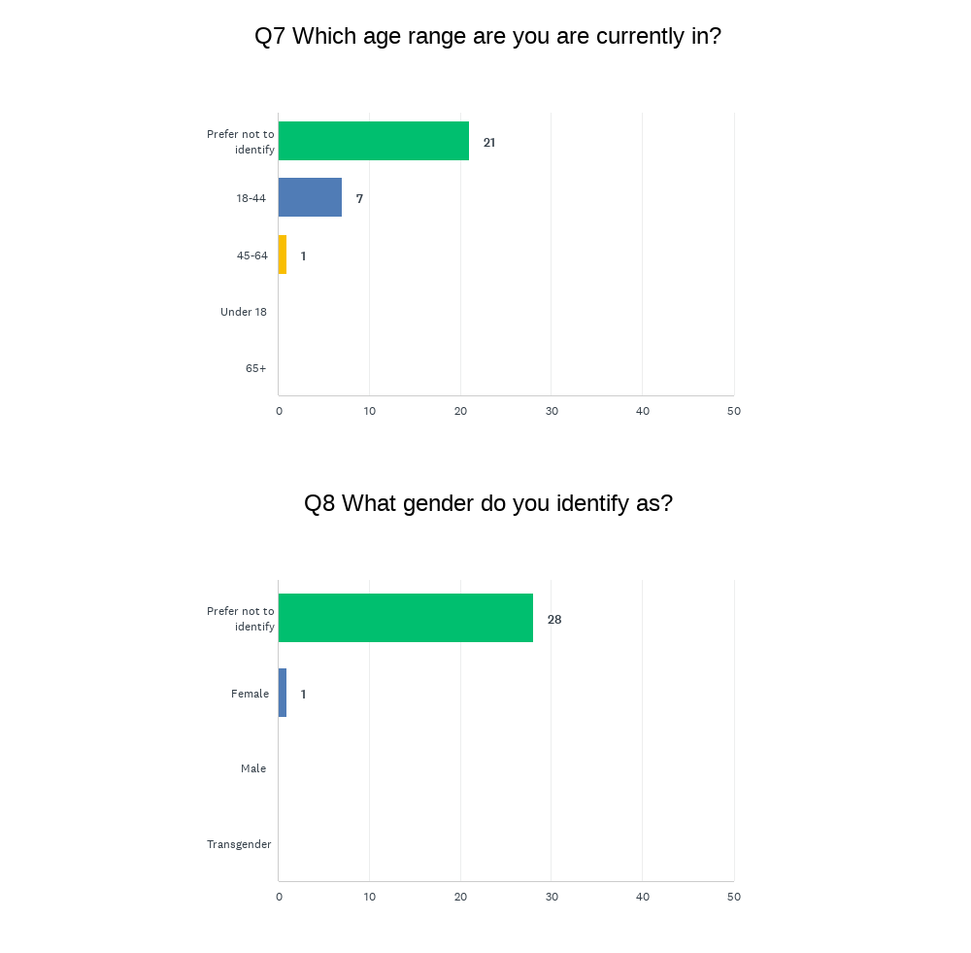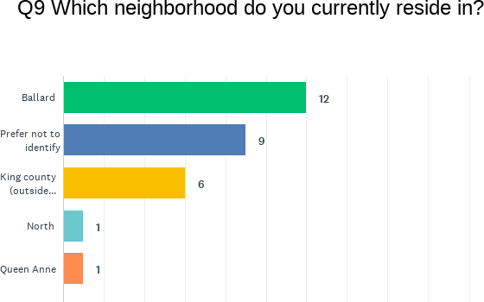

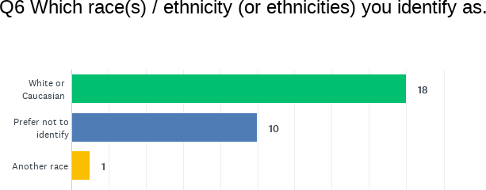
  - Question One: What concerns, if any, do you have about the use of this technology?
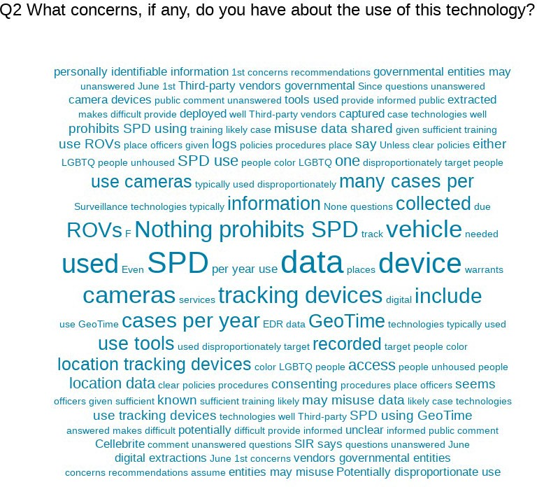
  - Question Two: What value, if any, do you see in the use of this technology?

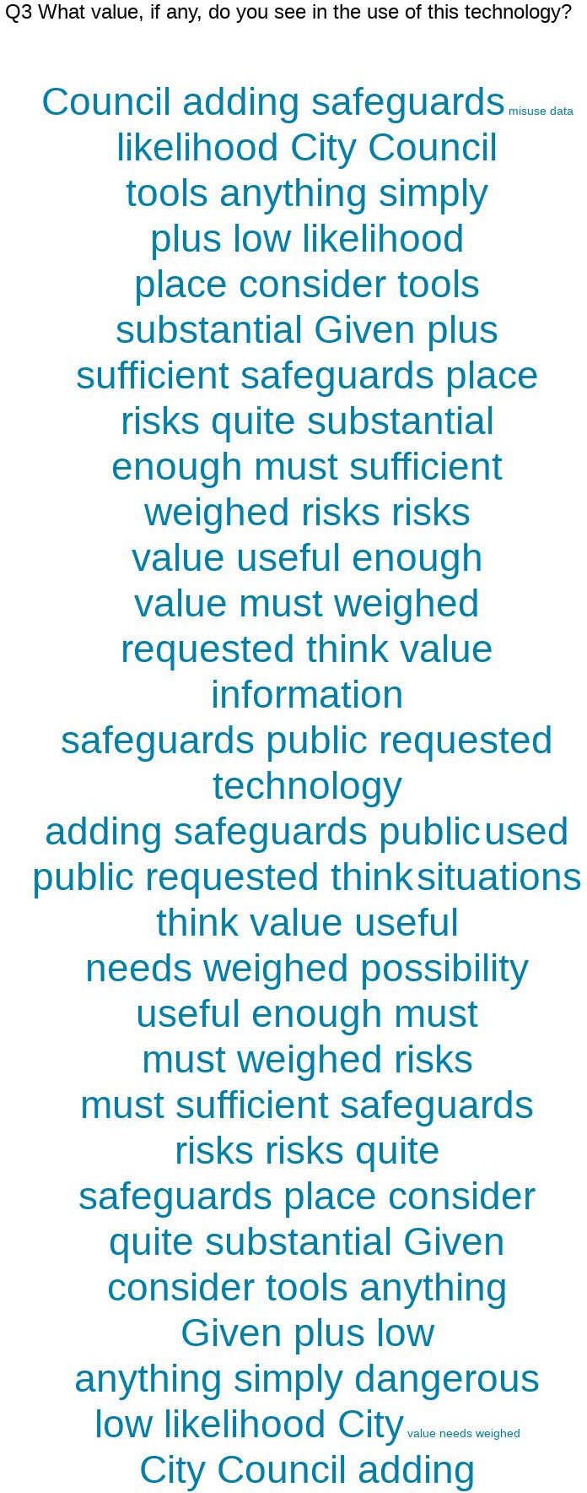

  - Question Three: What would you want City leadership to consider when making a decision about the use of this technology?
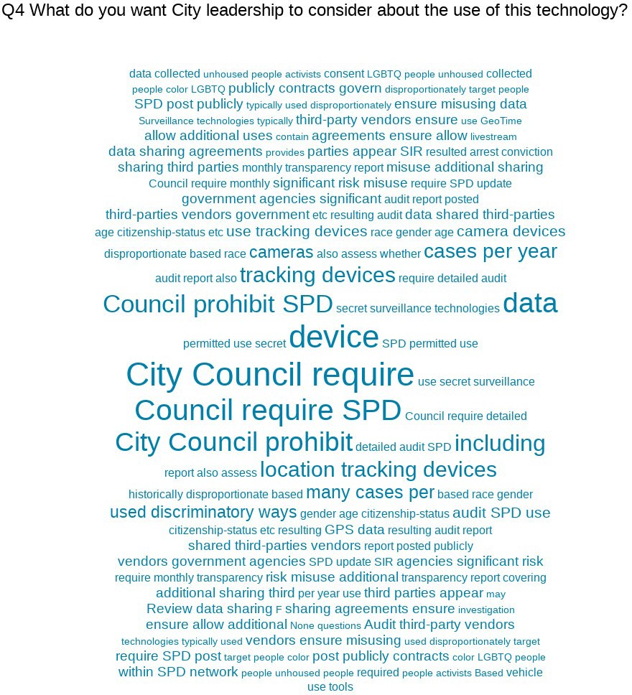
  - Question Four: General response to the technology.

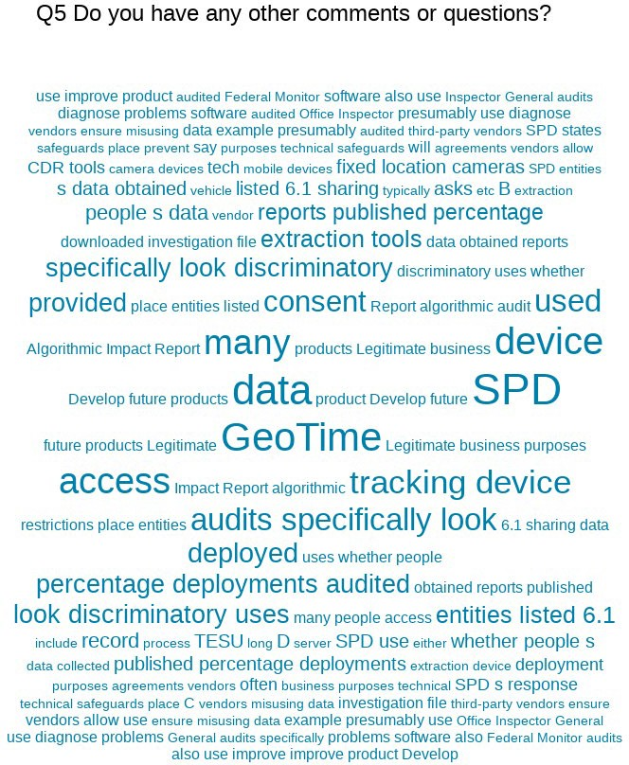

Response to Public Comments
  - How will you address the concerns that have been identified by the public?
What program, policy and partnership strategies will you implement? What strategies address immediate impacts? Long-term impacts? What strategies address root causes of inequity listed above? How will you partner with stakeholders for long-term positive change?

Equity Annual Reporting
  - What metrics for this technology be reported to the CTO for the annual equity assessments?
Metrics on covert tracking technology are gathered by the OIG for their annual surveillance technology audits.
Usage reports on GPS pursuit mitigation trackers will be available through the RTCC information portal and reports.

Privacy and Civil Liberties Assessment

Purpose
This section shall be completed after public engagement has concluded and the department has completed the racial equity toolkit section above. The privacy and civil liberties assessment is completed by the community surveillance working group (“working group”), per the surveillance ordinance which states that the working group shall:
“Provide to the executive and the City Council a privacy and civil liberties impact assessment for each SIR that must be included with any departmental request for surveillance technology acquisition or in-use approval. The impact assessment shall include a description of the potential impact of the surveillance technology on civil rights and liberties and potential disparate impacts on communities of color and other marginalized communities. The CTO shall share with the working group a copy of the SIR that shall also be posted during the period of public engagement. At the conclusion of the public engagement period, the CTO shall share the final proposed SIR with the working group at least six weeks prior to submittal of the SIR to Council for approval. The working group shall provide its impact assessment in writing to the executive and the City Council for inclusion in the SIR within six weeks of receiving the final proposed SIR. If the working group does not provide the impact assessment before such time, the working group must ask for a two-week extension of time to City Council in writing. If the working group fails to submit an impact statement within eight weeks of receiving the SIR, the department and City Council may proceed with ordinance approval without the impact statement.”

Working Group Privacy and Civil Liberties Assessment
From: Seattle Community Surveillance Working Group (CSWG) To: Seattle City Council
Date: August 4, 2022
Re: Privacy and Civil Liberties Impact Assessment for Tracking Devices

Executive Summary

The CSWG has completed its review of the Surveillance Impact Reports (SIRs) for the six surveillance technologies included in Group 4b of the Seattle Surveillance Ordinance technology review process. These technologies are GeoTime; Computer, Cell Phone, and Mobile Device Extraction Tools; Camera Systems; Remotely Operated Vehicles; Crash Data Retrieval; and Tracking Devices. This document is the CSWG’s Privacy and Civil Liberties Impact Assessment for Tracking Devices used by Seattle Police Department (SPD) as set forth in SMC 14.18.080(B)(1), which we provide for inclusion in the final SIRs submitted to the City Councils.

This document first provides our recommendations to Council, then provides background information, key concerns, and outstanding questions regarding Tracking Devices.

Our assessment of Tracking Devices as used by Seattle Police Department (SPD) focuses on the following major issues.

- No transparency on tracking device system vendor names and model numbers.

- Inadequate policies defining purpose limitations for tracking device use.
- Inadequate policies on data storage, safeguards, and retention.
- Inadequate policies on oversight and auditing.

The Council should adopt clear and enforceable rules that ensure, at the minimum, the following:

- Tracking devices are only used with authorization of a court-ordered warrant.
- There is a policy defining the incident types for which SPD may use tracking devices, and how they may be used. For example, SPD’s deployment of tracking devices is limited to cases that are serious and violent offenses, and evidence of these offenses must be provided in warrant applications for their use.
- Data collected via the tracking device never leaves SPD-owned equipment.
- The following are made publicly available:
  - The names of the manufacturers, vendors, model names, and model numbers of tracking devices;
  - How many tracking devices SPD has;
  - How many people have access to the tracking devices;
  - The purchase orders and contracts for each of the tracking devices.
- The following are made publicly available on at least a monthly basis:
  - The reasons for use;
  - The frequency with which tracking devices are used;
  - The average and median length of time tracking devices are deployed;
  - The number of individuals and/or devices and items and/or vehicles tracked;
  - Whether the use of a tracking device resulted in an arrest, conviction, injury, fatality, or other physical and economic harm or burden on an individual or group;
  - To whom and under what circumstances data gathered from a tracking device have been or are being shared;
- There must be strong access controls (authentication, authorization, logging, etc.) in place tracking devices.
- There is a clear data retention policy.
- There is adequate and standardized training for all personnel who use tracking devices and the training includes a privacy component specific to the risks inherent to using tracking devices as an investigative tool.
- There must be a detailed direct audit log of user actions with tracking devices and SPD must produce a publicly available annual audit report about its use of the technology.
- There must be measures in place to validate the accuracy of the data collected by tracking devices.

Key Concerns

- No Transparency on Tracking Device Vendor and Product Names. The SIR does not disclose the names of the manufacturers and the specific model numbers and names of the tracking devices used by SPD. Without this information it is challenging to comprehensively review all the functions and capabilities of the technologies in use and provide recommendations on how each technology should be regulated.

- Lack of Clarity on Usage Limitations and Types of Incidents for Which Tracking Devices are Used. While the SIR states that officers/detectives will provide written consent and/or a court

approved warrant for all vehicletracking technology deployments, it does not describe the incident types for which tracking devices are used. Especially with consent-based uses of tracking devices, it is unclear from the SIR how the use of tracking devices is constrained (whereas a judicial warrant would articulate formal parameters around data collection, such as time frame).
Additionally, it is unclear whether SPD has a policy limiting the use of geolocation trackers to vehicles.

- Lack of Legitimacy of “Consent-Based” Use of Tracking Devices and Lack of Clarity on How Consent is Obtained. It is unlikely that consent-based use tracking devices is legitimately consensual given the power and information asymmetry between police and members of the public, and particularly for communities that are disproportionately surveilled and policed. There are important racial differences in how individuals interact with law enforcement, and individuals may fear that refusing to give their consent to police will lead to deadly consequences. Additionally, the SIR does not describe the process by which officers obtain consent from witnesses or confidential informants. It is also unclear from whom consent is being sought—the vehicle owner, driver, and/or passengers. Lastly it is unclear if this process is standardized.

- Lack of Clarity on How Many and Which Personnel Have Access to Tracking Devices and How They are Secured to Prevent Unauthorized Access. It is unclear which units have and how many people in total have access to the tracking devices.

- Lack of Clarity on Frequency of Usage of Tracking Devices. It is unclear how many cases per year use tracing devices, how many deployments there are per year, and the average and median length of time tracking devices are deployed.

- Lack of Transparency and Inadequate Policies on Data Storage, Safeguards, and Retention. It is unclear whether the data collected via the physical tracking devices ever leaves SPD-owned equipment. The SIR states that “data is securely stored by the vehicle tracking technology vendor and will be transferred to the case investigator only via Seattle Police Department owned and authorized technology. At that time, vehicle tracking data collected by the tracking device is downloaded from the vendor software and resides only with the investigation file.”135 It is unclear if the data is within the SPD network on-premises or if it flows to a vendor providing Software-as-a-Service. Additionally, the SIR does not state if any data retention policy exists. The SIR states that SPD deletes tracking device data from the software and hardware after the conclusion of a tracking schedule, but it does not state how long the data are kept after being moved to an investigation file.

- Lack of Clarity on Training. It is unclear how the vendor trains TESU personnel and how consistency in this training is ensured.

- Inadequate Data Sharing Policies. The SIR states that SPD may share data obtained from tracking devices with outside entities but does not address whether SPD maintains a record of those disclosures.

- Inadequate Oversight and Auditing Policies. The SIR states that no formal audits exist for tracking device deployments. It is unclear if SPD has measures to prevent or detect the use of a tracking device being used outside of the confines of a case or legal investigation.

Outstanding Questions

- What are the manufacturers, vendors, model numbers, and model names of the tracking devices in use by SPD?
- Is there any policy defining the incident types for which SPD may use tracking devices?
- What is the process of getting consent?
- Is the “online portal” hosted within the SPD network on-premise, or is it hosted on the vendor’s website?
- Does the data collected via the tracking device ever leave SPD-owned equipment
- Are the trackers placed anywhere other than a vehicle?
- Is the TESU personnel training standardized and documented?
- What is the retention period for data collected by tracking devices?
- How many cases per year use tracking devices?
- How many deployments of tracking devices are there per year?
- How long is the average and median length of time tracking devices are deployed?
- How many tracking devices does SPD have?
- How many people have access to SPD’s location tracking devices?
- How many times has SPD deployed a tracking device on a vehicle either not owned by the suspect or owned by the suspect but also frequently used by other individuals?
- Are there measures in place that would prevent or detect the use of a tracking device outside the confines of a case or legal investigation?
- Have there been any audits of SPD’s use of tracking devices? If so, when was the last audit and where can that audit report be found?

The answers to these questions can further inform the content of any binding policy the Council chooses to include in an ordinance on this technology, as recommended above.

Memo
To: Seattle City Council
From: Jim Loter, Interim Chief Technology Officer
Subject: CTO Response to the Surveillance Working Group Tracking Devices SIR Review

Purpose
As provided in the Surveillance Ordinance, SMC 14.18.080, this memo outlines the Chief Technology Officer’s (CTO’s) response to the Surveillance Working Group assessment on the Surveillance Impact Report for Seattle Police Department’s Tracking Devices.

Background
The Information Technology Department (ITD) is dedicated to the Privacy Principles and Surveillance Ordinance objectives to provide oversight and transparency about the use and acquisition of specialized technologies with potential privacy and civil liberties impacts. All City departments have a shared mission to protect lives and property while balancing technology use and data collection with negative impacts to individuals. This requires ensuring the appropriate use of privacy invasive technologies through technology limitations, policy, training and departmental oversight.
The CTO’s role in the SIR process has been to ensure that all City departments are compliant with the Surveillance Ordinance requirements. As part of the review work for surveillance technologies, ITD’s Privacy Office has facilitated the creation of the Surveillance Impact Report documentation, including collecting comments and suggestions from the Working Group and members of the public
about these technologies. IT and City departments have also worked collaboratively with the Working Group to answer additional questions that came up during their review process.

Technology Purpose
The Seattle Police Department (SPD) utilizes geolocation trackers to track and locate vehicle information during criminal investigations. Geolocation trackers are devices that SPD utilizes as a tool to locate and track the movements and locations of vehicles. Trackers are utilized only after obtaining legal authority via a court order or consent, and once the consent or terms of the order have expired all data collected is maintained only in the investigation file

Working Group Concerns
In their review, the Working Group has raised concerns about these devices being used in a privacy impacting way, including data collection, sharing, retention, deletion, storage, and protection.
We believe that policy, training and technology limitations enacted by SPD provide adequate mitigation for the potential privacy and civil liberties concerns raised by the Working Group about the use of this operational technology.

Recommended Next Steps
I look forward to working together with Council and City departments to ensure continued transparency about the use of these technologies and finding a mutually agreeable means to use technology to improve City services while protecting the privacy and civil rights of the residents we serve. Specific concerns in the Working Group comments about this technology are addressed in
the attached document.

Response to Specific Concerns: Tracking Devices

Concern: No Transparency on Tracking Device Vendor and Product Names
CTO Assessment: The policies in place in the SIR and SPD manual operate regardless of the manufacturer or model of the devices. The conditions under which the devices are used are clearly outlined in the SIR and are further regulated by RCW 9.73.
SIR Response: N/A

Concern: Lack of Clarity on Usage Limitations and Types of Incidents for Which Tracking Devices are Used
CTO Assessment: These technologies are used surreptitiously and without consent. These technologies are operated under the authorization of a warrant from a court. Warrant and consent procedures are governed by state and federal law.
SIR Response:
Section 3.2
Tracking devices are only utilized with express consent or search warrant authority. SPD must comply with all legal requirements for securing consent or a search warrant (see US v. Jones and State v.
Jackson).

Section 4.9
To deploy and utilize vehicle trackers, Officers/Detectives must submit a request form that requires proof of consent or search warrant, and active investigation, as evidenced by a GO number. After the scheduled parameters for collection of data expire, data is downloaded from the supporting software, and included in the investigation file. At that point, only SPD personnel involved in the investigation have access to this information.

Concern: Lack of Legitimacy of “Consent-Based” Use of Tracking Devices and Lack of Clarity on How Consent is Obtained.
CTO Assessment: The SIR contains discrete sections relating to each of the concerns in addition to additional policies governing the use in the SPD manual and state law (RCW 9.73). As the data collected from these systems are primarily intended in use for criminal prosecution, there are other superseding policies and procedures that must be followed (circumstances around sharing or retention for example).

SIR Response: N/A

Concern: Lack of Clarity on How Many and Which Personnel Have Access to Tracking Devices and How They are Secured to Prevent Unauthorized Access
CTO Assessment: The SIR outlines the conditions under which devices are used in investigations in addition to the standards that are required by a legal entity to authorize the use of Tracking Devices. Data obtained from these devices are processed in accordance with SPD’s evidence handling policies as well as state and federal law.

SIR Response:
Section 4.7
Only authorized SPD users can access the vehicle tracking devices or the data while it resides in the system. Access to the vehicle tracking systems/technology is specific to system and password-protected.
Data removed from the vehicle tracking system/technology and entered into investigative files is securely input and used on SPD’s password-protected network with access limited to detectives and identified supervisory personnel.
All SPD employees are backgrounded and access is controlled by SPD Manual Title 12 provisions governing Department Information Systems including SPD Policy 12.040 - Department-Owned Computers, Devices & Software, SPD Policy 12.050 - Criminal Justice Information Systems, SPD Policy
12.080 – Department Records Access, Inspection & Dissemination, SPD Policy 12.110 – Use of Department E-mail & Internet Systems, and SPD Policy 12.111 – Use of Cloud Storage Services.
Section 5.1
Data is securely stored by the vehicle tracking technology vendor and will be transferred to the case investigator only via Seattle Police Department owned and authorized technology. At that time, vehicle tracking data collected by the tracking device is downloaded from the vendor software and resides only with the investigation file.

Concern: Lack of Clarity on Frequency of Usage of Tracking Devices
CTO Assessment: Tracking devices are used when supported by a search warrant or consent (of a witness or a confidential informant), in conjunction with an active investigation.
SIR Response:
Section 4.4
Trackers are used, as appropriate, when supported by a search warrant or consent (of a witness or a confidential informant), in conjunction with an active investigation. The length of time that any one tracker might be utilized in an investigation is established, and constrained, by parameters established within the requisite search warrant.

Concern: Lack of Clarity on Training
CTO Assessment: Investigators who use the tracking devices receive multiple mandated trainings about cybersecurity and privacy. The conditions of use of these devices are covered by legal requirements which must be met prior to deployment.
SIR Response:
Section 7.2
SPD Policy 12.050 mandates that all employees receive Security Awareness Training (Level 2), and all employees also receive City Privacy Training.

Concern: Inadequate Data Sharing Policies
CTO Assessment: No entities outside of SPD have direct access to the data or the devices. Only evidence related to the investigation would be shared with identified partners in the SIR. Data sharing is a legal requirement for assisting with criminal prosecutions or complying with legal requirements with other law enforcement agencies.
SIR Response:
Section 6.1
No person, outside of SPD, has direct access to the tracking units or the data.
Data obtained from the system may be shared outside SPD with the other agencies, entities, or individuals within legal guidelines or as required by law.
Data may be shared with outside entities in connection with criminal prosecutions:
- Seattle City Attorney’s Office
- King County Prosecuting Attorney’s Office
- King County Department of Public Defense
- Private Defense Attorneys
- Seattle Municipal Court
- King County Superior Court
- Similar entities where prosecution is in Federal or other State jurisdictions

Data may be made available to requesters pursuant to the Washington Public Records Act, Chapter
42.56 RCW (“PRA”). SPD will apply applicable exemptions to the data before disclosing to a requester. Individuals have the right to inspect criminal history record information maintained by the department (RCW 10.97.030, SPD Policy 12.050). Individuals can access their own information by submitting a public disclosure request.

Per SPD Policy 12.080, the Crime Records Unit is responsible for receiving, recording, and responding to requests “for General Offense Reports from other City departments and from other law enforcement agencies, as well as from insurance companies.”
Discrete pieces of data collected by these tracking devices may be shared with other law enforcement agencies in wanted bulletins, and in connection with law enforcement investigations jointly conducted with those agencies, or in response to requests from law enforcement agencies investigating criminal activity as governed by SPD Policy 12.050 and 12.110. All requests for data from Federal Immigration

and Customs Enforcement (ICE) authorities are referred to the Mayor’s Office Legal Counsel in accordance with the Mayoral Directive, dated February 6, 2018.

SPD shares data with authorized researchers pursuant to properly execute research and confidentiality agreements as provide by SPD Policy 12.055. This sharing may include discrete pieces of data related to specific investigative files collected by the devices.

Concern: Inadequate Oversight and Auditing Policies
CTO Assessment: SPD has existing audit functionality with the Office of Inspector General, unit supervisors, or the federal monitor. Audit, Policy & Research Section personnel can also conduct audits of all data collection software and systems. Additionally, the Surveillance Ordinance does mandate yearly auditing of these technologies by the Office of Inspector General and the IT department in some circumstances.
SIR Response:
Section 8.1
Each unit maintains logs of deployment. These logs are available for audit, both internally and externally.
Per SPD Policy 12.080, the Crime Records Unit is responsible to receive and record all requests “for General Offense Reports from other City departments and from other law enforcement agencies, as well as from insurance companies.”
Any requests for public disclosure are logged by SPD’s Public Disclosure Unit. Any action taken, and data released subsequently, is then tracked through the request log. Responses to Public Disclosure Requests, including responsive records provided to a requestor, are retained by SPD for two years after the request is completed.

Section 8.2
No formal audits exist for tracking device deployments; however, requests to utilize tracking devices, as well as logs of deployments, are kept within each unit, and are subject to audit by the unit supervisors, Office of the Inspector General, and the federal monitor at any time.

Appendix A: Glossary
Accountable: (taken from the racial equity toolkit.) Responsive to the needs and concerns of those most impacted by the issues you are working on, particularly to communities of color and those historically underrepresented in the civic process.
Community outcomes: (taken from the racial equity toolkit.) The specific result you are seeking to achieve that advances racial equity.
Contracting equity: (taken from the racial equity toolkit.) Efforts to achieve equitable racial outcomes in the way the City spends resources, including goods and services, consultants and contracting.
DON: “department of neighborhoods.”
Immigrant and refugee access to services: (taken from the racial equity toolkit.) Government services and resources are easily available and understandable to all Seattle residents, including non-native English speakers. Full and active participation of immigrant and refugee communities exists in Seattle’s civic, economic and cultural life.
Inclusive outreach and public engagement: (taken from the racial equity toolkit.) Processes inclusive of people of diverse races, cultures, gender identities, sexual orientations and socio-economic status.
Access to information, resources and civic processes so community members can effectively engage in the design and delivery of public services.
Individual racism: (taken from the racial equity toolkit.) Pre-judgment, bias, stereotypes about an individual or group based on race. The impacts of racism on individuals including white people internalizing privilege, and people of color internalizing oppression.
Institutional racism: (taken from the racial equity toolkit.) Organizational programs, policies or procedures that work to the benefit of white people and to the detriment of people of color, usually unintentionally or inadvertently.
OCR: “Office of Civil Rights.”
Opportunity areas: (taken from the racial equity toolkit.) One of seven issue areas the City of Seattle is working on in partnership with the community to eliminate racial disparities and create racial equity. They include: education, health, community development, criminal justice, jobs, housing, and the environment.
Racial equity: (taken from the racial equity toolkit.) When social, economic and political opportunities are not predicted based upon a person’s race.

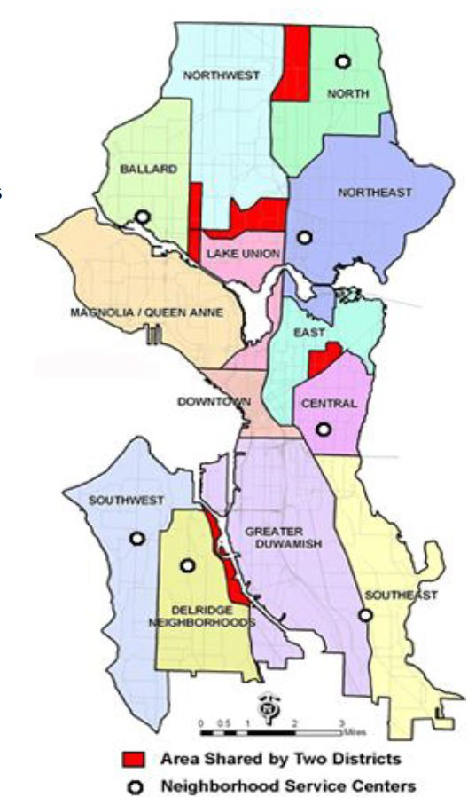
Racial inequity: (taken from the racial equity toolkit.) When a person’s race can predict their social, economic, and political opportunities and outcomes.
RET: “racial equity toolkit”
Seattle neighborhoods: (taken from the racial equity toolkit neighborhood.) Boundaries defined for the purpose of understanding geographic areas in Seattle.
Stakeholders: (taken from the racial equity toolkit.) Those impacted by proposed policy, program, or budget issue who have potential concerns or issue expertise. Examples might include: specific racial/ethnic groups, other institutions like Seattle housing authority, schools, community-based organizations, change teams, City employees, unions, etc.
Structural racism: (taken from the racial equity toolkit.) The interplay of policies, practices and programs of multiple institutions which leads to adverse outcomes and conditions for communities of color compared to white communities that occurs within the context of racialized historical and cultural conditions.
Surveillance ordinance: Seattle City Council passed ordinance 125376, also referred to as the “surveillance ordinance.”
SIR: “surveillance impact report”, a document which captures the fulfillment of the Council-defined surveillance technology review process, as required by ordinance 125376.
Workforce equity: (taken from the racial equity toolkit.) Ensure the City's workforce diversity reflects the diversity of Seattle.

Appendix B: Meeting Notice(s)
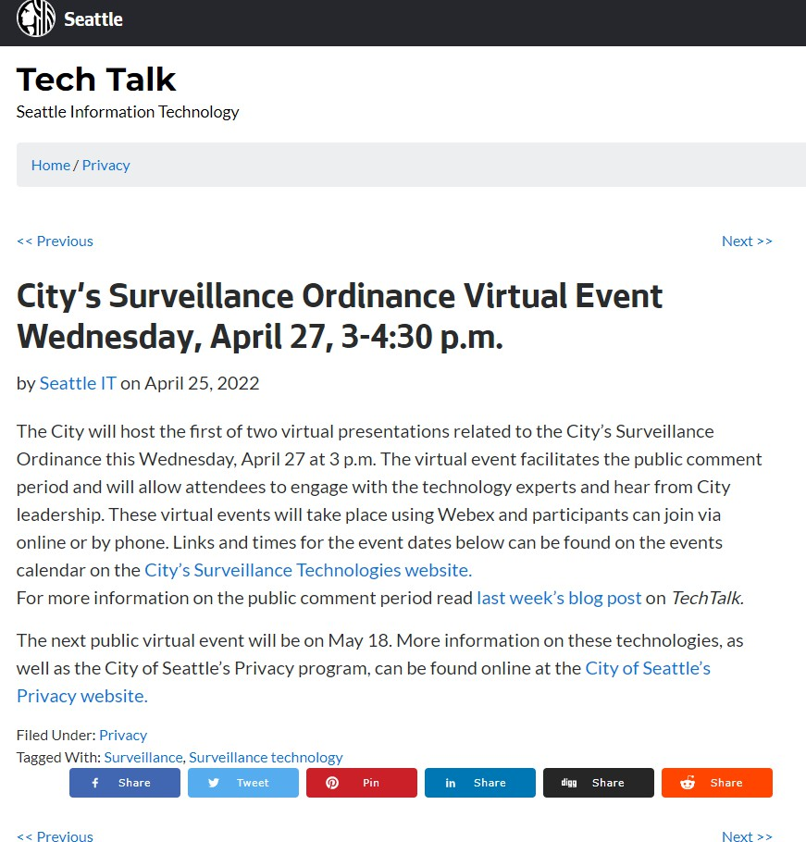

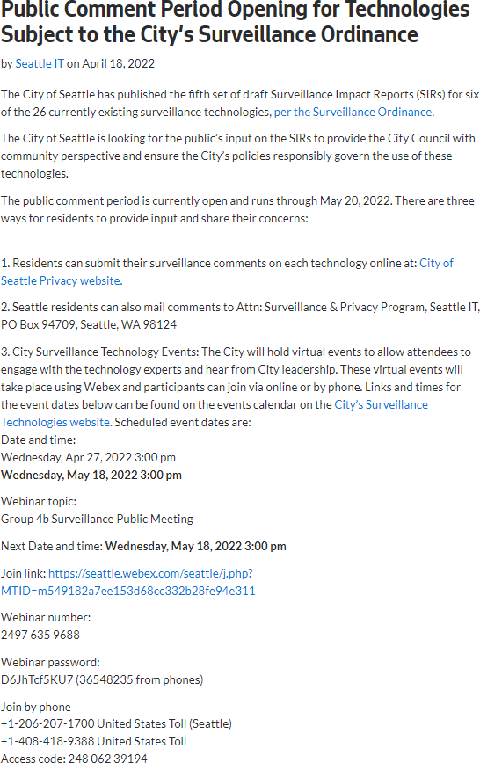

Appendix D: Letters from Organizations or Commissions

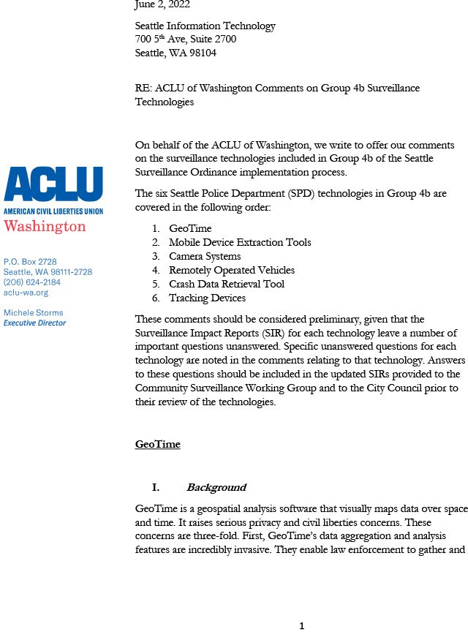

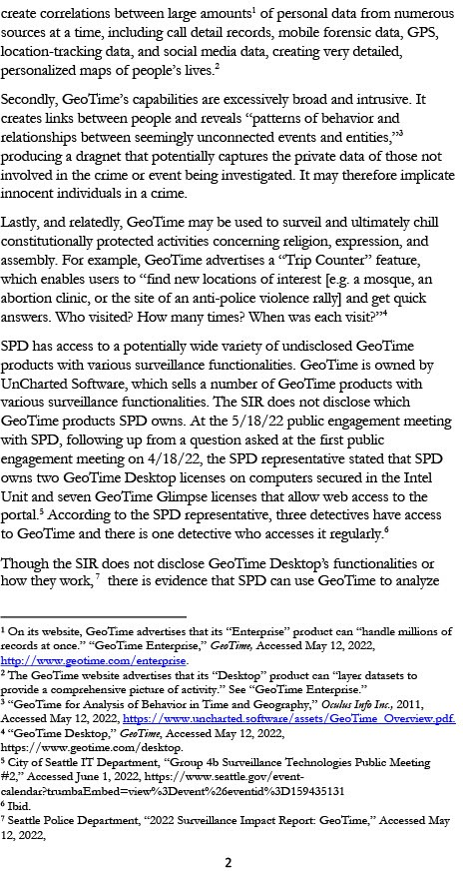

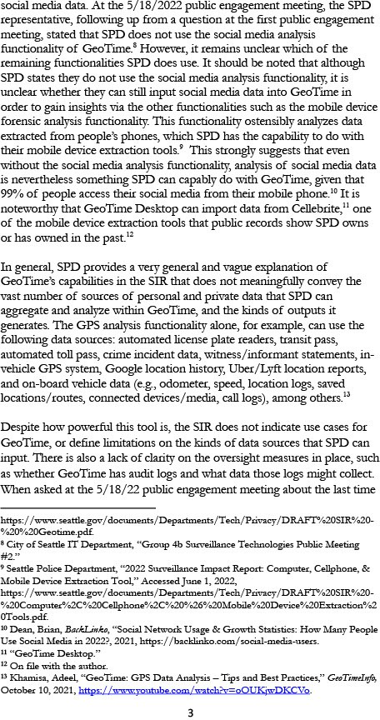

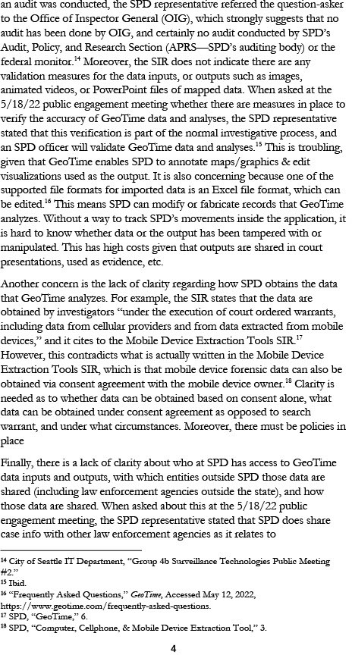

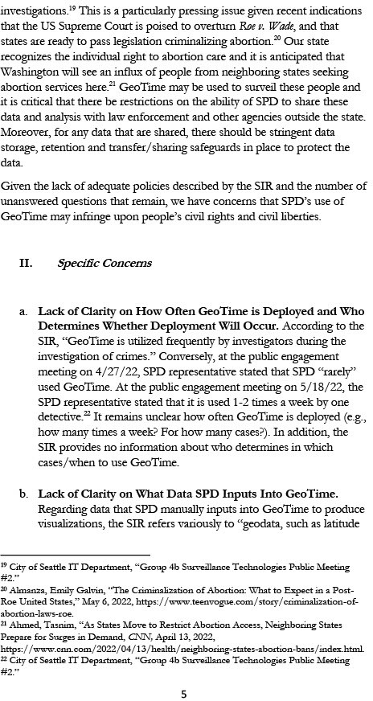

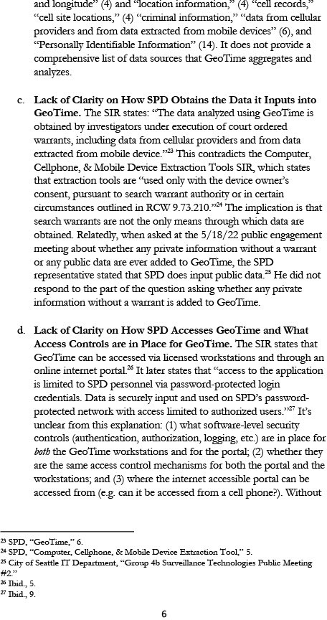

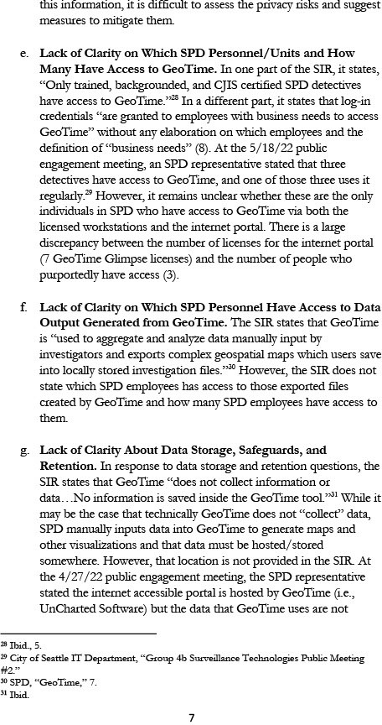

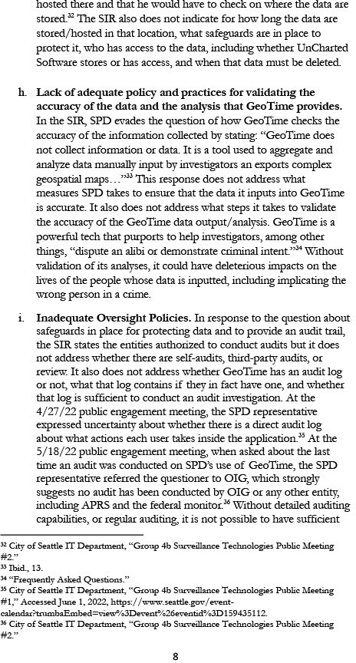

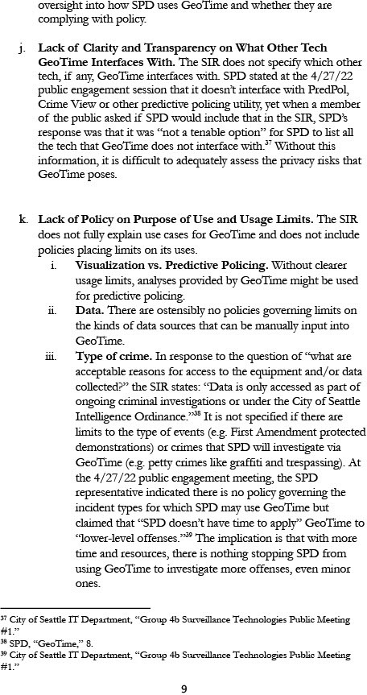

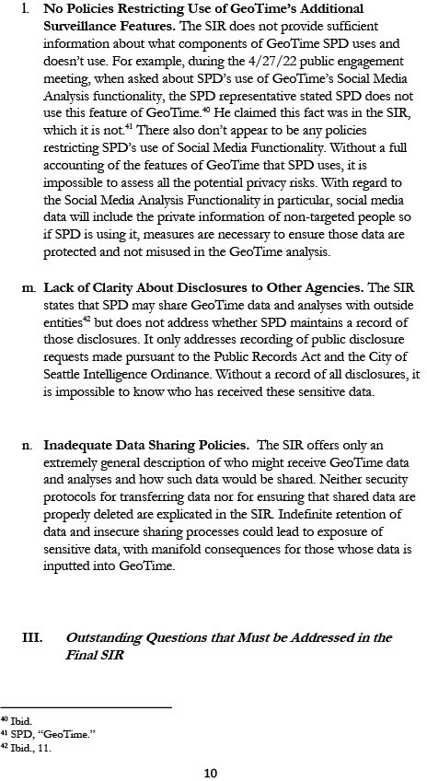

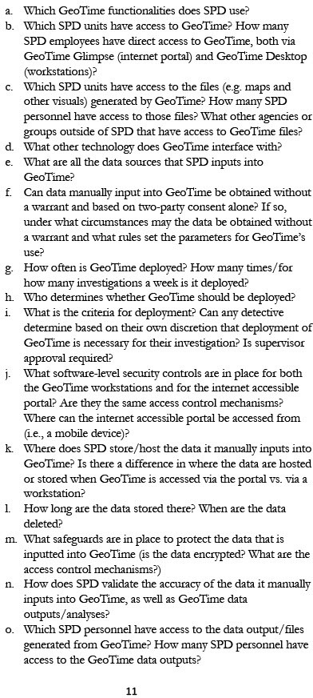

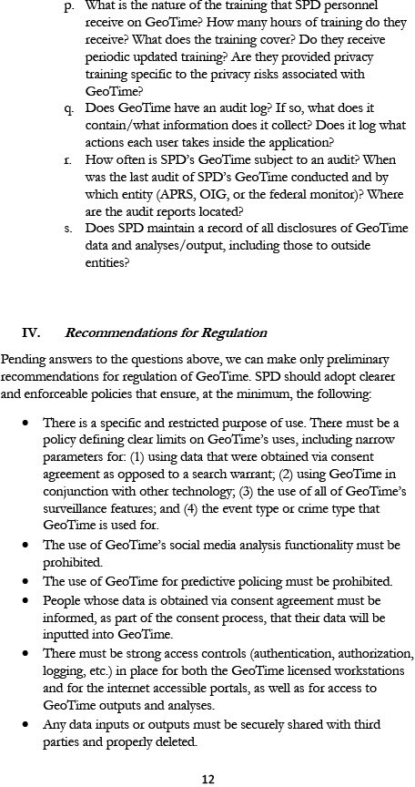

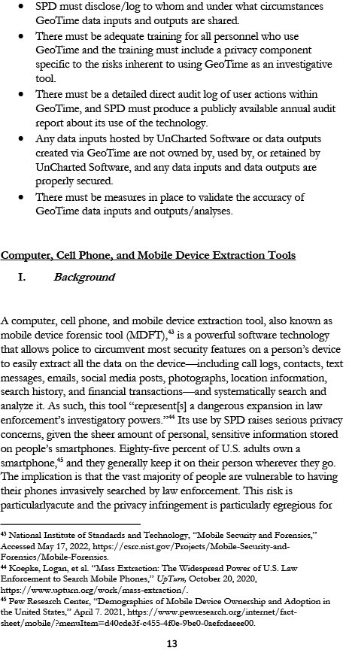

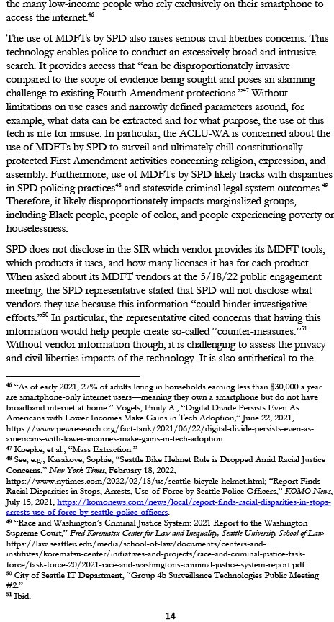

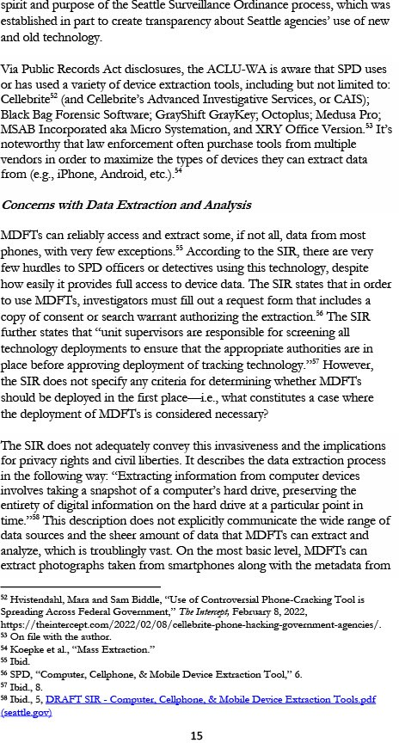

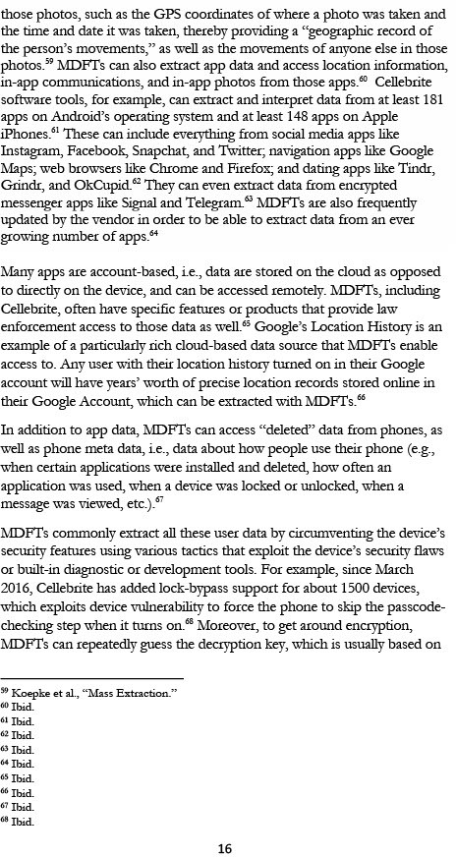

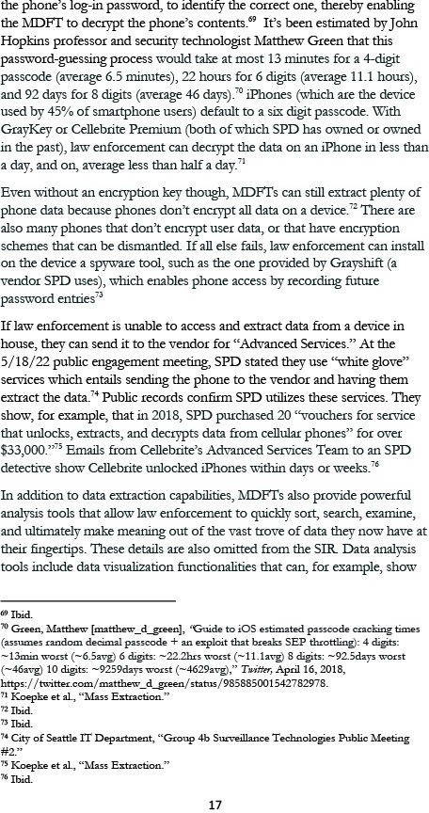

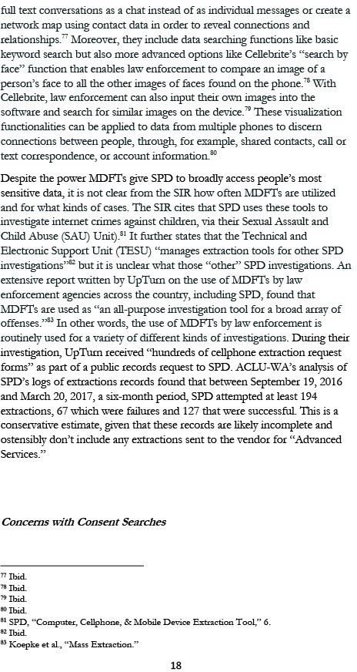

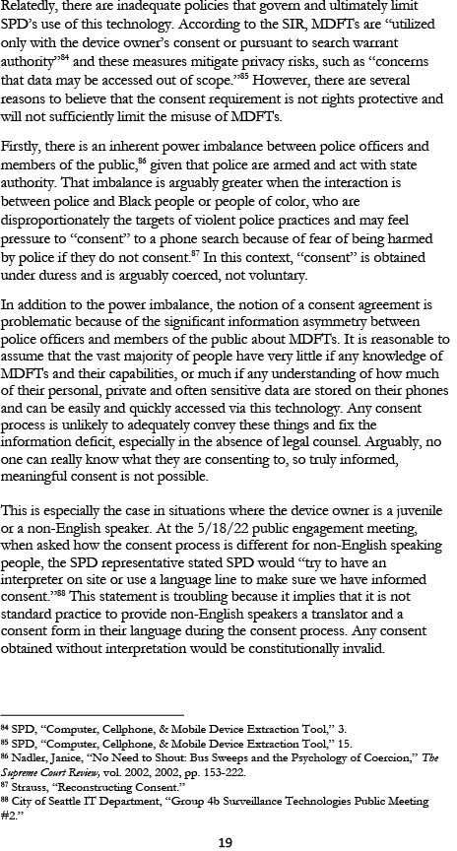

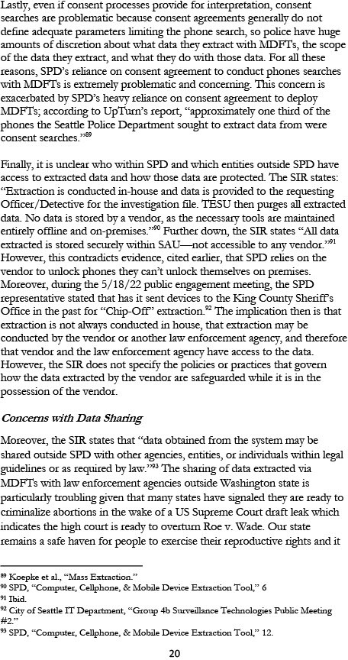

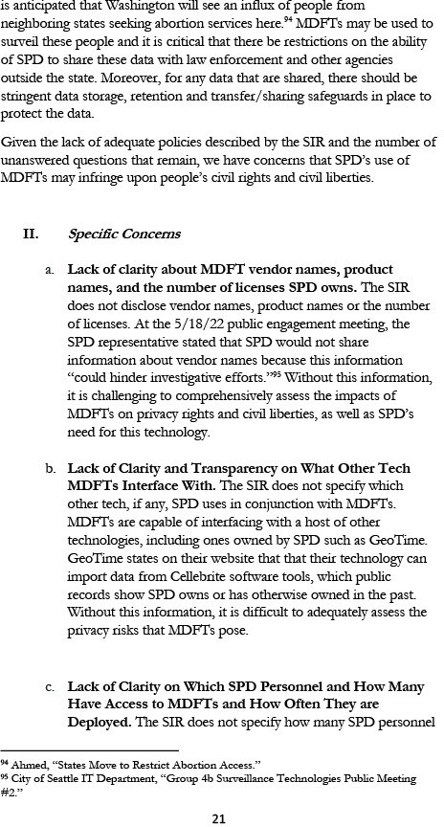

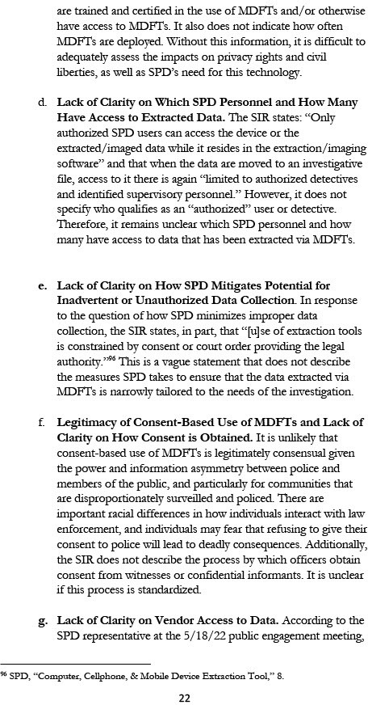

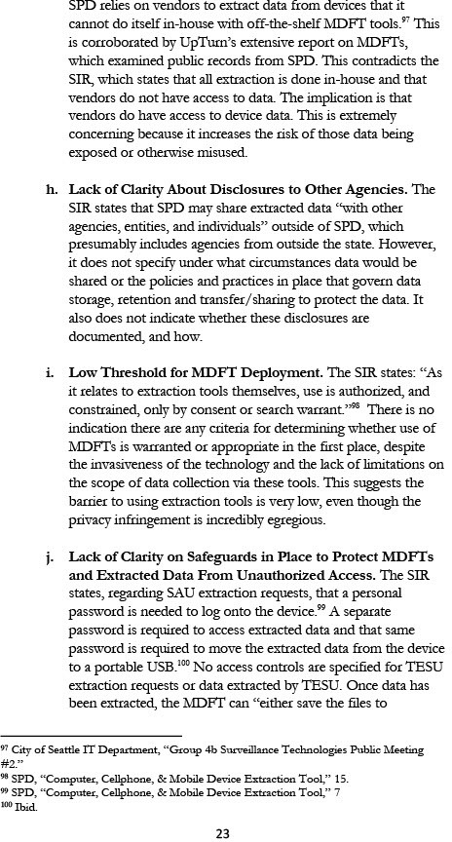

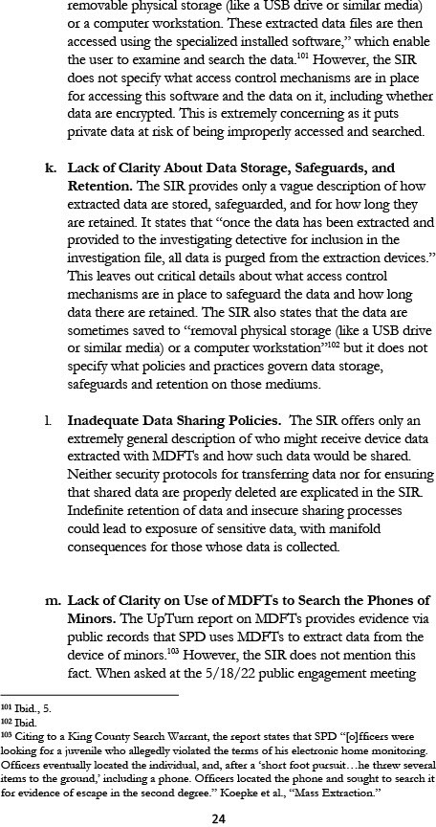

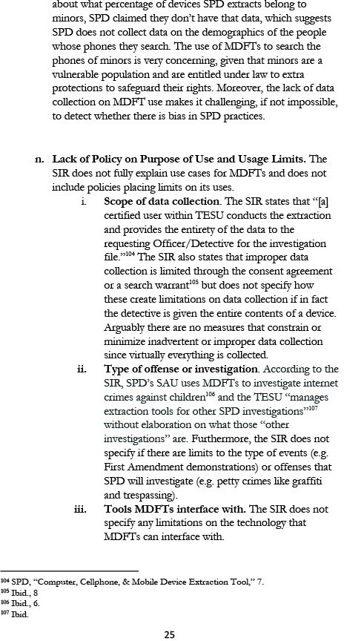

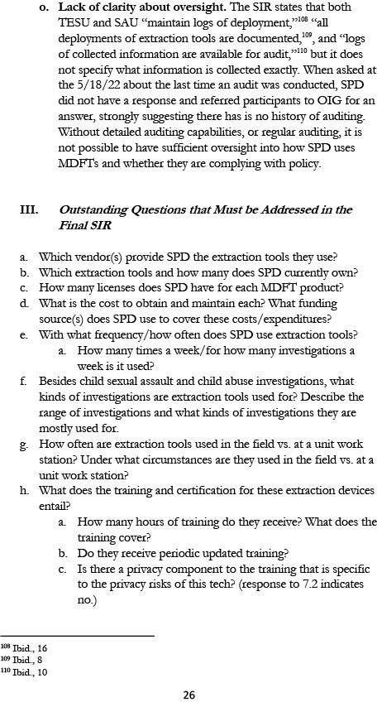

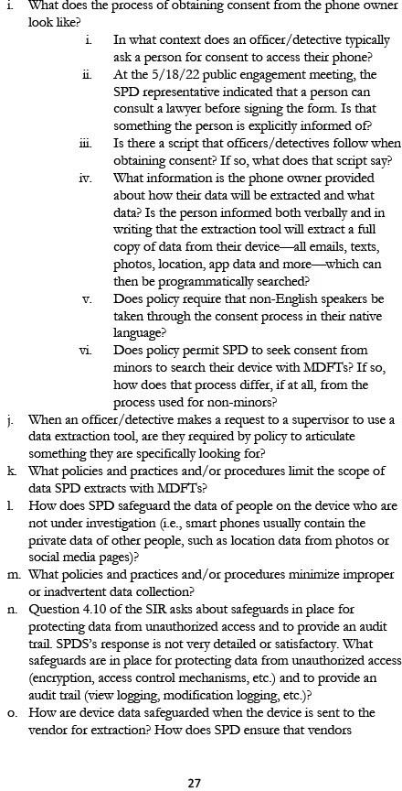

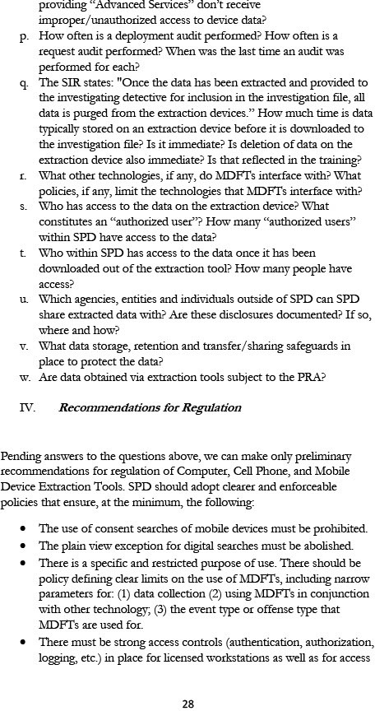

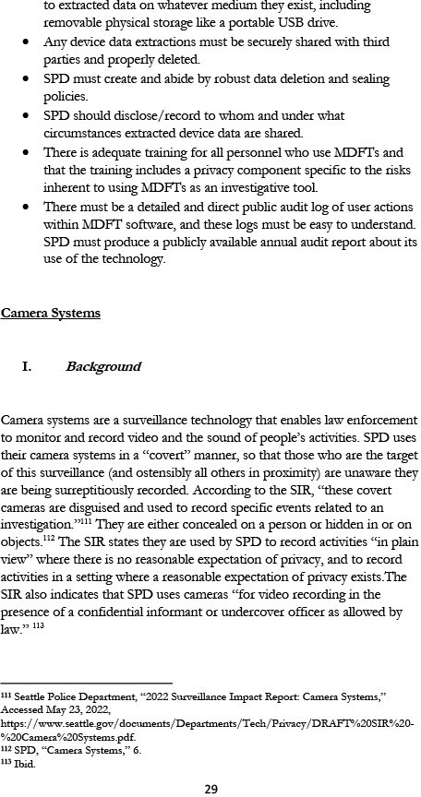

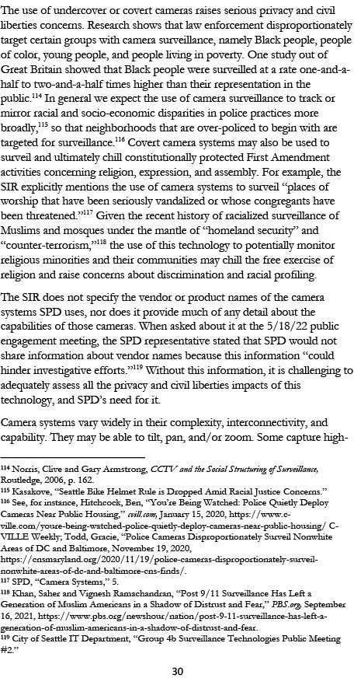

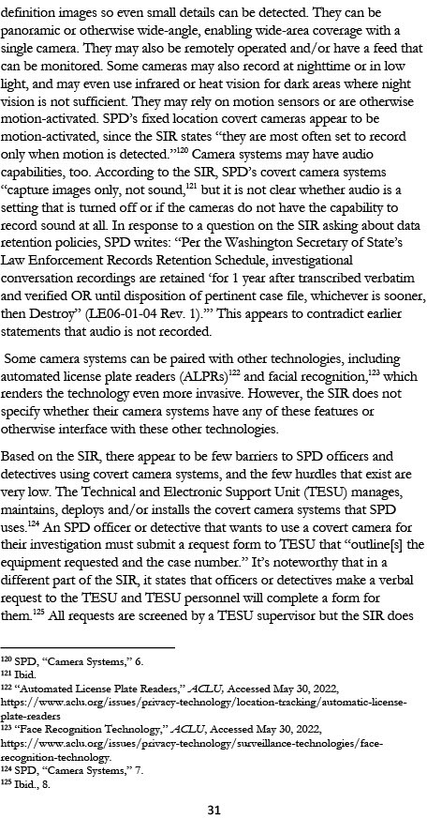

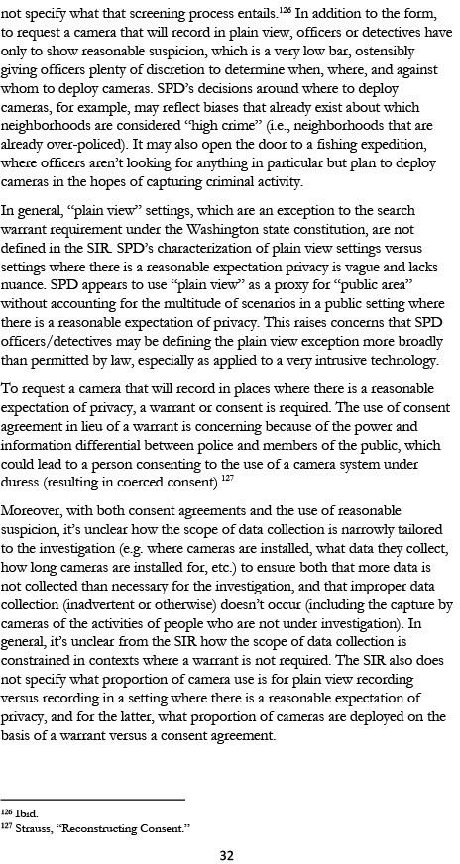

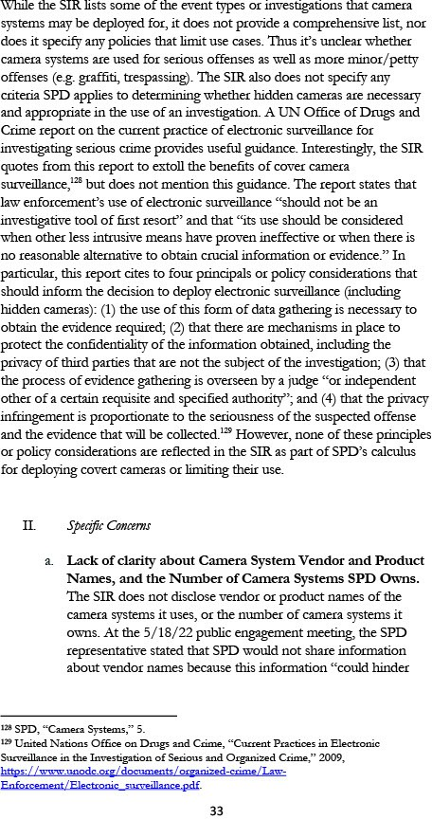

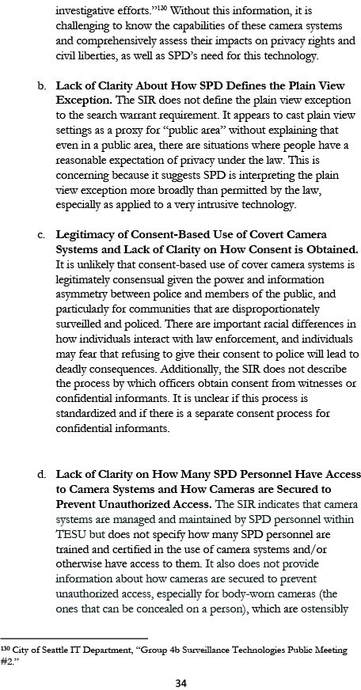

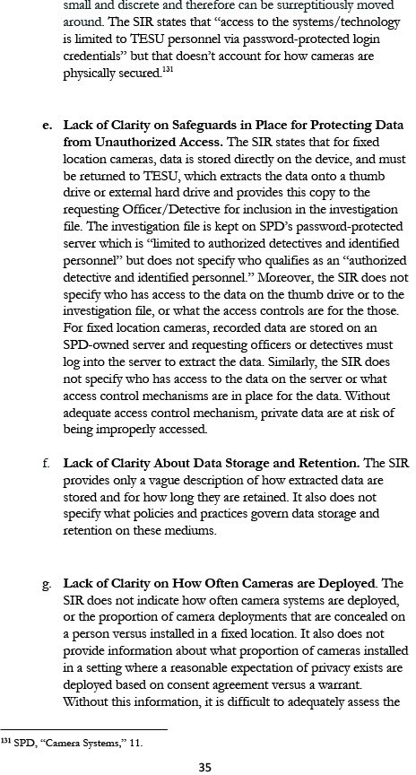

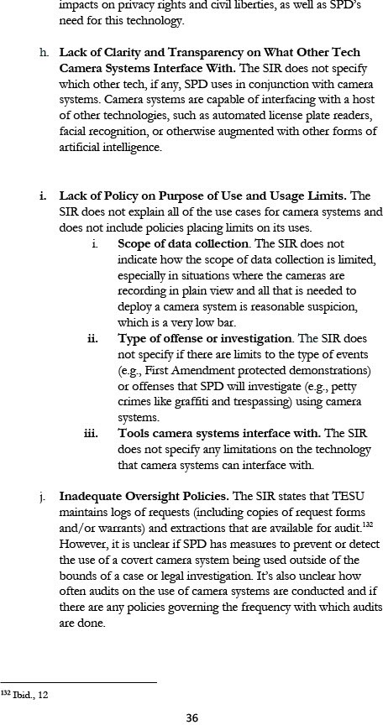

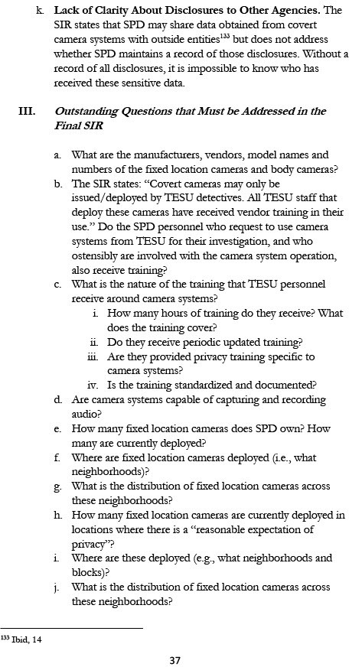

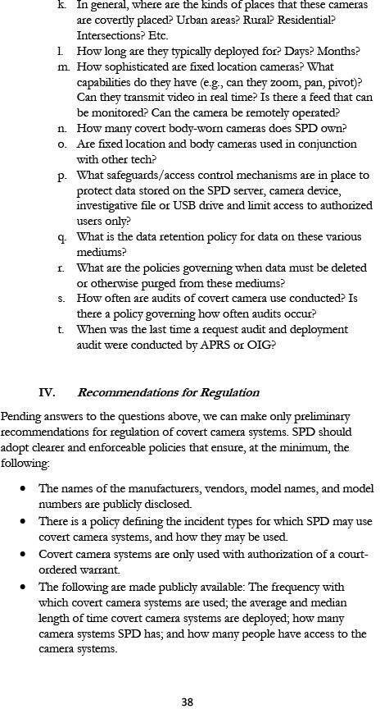

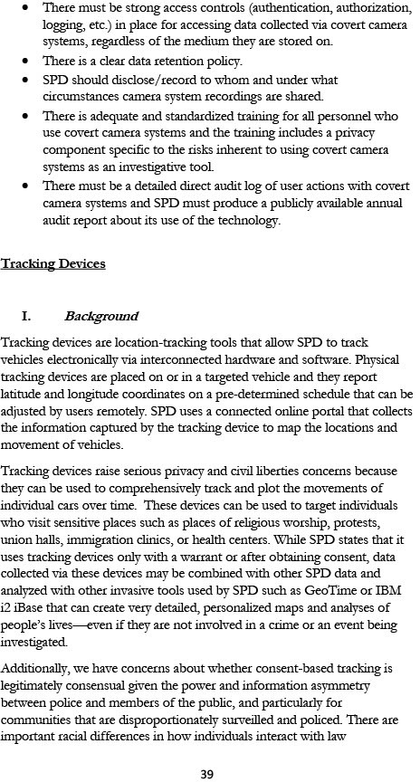

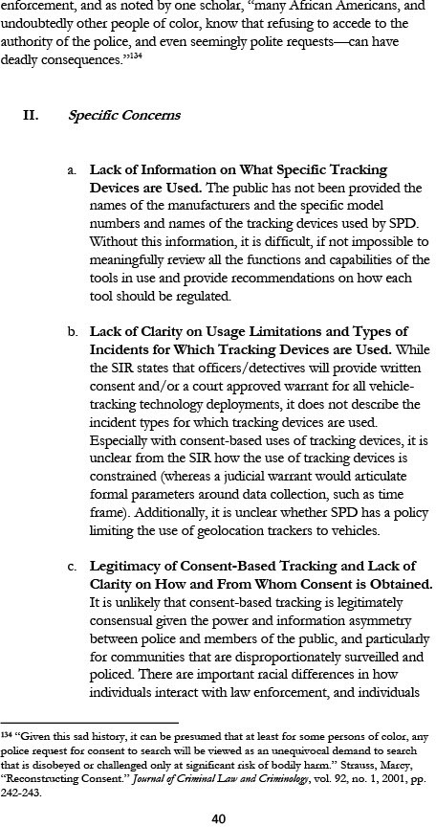

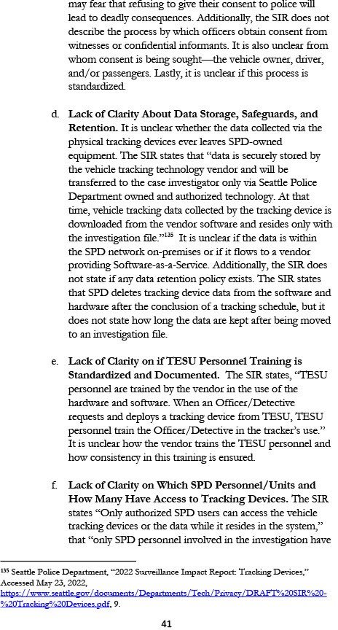

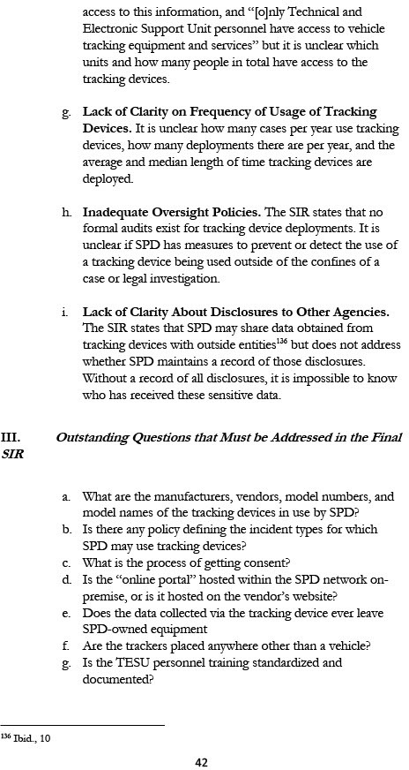

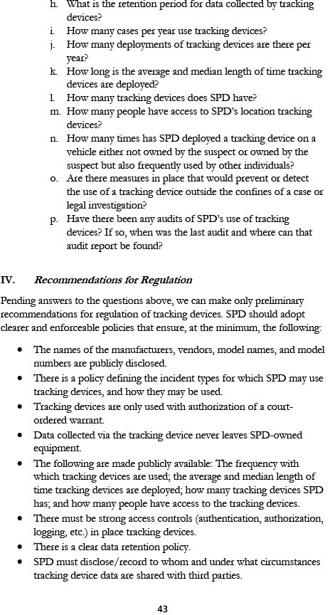

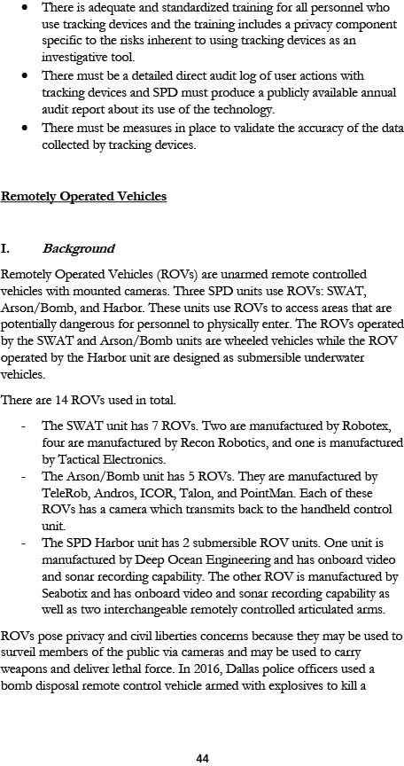

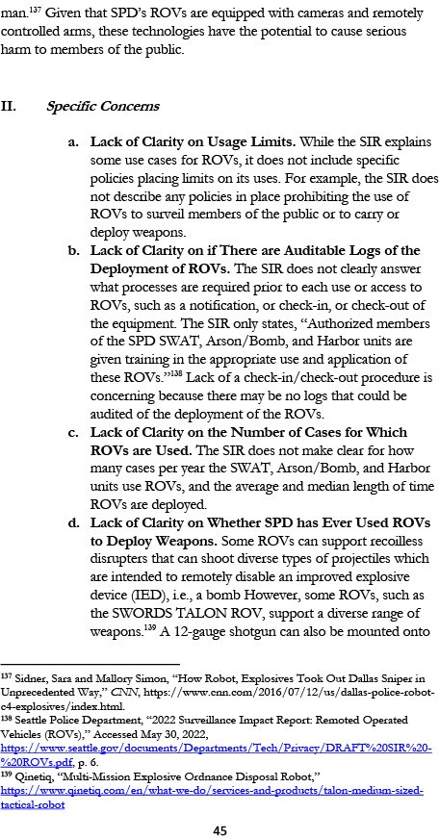

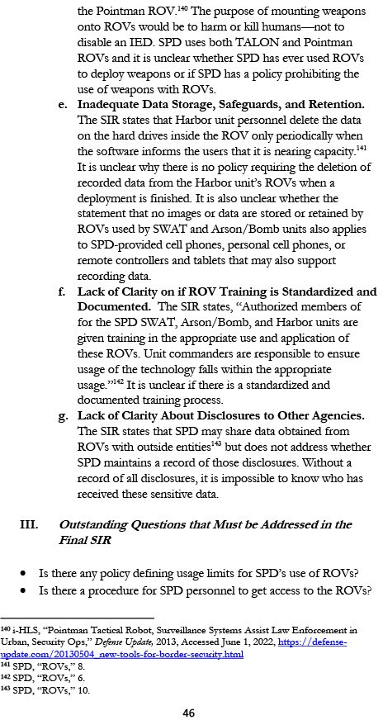

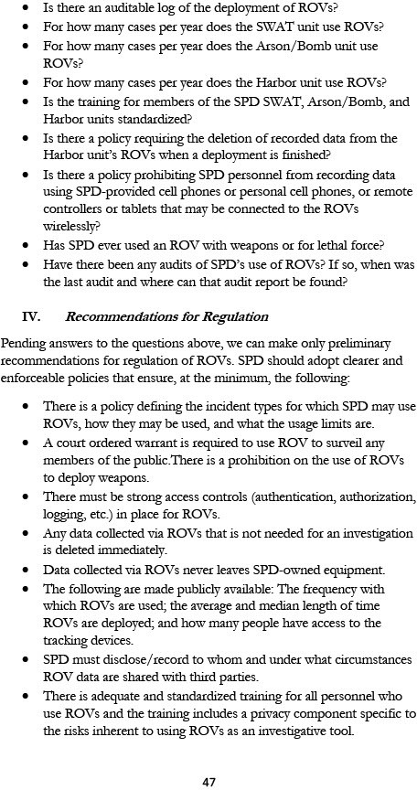

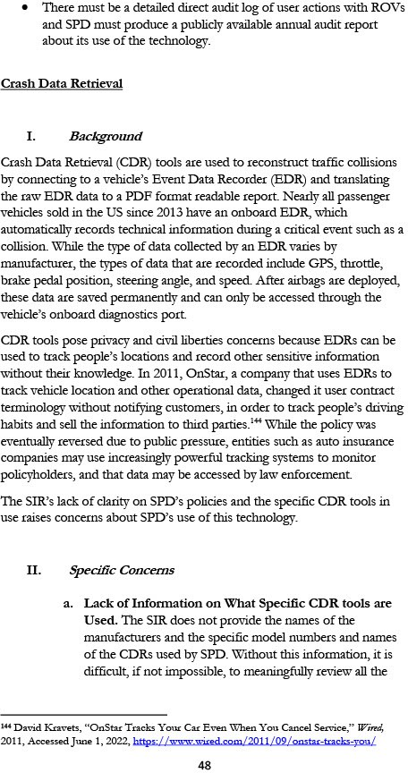

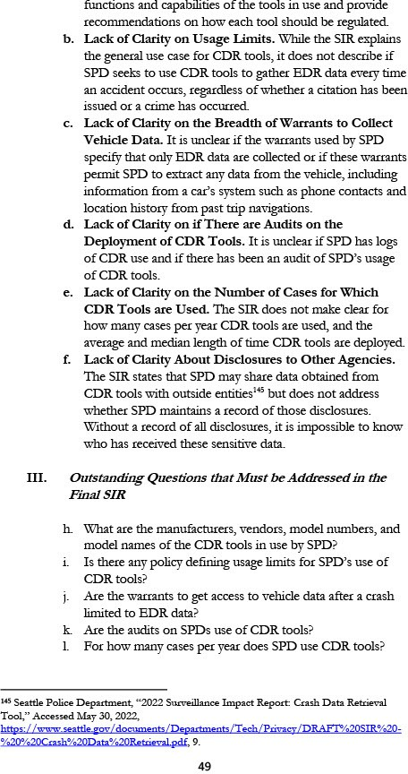

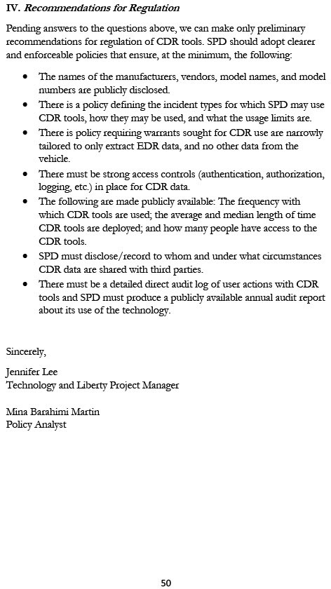

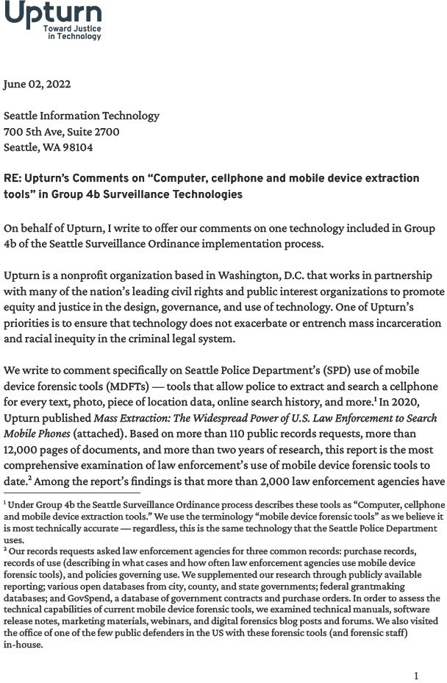

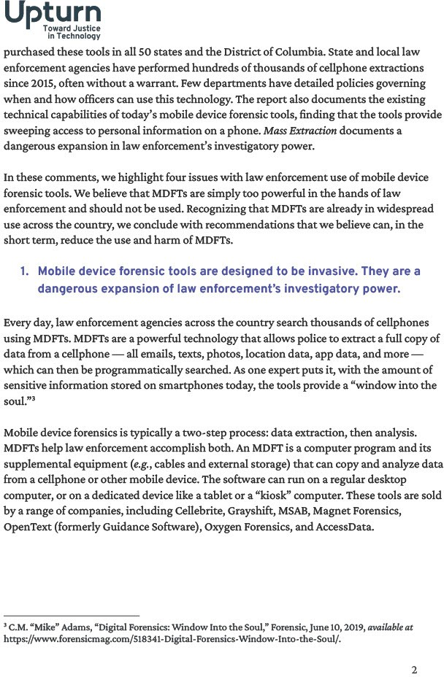

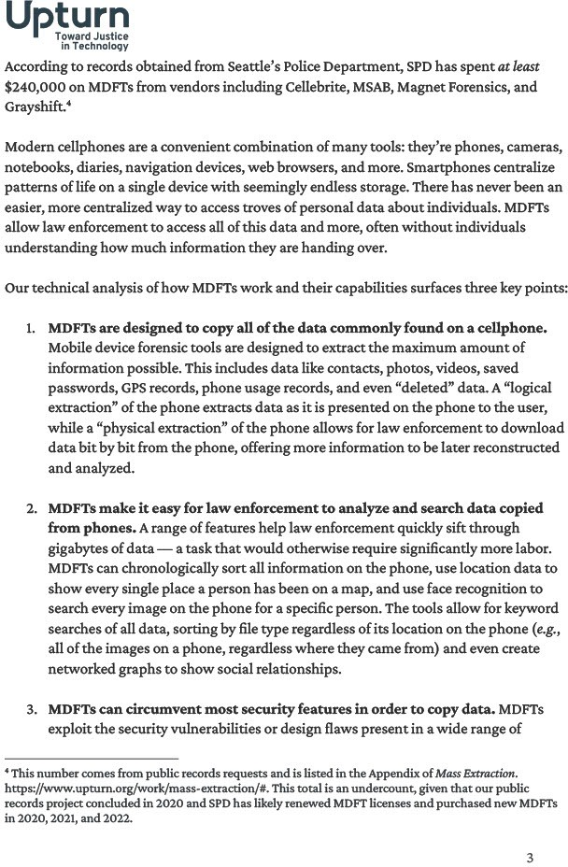

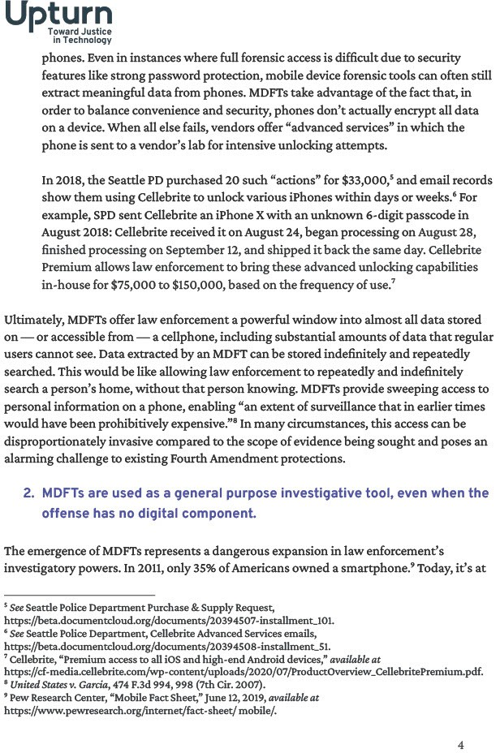

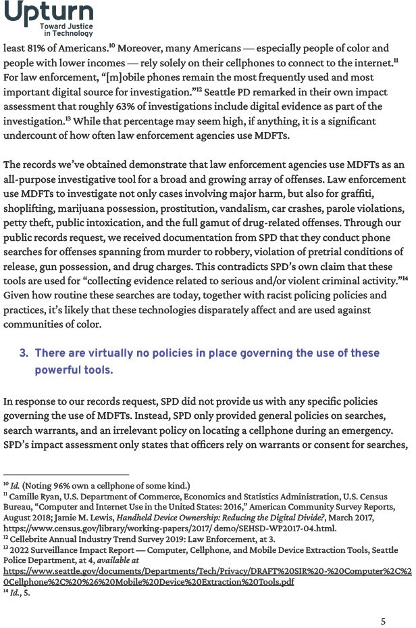

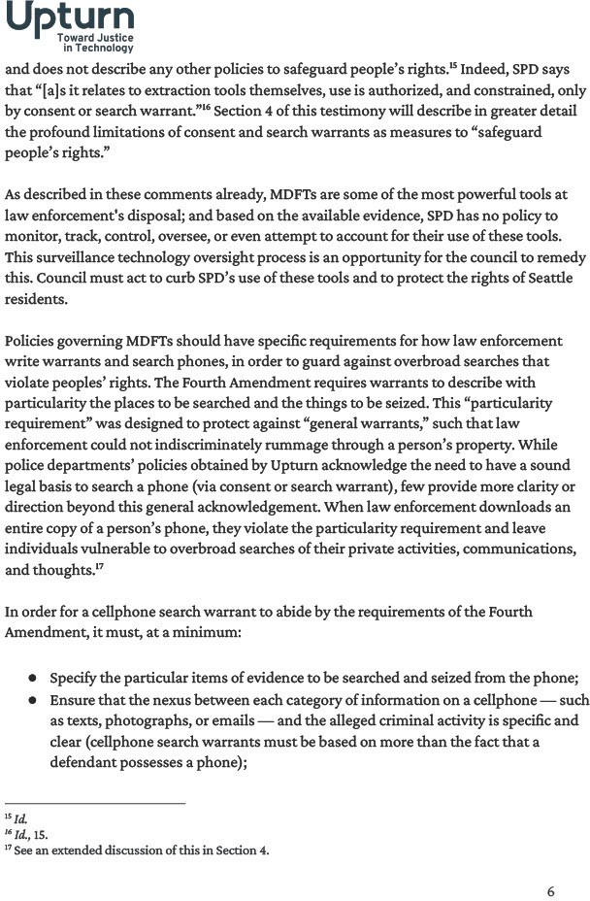

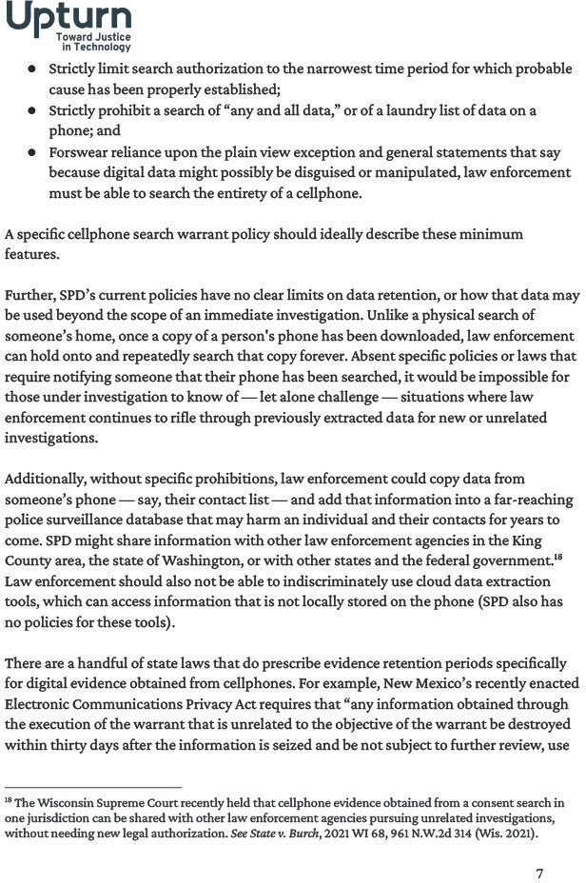

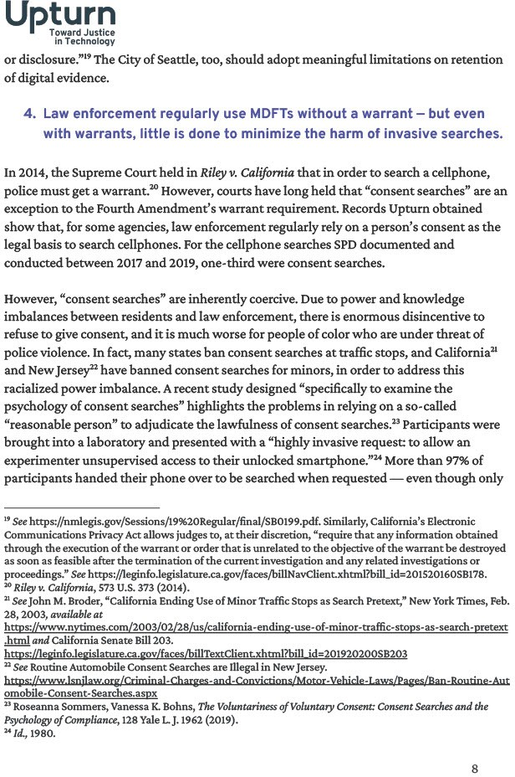

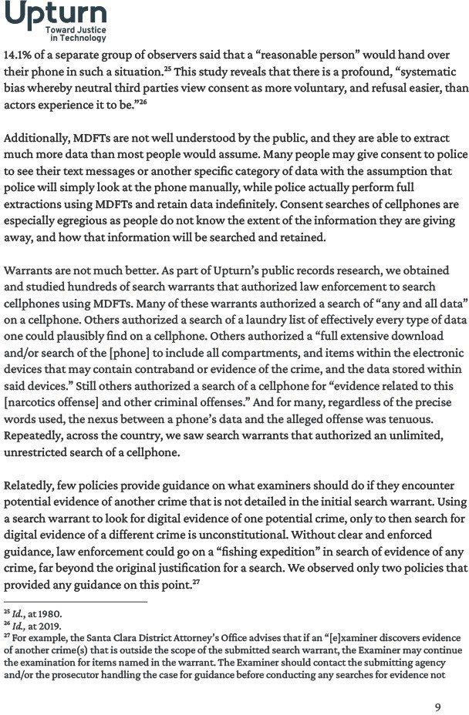

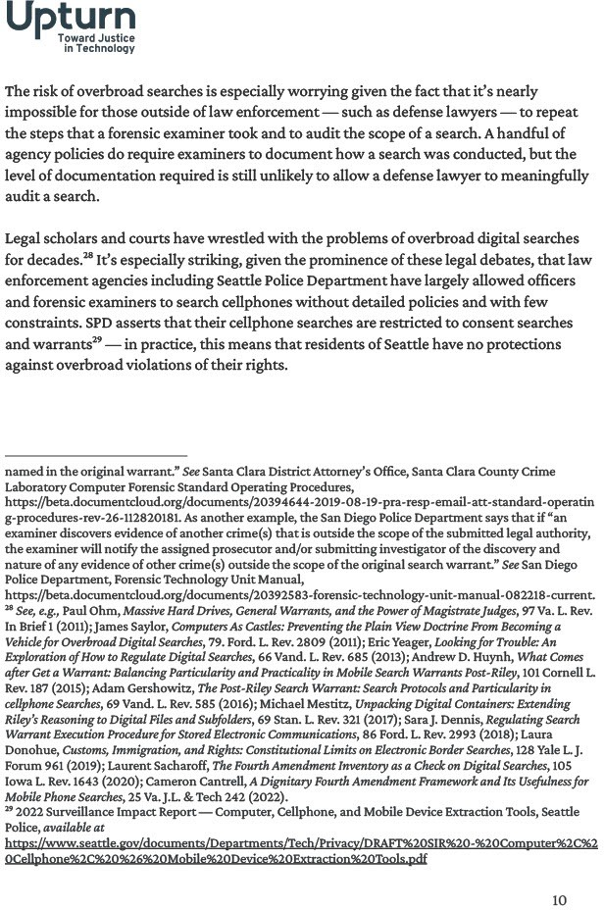

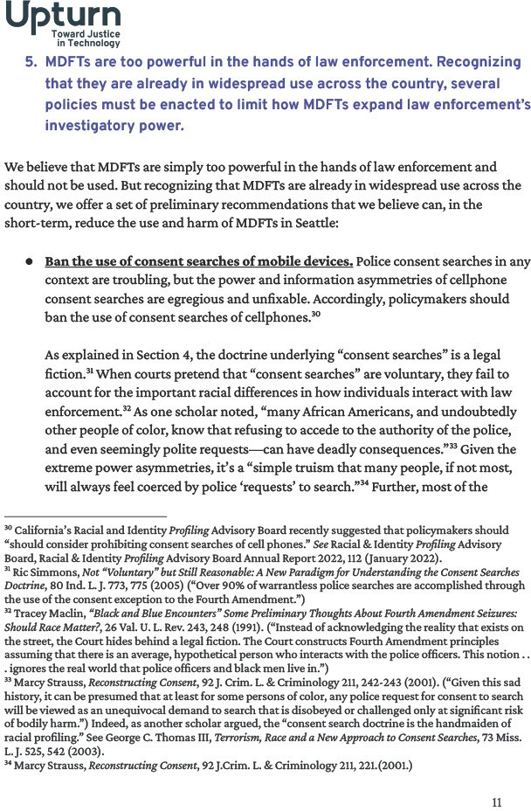

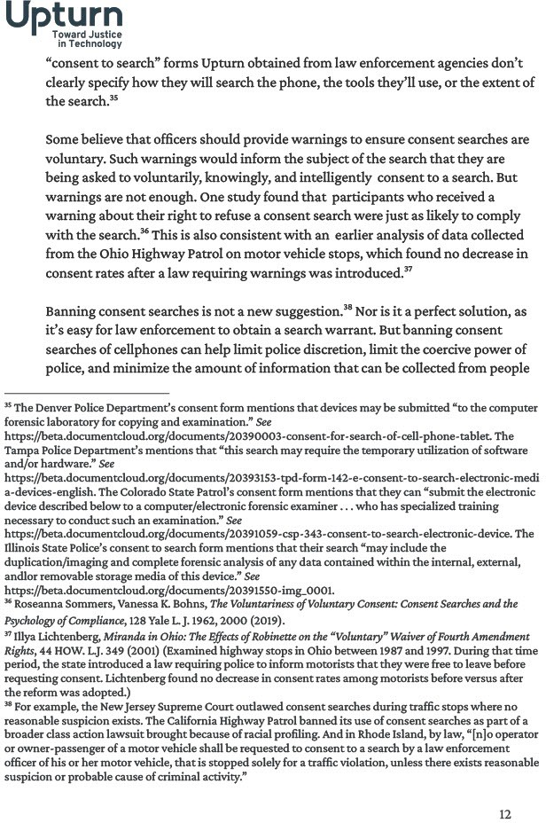

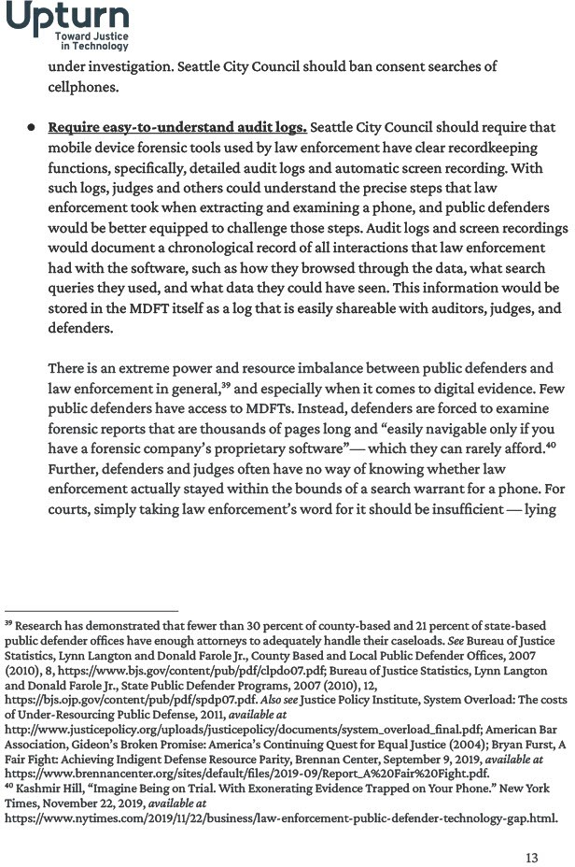

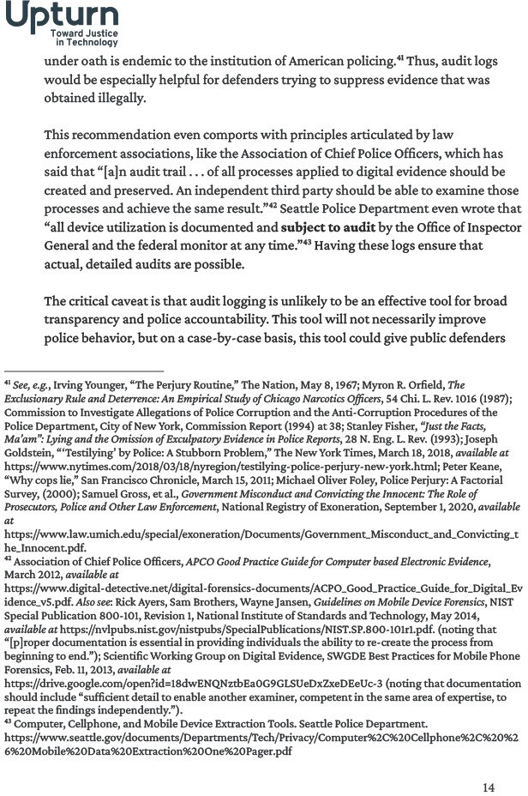

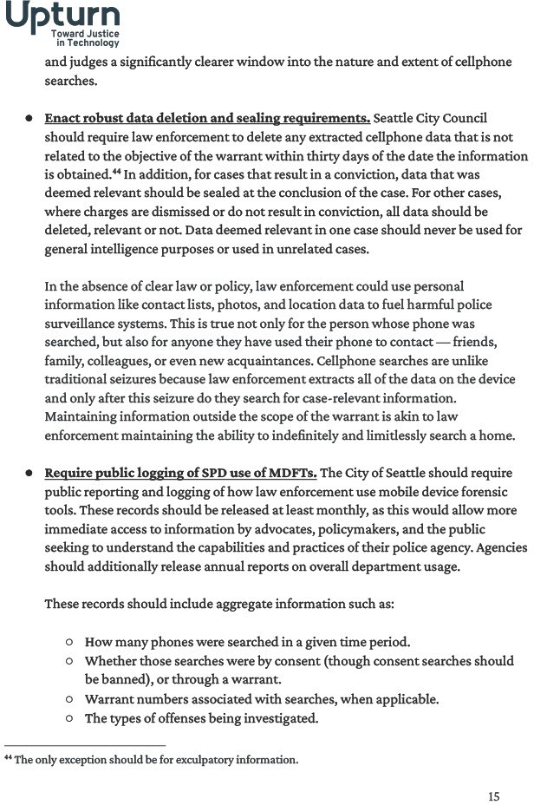

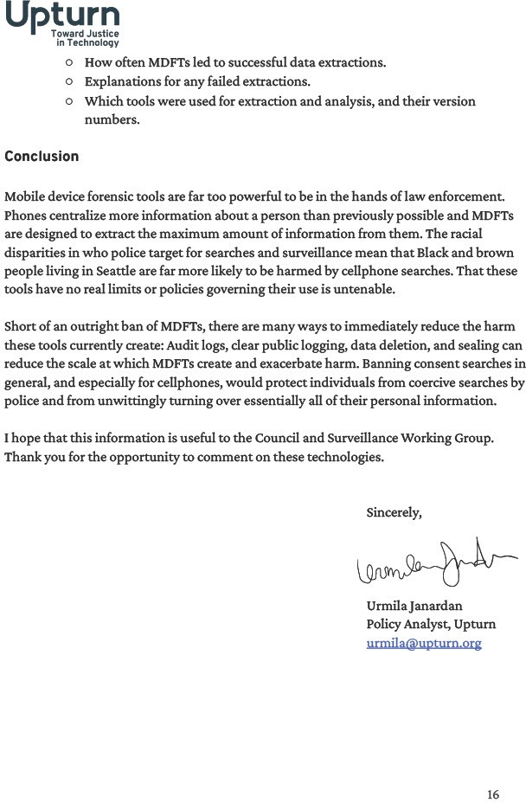

Appendix E: Questions and Department Responses

Question | Response
This question is regarding the tracking  devices; could you share if there are any other agencies or law enforcement agencies specifically outside of Washington state that use  this technology? | I don't know, honestly, I'd have to refer you to those other  agencies. There's just too many, but I can tell you the tracking devices are relatively common tool in law enforcement, but as to what agencies use them, I couldn't tell you.
[Regarding] the tracking devices, could  you share the name of the vendor? | I'm sorry, similar to what we did related to the cameras and  the audio recording devices. If we were shared the name, the making models of the vendors of the devices we use, it would allow people to develop countermeasures. To to work against them and so we're not going to be sharing those at  this time.

Appendix F: All Comments Received from Members of the Public
ID: 114044476537
Submitted Through: SurveyMonkey
Date: 6/3/2022 6:11:20 AM
Which surveillance technology that is currently open for public comment, do you wish to comment on?
SPD: Tracking Devices
What concerns, if any, do you have about the use of this technology?
SPD cannot be trusted to refrain from abusing collected data for unlawful purposes nor to responsibly safeguard that data from use by other bad actors.
What value, if any, do you see in the use of this technology?
There is no worthwhile value to be realized from SPD's use of this technology, while it may have valid uses in other contexts.
Do you have any other comments?
Why solicit comments when you have already decided your course? Events in the City of Seattle over the past 3 years have incontrovertibly demonstrated that there is no level of criminality to which SPD can descend such that the Mayor's office will not defend them, even at the cost of the Mayor's own political fortunes. Is there a backbone anywhere in this town?

ID: 114044270807
Submitted Through: SurveyMonkey
Date: 6/2/2022 11:05:56 PM
Which surveillance technology that is currently open for public comment, do you wish to comment on?
SPD: Tracking Devices
What concerns, if any, do you have about the use of this technology?
Surveillance technologies are typically used disproportionately to target people of color, LGBTQ+ people, unhoused people. Unless there's clear policies and procedures in place, and officers have been given sufficient training, that's very likely to be the case with these technologies as well. Third-party vendors and other governmental entities may misuse the data shared with them. Tracking data is often processed as part of automated analyses that introduce further racial bias risks.
What value, if any, do you see in the use of this technology?
The technology can make it easier for SPD to collect some kinds of evidence -- although this value needs to be weighed against the possibility of discrimination and misues of data..
Do you have any other comments?
What specific tracking devices does SPD currently use, and what devices are being considered for the 5G upgrades discussed in section 2.3? What are the contractual agreements with the vendors? What purposes do any of the agreements with vendors allow them to use the data for? For example, they can presumably use it to diagnose problems with their software. Can they also use it to improve their product? Develop future products? "Legitimate business purposes"? Are there any technical safeguards in place to prevent third-party vendors misusing the data? Is any automated analysis done by vendors, SPD, or any of the entities the data is shared with? If so, is there an Algorithmic Impact Report or algorithmic audit? Has SPD audited third-party vendors to ensure that they are not misusing the data? What restrictions are in place on the entities listed in 6.1 further sharing the data? Can any of the entities listed in 6.1 potentially share this data with fusion centers? Does TESU training, and the various auditing, specifically cover discriminatory uses? How detailed is the information currently being tracked about how these systems are used? Is there enough information there to identify discriminatory patterns? What percentage of deployments have been audited by Office of the Inspector General? Do these audits specifically look at discriminatory uses? Have any of these reports been published? What percentage of deployments have been audited by Federal Monitor? Do these audits specifically look at discriminatory uses? Have any of these reports been published? What percentage of deployments have been audited by SPD’s Intelligence and Analysis Section? Do these audits specifically look at discriminatory uses? Have any of these reports been published?

ID: 114043263151
Submitted Through: SurveyMonkey
Date: 6/1/2022 6:25:21 PM
Which surveillance technology that is currently open for public comment, do you wish to comment on?
SPD: Tracking Devices
What concerns, if any, do you have about the use of this technology?

None of my questions about these tracking devices have been answered, which makes it very difficult to provide informed public comment. These are my unanswered questions: A) How many cases per year use these tracking devices? B) How many tracking devices does SPD have? C) How long is median length of time the tracking devices are deployed? D) The tracking device SIR seems to describe the steps needed for evidence collected to be potentially admissible in court. However, what measures would prevent or detect the improper use of a tracking device, such as such as the device being borrowed (perhaps in return for a favor done by the officer for the TESU personnel) and then placed on the vehicle owned by an ex-wife/ex- girlfriend of an SPD officer so that the officer, outside the confines of a case or legal investigation, could use the device for personal purposes? Is there any SPD policy prohibiting the use of TESU equipment for personal purposes? E) How many times has SPD deployed a location tracking device on a vehicle either not owned by the suspect or owned by the suspect but also frequently used by other individuals (spouse, teenage children, friends, etc)? F) Since the fiscal information in the tracking device SIR is incomplete, how much does SPD spend annually in total for the tracking devices (including procurement, licensing, maintenance, & training)? G) When was the last audit of SPD's use of location tracking devices? Where can that audit report be found? H) How many people have access to SPD's location tracking devices? I) The tracking device SIR in item 3.3 says "When an Officer/Detective requests and deploys a tracking device from TESU, TESU personnel train the Officer/Detective in the tracker’s use." How is consistency in this training ensured (like what ensures that different TESU personnel don't give differing or incomplete training to an Officer or Detective)? Is the training standardized in some way, such as documented steps to complete? And does the training from the TESU include any privacy component? J) Is there any policy defining the incident types for which SPD may use location tracking devices? K) The tracking device SIR in item 2.3 says "The data captured by a device is downloaded out of the online portal after the conclusion of a tracking schedule". Is the "online portal" hosted within the SPD network on-premise; or is this hosted on the vendor's website (aka Software-as-a-Service) - that is, before the data is downloaded to the case file where does it exist - is it within the SPD network on-premise or is does flow to a vendor providing Software-as-a-Service? L) Has SPD ever deployed a location tracking device on a vehicle known to be used as either a taxi cab or ride-share vehicle? Since these questions are unanswered (as of June 1st), my concerns and recommendations here can only assume the worst. These concerns should be considered incomplete, since answers to my questions would highly likely change the concerns I have. Regardless, here are my current concerns: 1) Potential use of these location trackers when investigating low level offenses.
The UN ODC report cited by SPD in the Undercover Cameras SIR, states that "The use by law enforcement of electronic surveillance should not be an investigative tool of first resort, instead its use should be considered when other less intrusive means have proven ineffective or when there is no reasonable alternative to obtain crucial information or evidence" and "In general, the principles or policy considerations which limit the use of electronic evidence surveillance in the investigation of serious crime include: * Necessity: that the use of electronic evidence gathering is necessary to gather the evidence or information required. * Subsidiarity: that other less intrusive forms of inquiry or investigation are not sufficient to gather the confidentiality: that there are mechanisms in place to protect the confidentiality of the information obtained, including the privacy of third parties not the subject of the authorization or warrant. * Judicial

control: that the process of evidence gathering is overseen by a judge or independent other of a certain requisite and specified level of authority. * Proportionality: that the intrusion into privacy is proportionate to the seriousness of the suspected offence and the evidence it is anticipated will be obtained." I'd like to draw attention to the principle of proportionality here. Given how privacy invasive it is to use covert technologies, SPD's use of undercover location tracking devices should only be for investigations of violent crimes. 2) SPD has not named in the SIR the covert location tracking devices' manufacturers or models, so the public's assessment of them is very incomplete. This means the public has been blocked by SPD from validating that the features of these devices match the scope of the SIR. Moreover, the public has also been blocked from investigating these manufacturers' business practices and whether they have ever been fined for unethical/illegal business actions or security breaches. SPD should not be permitted to use any secret surveillance technologies. One of the purposes of the surveillance ordinance is to provide transparency to the public. The public also has not seen any of the contracts, terms or service, customer agreements, privacy policies, or any other legal documents governing the use of these tracking devices. It's very problematic to have a city department attempt to hide information from the public, whom they are accountable to and is funding these tools in the first place. Moreover, for this same transparency reason, SPD should be prohibited from signing an NDA with any surveillance technology manufacturer/vendor/reseller. 3) Nothing prohibits an SPD employee from using one of these covert tracking devices for their own personal use, outside the confines of a legal criminal investigation. Specifically, these devices could be used for the purpose of domestic abuse where the SPD employee stalks their wife/gf/partner's location so as to exert authority & control on what she is able to do & where she is allowed to go. As such, there needs to be an explicit prohibition against individuals using these devices for personal use and holding them criminally/civilly liable if they do. 4) Potentially disproportionate use of these tracking devices. It is known that there are racial disparities in arrest rates. Therefore, it is likely that the use of these covert location tracking devices also reflect a racial disparity in their use. 5) There needs to be an explicit prohibition on using these devices to track the whereabouts of activists, journalists, or communities of immigrants or racial/religious minorities. 6) It's concerning that these devices could be deployed on vehicles that are used primarily as taxi cabs or ride-share vehicles; or on a vehicle either not owned by a suspect, or owned by a suspect and frequently used by other individuals (family members, spouse, significant other, teenage children, friends, etc). This could gravely endanger and violate the privacy of people who are not suspects. 7) Item 2.3 in the SIR mentions an "online portal that collects the information captured by the hardware, and allows for graphic representation of that information, including mapping of locations and movement, alerts for established events (i.e., a vehicle has moved beyond an established boundary, etc.), and scheduling of “check- ins” (the reporting interval records the locations set in seconds, minutes or hours)." I'm concerned that the online portal is hosted externally to the SPD network. That would mean that the manufacturer of the device's portal would have access to all the GPS data being collected by the device. Hosting the portal externally removes the opportunity for Seattle to have strong data governance and security controls. Hosting the location data externally would expose Seattle to the risk of a security breach at the manufacturer resulting in the GPS data being exposed to the public. The portal should not be hosted externally. SPD should also update the SIR to include what security

controls are in place to prevent the public from accessing the portal. 8) Lack of clarity around whether these devices track only vehicles or people as well. Item 2.5 in the SIR only refers to "vehicle trackers" and when asked if the trackers are for vehicles only or if they are ever carried on a person or perhaps via a cellphone app, SPD said they are only to track vehicles. However, the Seattle Master List of Surveillance Technologies describe the location trackers as, "A hidden tracking device carried by a moving vehicle or person that uses the Global Positioning System to determine and track the precise location." The SIR does not describe why or how these devices would be used by a person, not a vehicle. As such , the SIR should be updated to clarify the use of these devices for tracking things other than vehicles. 9) Item 8.2 in the SIR states, "No formal audits exist for tracking device deployments..." This is concerning since if I understand correctly, SPD's use of these tracking devices have never been audited. 10) SPD has not disclosed in the SIR how much these tracking devices are costing the city every year. Item 1.2 of the Fiscal Information section of the SIR only mentions a cost of "$600 Per Unit", which is wildly incomplete. SPD hasn't provided the tally of the number of devices they have, so it's impossible for the public to know how much these devices have cost the City in total.
Moreover, based on the Federal GSA price sheet for CovertTrack products (which is a common manufacturer of these devices), I'd expect there to also be recurring costs for data service and/or cell service for the devices; but those don't appear to be included in Item 1.2 in the SIR. SPD has not been transparent with the public regarding the upfront and recurring costs these devices have for the City in total. 11) Item 3.3 in the SIR says, "When an Officer/Detective requests and deploys a tracking device from TESU, TESU personnel train the Officer/Detective in the tracker’s use." It is unclear to the public how consistency in this training is ensured (such as, what ensures that different TESU personnel don't give differing or incomplete training to an Officer/Detective). Is the training standardized in some way, such as documented steps to complete? 12) The answer to item 4.4 in the SIR didn't actually address the question posed.
I'm concerned that SPD has not disclosed: How many cases per year use these tracking devices? How many deployments of these tracking devices are there per year? How long is median length of time they are deployed per the search warrant parameters? How many tracking devices does SPD have?
What value, if any, do you see in the use of this technology?
Any value must be weighed against it's risks. The risks here are quite substantial. Given that plus the low likelihood for City Council adding the safeguards the public has requested, I don't think the value is useful enough. There must be sufficient safeguards in place before I'd consider these tools anything but simply dangerous.
Do you have any other comments?

ID: 114034985261
Submitted Through: SurveyMonkey
Date: 5/20/2022 2:16:41 PM
Which surveillance technology that is currently open for public comment, do you wish to comment on?
SPD: Tracking Devices
What concerns, if any, do you have about the use of this technology? What value, if any, do you see in the use of this technology?
Do you have any other comments?

1. SPD’s response to question 1.1 states that geolocation trackers are used in criminal investigations. Historically, what is the range of criminal investigations they have been used for? What kind of criminal investigations are they mostly used for? 2. With regard to SPD response to question 1.1—how long does the “consent or terms of the [court] order” typically last? In other words, typically how long is the period of surveillance? Who sets those terms? How is that period of time determined? 3. In response to question 1.2, SPD states “this [tech] could raise potential privacy concerns, such as general surveillance or tracking of the general public.” However it’s not clear from the SIR how this might happen. SPD indicates that the tracking device will “track and collect location information” for vehicles and, indirectly, for the occupants of the vehicle. What other information does the tracking device collect that leads SPD to say it raises concerns around “general surveillance or tracking of the general public?” 4.
According to SPD’s response to question 2.1, consent to use geo-location trackers can be obtained from a witness or confidential informant. a. Why is consent asked from these individuals in particular? What is their connection to the person being surveilled? b. Under what circumstances does SPD get consent from a witness or confidential informant vs. seeking a warrant from a judge? 5. 2.3—is the data stored on both the hardware and the software? What data storage safeguards are in place? 6. Question 3.2 asks for legal standards and conditions that must be met before the tech is used. SPD’s response to question 3.2 states: “Tracking devices are utilized with express consent or search warrant authority,” and cites to case law regarding legal requirements for securing consent, without articulating what exactly they do to ensure compliance with legal standards. They also don’t cite to any internal policy about obtaining consent. consent?” a. How is this consent obtained? What does that process of obtaining consent look like? (concerns about undue pressure). How do you know meaningful consent has been obtained? and 7. In the response to question 3.1 describing the process of access to tech—where does obtainment of warrant or securing consent fall in this process? 8. SPD’s response to question 3.3 states that “When an officer/detective requests and deploys a tracking device from TESU, TESU personnel train the Officer/Detective in the tracker’s use.” To clarify, does the officer receive training both before the tech is deployed and during the process of deployment? a. What is the nature of the training that TESU personnel provide? When does it happen? How many hours is it? What does it cover? How do TESU personnel know that the officer has understood the training and will be able to correctly administer the tech? b. Moreover, the response to question 7.2, which asks what privacy training is provided to users either generally or specifically relevant to the project/technology, is that all employees receive “Security Awareness Training.” Training from TESU about the tech is not cited here. Does the training provided by TESU to users include anything about privacy measures and data storage/access? c. What is the nature of the training that TESU personnel receive? How many hours of training do they receive? What does the training cover? Do they receive periodic updated training? 9. In response to question 3.3, SPD states “If the geolocation tracking device is being utilized pursuant to a search warrant, the warrant dictates the scope and parameters of the information being collected.” a.
What/who dictates the scope and parameters of the information being collected if a tracking device is deployed pursuant to consent from a confidential informant or witness? 10.
The response to question 4.1 states: “Vehicle tracking data is temporarily stored by third-party vendors (as described in 2.3 above), until the schedule for collection of data has

expired (per the search warrant or consent authorities), at which time all data collected is downloaded and attached to the investigation file.” What privacy measures are in place, if any, around how the data is stored (by the third party vendor and by SPD), and who can access it?
a. Is the data, when it is both stored by the third party vendor and when it is downloaded into the investigation file, encrypted? b. Once the data is downloaded into the investigation file, section 4.9 indicates that “only SPD personnel involved in the investigation have access to this information.” What access control mechanisms are in place to ensure this? Section 4.10 does not adequately address this. c. How is an audit trail provided? How does TESU document data access in the device? How is data access tracked once the data has been downloaded into the investigation file? Note that these are two separate questions about documenting data access—one has to do with access to data when it is still in the device, and the other with when it is downloaded from the device into the investigation file. Section 4.10 does not provide any details on this. d. Who has access to the investigation file itself? (Idea here is that although data access may be restricted, if the data is described in other documents within the investigation file, then that still compromises the privacy of the data.) e. How long does the third party vendor store the data? Do they delete the data when it is downloaded to the investigation file? f. How long does the data stay in the investigation file? Is the data deleted at the conclusion of the investigation? 11. The SPD response to question 4.7 states that “only authorized SPD users can access the vehicle tracking devices or the data while it resides in the system.” What is the criteria for being an “authorized SPD user”? 12. The SPD response to question 5.1 states: “Data is securely stored by the vehicle tracking technology vendor and will be transferred to the case investigator only via SPD owned and authorized technology.” a.
What does “securely stored” entail? 13. Question 5.3 asks “what measures will be used to destroy improperly collected data?” SPD cites to policy 6.060, which governs collection of “restricted information” as well as “private sexual information” but doesn’t address collection of data (inadvertent or otherwise) outside the scope provided for in the warrant or necessary for the investigation. What measures will SPD use to destroy that data? 14. How many of these devices does SPD own? How many are in use right now/how many investigations are currently utilizing them? a. Where/what neighborhoods are they being deployed?
What is the distribution of deployment across neighborhoods currently and historically? b.
On average, how many days/months/years are these devices used in an investigation?
- How does this average differ across neighborhoods? 15. What is the name of the tracking device vendor? 16. SPD does not list any other agencies, law enforcement or otherwise, that use this tech. Are there agencies, particularly law enforcement agencies, outside WA state that use this tech? 17. In response to the RET question 1.3 about the risks for racial or ethnic-based bias through each use or deployment of this tech and how the department is mitigating, SPD’s response is not very satisfying. If you’re not tracking how you deploy these devices and against whom, and we know from empirical research that police target low-income/POC neighborhoods, then how do you know you’re not being biased and when you need to course correct? 18. Similarly, SPD states in response to question 1.4.2 “there is no distinction in the levels of service SPD provides to the various and diverse neighborhoods, communities, or individuals within the city. What is the basis for this statement? We have plenty of evidence to the contrary, not least of which is a ten-year (and counting) federal Consent Decree, that was created because of SPD’s “racially biased policing.”

Other more recent examples include racial and socio-economic disparities in enforcement of helmet laws by police and racial disparities in Terry Stops. a. What is SPD doing to ensure that these tracking devices are not used disproportionately in investigations of certain groups, such as Black people and people of color? Per SPD’s response to question 8.2, “no formal audits exist for tracking device deployments” so there’s not a way to be proactive about detecting racial disparities in the deployment of these devices.

ID: 114034385473
Submitted Through: SurveyMonkey
Date: 5/19/2022 9:11:20 PM
Which surveillance technology that is currently open for public comment, do you wish to comment on?
SPD: Tracking Devices
What concerns, if any, do you have about the use of this technology? What value, if any, do you see in the use of this technology?
Do you have any other comments?
  - How many cases per year use these tracking devices? B) How many tracking devices does SPD have? C) How long is median length of time the tracking devices are deployed? D) The tracking device SIR seems to describe the steps needed for evidence collected to be potentially admissible in court. However, what measures would prevent or detect the improper use of a tracking device, such as such as the device being borrowed (perhaps in return for a favor done by the officer for the TESU personnel) and then placed on the vehicle owned by an ex-wife/ex- girlfriend of an SPD officer so that the officer, outside the confines of a case or legal investigation, could use the device for personal purposes? Is there any SPD policy prohibiting the use of TESU equipment for personal purposes? E) How many times has SPD deployed a location tracking device on a vehicle either not owned by the suspect or owned by the suspect but also frequently used by other individuals (spouse, teenage children, friends, etc)? F) Since the fiscal information in the tracking device SIR is incomplete, how much does SPD spend annually in total for the tracking devices (including procurement, licensing, maintenance, & training)? G) When was the last audit of SPD's use of location tracking devices? Where can that audit report be found? H) How many people have access to SPD's location tracking devices? I) The tracking device SIR in item 3.3 says "When an Officer/Detective requests and deploys a tracking device from TESU, TESU personnel train the Officer/Detective in the tracker’s use." How is consistency in this training ensured (like what ensures that different TESU personnel don't give differing or incomplete training to an Officer or Detective)? Is the training standardized in some way, such as documented steps to complete? And does the training from the TESU include any privacy component? J) Is there any policy defining the incident types for which SPD may use location tracking devices? K) The tracking device SIR in item 2.3 says "The data captured by a device is downloaded out of the online portal after the conclusion of a tracking schedule". Is the "online portal" hosted within the SPD network on-premise; or is this hosted on the vendor's website (aka Software-as-a-Service) - that is, before the data is downloaded to the case file where does it exist - is it within the SPD network on-premise or is does flow to a vendor providing Software-as-a-Service? L) Has SPD ever deployed a location tracking device on a vehicle known to be used as either a taxi cab or ride-share vehicle?

Email Comment
Questions:

    - The SIR articulates the steps for evidence to be admissible in court, but does not define what individuals may do with these devices. So, what measures are in place, or needed, to prevent improper use of a tracking device? (e.g. for personal and/or stalking purposes)
    - What are the names of the specific manufacturers and their individual product names of the undercover location tracking devices that SPD is using, has or plans to purchase, and used in the past?
    - What measures are in place to track which officers use these devices, the types of purposes or incidents they are used for; the periods of time or frequency of each officers’ use of these tools; and the race, ethnicity, religious affiliation, gender, age and economic demographics of the people being tracked by such officers using these devices?
    - What systems, reporting measures, and oversight does SPD have in place to ensure that these devices are not being used for nefarious purposes, and/or to disproportionately profile immigrants, BIPOC, muslim, lgbtq+, activist, or houseless individuals? Is there a way for the public to review reports with these details?
    - Is there any SPD policy prohibiting the use of TESU equipment for personal purposes?
Key Concerns:

    - It’s unclear whether the deployment of this technology is disproportionately used against marginalized and minority individuals and communities.
    - What measures would prevent or detect the improper use of a tracking device, such as such as the device being borrowed (perhaps in return for a favor done by the officer for the TESU personnel) and then placed on the vehicle owned by an ex-wife/ex-girlfriend of an SPD officer so that that officer – outside the confines of a case or legal investigation, could use the device for personal purposes?
    - It seems important to minimize deployments of tracking devices to when it’s absolutely necessary and to narrow the situations in which they are permitted to be deployed in order to protect the privacy of non-suspects. For instance, the use of tracking devices on vehicles that are used primarily as taxi cabs/ride-share vehicles, or on a vehicle either not owned by a suspect – or owned by a suspect but frequently used by other individuals (family members, spouse, significant other(s), teenage children, friends, etc) could endanger and violate the privacy of people who are not suspects. It seems like there should be a process that ensures that tracking devices are not employed in situations where a vehicle is shared, or used for the purpose of employment (ride & food delivery gig- workers, etc).

Recommendations:

    - Remedies/Penalties – City Council should state that the use of a location tracking device except pursuant to that defined in the final SIR exposes the user to criminal or civil liability.
    - Scoping – City Council should restrict the use of SPD’s deployment of these covert cameras to cases that are serious and violent offenses, and must provide evidence of such in warrant applications for their use. The use of covert technologies, being major intrusions into privacy, must be proportional to the seriousness of the suspected offense. (UNODC, United Nations Office of Drug and Crime)
    - Contractual & Inventory – City Council should request the Purchase orders and contracts for each of the undercover location tracking devices vendors SPD has used, is using, or plans to use in the future, and update the SIR to include this information.
    - Regulation and Transparency Report – City Council should require that each use of covert location tracking devices and associated software systems be registered with the city and compiled into monthly transparency report, accessible on the City’s website, to include the following details: Make and Model of tracking device, reason for use, length of use; number of parties’ and/or devices, items and/or vehicles tracked, whether the tracking is/was ongoing, and for what duration – up to of the time of reporting – tracking devices remained on or with a target, or, whether employed as part of a singular investigative incident lasting no longer than 24 hours; and whether the employment of such tracking device resulted in an arrest, conviction, harm, injury, fatality or other physical or economic accident, injury or burden on an individual or group; whether the data gathered from the employment of tracking device(s) is/was shared with or uploaded to any other software program, entity, company, agency or person, outside of the SPD officer employing the device, and, the name (make/model) of such shared with.

Concerns:
Covert technologies employed by police (or any gov agency) are dangerous in their own ways. It's important to weigh the use of this tech against the seriousness of a crime.
The use of covert surveillance tech to obtain evidence — through entrapment or other orchestrated means is a great risk in the use of covert technologies, and those kinds of activities should not be in scope for the role of police.

In addition, the possible personal, nefarious and disproportionate use of these tracking devices is also a great risk.

Questions:
- What are the names of the specific manufacturers and their individual product names of the undercover location tracking devices that SPD is using, has or plans to purchase, and used in the past?
- What systems, reporting measures, and oversight does SPD have in place to ensure that these devices are not being used for nefarious purposes, and/or to disproportionately profile immigrants, BIPOC, muslim, lgbtq+, activist, or houseless individuals? Is there a way for the public to review reports with these details?
- Is there any SPD policy prohibiting the use of TESU equipment for personal purposes?
Key Concerns:
- What measures would prevent or detect the improper use of a tracking device, such as such as the device being borrowed (perhaps in return for a favor done by the officer for the TESU personnel) and then placed on the vehicle owned by an ex-wife/ex-girlfriend of an SPD officer so that that officer – outside the confines of a case or legal investigation, could use the device for personal purposes?
- It seems important to minimize deployments of tracking devices to when it’s absolutely necessary and to narrow the situations in which they are permitted to be deployed in order to protect the privacy of non-suspects. For instance, the use of tracking devices on vehicles that are used primarily as taxi cabs/ride-share vehicles, or on a vehicle either not owned by a suspect – or owned by a suspect but frequently used by other individuals (family members, spouse, significant other(s), teenage children, friends, etc) could endanger and violate the privacy of people who are not suspects. It seems like there should be a process that ensures that tracking devices are not employed in situations where a vehicle is shared, or used for the purpose of employment (ride & food delivery gig-workers, etc).
Recommendations:
- Remedies/Penalties – City Council should state that the use of a location tracking device except pursuant to that defined in the final SIR exposes the user to criminal or civil liability.
- Scoping – City Council should restrict the use of SPD’s deployment of these covert cameras to cases that are serious and violent offenses, and must provide evidence of such in warrant applications for their use. The use of covert technologies, being major intrusions into privacy, must be proportional to the seriousness of the suspected offense. (UNODC, United Nations Office of Drug and Crime)
- Contractual & Inventory – City Council should request the Purchase orders and contracts for each of the undercover location tracking devices vendors SPD has used, is using, or plans to use in the future, and update the SIR to include this information.

QUESTIONS
Names of manufacturers & devices?
How to audit (target's race, religion, gender, age, etc)?
Protections against targeting of immigrants, BIPOC, activists, Muslims, journalists, etc?

CONCERNS
Personal use of these devices outside of a legal investigation (i.e. being loaned to officer in return for a favor & used for stalking an ex-wife/ex-girlfriend).
Disproportionate use.
Use of these devices for low level offenses.
Use on taxi cabs/ride-share vehicles, or vehicles not owned by suspect, or owned by suspect but used by others (family, friends) violates the privacy of non-suspects.

RECOMMENDATIONS
Require provision that use outside of what is defined in the SIR exposes the individual to criminal/civil liability.
Restrict use to only violent offenses. Covert technologies, being major intrusions into privacy, must be proportional to the seriousness of the suspected offense.
Prohibit the use of covert tracking devices on shared items or vehicles. Post the contracts publicly.
Require a monthly transparency report covering: device model name, offense, length of use, number of people/vehicles tracked, targets' demographic data, whether ongoing, whether it resulted in an arrest/conviction, & where/who data was shared with.

