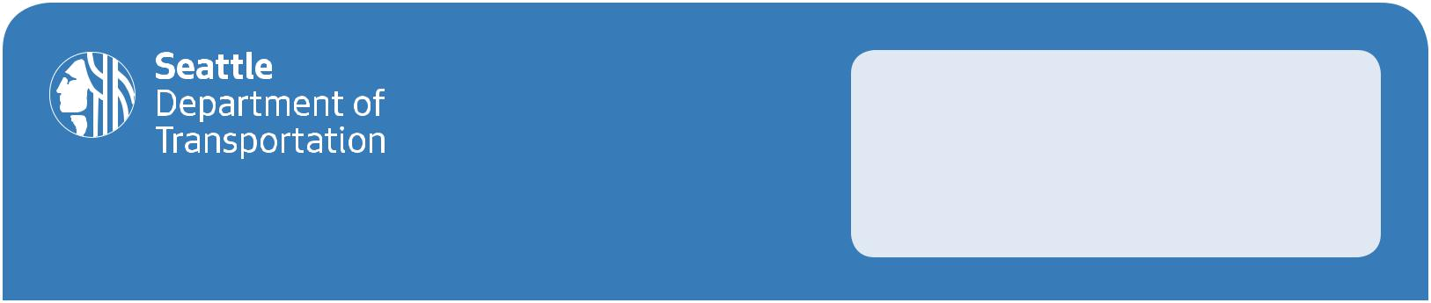
Please share your questions,

comments and concerns. All

information provided on the comment

sheet is subject to public disclosure.

Meeting Name:

23rd Ave Vision Zero Drop-In Session

COMMENT SHEET

Name: Email:

Date: 10/19/17

(Official Use Only)

TELL US WHAT YOU THINK

- Prioritize where you’d like to see a new traffic signal on 23rd/24th Ave E, with 1 being the highest and 4 being the lowest.
  - E Lynn St

  - Interlaken Pl E

  - Interlaken Blvd E

  - Other intersection (location/priority):

- Would you be interested in having on-street parking on 24th Ave E in the Montlake Business District during off-peak hours? Use the comment section to explain your answer.
  - Yes

  - Maybe

  - No

- Circle your top 2 transportation priorities for this street.

  - Reduce speeding

  - Prevent additional cut-through traffic

  - Reduce congestion

  - Support frequent and reliable bus service

  - Improve pedestrian and bicycle crossings

  - Other:

Comments:

