
Comparative Impacts of Alternatives A, C, D
and the Rehabilitation Alternative

Background
The following table summarizes impacts of the Magnolia Bridge Replacement Project alternatives based on analysis in fourteen environmental discipline reports prepared from late 2003 through 2005. Please note that none of the impacts in the table are considered “significant,” as defined by environmental regulations. In other words, the project team has determined that measures can be taken to mitigate for – or remedy – the predicted impacts listed in the attached table.
The three build alternatives and rehabilitation alternative include:
- Alternative A: Replace the existing bridge with a new structure directly to the south.
- Alternative C: Construct a bridge over the railroad, a segment of surface road through the Port of Seattle’s property, and a bridge that climbs the bluff up the Magnolia hillside.
- Alternative D: Construct a new bridge in the form of a long arc to the north of the existing bridge.
- Rehabilitation Alternative: Bring the bridge up to current load and design standards using the existing bridge structure to the extent possible. Replace the bridge deck (roadway) and stabilize the foundation and concrete columns.
The “No Build” alternative would include keeping and maintaining the existing bridge for as long as possible. SDOT estimates that in 20-25 years it will be necessary to post load limits for the bridge, and replace the bridge soon thereafter.
Findings
For several topics traditionally evaluated in Environmental Impact Statements, impacts under each alternative were very similar (if not identical) or are not applicable. The following topics fall in this category and are not included in the table:
- Water Quality: Storm water would be treated before discharge for all alternatives.
- Wetlands: No areas with potential wetland characteristics were identified.
- Air Quality: Air quality standards for carbon monoxide (CO) would be met.
- Noise: Future noise levels would exceed impact thresholds standards at first row homes along West Galer Street. However, no substantial noise impacts, over existing conditions, were predicted under any of the analyzed alternatives.
- Prime and Unique Farmlands: No farmlands are present in the project area.
- Cultural, Historic and Archaeological Resources: Archaeological resources could be present underground in the project area. An archaeologist may monitor some areas during construction. No historic resources would be affected by any of the alternatives.
The following table compares the impacts of each alternative for the remaining environmental topics.

Topic | Alternative A  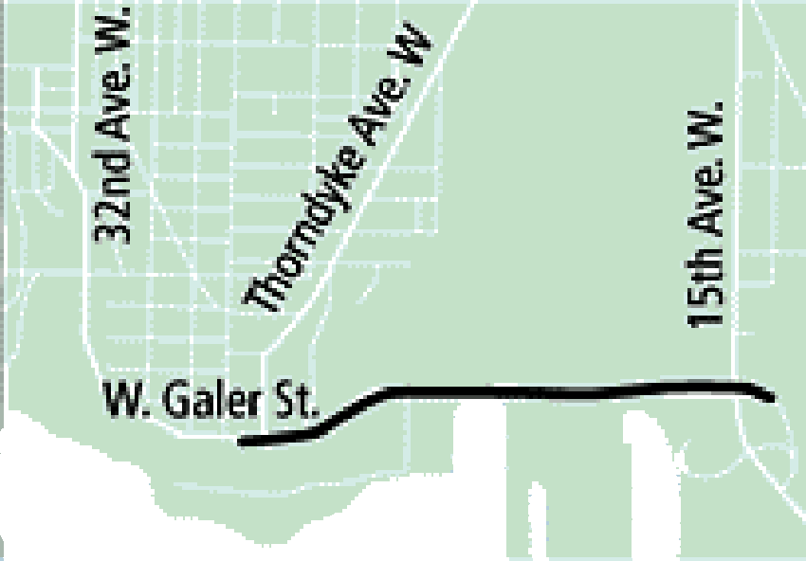 | Alternative C  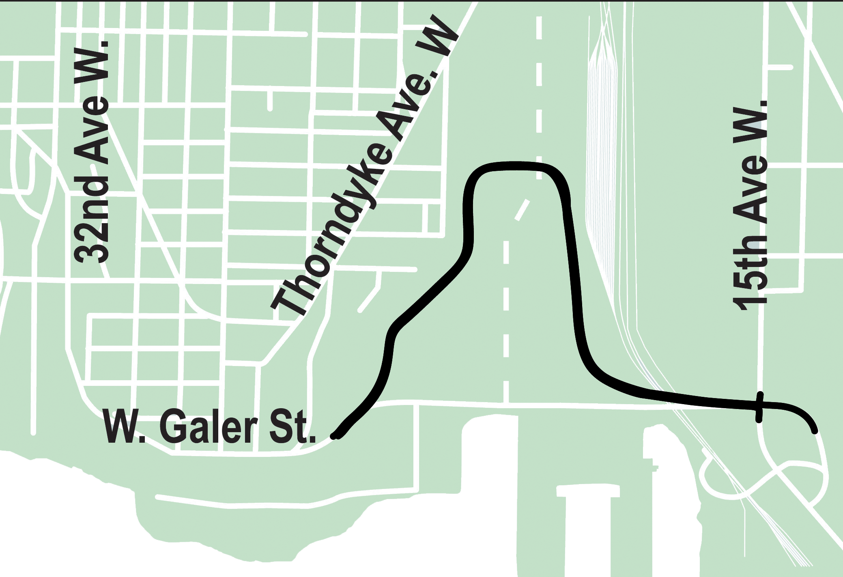 | 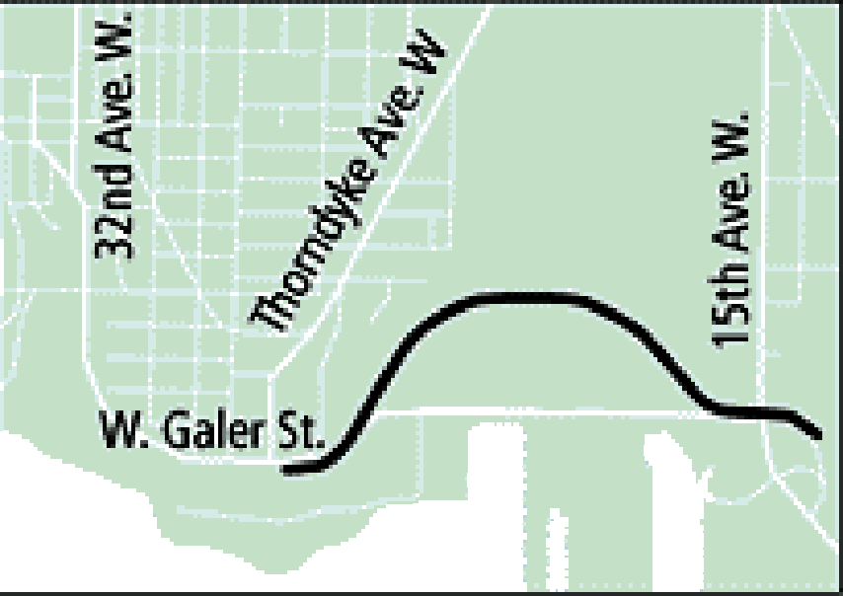  Alternative D | Rehabilitation
Estimated Construction Detour Time (requiring an 8-minute detour across Dravus Street and impacting traffic on 15th Avenue) | 14-20 months | 8-14 months | 6-12 months | 21-27 months
Added Travel Time | Same as No Build | Would add 0.5 mile to route  Up to 80 seconds additional travel time due to added distance and intersection | Would add 0.1 mile to route and about ten seconds in additional travel time | Same as No Build
Pedestrian Use and Safety | Ten-foot-wide barrier-separated sidewalk on south side of bridge for pedestrians and 16-foot-wide outside traffic lanes for bicyclists | Ten-foot-wide barrier-separated sidewalk on south side of alignment for pedestrians and 16-foot-wide outside traffic lanes for bicyclists  Additional 0.5 mile in length and 6.5% slope increases walking time by about ten minutes | Ten-foot-wide barrier-separated sidewalk on south side of bridge for pedestrians and 16-foot-wide outside traffic lanes for bicyclists | Similar to No Build. Would maintain minimum 6-foot-wide sidewalk on south side of bridge.
Residential and Business Relocation | No residential displacement  Potential relocation of or alternative access to one business prior to construction  Potential loss of tax revenue to Seattle if affected business moves out of city | No residential displacement  Requires mitigation of impacts to Trident Seafoods  Displaces one business and potential relocation of or alternative access to another  Potential loss of tax revenue to Seattle if affected business moves out of city | No residential displacement  Potential relocation of three businesses and one vacant business property, and potential relocation of or alternative access to one business  Potential loss of business and tax revenue effects from businesses dependent on the displaced businesses if relocation in Terminal 91 or vicinity is not possible (cluster economy effect) | No residential displacement  Potential relocation of or alternative access to one business prior to construction  Potential loss of tax revenue to Seattle if affected business moves out of city
Displacements/ Environmental Justice | Potential displacement of Anthony’s Seafood; building access revision may avoid this displacement or business would be relocated | Potential displacement of Anthony’s Seafood; building access revision may avoid this displacement or business would be relocated  Trident Seafood building access would be reconfigured  Snider Petroleum business would be relocated | Potential displacement of Anthony’s Seafood; building access revision may avoid this displacement or business would be relocated  Snider Petroleum business would be relocated  The building housing part of City Ice operations would be removed and relocated at a different on-site location | Potential displacement of Anthony’s Seafood; building access revision may avoid this displacement or business would be relocated
Waterways, Hydrological Systems, and Floodplains | Project would add up to 1.2 acres of impervious surface to study area  About 3.2 acres would be in 200-foot shoreline area | Project would add up to 0.2 acre of impervious surface to study area  About 0.2 acre would be in 200-foot shoreline area | Project would remove 0.3 acre of impervious surface from study area | Project would be similar to no build  About 2.7 acres would be in the 200-foot shoreline area
Vegetation | Minor impacts to upper intertidal vegetation that is not habitat for endangered species  0.5 acre of forest removed | About 0.3 acre of forest and disturbed vegetation removed | About 0.3 acre of forest and disturbed vegetation removed | Minor impacts to upper intertidal vegetation that is not habitat for endangered species  0.3 acre or less of vegetation disturbance for foundation rehabilitation
Fish, Wildlife, and Habitat | About 0.1 acre of intertidal vegetation and habitat would be removed for four bridge piers  About 0.5 acre of forest habitat would be removed | About 0.3 acre of forest and disturbed habitat at the west end of the bridge would be removed | About 0.3 acre of forest and disturbed habitat at the west end of the bridge would be removed | 0.3 acre or less of habitat disturbance for foundation rehabilitation
Geology, Soils, and Topography | Slope instability at cuts mitigated by retaining walls  Liquefaction and lateral spreading mitigated by ground improvement measures | Slope instability at cuts mitigated by retaining walls  Liquefaction and lateral spreading mitigated by ground improvement measures | Slope instability at cuts mitigated by retaining walls  Liquefaction and lateral spreading mitigated by ground improvement measures | Liquefaction and lateral spreading mitigated by ground improvement measures  Mitigate groundwater impacts caused by ground improvement measures
Land Use | Consistent with Seattle, Port and BINMIC policies  Would be constructed in Shoreline District (similar to existing bridge) | Consistent with Seattle, Port and BINMIC policies | Consistent with Seattle, Port and BINMIC policies | Consistent with Seattle, Port and BINMIC policies  Some construction would be in Shoreline District
Recreation | Bridge would be built over about 0.9 acre of park land, and three bridge piers would be constructed on park land  This use would be mitigated through a joint development agreement | Bridge would be built over about 0.3 acre of park land  This use would be mitigated through a joint development agreement | Bridge would be built over about 0.3 acre of park land  This use would be mitigated through a joint development agreement | Construction would be in existing right of way and easements adjacent to park land
Visual Quality | Some impact due to increased structure width compared to No Build  Cleaner appearance under the bridge compared to No Build with removal of existing structure and its steel framing  Views from the bridge would remain very similar to existing conditions | Somewhat reduced impact due to increased distance from park land compared to No Build  Cleaner appearance under the bridge compared to No Build with removal of existing structure and its steel framing  Views from the bridge would be different than existing conditions, as much of the route would be further from the coast, obstructed by buildings, and at ground level | Somewhat reduced impact due to increased distance from park land compared to No Build  Cleaner appearance under the bridge compared to No Build with removal of existing structure and its steel framing  Views from the bridge would be similar to existing conditions, though users of the bridge would be further from the shoreline | Similar to No Build, but removal of much of the under-bridge steel framing  Views from the bridge would remain very similar to existing conditions
Services and Utilities | No change in demand for public services  No increase in distance for emergency response vehicles between 15th Ave W and Magnolia  A special emergency response plan will be implemented during construction to mitigate any service impacts | Emergency vehicle response distance would increase by 0.5 mile between 15th Ave W and Magnolia  A special emergency response plan will be implemented during construction to mitigate any service impacts | Emergency vehicle response distance would increase by 0.1 mile between 15th Ave W and Magnolia  A special emergency response plan will be implemented during construction to mitigate any service impacts | No change in demand for public services  No increase in distance for emergency response vehicles between 15th Ave W and Magnolia  A special emergency response plan will be implemented during construction to mitigate any service impacts
Hazardous Materials | Potential contamination could be disturbed at excavation sites  Lead-based paint on steel portions of existing bridge to be demolished | Potential contamination could be disturbed at excavation sites  There may be asbestos and lead-based paint in buildings to be demolished  Lead-based paint on steel portions of existing bridge to be demolished | Potential contamination could be disturbed at excavation sites  There may be asbestos and lead-based paint in buildings to be demolished  Lead-based paint on steel portions of existing bridge to be demolished | Potential contamination could be disturbed at excavation sites  Lead-based paint on steel portions of existing bridge to be demolished

