Cowen Park Bridge Seismic Retrofit construction starting as early as Tuesday, November 12
WHAT TO EXPECT
We will minimize construction impacts as much as possible. During construction, please expect:
- Typical weekday work hours of 7 AM – 5 PM, Monday through Friday
- Redirects for people walking and biking across the bridge
  - People walking across the bridge will be directed to one side
  - People biking will merge with traffic for the duration of construction
- 3 weekend full bridge closures and detours. We will post detours and notify nearby homes 72 hours in advance.
- Temporary closure of the upper trail underneath the bridge within Cowen/Ravenna Park
- Noise, dust, and vibrations during work hours
- Equipment and construction materials near the site, including trucks using the access road to the west from Brooklyn Ave NE, to move materials and equipment in and out of the work zone
STAY IN TOUCH
For more information or to sign up for the project listserv please visit the project webpage: www.seattle.gov/transportation/Cowen-Park-Bridge

The project team can be contacted by email at CowenParkBridge@seattle.gov or phone at (206) 775-8734.
PROJECT OVERVIEW
Earthquakes could have a significant detrimental effect on Seattle's infrastructure. To address this risk to city infrastructure, the City of Seattle established the bridge seismic retrofit program. As part of the Levy to Move Seattle, 16 bridges were selected for seismic retrofits, including the Cowen Park Bridge.
The retrofits will strengthen the bridge so it can better withstand seismic events like earthquakes. This work will include:
- Strengthening the existing arch and end of bridge support columns with fiber wrapping
- Strengthening support beams and reinforcing the interior columns
- Replacing and repairing expansion joints
Thank you in advance for your patience during this work!

SCHEDULE
Construction is anticipated to start as early as Tuesday, November 12, 2019 and last approximately 6 months. This schedule is weather dependent and subject to change.

We currently anticipate three weekend closures of the bridge to all vehicle traffic. The weekend closures are scheduled for Spring 2020. Pedestrian and bike access will be maintained. Information about detour routes and anticipated impacts will be shared closer to the weekend closure start date.

This schedule is weather-dependent and subject to change.
For translation and interpretation, please call 206-775-8734.
Si usted necesita esta información traducida al español por favor llame al 206-775-8734.
This project is funded by the 9-year Levy to Move Seattle, approved by voters in 2015. Learn more about the levy at www.seattle.gov/LevytoMoveSeattle.
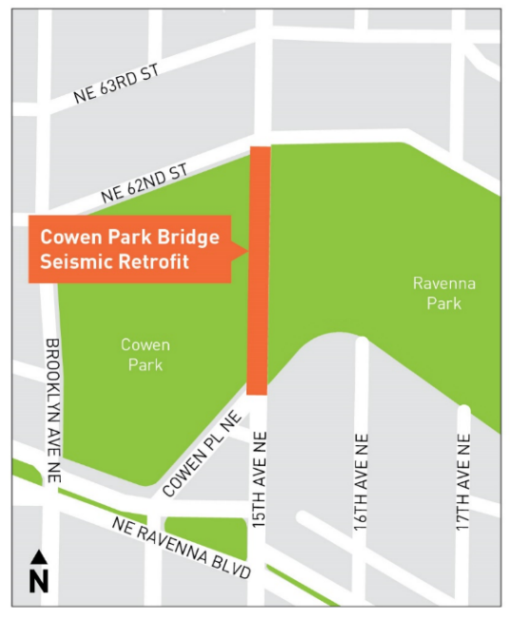
Cowen Park Bridge Seismic Retrofit Project Area Map

