Subject: Update on West Marginal Way SW- Changes are coming

Hello Community Partners,

You may have heard that improvements and changes are coming to West Marginal Way. Since the closure of the West Seattle High-Bridge on March 23, more vehicles are driving on this corridor. We want to give you an update on the timeline for some of these improvements. We also want to give you an update on some of the other proposals the Seattle Department of Transportation (SDOT) is considering.

In 2020, SDOT will be updating the painted lines on the street at the Highland Park Way/West Marginal Way Intersection. This restriping will help to reduce some of the wait times at the intersection and potentially get more cars through the signals when they’re green. To accommodate the new restriping, the bus stop on the east side of the intersection will relocate to the west side. See below for the restriping changes.
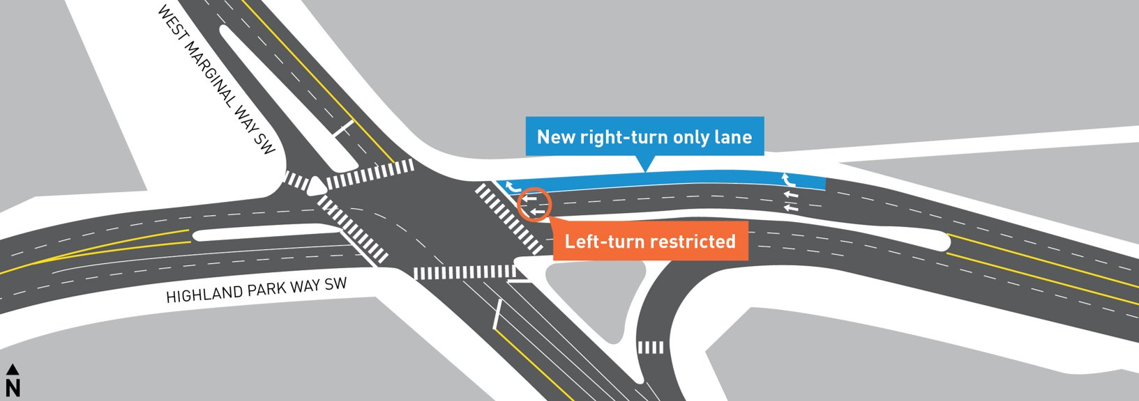

In 2020, SDOT will also be installing 6 new Radar Speed Signs along West Marginal Way between SW Marginal Pl and SW Front St. These signs display the speed of drivers. These signs are meant to encourage motorists to drive the posted speed limit which is 30 MPH on West Marginal Way. For an example of a Radar Speed Sign, see below.

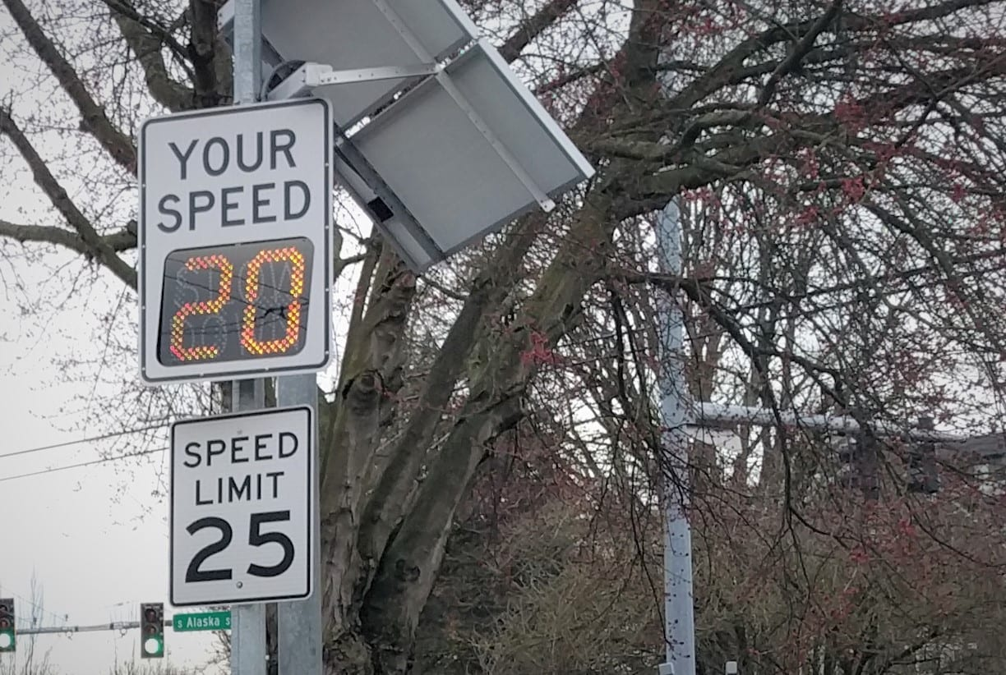

In 2021, SDOT will be building a temporary pedestrian signal and painted crosswalk at the Duwamish Longhouse. This temporary signal should help pedestrians feel safer when crossing West Marginal Way. SDOT plans to build the permanent signal in 2022 after it’s planned and designed. To see a rendering of the temporary signal and crosswalk, see below.

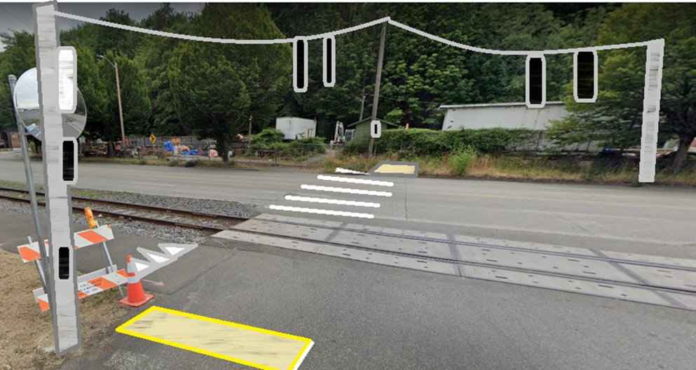

In addition to the temporary signal and crosswalk, SDOT will also be putting in a new sidewalk on the west side of West Marginal Way between the Duwamish Longhouse and SW Idaho St.

Other proposals SDOT is considering:
Duwamish Trail missing link – Under consideration right now is how to fill the missing gap in the bicycle network between the Duwamish River Trail and the West Seattle Bridge Trail. Over the coming months, we will be working with people who ride bikes, drive, and use West Marginal Way on how to fill this gap. If you would like to be a part of the conversation, please send us an email at WestSeattlebridge@seattle.gov.

Freight mobility improvements – We are currently working with West Marginal Way businesses and our freight partners on the best way to improve freight access in and out of West Marginal Way businesses. At this time, we are not planning to put in a freight only lane.

If you would like a more information about this topic or anything related to the West Seattle Bridge closure, please reply to this email. SDOT representatives would be happy to come brief your group virtually. Interpretation is available upon request.

To give feedback or input, please send an email toWestSeattlebridge@seattle.gov. For the latest information, visit the Reconnect West Seattle Website at www.seattle.gov/reconnectwestseattle.

