2nd Ave walk and talk summary
Updated: 7/1/16

Overview
The 2nd Ave walk and talk was a chance for project neighbors to walk along the project area with the project team and learn about the final design.

Location: Attendees met outside Bedlam Coffee on 2nd and Bell and walked north from Bell to Broad St, stopping at particular locations for discussion (shown below)
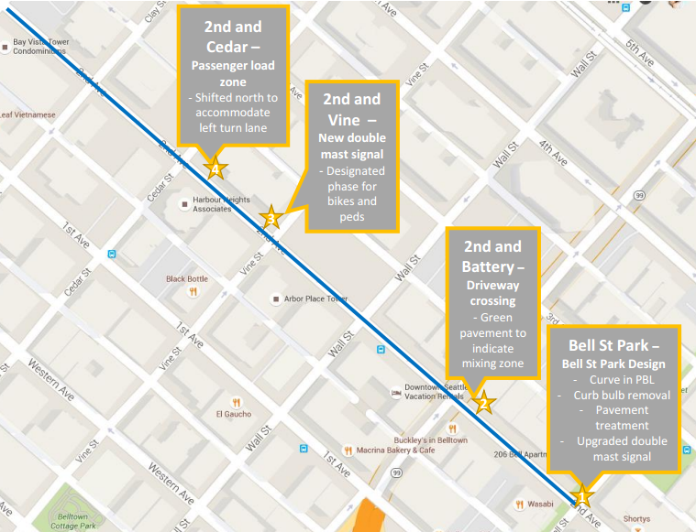
Date: Tuesday, June 14 from 5-6 PM

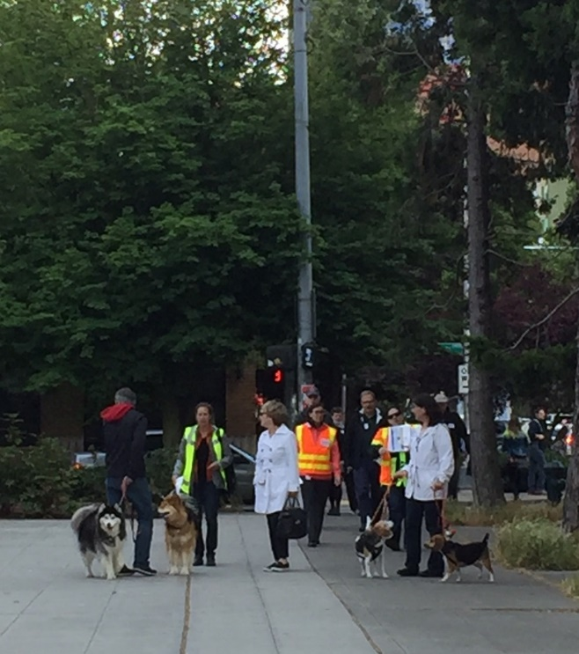
Staff
- Emily Reardon | SDOT
- MariLyn Yim | SDOT
- Sam Woods | SDOT
- Lauren Stensland | EnviroIssues
- Sara Colling | EnviroIssues

Notifications
We used the following methods to invite project neighbors to the event:
- Sent listserv email to our 2nd Ave stakeholder list
- Sent follow up emails to stakeholders we’ve met with
- Flyered each business and resident building on both sides of the project area

Discussion
Questions
- Why preserve parking rather than a thru-lane?
  - Having a parking lane next to the protected bike lanes helps further “protect” people biking from moving vehicles. Also, because left turn lanes will be added at some intersections, the thru lane would start and stop intermittently and drivers would need to weave in and out of the lane, potentially slowing traffic.
- Will the Bell St Park design be preserved?
  - Yes, the protected bike lane design will be consistent with the aesthetics of Bell St Park.
- Will the landscaping improvements include the west side of 2nd Ave?
  - Some new trees will be planted on the west side of 2nd Ave, but the landscaping improvements will not be as extensive as the east side of 2nd Ave.
- Will there be ‘No Turn on Red’ signs installed?
  - All turns across the protected bike lane will be controlled, i.e. must wait for a green arrow. There will be ‘No Turn On Red’ signs at every intersection where there is a southbound left turn or a westbound left turn that crosses the protected bike lane. Right turns on red will still be allowed for eastbound right turns (turning onto 2nd) and southbound right turns (turning off of 2nd) because they don’t cross the protected bike lane.
- Will the Pronto station near Vine St be moved?
  - It will be relocated slightly, but will remain in the same general area.
- What is the timeline for construction?
  - The project is scheduled to go to bid this summer, with construction starting in the fall. We anticipate construction taking approximately 8 months, with completion expected in summer 2017.
- Will the contractor work the entire length of the project area?
  - No, we have stipulated that the contractor can work on up to 4 blocks at a time in order to help mitigate construction impacts.
- Will there be other opportunities to hear more about construction details?
  - Yes, ahead of construction there will be a drop-in event so the community can hear more detail about sequence, anticipated impacts, and perhaps have the opportunity to meet the contractor. We will provide advanced notice of the meeting.

Comments
- Overall, attendees were very supportive of the project and are happy that the protected bike lane extension will also include improvements such as the three new signals at Cedar, Clay and Vine. Additionally, the group was pleased to hear there will be improvements made to the pedestrian areas, including the tree pits.
- It would be helpful to reach out to Alley Gallery Art (part of Belltown Community Council) because they are working on improving the alleys in Belltown. The project’s art component could potentially collaborate with them.
- Some neighbors are concerned about converting the tree planters to “flexi-pave” because so many people in the neighborhood have dogs which use the planters.
- Neighbors are interested in designating the neighborhood as an historic district.
- Some neighbors would like to see native plants included in the planting list for the buffers.
- The City should ensure that storm drain grates in the protected bike lane are designed to withstand bike usage.

