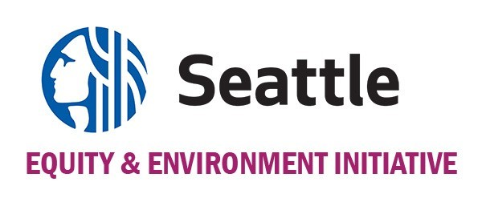
The Environmental Justice Fund Proposal Application 2022
A program of the City of Seattle. Administered by The Bullitt Foundation.

PROJECT TIMELINE

Organization/group name: ____________________
Use the table below to show us a brief timeline for your project. Add lines, if needed. (Activities must begin no earlier than January 3, 2023 and must be completed no later than June 30, 2024.)

Activity | Date/Timeline

