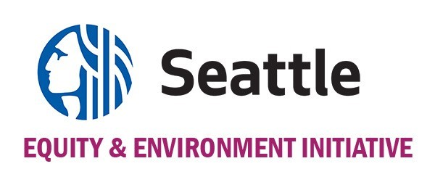
The Environmental Justice Fund Proposal Application 2021
A program of the City of Seattle. Administered by The Bullitt Foundation.

PROJECT TIMELINE

You organization/group name: ____________________
Use the table below to show us a brief timeline for your project. Add lines, if needed. (Projects must begin no earlier than January 3, 2022 and must be completed no later than June 30, 2023.)

Activity | Date/Timeline

