FOOD EQUITY FUND
CAPACITY BUILDING GRANT APPLICATION
For additional information, refer to the Guidelines. For additional questions, call (206) 727-FOOD (3663) or email foodequityfund@seattle.gov and talk to a project manager. Applications for the Capacity Building Grant are accepted on a rolling basis until October 31st 2023 or until funding is no longer available. Email application and attachments to foodequityfund@seattle.gov.
Information submitted is considered a public record and may be subject to public disclosure. For more information, see the Public Records Act, RCW Chapter 42.56. To learn more about how we manage your information, see our Privacy Statement at http://www.seattle.gov/privacy.
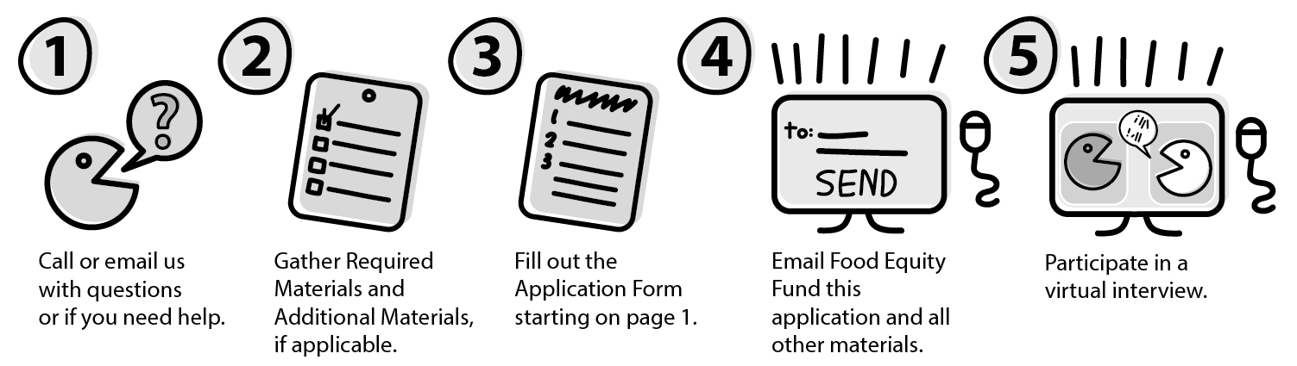

---SECTION ONE---

APPLICANT INFORMATION
NOTE: If your group is not an established 501(c)(3) organization, provide contact information for the fiscal sponsor who will assume financial responsibilities related to the grant, should funding be awarded.
Organization/group name:
Website:
Federal Tax ID Number:
Applicant Contact Person Name:
Applicant Organization’s Address:
Project Contact Phone Number:
Project Contact Email Address:

If not a 501(c)(3), Fiscal Sponsor Organization Name:
Fiscal Sponsor Address:
Federal Tax ID Number:
Fiscal Sponsor Authorized Signer Email:
Fiscal Sponsor Authorized Signer Phone Number:

ORGANIZATION INFORMATION

- Did you work with a Food Equity Fund Project Manager on your application? If so please provide their name (write ‘n/a’ if not applicable):
- When was your organization or group formed?

- Organization or group’s budget in 2022 (if applicable):

- Organization or group’s budget for 2023 (if applicable):

- For the required virtual interview, what language or accessibility requests do you have, if any? This is for planning purposes only and has no bearing on selection.

GRANT REQUEST INFORMATION

- Brief Description of Grant Request (2-4 sentences):

- Proposal Duration: Start: _________ (month/year) - End: __________(month/year)

- Request Amount: __________ ($5,000- $20,000)

- What priority communities will primarily benefit from your project? Please specify. We define priority communities as Black, Indigenous, People of Color (BIPOC), immigrants, refugees, people with low incomes, youth and/or elders.

- Address of Primary Site of Activities:

- What specific Seattle neighborhoods does your work mainly operate in?

- Has your community group or organization received a Food Equity Fund grant before? (Does not apply if you have served as a fiscal sponsor for another group.)
____YES _____NO

- Will your proposal include a physical improvement project? A physical improvement includes building semi-permanent or permanent structures OR making improvements or renovations to a building or exterior space. Examples may include but are not limited to garden bed, greenhouse, shed, commercial kitchen, etc. Property owner permission is required with your application if a physical improvement is made to property not owned by your group or organization. If you have questions about whether your proposal needs property owner permission, please reach out to foodequityfund@seattle.gov.
YES NO
If yes, you must provide documentation of permission from the property owner as an additional attachment.

---SECTION TWO---

WRITTEN RESPONSE
Briefly answer the following questions using Times New Roman, size 12 font. For the narrative, you may use whatever format allows you to best convey your responses (ie. bullet points or paragraphs). Being clear is more important than the length of your answer.
Include: Responses to Narrative, Grant Request Budget, Workplan, and Leadership Bios as attachments
- Briefly share your organization or group’s history, mission, and vision. Please share a successful effort or accomplishment that aligns with your proposed work.
- Who is the community you are a part of and how are they engaged throughout your proposed work? You may also include any existing partnerships and their role in your response.

- Please briefly describe what you will do with a Food Equity Fund Capacity Building grant. Please use the workplan and budget templates to go into further detail.

---SECTION THREE---

***CERTIFICATION***
I agree that I am authorized to submit this application on behalf of the applicant organization, and that the statements herein are true, complete, and accurate to the best of my knowledge.

_____________________________ ______________________________
Signature Printed Name, Title

VIRTUAL INTERVIEW – FOR REFERENCE ONLY
After a Food Equity Fund Project Manager reviews the written submission, all applicants will be required to schedule a 30-45 minutes virtual interview. Below are the questions that will be asked during the interview.
- Describe your organization or group’s leadership structure. How will key decisions be made throughout your proposed work?
- What are the food needs in your community? What community-led solutions are you proposing to address these food needs?

- How does your proposal advance the leadership of the priority communities: Black, Indigenous, People of Color, immigrants, refugees, people with low incomes, youth and/or elders in the food system?
There may be 1-3 application specific questions asked during the virtual interview, and program staff will send them to applicants ahead of time.

