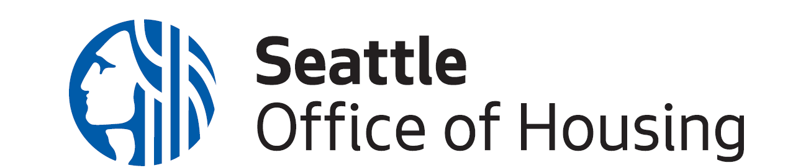
2023 Office of Housing Redevelopment Request for Interest
Statement of Interest

Please complete and save as a Word document or PDF with the following name:
“Developer Name_Statement of Interest_2023 Redev RFI”

Applicant Organization: | Click to enter text
Organization Executive Director: | Click to enter text
Check the top two projects you are interested in. | ☐ Lake City Community Center  ☐ Mount Baker Redevelopment Sites  ☐ South Park Henderson Street Project  ☐ Sound Transit 45th St U District Site
Check the project you are least interested in. | ☐ Lake City Community Center  ☐ Mount Baker Redevelopment Sites  ☐ South Park Henderson Street Project  ☐ Sound Transit 45th St U District Site
Please list any potential partners for the 2023 RFPs, if applicable.  State the RFP, potential partner, and nature of partnership. | Click to enter text
Application Primary Contact: | Name: Click to enter text  Title: Click to enter text  Email: Click to enter text  Phone: Click to enter text

Please provide a brief narrative answering the following prompt. Please use a maximum of three (3) pages, 1” margins, and single spacing.

Describe why you are interested in submitting a future application for your top two projects, and why you are not interested in your least interested project. Please include information about determining factors such as project size, details, timing, organizational capacity, etc., and how these sites rank in priority among existing, and future pipeline, projects.

Click to enter text

