ACCEPTING APPLICATIONS NOW!
2019 Family Child Care Advisory Council
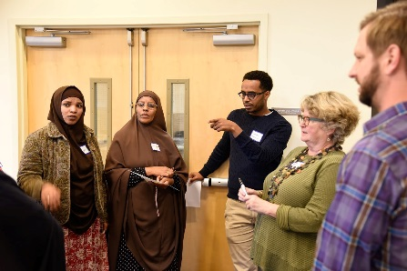
The Department of Education and Early Learning (DEEL) at the City of Seattle is accepting applications for the 2019 Family Child Care Advisory Council (FCCAC). This is the second year of the FCCAC. The 2018 FCCAC engaged in reviewing DEEL FCC initiatives and making strategic recommendations for the City to consider.
The FCCAC, which consists primarily of active family child care providers, convenes to engage three primary activities:
- Network with other family child care providers and stakeholders engaged in working with FCCs;
- Advise the City of Seattle on new or existing programs and initiatives that work with FCCs; and
- Take collective action and advocate for issues like professional development and business sustainability.
APPLY NOW!
We are looking for individuals interested in engaging in the work of the Council. Specifically:
1) family child care owners and operators
2) community partners that work closely with FCC providers.
Commitment:
- FCCAC members must commit to attending all meetings, a total of 6 (held on Saturdays)
- The City of Seattle will be providing a small participating stipend or honorarium for those selected and agreeing to serve on the 2019 FCC Council
- Space is limited to 20 members for 2019
Note: There will be opportunities to participate in FCC activities for non-FCCAC participants—stay tuned!
If you are interested in participating, please fill out an application and return to Cameron Clark at cameron.clark@seattle.gov or in person at: 700 5th Ave, Suite 1700, Seattle, WA 98104 or by mail at: PO Box 94665, Seattle, WA 98124-6965 c/o Cameron Clark. All applications should be returned by March 9th, 2019.

Family Child Care Advisory Council Application
If you are interested in participating on this Council for 2019, please complete this application no later than March 9th and send all applications to Cameron Clark to Cameron.clark@seattle.gov. You can also mail applications to: PO Box 94665, Seattle, WA 98124-6965 c/o Cameron Clark or drop off applications at: 700 5th Ave, Suite 1700, Seattle, WA 98104.
APPLICATION
- Name: Contact Information (email/phone):

- How you would you describe yourself:
Family Child Care Owner ☐ Parent☐ Other ☐
- Why would you like to participate on this Council?

- What issues, related to family child care, are most important to you?

- What is the address of your business or organization (if applicable):

- If you are a family child care home provider, what neighborhood do you operate in?

- How would you describe your race?

- What languages do you speak?

Anticipated Schedule: We anticipate the first meeting will take place on Saturday, March 30th. The time and location are still to be determined. Future tentative dates include April 27th, June 22nd, September 14th, and November 16th. All meetings will take place on Saturdays.

