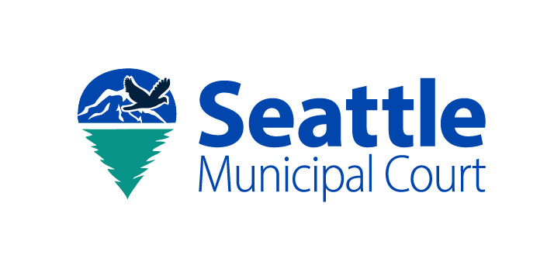

Declaration of Non-Responsibility

Traffic Camera Enforcement Program
This declaration may not be used by employers to transfer responsibility to employees. Only registered owners may submit this declaration.

Case Information
Notice Number (13-digit):
License Plate Number:
State:

Declaration
I declare under penalty of perjury under the laws of the State of Washington that the information provided is true and correct.
At the time of the violation, the vehicle was:
☐ Stolen
☐ Sold
☐ In the care, custody, or control of another person

Registered Owner Information
Signature:
Printed Name:
Date:
Street Address:
City:
State:
Zip Code:
Telephone Number:
Email Address:

Submission Instructions
Return this declaration to Seattle Municipal Court before the due date.
Seattle Municipal Court
Photo Enforcement Citations
PO Box 34987
Seattle, WA 98124-4987

