Centering Art & Racial Equity 2026 Application Preview

# INTRODUCTION

Use this document as a helpful worksheet to gather your responses before you copy and paste them into the online application. **It may not be used in place of the online application.** If you don’t have computer or internet access, contact Kathy Hsieh, as soon as possible: [kathy.hsieh@seattle.gov](mailto:kathy.hsieh@seattle.gov) or call 206-733-9926.

**We have interpreters who can speak to you in your language, including American Sign Language (via video).** Call us and tell us what language you speak. Expect a short pause while we find an interpreter to join the call.

**Applications must be submitted by Tuesday, August 5, 2025, 5:00 p.m. Pacific.**

## **GENERAL INFORMATION**

To streamline the application for organizations interested in applying to both Centering Art & Racial Equity and the [Cultural Facilities Fund](https://seattle.gov/arts/programs/grants/cultural-facilities-fund), the two grants share the same online application. **The application for both is available through the City of Seattle’s grant portal at** <https://seattle.fluxx.io/>.

The application contains a mix of multiple-choice and open-ended questions, as well as requests for file uploads. We estimate this application will take approximately 12 hours to complete. If you are also applying to the Cultural Facilities Fund, you will need to plan for additional time to apply.

The application **deadline is** **5 p.m. Pacific,** **Tuesday, August 5, 2025.**Please allow plenty of time to complete your application. Applications will not be accepted after the deadline.

# STEPS TO APPLY

1. **Read the guidelines** on the [Materials webpage](https://seattle.gov/arts/programs/grants/centering-art-and-racial-equity-grant/materials) for this grant.

* Make sure your organization is eligible.

1. **Go through this Application Preview document** to note what you will need to follow-up on -Programming Form and links, financial information, Racial Equity Self-Assessment, demographic information, etc.
2. If you decide to apply, you should reach out in advance to others in your organization that you’ll need support from and **schedule time to gather the information you’ll need**.
3. **Make sure you have an account** in the City of Seattle’s online grant portal at: <https://seattle.fluxx.io/>
   * If you have received a grant award from the Seattle Office of Arts & Culture in the past few years, then you probably have an account.
   * If you haven’t received a grant award since before 2022, or you’re not sure if you have an account, please feel free to contact [Kathy.Hsieh@seattle.gov](mailto:Kathy.Hsieh@seattle.gov) or [culturalfacilitiesfund@seattle.gov](mailto:culturalfacilitiesfund@seattle.gov) to look that up for you ***before*** you start an application.
   * If you’re sure you have an account but can’t remember how to login – your username is the email address you registered with. If you’ve forgotten your password, use the password reset option to update your password. Note that the system will block you from access if you enter the wrong password too many times. You’ll need to wait 24-hours before you can try again.
4. **Start an application.** Do this at least a month in advance of the deadline so that there’s time to seek support if you need it.
   * After logging in, go to the vertical gray menu bar on the left-side of the page.
   * Under the [INFORMATION] section, click on [Office of Arts & Culture].
   * Our grants page will open up on the right. Scroll down until you find the Centering Art & Racial Equity listing.
   * Click on the [Start NEW Centering Art & Racial Equity opportunity].
   * A blank application will open up.
   * Click on the Edit button in the top right corner of the application.



* + You need to fill in and save the Organization Name field in order to save the application. Please be sure to fill in at least this field and then click [Save] or [Save and Close] before logging off or shutting down. If no Organization Name is selected, you will not be able to find the application again.

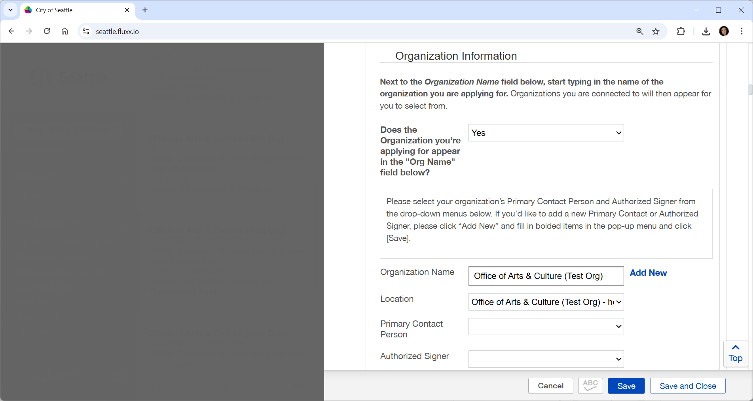



1. You may **return to the application at any time** by logging in and scrolling down the gray vertical menu bar on the left to the [APPLICATIONS] section and clicking on [Applications in Progress]. Your application summary box will open up on the right. Click on the summary box to open the application up to the right.

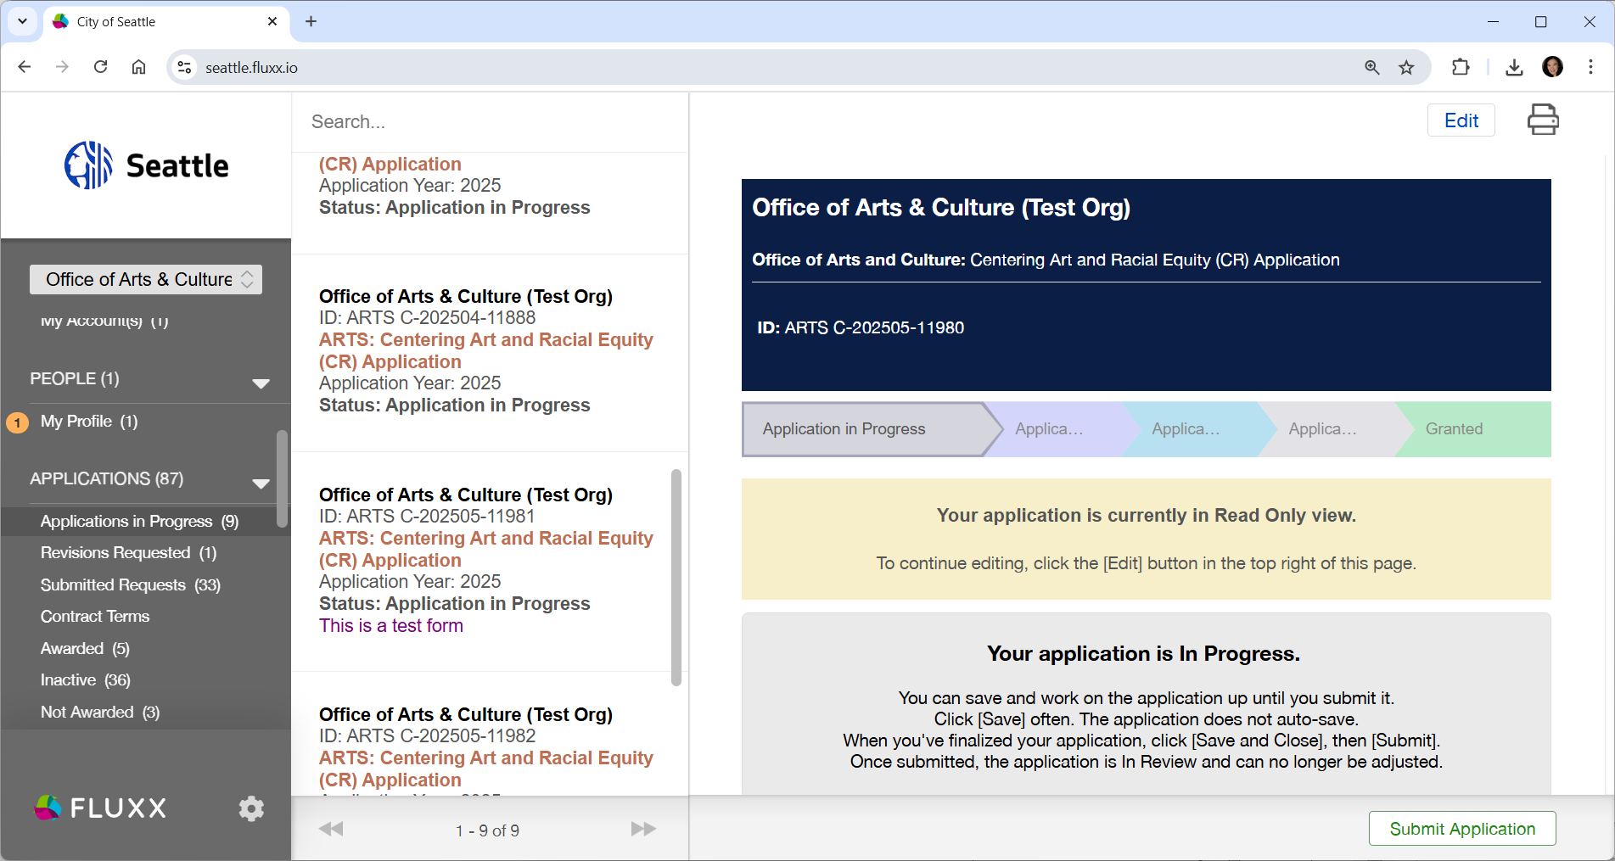



1. 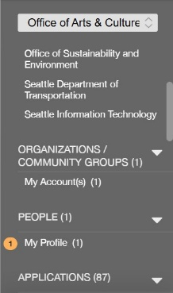When you have a chance, you should **double-check and update your Organization and Individual account profiles**.
   * On the gray vertical menu bar, scroll to [ORGANIZATIONS/COMMUNITY GROUPS] and click on [My Account(s)] to update your organization profile.
   * Scroll to [PEOPLE] and click on [My Profile] to update your personal profile.
   * The [Edit] key is on the top right corner of the page.
   * Click [Save and Close] when you are done.
2. **Attend a workshop**. Please see the schedule below or in the guidelines.
   * If you can’t attend a workshop, a pre-recorded workshop will be available online as soon as it is ready.
3. **Work on your application.**
   * Give yourself plenty of time, especially for the Racial Equity Self-Assessment. That portion of the application is meant to be a free tool for your organization’s humans to get together and evaluate your organization through a racial equity lens. For organizations founded on anti-racist values, it’s an opportunity to explore how inclusive you are at the intersections of gender, disability, class, age, education, country of birth, religion or sexual orientation. For those just beginning your journey, it’s a chance to assess where you are at so that you can plan how you’ll move forward.
   * Write your application as if you were telling a new friend about your organization. Don’t assume they know anything about your organization and be clear about what makes your organization worth knowing about. Provide specific examples that bring your organization to life for them.
4. **Submit your application early.**
   * Give yourself extra time to submit in case you run into any technical issues.
   * If anything is missing when you try to submit, the system will give you an error message and take you to each part of the application that needs to be updated.
   * Sometimes after you fix all the errors and try to re-submit, then system will show you a few last errors to fix. All of this takes time so give yourself plenty of time in advance of the deadline date.

## **HELPFUL LINKS**

You can find these documents under the [Supplemental Documents section](https://seattle.gov/arts/programs/grants/centering-art-and-racial-equity-grant/materials) for this grant on our website.

* Guidelines
* Glossary
* Continuum on Being an Anti-Racist Arts Organization
* Evaluation Criteria
* FAQs
* Individual Demographic Survey on Race

## IMPORTANT NOTICES

* **Need tech support?**Contact Kathy Hsieh at [kathy.hsieh@seattle.gov](mailto:kathy.hsieh@seattle.gov) or 206-733-9926.
* **Saving Your Application:** The grant portal does not autosave; we encourage you to click the [Save] button regularly.
* **Internet Browsers:** The City’s grant portal uses the Fluxx grants management software, a women-led, industry-leading cloud-first grant platform. Safari, Chrome and Edge are compatible internet browsers.
* **Privacy Notice:** Information that you provide in your online application will become part of a record that is subject to public disclosure. The Office of Arts & Culture will not publish this information, but we are legally bound to provide it upon request. For more information, see the Public Records Act, RCW Chapter 42.56. To learn more about how we manage your information, see our Privacy Statement at [seattle.gov/tech/initiatives/privacy](https://seattle.gov/tech/data-privacy).

# ELIGIBILITY

You should only apply if you meet these eligibility requirements.

**Eligible organizations are** arts, culture, heritage, and arts service organizations with:

* Their primary location within Seattle city limits
* An arts and culture mission and programs or a culturally specific organization with significant arts and cultural programming
* A minimum three-year history of providing public benefit through arts and culture to Seattle residents
* A Federal Tax ID number, though not required to have 501(c)(3) status
* A commitment to and actions consistent with being an anti-racist organization through an intersectional lens
* No concurrent funding through the Seattle Office of Arts & Culture’s smART ventures funding program

**Unsure or would like to discuss your eligibility?** Please contact Kathy Hsieh ([kathy.hsieh@seattle.gov](mailto:kathy.hsieh@seattle.gov)) for assistance.

# APPLICATION PREVIEW

These questions are for applicants interested in Centering Art & Racial Equity. For those interested in also applying to the Cultural Facilities Fund, please view that program information at <https://seattle.gov/arts/programs/grants/cultural-facilities-fund>.

**Bolded** questions are required.

* **Which program/s are you applying for?**
  + Centering Art & Racial Equity
  + Cultural Facilities Fund
* **Organization Information**
  + **Organization Name, Mailing Address, Email, Phone, Federal Tax ID #**
    - **Please note that only organizations with Federal Tax ID #s are eligible.** If you are a new organization not already in our online grant system, please select that you are an **Organization** *(Non-profit or Small Business that has its own Tax ID number) and* ***NOT*** *a* ***Community Group*** *(defined as a group working together but with no official documentation or Tax ID number) when filling in your organization information.*
  + **Primary Contact Person Name, Title, Email, Phone**
  + **Authorized Signer Name, Title, Email, Phone**
  + **Do you use a fiscal sponsor?**
    - **If Yes, Fiscal Sponsor Org Name, Contact Name,** Position/Title, **Email,** Phone
* **Best phone number or email address to contact you about this application?**
  + **Date Organization formed**
  + **Mission Statement** (Maximum Characters: 1,000)
    - Please share your organization’s mission statement. You may also include your Vision and Values, space permitting.
  + **Public Benefit** (Maximum Characters: 1,000)
    - Please share a brief, high-level description of the types of public benefit your organization provides for people in Seattle. Examples: free or discounted access; educational engagement programs; the creation of paid income for artists and cultural workers; more inclusive participation for a greater diversity of communities; access for people with disabilities, etc.
  + **Organization History** (Maximum Characters: 2,000)
    - Please share a brief history of your organization.
  + **Are you a 501(c)3 Non-profit? A WA State Non-Profit Corporation?**
    - These questions help us understand our sector and are not requirements for funding.
  + **How many Full-Time Equivalent (FTE) staff work for your organization?**
    - Paid FTE
    - Volunteer FTE
  + Website link (if applicable)
  + **Primary** and Secondary Art Discipline/s
  + **In what City Council District does most of your programming take place?**
  + If you provide programming in additional City Council Districts, please select them.
  + How did you hear about this opportunity?
* **Community Involvement**
  + **You will need to acknowledge that you understand that the Office of Arts & Culture will not publish organizational demographic information, but we are legally bound to provide it upon request.**
  + **How do you define your community?**
    - *Describe those you work with, including your staff, artists, supporters, volunteers, collaborators and board. Share about your efforts to engage, partner with, create access for, and include them. Please include information about both those involved in making decisions within your organization as well as who your audience is.* (Maximum Characters 1,500)
  + Mission and Community
    - **Does your organization's mission explicitly center and/or reflect a specific cultural community based on race?**
      * **If yes, which? Please select one. We encourage using the text box if you do not see your org reflected in the options or need space to elaborate.**
    - **Does your organization's mission explicitly center and/or reflect a specific community based on social identity? Select all that you feel safe in sharing.**
  + Programming & Services
    - **Do your programming and services explicitly center and/or reflect a specific cultural community based on race?**
    - **If yes, which? Select one. Use text box below to elaborate if your programming and services center more than one.**
    - **Do your programming and services explicitly center and/or reflect a specific community based on social identity? Select all that apply.**
  + Leadership
    - **What percentage of your organization’s leadership (Executive Staff, Board) is filled with BIPOC People of the Global Majority?**
    - **Please select any community/ies that each make up 25% or more of the leadership of your organization (Executive Staff, Board).** If your organization is mostly volunteer-led, this may include unpaid leadership. Select up to four, as applicable.
  + Non-Leadership Staff/Artists
    - **Over the past two years, what percentage of your non-leadership staff, artists and contract workers was filled with BIPOC People of the Global Majority?**
    - **Please select any community/ies that, over the past two years of your organization’s programming and services, each make up 25% or more of the combined non-leadership staff, artist and contract workers of your organization.** Select up to four, as applicable.
  + Audience & Supporters
    - **Over the past year, what percentage of your community partners, audience, and supporters was represented by BIPOC People of the Global Majority?**
    - **Please select any community/ies that, over the past year, each make up 25% or more of the community partners, audience, and supporters of your organization:** Select up to four, as applicable.

***These questions are only for those applying to Centering Art & Racial Equity***

* **Aims and Actions**
  + **Brief Organization Description - How would you describe your organization in one or two sentences?** (Maximum Characters: 250)
  + **Given Seattle’s broad and diverse cultural scene, what does your organization offer/do that makes you stand out from the rest? What is unique about what you provide Seattle and the impact that you have on the people here? What is your niche in Seattle’s arts and culture ecosystem?** (Maximum Characters: 1,500)
  + **How does your recent, current, and upcoming work serve your mission or vision? Please feel free to include both programmatic and organizational, internal and public-facing work in what you share.** (Maximum Characters: 2,500)
  + **What challenges are you dealing with as an organization and what strategies or steps are you taking to address them? Please feel free to reflect on the past year or two as well as the current one.** (Maximum Characters: 2,500)
* **Programming**
  + Complete and upload **Programming Form** to provide a listing of your programs, events and services for your most recently completed year plus your current year.
  + **Program Links:** Please share at least one or up to three links that provide a more sensorial experience of your organization, programs, services, projects and/or events. You may choose from a variety of options - a link to your website, a social media event page, a photo page, a video, a sound file, an event ticketing page, a project crowdfunding page, an article highlighting your organization/work – someplace online where the panelists can get a more experiential example of your programmatic work as an organization. Note: the links will need to be viewable at least through March 2026.
* **Financial**
  + Complete and upload the **Income and Expense Form** or a copy of your own most-recently-completed fiscal year profit and loss financial statement.
  + Total Operating Income and Expense amounts for your 3 most recently completed fiscal years – just the totals, not the detailed actuals.
    - **What was your most recently completed fiscal year?**
    - **Total Operating Income for the above fiscal year:**
    - **Total Operating Expenses for the above fiscal year:**
    - **What was the fiscal year previous to your most recent one?**
    - **Total Operating Income for the above fiscal year:**
    - **Total Operating Expenses for the above fiscal year:**
    - **What was your 3rd most recently completed fiscal year?**
    - **Total Operating Income for the above fiscal year:**
    - **Total Operating Expenses for the above fiscal year:**
  + Notes to Financial Information – Please use this space to explain anything that might be confusing or out of the ordinary to better help reviewers understand your financial situation. (Maximum Characters: 1,000)
* **Racial Equity**

Please provide an honest assessment of where your organization is as an anti-racist one or your journey towards becoming one. We encourage your leadership, including board members, and if possible, artists, staff and community to use this assessment as a tool for reflection and collective conversation prior to completing it for the application. For this section, you will need to download and refer to the **Continuum on Being an Anti-Racist Arts and Cultural Organization.** Please consider how your organization is anti-racist or working to become more anti-racist, both in terms of internal practices and in programming, partnerships and other work with community.

* + **Continuum on Being an Anti-Racist Arts and Cultural Organization**: **Please identify where on the Continuum on Being an Anti-Racist Arts and Cultural Organization you would currently locate your organization - not where you aspire to be. Please share why you chose this location on the Continuum and provide specific examples to illustrate your choice.**(Maximum Characters: 1,500)

*Note that some organizations are between two places on the Continuum, and/or may show up in one place for some behaviors/attitudes and show up in another place for others or may realize that different people involved with the organization are in different places. It’s fine to share the complexity and nuance of your choice even if that means specifying more than one number.*

* + **Briefly describe who was involved and the process used to make your selection.** (Maximum Characters: 500)
  + **Please provide examples that demonstrate how you uphold and center anti-racist and human centered values and/or are evolving towards doing so. How are you working in solidarity with those furthest from justice? What’s working? Where do you have room for growth?** (Maximum Characters: 2,500)

*Feel free to share about actions, programs, and the policies, practices and procedures that center racial equity in any of the following areas, if they apply: training, hiring and retention, board development, artist selection, programming development and implementation, community engagement and partnerships, audience development and demographics, budgeting or other organizational work.*

Before submitting, you will need to select “Yes” to the following statement:  
**I agree that I am authorized to submit this application on behalf of the applicant organization, and that the statements herein are true, complete and accurate to the best of my knowledge.**

# Application Support

Join a virtual workshop to learn more about this grant and how to submit your best application. The first hour will focus on applying for our Centering Art & Racial Equity grant. If you are also interested in learning about our Cultural Facilities Fund grant, you should plan to stay for the full 90 minutes.

## Workshop 1

Thursday, May 29, 2025, 10:30 a.m. - 12:00 p.m. Pacific

[RSVP to 5/29](https://www.seattle.gov/arts/experience/arts-events?trumbaEmbed=view%3Devent%26eventid%3D182685574)

** ASL-interpreted

Monday, June 2, 2025, 2:30 - 4:00 p.m. Pacific

[RSVP to 6/2](https://www.seattle.gov/arts/experience/arts-events?trumbaEmbed=view%3Devent%26eventid%3D182685635)

## Workshop 3

Tuesday, June 24, 2025, 12:00 - 1:30 p.m. Pacific

[RSVP to 6/24](https://www.seattle.gov/arts/experience/arts-events?trumbaEmbed=view%3Devent%26eventid%3D182686393)

## Workshop 4

Wednesday, July 9, 2025, 1:00 - 2:30 p.m. Pacific

[RSVP to 7/9](https://www.seattle.gov/arts/experience/arts-events?trumbaEmbed=view%3Devent%26eventid%3D182686067)

# What Happens Next?

**Panel Review Process**

We will be working with a community of panelists to review everyone’s applications in relation to the criteria for this grant. Applications will be read, discussed, scored, then ranked by score. Our staff facilitates the panel process but does not vote or try to influence the outcome.

**Award Decisions**

We hope to notify you about the status of your application by March 31, 2026.

If selected for funding, we will work with you to provide funding between April – December 2026, pending your submission of a report about a public program taking place within Seattle city limits between April – early November 2026 that is connected to art, culture and/or heritage with benefit for people in Seattle.

# Questions?

Please feel free to contact Kathy Hsieh at [Kathy.Hsieh@seattle.gov](mailto:Kathy.Hsieh@seattle.gov) or at (206) 733-9926.