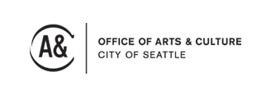
Arts Mean Business Intake Form

Hiring : When do you think you will have your funded position filled? Or if it has already been filled, when did your new-hire start their position?

Goals : With this position, what specific measurable goals does your organization hope to accomplish? How will you evaluate whether your goals have been achieved or not?

Visibility : Please describe the current level of coverage your organization receives via the media (TV, radio, newspapers, internet). Include a brief description of how you currently reach out to and engage with the community you serve.

Please return this form to:
Arts Mean Business, Seattle Office of Arts & Culture, PO Box 94748, Seattle, WA 98124-4748.

