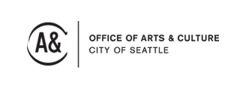
Arts Mean Business FINAL REPORT

Project Description: Please describe the job/position and major accomplishments of that employee/contractor.

Impact : How has the work of this job position enabled your organization to better serve your community and benefit the public? Please also include any measurable data you may have to demonstrate impact.

Learning: What have you learned through this process – about your organization, about your community? Has the position met or exceeded your expectations? Is there any course correction you have taken or plan to take to increase the effectiveness of the position? Anything you would do differently in the future?

Please return This form to:
Arts Mean Business, Seattle Office of Arts & Culture, PO Box 94748, Seattle, WA 98124-4748.

