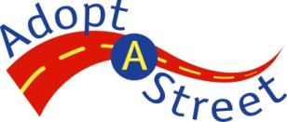
Clean Up Report Checklist

- PLACE BAGS FOR TRASH PICK UP
Leave bags on a public intersecting street corner (ex. 24th Ave S & S Dearborn St).
- Away from encampment sites
- Away from personal or public trash bins
- Away from private property

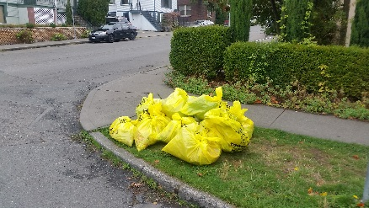
- TAKE A PICTURE
This makes the bags easier to locate and speeds up the trash pickup process.
Make sure that no volunteers are present in the picture. You can send us pictures of your volunteer crew separately!

- REPORT YOUR CLEANUP
Within 24 hours after your event, please report your clean up to our Adopt-A-Street phone number (206-684-7647) or email (adoptastreet@seattle.gov). Make sure to include:
- Volunteer group name and phone number
- Date of cleanup
- Number of hours spent on cleanup
- Number volunteers who participated
- Number of bags collected
- The location and picture of bags, if two or more (only if you need a trash pickup)
ALWAYS report your cleanup, even if you do not need a trash pickup service.
OTHER REMINDERS
- Trash bags are picked up within 2-5 days of the sent request. If the bags are not picked up within 5 days, please contact us as soon as possible.
- We will only pick up two or more bags at each location. If you are unable to collect two bags during your cleanup, please contact the Adopt A Street hotline to make arrangements for single bag collection.
- Do not add Adopt A Street bags to your personal waste container. You will be charged an extra bags fee if the bag exceeds the limit per container.
- If you collected any sharps, please place them in a sealed and labeled sharps container and dispose of them at your nearest Transfer Station.

North Transfer Station 1350 N 34th St, Seattle, WA 98103
South Transfer Station 130 S Kenyon St, Seattle, WA 98108

