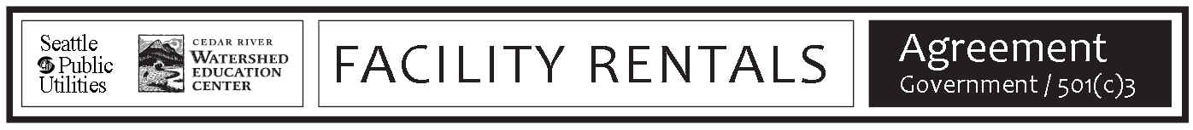

Name of Event | # of guests (max. 120)

Rental Date | Day of Week | Arrival Time  (When you enter room to setup) | Meeting Start Time | Meeting End Time | Departure Time  (When you leave after meeting cleanup)

Spaces requested | Auditorium (seats 65 –80) | Meeting Room (seats 8 –10)
Full Lab (seats 15 – 30) | ½ Lab - Lichen  Close to Drum Courtyard | ½ Lab – Lichen  Closer to lake trail, includes whiteboard
Heritage Courtyard (seats 80 - 120) – Must rent Auditorium or Lab to reserve Heritage Courtyard

Group/Company |  |  |  | 501(c)3 Yes No
Contact Person(s) (must be attending the event)
Address |  | City |  |  | Zip
Day Phone | Cell Phone |  | E-mail

Do you have a facilitator/guest presenter? No Yes –

If yes, have your provided them with an inventory? Informed them of arrival/departure times

Serving Food? No Yes - If yes, Catered Potluck Boxed Lunches Other

Serving Alcohol? No Yes If yes, Banquet Permit Attached Liability Insurance Attached

Equipment Notes (In detail specify your needs i.e. PowerPoint on thumb drive):

Notes:

I HAVE READ THE RULES ON THE BACK OF THE FORM AND SIGNED
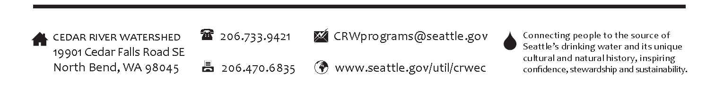
CEDAR RIVER WATERSHED EDUCATION CENTER RENTAL USER RULES

Setup, cleanup and decorating
- No tacks, pins, nails or any sharp objects may be used on the walls or structures inside or out. Only painters tape, Post-it easel pads, or adhesives approved by the facility coordinator may be used to hang items. Do not use duct tape or scotch tape.
- Tents must be approved by CRWEC staff.
- Recycling and composting are required.
- The facility must be returned to its original condition including removal of garbage to the facility dumpster or the recycle containers. If trash exceeds three 30-gallon bags it must be taken off site.
- No helium balloons allowed.
- User must ensure that all guests respect the natural landscape, other visitors and cause no harm to the buildings and exhibits. CRWEC staff have final discretion over decorations.

Candles, smoking, barbecues, campfires, AND WEAPONS
- Use of candles, barbecues, other alternative cooking methods, or the campfire circle must be approved on a case-by-case basis in advance of the event. Fires and candles must not be left unattended.
- No smoking anywhere except in designated smoking areas. These unsheltered areas are located away from windows or doors according to Washington State law. All cigarettes must be deposited in ashtrays.
- The possession and use of weapons while on Cedar River Watershed property is prohibited except by those authorized in the performance of their duties such as law enforcement officers.

Supervision, Staffing, Event Size, Parking
- Rental may NOT exceed 120 people.
- Children must be supervised at all times. Adult supervision must be designated.
- Parking is allowed in designated areas only. User may need to provide “shuttle” service from the Rattlesnake Lake Parking Area to the CRWEC. See rental map for further information.
- User must leave facility by the time stated in rental agreement or be liable for additional fees.
- Unauthorized cars left overnight will be towed. To make arrangements to leave your car contact event staff.

Food and Alcohol
- No alcohol is allowed without permission. Groups officially sponsored and paid for by the business, during work hours may have 2 servings of beer or wine per person for weekday events without requiring a licensed bartender. $1 million in Liability Insurance including “Host Liquor Liability,” is required.
- Any event serving alcohol (including a ceremonial toast) must have a Banquet Permit from the Washington State Liquor Control Board: http://liq.wa.gov/licensing/banquet-permits.
- Personal use of privately provided alcohol except a ceremonial toast is not allowed anywhere on the premises including parking areas and Rattlesnake Lake Area. This includes private flasks, beer, wine, etc.
- Kegs are allowed in outside areas only.
- Alcohol in outside areas must be contained to the designated rental areas. See the rental map for details. The user is responsible for communicating this and supervising guests.

CRWEC FEES:
- Rental fees must be paid 30 days before the rental. We can accept purchase orders on request. No cash. We accept checks, Visa, MasterCard and Discover. Checks should be made payable to City of Seattle.
- Cancellations must be received in writing 30 days in advance of the event to receive a refund.
- Refunds are not given for unused rental time.

Renter’s Signature: Date | Date:

